27 May 2018

Nick P. Gondek

Conservation Metrics Inc.

145 McAllister Way

Santa Cruz, CA 95060

(414) 581-4445

nick@conservationmetrics.com

**Too much DNA? Subsampling strategies for Spatially Explicit Capture-Recapture Estimators**

NICK P. GONDEK,[1] *University of Minnesota, 2003 Upper Buford Cir, St Paul, MN 55108 USA*

DAVID L. GARSHELIS, *Minnesota Department of Natural Resources, 1201 E. Hwy 2, Grand Rapids, MN 55744, USA*

KAREN V. NOYCE, *Minnesota Department of Natural Resources, 1201 E. Hwy 2, Grand Rapids, MN 55744, USA, now retired*

JOHN F. FIEBERG,[2] *University of Minnesota, 2003 Upper Buford Cir, St Paul, MN 55108 USA*

**ABSTRACT** Genetic mark-recapture studies estimate animal abundance using non-invasive DNA identification methods to "capture" and subsequently "recapture" individuals that leave genetic material at trap sites. Due to the cost of genotypic analysis, researchers often choose to process only a subsample of this genetic material. We explored the effect of subsampling on spatially-explicit capture recapture (SECR) estimators using hair-snare data obtained from a 2012 genetic mark-recapture study of black bears (*Ursus americanus*), and by simulating capture histories from a known population. Similar to effects on non-spatial mark-recapture estimators, subsampling produced density estimates that were lower, on average, than the full data estimate when individuals left varying numbers of samples at a trap; however non-proportional subsampling (sampling at least one observation from each unique trapping site and sampling period combination) had much less of an effect on estimator performance than simple random sampling. Thus, non-proportional subsampling may be preferable to simple random sampling, despite the inherent violations of SECR assumptions that may result. The benefits of using non-proportional sampling will be greatest when individuals exhibit substantial heterogeneity in their capture propensities, leave multiple samples at a trap, and when available funding severely limits the number of samples that can be processed.

Mark–recapture is one of the most commonly used methods to estimate animal abundance. Abundance and its associated temporal trends are of critical importance for making informed management decisions (Borchers *et al.* 2002; McCrea and Morgan 2014). Abundance estimates can be difficult to interpret, however, without some understanding of the effective area to which they apply; extrapolation to a regional scale by way of density is normally desired (Borchers *et al.* 2002; Royle *et al.* 2013).

Various methods have been used to estimate the effective area sampled in mark–recapture studies (e.g., by quantifying how far animals move); this area can then be used to convert abundance estimates to density (Wilson and Anderson 1985, White and Shenk 2001, Ivan et al. 2013ab). By contrast, spatially-explicit capture recapture methods (SECR) use the data obtained in mark–recapture to estimate density directly (Efford *et al.* 2005; Borchers 2012; Royle *et al.* 2013). Specifically, SECR models make use of the location of captures, and also make better use of recapture data by including captures at multiple sites within the same sampling period, so as to yield the spatial distribution of individuals on the trapping grid. As such, SECR accounts for an important source of individual heterogeneity in capture probabilities that is unaccounted for in traditional (non-spatial) mark–recapture estimators: animals with home ranges near the edge of the trapping grid will be less likely to be captured than animals with activity centers near the center of the trapping grid.

Hair-traps provide a means of detecting and recapturing a large number of unique individuals, identified by their DNA, and are therefore well-suited for SECR-based density estimates. Since development of an efficient, noninvasive method of snaring hair just 20 years ago (Woods *et al.* 1999), barbed wire hair snares (and accompanying genetic advances) have revolutionized mark–recapture estimation, especially for bears (Proctor et al. 2010). Because animals are not restrained by a hair-trap, and likely have a minimal negative behavioral response, many more captures, spread over many more traps, may occur, compared to physically trapping. Due to the costs of genetic analysis, however, investigators may only be able to process a subsample of the genetic material collected at trapping sites (Boulanger *et al.* 2004; Petit and Valiere 2006; Gervasi *et al.* 2008; Settlage *et al.* 2008; Sawaya *et al.* 2012).

Subsampling (of the full sample of hair) has been shown to be problematic for non-spatial mark–recapture estimators, especially when individuals exhibit a behavioral response to having been previously captured and this behavioral response is not consistent across individuals (Tredick *et al.* 2007; Ebert *et al.* 2010; Augustine *et al.* 2014). In this case, individuals that leave many DNA samples (e.g., clusters of hair) are likely to be identified in a subsample, whereas individuals that leave few samples are often excluded. In other words, samples of DNA selected in a subsample of data are likely to come from individuals that are repeatedly captured, whereas the animals captured rarely may be missed. As a result, subsampling tends to result in estimates of capture probability that are biased high (many repeat captures) and abundance estimates that are biased low; this effect is exacerbated as subsample size decreases (Augustine *et al.* 2014).

One common way of attempting to reduce mark–recapture biases from subsampling is to select samples that are likely to include the maximum number of individuals, and exclude samples that are most apt to be redundant and non-informative. In hair-snaring studies of bears, preference is often directed to samples from novel site by session (hereafter site-session) combinations (Settlage *et al.* 2008; Thompson *et al.* 2005; Drewry *et al.* 2013; Laufenberg et al. 2016; Morehouse and Boyce 2016; Murphy *et al.* 2016, 2017; Humm et al. 2017). However, this approach tends to increase inclusion probabilities for samples left at infrequently visited sites and decrease inclusion probabilities for samples left at frequently visited sites. Because SECR models incorporate the spatial capture histories, we hypothesized that purposefully altering this distribution through spatially-explicit subsampling could be problematic for SECR, even if beneficial for non-spatial mark–recapture.

Whereas some investigations have yielded empirically-based recommendations for subsampling for non-spatial mark–recapture estimators (Tredick et al. 2007, Dreher et al. 2009), the issue has gained less attention for SECR models, even though these are now the norm (but see Murphy *et al*. 2016 and Humm *et al.* 2017, discussed further below). Our objective was to use a northern Minnesota genetic mark-recapture data on American black bears (*Ursus americanus*) set in tandem with simulated data sets with known individuals, to compare abundance and density estimates using (1) subsampling strategies commonly utilized in wildlife studies and (2) various subsampling rates reflective of different budgetary constraints. Using these results, we provide guidance for obtaining genetic SECR density estimates when budget constraints preclude processing all samples of genetic material.

**STUDY AREA**

Our study area for collection of black bear samples was in Itasca County, northern Minnesota. The area is comprised primarily of public lands within the Chippewa National forest and lesser amounts in state and county forests, interspersed with industrial timber lands and private lands. The area was heavily forested, with minor topographical relief. About two-thirds of the forested area was uplands, dominated by aspen (*Populus grandidentata, P. tremuloides*), maple (*Acer spp.*), red pine (*Pinus resinosa*), paper birch (*Betula papyfiera*) or balsam fir (*Abies balsamea*). Lowlands were dominated by black spruce (*Picea marina),* tamarack (*Larix laricina*), black ash (*Fraxinus nigra*), and northern white-cedar (*Thuja occidentalis*).

The study area supported timber harvesting, and lake- or forest-centered recreation, including a fall bear hunting season. Access was facilitated by numerous (mostly unpaved) roads and trails (often abandoned logging roads). We gridded the 315 km2 area into 121 2.6-km2 (1-mi2) cells, and had access to each cell.

**METHODS**

## Empirical data set

We constructed 121 traps, one in each grid cell, designed to capture hair of bears that passed under or over a strand of barbed wire. Within each of these grid cells, we chose a trap location in what we perceived as good bear habitat to maximize visitation. We set traps at least 100 m from main roads, but often along trails that bears might use. We obtained a GPS location of each trap.

We used two strands of 4-pronged barbed wire, one at 45 cm and one at 75 cm off the ground, wrapped around 3–5 trees, to form an enclosure. Others observed that using two strands resulted in the detection of more bears, and better estimates of abundance than traditional single-strand hair traps (Lowe 2011, Wilton et al. 2014). We suspended a bag of bacon and a scent lure from a string (above the reach of a bear) across the middle of each trap, and put bait and scent lure on a pile of brush in the middle of the enclosure. Baits and lures were refreshed at each trap visit. We added different types of lures at each trapping session to maintain novelty for the bears. We checked all traps 6 times at intervals of 10 days during May–July, 2012. We did not move traps between sessions.

At each trap check, all bear hair was removed from the wire. Each clump of hairs on each barb was collected in a separate envelope, and labeled as to proximity to other barbs with hair, trap number, and date. We coded barbs of hair that were adjacent (next to, on either the same wire or the one above/below) as being from the same cluster. We assumed that samples from different clusters were more likely to be from different bears (or mixed genetic samples that could not be genotyped) than samples from within the same cluster (e.g., Tredick et al. 2006 found that bear hair on adjacent barbs was more likely than farther spaced barbs to be the same bear; however, when trap visitation is high, as in a high-density area, adjacent barbs may be different bears).

As our budget was not sufficient to analyze all collected hair samples, we subsampled the collection. In subsampling we made an attempt to maximize our detection of different bears that visited the sites, so we initially chose (randomly) 1 barb from each of the 377 site-sessions with hair; we then chose 736 random samples, without replacement, from each of the remaining 1265 barb-clusters (i.e., no repeats from within the same cluster). These samples were sent to Wildlife Genetics International (Nelson, British Columbia, Canada) for genotyping.

We set camera traps at a subset of the hair traps to provide additional information on individual bears visiting the same trap multiple times in a single session and where they left hair. We targeted sites where individually-identifiable radiocollared and eartagged bears were known to be present, but we were also able to distinguish other individuals as well.

## Simulated capture data

In order to assess the true effects of subsampling on density estimates, we needed a dataset with known density. Therefore, we created a simulated population with eight scenarios having different combinations of behavior, individual heterogeneity, sample redundancy, and uneven density of activity centers (Fig. 4). In all scenarios, we simulated capture histories for 30 bears during 6 time periods on a 6 by 6 trapping grid with traps spaced 800 meters apart, for a total non-buffered area of 23 km2. The number of bears and size of the trapping grid were chosen to roughly mimic the empirical data set up. Rather than basing our simulations on a desired number of DNA samples for each simulation, we instead modified the likelihood of capture, recapture, and propensity of bears to leave redundant samples in each scenario, allowing us to quantify impacts of subsampling on estimator performance across a range of realistic conditions.

We developed a simulation model to create capture histories allowing for the possibility of: 1) capture heterogeneity among individuals; 2) behavioral response to traps (i.e., enhanced attraction to traps following initial capture); and 3) individual bears leaving multiple hair clusters at a site during a single trapping period. To describe the different scenarios, we have compiled a list of terms and definitions used in model notation (Table 1; Fig. S1).

We simulated ‘activity centers’, (*Ai*; *i* = 1, 2, …, *N*), for *N* = 30 individuals using a simple sequential inhibition (SSI) process with an inhibition distance *ϕ* = 200m (Baddeley, 2017).

A ~ rSSI(N, ϕ) (1)

In a simple sequential inhibition process, points are generated at random in the window of interest, and if a new point is generated within *ϕ* distance of an existing point, that point is discarded and a new one is generated. In scenarios with uneven density of activity centers across the trapping grid, we simulated separate SSI processes in two spatial strata, with *Nα* of activity centers located exclusively in the left half of the trapping grid and the remaining activity centers simulated at random from within the entirety of the trapping grid (Fig. 2A).

We assigned a normally distributed ‘individual heterogeneity’ parameter, δi, to each individual, which characterized that individual’s heightened or depressed propensity for capture relative to the population:

δi ~ Normal(0, Δ) (2)

We determined the capture probability for individual *i*, at trap *k*,during trapping session *t, gi,k,t*, using:

$$\begin{aligned}g_{i,k, t}\left(Ψ_{i,k}, C_{i,k},b,δ_{i}, σ\right)=\frac{exp\left(g_{0}+C_{i,k,t}*b+δ_{i}\right)}{1+exp⁡(g_{0}+C_{i,k,t}*b+δ_{i})}e^{\frac{- {Ψ_{i,k}}^{2}}{2σ^{2}}},\#(3)\end{aligned}$$

where Ψi,k is the distance between the individual’s activity center and trap k, Ci,k ,t is 1 if the individual i was previously captured at trap k during any previous trapping period (and 0 otherwise), and δi measures the individual’s propensity for capture (Fig. 2B). The general form of the model in eq 3 is referred to as a half-normal detection function; g0 determines the maximum probability of detecting an animal and σ represents the rate at which detection drops off with distance between an individual’s activity center and the trap. Note, it is common to use a parameter b to model a change in capture probabilities across all traps following an initial capture and a parameter bk when modeling a change in capture probabilities that applies only to those traps where the individual has been previously captured (see Model Fitting). Here (eq. 3), we use b rather than bk even though we apply this effect only to those traps where the individual has been previously captured, and we pair this parameter with a set of trap-specific indicator variables, Ci,k ,t.. We feel this specification is more natural since the effect of a previous capture is assumed to be the same at every trap where a bear has been previously caught.

Capture histories were then simulated as Bernouli random variables:

c­i,k,t ~Bernouli(gi,k,t) (4)

If captured, we simulated a number of samples left at the trap, Ii,k,t, using a Poisson distribution:

Ii,k,t ~ Poisson(λ­i ci,k,t) with log(λ­i) = γ+δi (5)

By including δi (above), we assume that bears that have a higher propensity for being captured are also more likely to leave more samples at a trap.

## Subsampling simulations

We conducted simulations to explore the effects of two alternative strategies for subsampling hair left at hair traps in both the empirical and simulated data sets: 1) *simple random sampling* (SRS), and 2) a subsampling method that gives preference to unique site-sessions, which we will refer to as *site-session preferred* (*SPR*). With simple random sampling, *n* samples were chosen at random from the set of hair clusters pooled across the different sites and trapping periods. Alternatively, with *SPR*, we tried to maximize the number of unique site-sessions represented in the subsample. Let *m* represent the number of unique site-sessions in the full data set. If *m > n*, we randomly choose *n* unique site-sessions, with 1 sample randomly selected from each of these site-sessions (in the survey sampling literature, this would be referred to as a 2-stage cluster sample). When *n* > *m*, we randomly chose one sample at random from each unique site-session and then took a second simple random subsample of size *n – m* from the remaining clusters (from the pooled data) to give a total of *n* samples. This mimics how we actually subsampled the hair in the empirical dataset, but here we resampled the resulting genetic dataset.

We subsampled the empirical (black bear) data set and simulated data sets (from each of the 8 simulation scenarios) using both subsampling strategies, with subsample sizes of *n* = 250, *n* = 550, and *n* = 850, representing 25%, 54% and 83%, respectively, of the empirical genetic dataset, 15%, 33% and 52% of the hair clusters (before we subsampled), and 9%, 20%, and 31% of the barbs with hair. In the simulated dataset, by contrast, this subsampling was for the full dataset, using clusters as the sampling unit (i.e., assuming each cluster is a unique bear), and assuming that all bear visits yielded a sufficient DNA sample.

We fit SECR models to each subsampled data set and the original (i.e., “full”) genotyped data set. In the context of this study, an observation (i.e. hair cluster) can be considered ‘redundant’ if it does not contribute a unique (individual x site x session) combination to the capture history of interest (i.e., a sample is redundant if there is another observation of the same individual at the particular site-session). Importantly, samples were not redundant if a bear was detected at different sites in the same sampling session (as would be the case in traditional mark–recapture). To better understand the performance of the estimators under different types of subsampling, we calculated the percentage of each data set that was not-redundant.

**Model Fitting**

A variety of functions can be used to model how detection probabilities change as a function of distance between an animal's activity center and a trap location. Here, we only consider the half-normal curve(Fig. 2B), which we used to simulate capture histories. For each simulated (and potentially subsampled) data set, we fitted two SECR models to the observed capture histories, a null model (*g0* ~ 1), and a model where an individual’s likelihood of capture at a given trap changed after initial capture at that specific trap (*g0* ~ *bk*; note again, the *bk*parameter in this model is equivalent to theparameter *b* in eq. 3.) For each subsample of the real black bear data, we fit two additional models: a model where likelihood of capture depended on the trapping period (*g0* ~ *t*), and one where capture probabilities varied by trapping period and depended on whether the animal had been previously caught at the trap (*g0* ~ *bk* + *t*). In each case, we assumed $σ$ was constant for all individuals.

We fit models using the R programming language (R Core Team 2015), package ‘secr’, and packages ‘foreach’ and ‘doParallel’ for optimization of model fitting and capture history simulation using parallel processing (Analytics and Weston 2014, 2015; Efford 2015). Within the package 'secr', we used the function 'secr.fit' for fitting models to subsampled data. This function requires a capture history and a trapping grid and returns a derived density estimate, along with estimated parameters describing the effect of time, trap-specific behavioral responses, and any other individual-level covariates (e.g., sex) on capture probabilities (Efford *et al.* 2005).

## Simulation Process

We generated 220 sets of capture histories for each of the eight unique simulated bear populations. We then subsampled each set of capture histories using both SPR and SRS sampling designs with sample size equal *n* = 250, 550, or 850. Thus, each simulated set of capture histories was subsampled 6 times (2 methods x 3 sample sizes). We also subsampled the real black bear capture history data set 220 times using both SPR and SRS sampling designs with *n*  = 250, 550, or 850. We then fit SECR models (*g0* ~1, *g0* ~ *bk*) to the subsampled, simulated capture histories and models (*g0* ~1, *g0* ~ *bk*, *g0* ~ *t*, *g0* ~ *t* + *bk*) to the subsampled real capture histories (see *Model Fitting*), and saved the resultant model objects for latter comparison.

# RESULTS

**Empirical Data set**

Bears visited 101 of the 121 hair trap sites, resulting in 377 total site-sessions yielding hair. We collected hair from 2784 barbs that occurred in 1642 separate clusters (composed of 1–11 adjacent barbs; 62% of clusters were just a single barb, <2% were >5 barbs). Sites had 1–26 clusters of hair: an approximately equal percent had 1, 2, 3, or 4 clusters (14–17%), and few had >8 clusters (total 9%).

Of 1113 samples sent for analysis, 1019 (91.6%) were successfully genotyped; these were from 96 different sites and 333 site-sessions. Genotyping identified 43 different individuals (26 males, 17 females). Individual bears were detected up to 132 times each, at 1–22 different hair traps, and up to 32 times in a single sampling session; 14 different bears were identified in session 1, and 21–28 different bears were identified in subsequent sessions, possibly suggesting that some individuals learned the location of the traps Sex ratio of individuals visiting hair traps was skewed to males in all sampling sessions and did not vary through time (*χ2*=0.96, *df*=5, *P*=0.97). In 46.7% of cases, individual bears were identified at only a single cluster of hair, whereas in 25.8% of cases, we identified individuals at three or more clusters of hair (up to 11) at a given site-session (Fig. 1).

Density estimates derived from fitting SECR models to subsets of *n* = 250 observations tended to be lower, on average, than estimates derived from the full empirical data set (Fig. 4, Fig. S2). Differences between estimates from subsampled and full genetic data sets were greatest when using SRS (versus SPR), and these differences became smaller as the size of the subsampled data sets increased (Fig S2). Including a trap response (*bk*) as a covariate in the half-normal detection function resulted in estimates from both SRS and SPR that were more consistent with the estimate from the full data set (Fig. 4, Fig S2).

**Simulated Data sets**

Density estimators were most biased when the model was mis-specified. Examples included scenarios where: (1) bears left multiple samples at a trap and a behavioral effect was present but not included in the SECR model (t6, t7), (2) individuals exhibited unmodeled heterogeneity in capture probabilities (t3, t5-t7), or (3) activity centers were not uniformly distributed (t7-t8; Fig. 3, Fig. 5). Similar to the empirical data set, 3 of 8 simulated capture scenarios (t5, t6, and t7) yielded SECR density estimates that tended to be lower, on average, than those derived from the full data set, and for these 3 scenarios, estimates from SRS samples were lower than those from SPR samples (Fig 4). In each of these scenarios, bears exhibited individual heterogeneity in their capture propensities and also left multiple samples at a trap. SPR estimates were also less variable than those obtained from SRS samples in these scenarios and in Scenario t4, where bears deposited multiple samples at a trap but there was no unmodeled heterogeneity (Fig. 4). Further, SPR subsampling resulted in lower proportions of redundant samples, on average, than SRS subsampling, particularly at lower sample sizes (Fig. 6). SPR and SRS performed similarly in simulations in which bears only deposited 1 sample at a trap (t1, t2, t3 and t8) and at higher sample sizes (Fis. S3). In all cases where models were properly parameterized, subsampled data resulted in estimators of capture probabilities (*gi,k,t*) and behavioral effects that were biased low (Fig. S4, S5).

# DISCUSSION

Counter to our hypothesis, we found that non-random sampling (SPR) of bear hair on barbed wire traps outperformed simple random sampling (SRS) for estimating density via SECR models. For simulated populations, estimates of bear density derived using SPR to subsample the data were closer to the true bear density than estimates derived using SRS. Additionally, in both the simulated and empirical datasets, SPR-subsampling yielded estimates closer to that derived using the full data set. Likewise, Humm et al. (2017) found that subsampling directed at unique site-sessions yielded SECR estimates that were similar to those derived from a dataset where, for one session, there was no subsampling of the bear hair. Murphy *et al.* (2016: Appendix A) used a simpler simulation model than ours and found that subsampling just a single sample per site-session yielded unbiased SECR estimates.

Our initial hypothesis that SRS sampling would be better in SECR estimates stemmed from the concern that selective sampling, which basically weighted each site-session equally in the first sample, would disproportionately weight sites that were infrequently visited. For example, bear A might have visited two sites, leaving one hair sample at one site and 10 hair samples at a second site, because it visited the second site repeatedly over a few days. Since these repeat visits to a site within a session are not useful information in present SECR models, it seems appropriate to ensure that a sample from the seldom-used site is included. However, suppose other bears also visited the second site and left multiple hair samples, totaling say 30 samples. In SPR sampling, the single hair sample at the first site would be chosen, as would one sample from the second site; thus, the probability of selecting a hair sample from bear A at the second site would be less than at the first site simply because (and even though) the second site was visited more. The enigma is that one does not know in advance whether a site with lots of hair is mainly redundant data, or many bears.

Our limited camera data indicated that differences in the amount of hair left at a site varied by: (1) individual bears repeatedly visiting the same site multiple times in the same day (even though never obtaining the suspended bait, but each time making an effort to do so, Fig. __; (2) individual bears coming back to the same site at intervals of a few days, visiting other sites in the interim; (3) individual bears rubbing on the wire at multiple locations; (4) variations in the amount of hair deposited, depending on whether the bear was shedding, and whether it went over the top wire, under the bottom wire, or between the two (Noyce and Garshelis 2013), and (5) some sites being visited by multiple bears within a session. We note that although we left some bait on the ground when sites were checked, birds or other mammals typically took it away soon after we left the site, before bears arrived, so the attraction to the site was almost solely scent.

We found that both within the constructs of our 8 simulated capture history scenarios and in the empirical black bear data set, any potential bias from SPR was outweighed by the selection of fewer redundant samples than SRS (Fig. 6). Furthermore, we note that our form of SPR included two stages –– one directed at ensuring the inclusion of all site-sessions, followed by SRS sampling, where sites with lots of hair would be sampled more.

The benefits of using non-proportional sampling (SPR) were greatest when individuals exhibited substantial heterogeneity in their capture propensities and left multiple samples at a trap, both of which were clearly true in the empirical study and are widely acknowledged in other bear hair-trapping studies (Boulanger *et al.* 2006; Tredick *et al.* 2007 ; Drewry *et al.* 2013; Murphy *et al.* 2016, 2017). The reduced bias of SPR sampling relative to SRS sampling was most evident when relatively few samples were processed, which is often the case in field studies with constrained budgets.

Our results mirror those found in studies investigating non-spatial mark-recapture estimators with missing data resulting from subsampling or failure to genotype, in that post-sampling behavioral effects were biased low (Tredick et. al 2007, Augustine et. al 2014). These biases were present whenever bears left multiple samples at the trap (t4-t7), and they were most notable when individual heterogeneity and redundancy were both present (t5-t7).

Bears in the empirical study exhibited substantial heterogeneity in the number of samples deposited at a given site-session; in 47% of cases, bears left only a single sample at a given site-session, but some left as many as 11 (Fig. 1, Noyce and Garshelis 2013). Thus, subsampling empirical data using SRS was highly likely to select redundant data from bears that tended to leave several samples at a single site-session. Conversely, SPR performed well because much of the data it excluded from the full data set was redundant (repeated individual by site by session combinations). Further, we note that by using clusters of hairs, rather than barbs as the sample unit, we removed some redundancy even before subsampling (recognizing, of course, that not all barbs within a cluster were redundant, nor were all clusters within a site-session redundant). This is somewhat analogous to Humm et al.’s (2017) repeat sampling at site-sessions, where they selected hair from a different side of the trap.

Both SECR and non-spatial mark-recapture estimators are biased when unmodeled heterogeneity in capture probabilities exists within the study population. Similarly, traditional SECR estimators are biased when activity centers are not uniformly distributed (as in scenario t7 and t8). We note that it is possible to model individual heterogeneity using finite mixture models (Borchers and Efford 2008), and to model spatial variation in the density of activity centers using habitat covariates (Royle *et. al* 2013). Another recent improvement are categorical spatial partial identity models (Categorical SPIM) that allow the use of partially identified genetic samples, which are often excluded due to the “shadow effect” (erroneously treating novel individuals as recaptures due to having similar genotypes; Mills *et al.* 2000, Augustine *et al.* 2018). We suspect it may be possible to develop SECR models that accommodate non-SRS subsampling designs. For the scenarios we considered, however, the effects of subsampling on SECR density estimates were relatively minor.

**MANAGEMENT IMPLICATIONS**

Genetic mark-recapture studies frequently result in more DNA samples than researchers can afford to process. In these cases, it is best to choose samples to process using a strategy that maximizes the number of unique site-sessions in the processed data set, as is commonly done. Our simulations indicate that randomly choosing 1 sample from unique site-sessions, and then selecting additional samples using simple random sampling (i.e., a random selection from the remaining pooled data, where sites with more hair would be sampled more) resulted in density estimates that were less variable and more accurate than estimates obtained using only simple random sampling, particularly when animals displayed individual heterogeneity in their propensity for capture. The benefits of using this subsampling approach (which ensures that sites with few samples are not excluded) are expected to increase as subsample size decreases; in areas where environmental factors cause low genotyping success (Gould *et al.* 2018); where traps are spaced closely, so if a bear is missed due to subsampling at one trap, it could be sampled at another nearby trap; and where individuals leave numerous DNA samples at a trap, as bears often do when they are shedding (Garshelis and Noyce 2013).

# ACKNOWLEDGEMENTS

# This project was funded in part by the Minnesota Department of Natural Resources (Game and Fish Fund) and Federal Wildlife Restoration (Pittman-Robertson) Program. JF received partial support from the Minnesota Agricultural Experimental Station and the McKnight Foundation.

# LITERATURE CITED

Analytics, R., and S. Weston. 2014. doParallel: Foreach parallel adaptor for the parallel package. <http://cran.r-project.org/package=doParallel>. Accessed 15 November, 2015.Analytics, R., and S. Weston. 2015. foreach: Provides Foreach Looping Construct for R. <http://cran.r-project.org/package=foreach>. Accessed 15 November, 2015.

Augustine, B. C., C. A. Tredick, and S. J. Bonner. 2014. Accounting for behavioural response to capture when estimating population size from hair snare studies with missing data. Methods in Ecology and Evolution 5:1154–1161.

Augustine, B. C., J. A. Royle, S. Murphy, B. Chandler, R. & J. Cox, J. & K. Marcella. 2018. Spatial Capture-Recapture for Categorically Marked Populations with An Application to Genetic Capture-Recapture. Preprint, BioRxiv 10.1101/265678.

Baddeley, A. 2017. spatstat: Spatial Point Pattern Analysis, Model-Fitting, Simulation, Tests. <http://cran.r-project.org/package=spatstat>. Accessed 15 November, 2015.

Borchers, D. 2012. A non-technical overview of spatially explicit capture--recapture models. Journal of Ornithology 152:435–444.

Borchers, D. L. and Efford, M. G. 2008. Spatially explicit maximum likelihood methods for capture–recapture studies. Biometrics 64, 377–385.

Borchers, D. L., S. T. Buckland, and W. Zucchini. 2002. Estimating animal abundance: closed populations. Volume 13. Springer Science and Business Media.

Boulanger, J., S. Himmer, and C. Swan. 2004. Monitoring of grizzly bear population trends and demography using DNA mark-recapture methods in the Owikeno Lake area of British Columbia. Canadian Journal of Zoology 82:1267–1277.

Boulanger, J., M. Proctor, S. Himmer, G. Stenhouse, D. Paetkau, and J. Cranston. An empirical test of DNR mark–recapture sampling strategies for grizzly bears. Ursus 17:149–158.

Dreher, B. P., G. J. M. Rosa, P. M. Lukacs, K. T. Scribner, and S. R. Winterstein. 2009. Subsampling hair samples affects accuracy and precision of DNA-based population estimates. Journal of Wildlife Management 73:1184–1188.

Drewry, J.M., F.T. van Manen, and D.M. Ruth. 2013. Density and genetic structure of black bears in coastal South Carolina. Journal of Wildlife Management 77:153–164

Ebert, C., F. Knauer, I. Storch, and U. Hohmann. 2010. Individual heterogeneity as a pitfall in population estimates based on non-invasive genetic sampling: a review and recommendations. Wildlife Biology 16:225–240.

Efford, M. 2015. secr: Spatially explicit capture-recapture models. <http://cran.r-project.org/package=secr>. Accessed 15 November, 2015.

Efford, M. G., B. Warburton, M. C. Coleman, and R. J. Barker. 2005. A field test of two methods for density estimation. Wildlife Society Bulletin 33:731–738.

Garshelis, D. L., and K. V Noyce. 2013. Capture heterogeneity in hair-trapping of bears. Pages 71–85 in L. Cornicelli, M. Carstensen, M. Grund, M. Larson, and J. SW. Lawrence editors. Summaries of wildlife research findings 2015. Minnesota Department of Natural Resources. St. Paul, USA.

Gervasi, V., P. Ciucci, J. Boulanger, M. Posillico, C. Sulli, S. Focardi, E. Randi, and L. Boitani. 2008. A preliminary estimate of the Apennine brown bear population size based on hair-snag sampling and multiple data source mark-recapture Huggins models. Ursus 19:105–121.

Gould, M.J., J.W. Cain III, G.W. Roemer, W.R. Gould, and S.G. Liley. 2018. Density of American black bears in New Mexico. Journal of Wildlife Management 82:775–788.

Humm, J., J. W. McCown, B. K. Scheick, and J. D. Clark. 2017. Spatially explicit population estimates for black bears based on cluster sampling. Journal of Wildlife Management 81:1187–1201.

Ivan, J. S., G. C. White, and T. M. Shenk. 2013a. Using auxiliary telemetry information to estimate animal density from capture–recapture data. Ecology 94:809–816.

Ivan, J.S., White, G.C. and Shenk, T.M., 2013b. Using auxiliary telemetry information to estimate animal density from capture–recapture data. Ecology, 94(4), pp.809-816.

Laake, and J.L. 2013. {RMark}: An R Interface for Analysis of Capture-Recapture Data with {MARK}. Seattle, {WA}. <http://www.afsc.noaa.gov/Publications/ProcRpt/PR2013-01.pdf>. Accessed 15 November, 2015.

Laufenberg, J. S., J. D. Clark, M. J. Hooker, C. L. Lowe, K. C. O’Connell-Goode, J. C. Troxler, M. M. Davidson, M. J. Chamberlain, and R. B. Chandler. 2016. Demographic rates and population viability of black bears in Louisiana. Wildlife Monographs 194.

Lowe, C. L. 2011. Estimating population parameters of the Louisiana black bear in the Upper Atchafalaya River Basin. Thesis, University of Tennessee, Knoxville, USA.

McCrea, R. S., and B. J. T. Morgan. 2014. Analysis of Capture-Recapture Data. Chapman and Hall, CRC.

Mills, L. S., J. J. Citta, K. P. Lair, M. K. Schwartz, and D. A. Tallmon. 2000. Estimating animal abundance using noninvasive DNA sampling: promise and pitfalls. Ecological applications 10:283–294.

Morehouse, A.T. and M.S. Boyce. 2016. Grizzly bears without borders: spatially explicit capture–recapture in southwestern Alberta. Journal of Wildlife Management 80:1152–1166.

Murphy, S. M., J. J. Cox, B. C. Augustine, J. T. Hast, J. M. Guthrie, J. Wright, J. McDermott, S. C. Maehr, and J. H. Plaxico. 2016. Characterizing recolonization by a reintroduced bear population using genetic spatial capture–recapture. Journal of Wildlife Management 80:1390–1407.

Murphy, S.M., B. C. Augustine, W. A. Ulrey, J. M. Guthrie, B. K. Scheick, J. W. McCown, and J. J. Cox. 2017. Consequences of severe habitat fragmentation on density, genetics, and spatial capture-recapture analysis of a small bear population. PLoS ONE 12(7): e0181849. https://doi.org/10.1371/journal.pone.0181849

Petit, E., and N. Valiere. 2006. Estimating population size with noninvasive capture-mark-recapture data. Conservation Biology 20:1062–1073.

Proctor, M., B. McLellan, J. Boulanger, C. Apps, G. Stenhouse, D. Paetkau, and G. Mowat. 2010. Ecological investigations of grizzly bears in Canada using DNA from hair, 1995–2005: a review of methods and progress. Ursus 21:169-188.

R Core Team. 2015. R: A Language and Environment for Statistical Computing. Vienna, Austria. <http://www.r-project.org/>. Accessed 15 November, 2015.

Royle, J. A., R. B. Chandler, R. Sollmann, and B. Gardner. 2013. Spatial capture-recapture. Academic Press.

Sawaya M.A., J.B. Stetz, A.P. Clevenger, M.L. Gibeau, and S.T. Kalinowski. 2012. Estimating grizzly and black bear population abundance and trend in Banff National Park using noninvasive genetic sampling. PLoS ONE 7(5): e34777. doi:10.1371/journal.pone.0034777

Settlage, K. E., F. T. MANEN, J. D. Clark, and T. L. King. 2008. Challenges of DNA-Based Mark-Recapture Studies of American Black Bears. The Journal of Wildlife Management 72:1035–1042.

Thompson, L.M., F. T. van Manen, and T. L. King. 2005. Geostatistical analysis of allele presence patterns among American black bears in eastern North Carolina. Ursus 16:59–69.

Tredick, C.A., and M.R. Vaughan. 2009. DNA-based population demographics of black bears in coastal North Carolina and Virginia. Journal of Wildlife Management 73:1031–1039.

Tredick, C. A., M. R. Vaughan, D. F. Stauffer, S. L. Simek, and T. Eason. 2007. Sub-sampling genetic data to estimate black bear population size: a case study. Ursus 18:179–188.

White, G. C., and T. M. Shenk. 2001. Population estimation with radio-marked animals. Pages 329–350 in J. J. Millspaugh and J. M. Marzluff, editors. Radio tracking and animal populations. Academic Press, San Diego, California, USA.

Wilson, K. R., and D. R. Anderson. 1985. Evaluation of two density estimators of small mammal population size. Journal of Mammalogy 66:13–21.

Wilton C.M., E.E. Puckett, J. Beringer, B. Gardner, L.S. Eggert, and J.L. Belant. 2014. Trap array configuration influences estimates and precision of black bear density and abundance. PLoS ONE 9(10): e111257. doi:10.1371/journal.pone.0111257

Woods, J.G., D. Paetkau, D. Lewis, B.N. McLellan, M. Proctor, and C. Strobeck. 1999. Genetic tagging of free-ranging black and brown bears. Wildlife Society Bulletin 27:616–627.

Figure 1. Histogram displaying the number of samples deposited across unique site-sessions by individual black bears (Ursus americanus) in a 2012 genetic mark-recapture study in northern Minnesota.

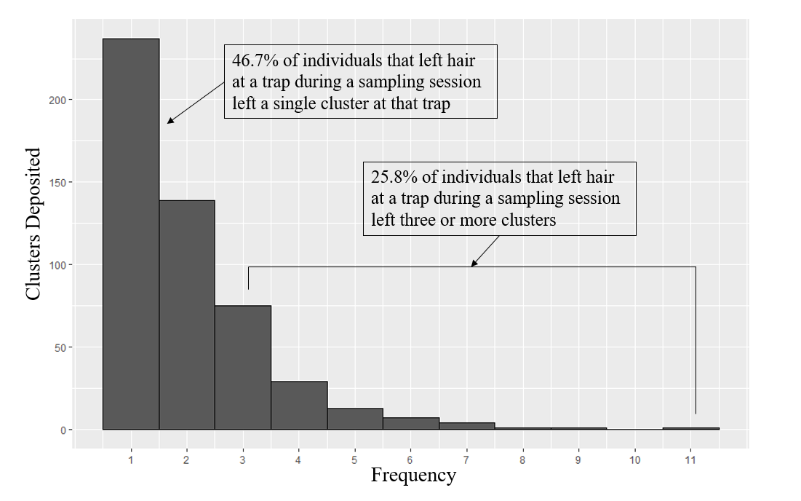

Figure 2. A) Example “Activity Centers” (black), used in SECR simulations, generated using either a heavy skew towards activity centers being located in one half of the grid (α = 0.75) or an absence of skew in the location of activity centers (α=0). Trap locations are represented as gray dots. (B) Example of half-normal capture probability curves for individuals*,* dependent on their individual propensity of capture $(δ_{i})$, whether the given trap has captured the individual in a previous session ( $C_{i,k, t,}, 1$ if previously captured, 0 if not), and their distance from the trap (d), as defined by Equation 3, $g_{i,k, t}\left(Ψ_{i,k}, C_{i,k},b,δ_{i}, σ\right)=\frac{exp\left(g_{0}+C_{i,k,t}*b+δ_{i}\right)}{1+\exp\left(g_{0}+C_{i,k,t}*b+δ_{i}\right)}e^{\frac{- {Ψ_{i,k}}^{2}}{2σ^{2}}}$. Capture probabilities are higher when an individual has been previously captured at a trap ( $C_{i,k,t,}=1)$ and for individuals with large heterogeneity parameters ($δ_{i})$.

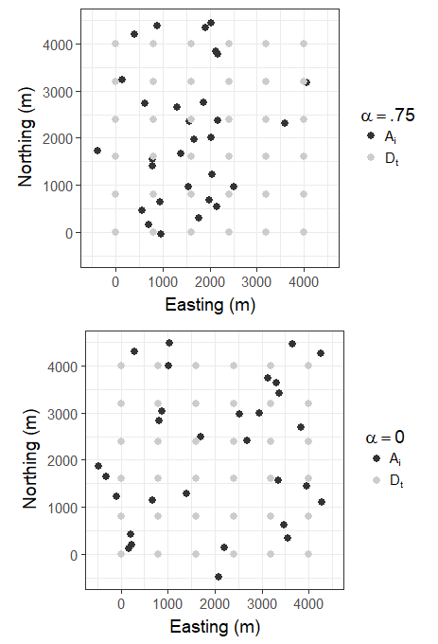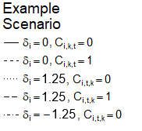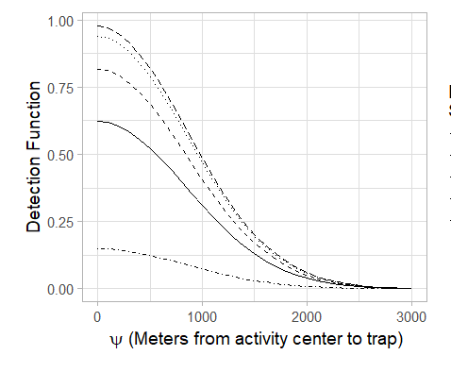Figure 3. Matrix of behavioral and density effects included in 8 scenarios used to generate simulated capture histories used in this study. Shaded boxes represent the presence of a given effect in the simulated capture histories.

B

A

|  |  |  |  |  |  |  |  |  |  |  |  |  |
| --- | --- | --- | --- | --- | --- | --- | --- | --- | --- | --- | --- | --- |
| **Effect** | **Description of effect** | **Effect scale** | **Present in scenario** | | | | | | | | **Terms** | |
| **t1** | **t2** | **t3** | **t4** | **t5** | **t6** | **t7** | **t8** | **If Absent** | **If Present** |
| Positive trap-specific behavior | Bears are more likely to revisit a given trap after visiting that trap | Population |  |  |  |  |  |  |  |  | b = 0 | b = 1 |
| Individual behavioral heterogeneity | Individual bears are more or less likely to visit any trap | Individual |  |  |  |  |  |  |  |  | Δ = 0,  δ = 0 | Δ = 1.25,  δ ~ N(0, Δ) |
| Sample redundancy | Bears leave >1 sample at a site-session | Population if Δ = 0; Individual if Δ > 0 |  |  |  |  |  |  |  |  | λi = 0 | λi = e(γ + δi) |
| Uneven density of activity centers | Bears are distributed disproportionately on trapping grid | Population |  |  |  |  |  |  |  |  | α = 0 | α = .75 |

Figure 4. Ratio of density estimates obtained using subsamples of the simulated and empirical data sets (${\hat{D}}_{Sub};$ n = 250) relative to the estimates obtained by fitting the given model on the full data set (${\hat{D}}_{Full})$. Boxes extend to the first and third quartiles of values, and whiskers extend to 1.5 times the interquartile range in either direction from the mean value. Simulation scenarios incorporated trap specific behavioral effects (t2, t6, t7), individual heterogeneity in capture probability (t3, t6, t7), redundancy in sample deposition (t4, t5, t6, t7), and/or uneven distribution of activity centers (t7 and t8; Figure 4) with 30 individuals over 6 trapping periods. Empirical data were genotypes of hair-snared black bears in northern Minnesota. Data were subsampled using either Simple Random Sampling (SRS) or using an approach that gave preference to unique site-sessions, Site-Session Preferred (SPR), and fitted to both a null model ($g0 \sim 1$) and a model with a trap-specific behavior covariate ($g0 \sim b_{k}$). 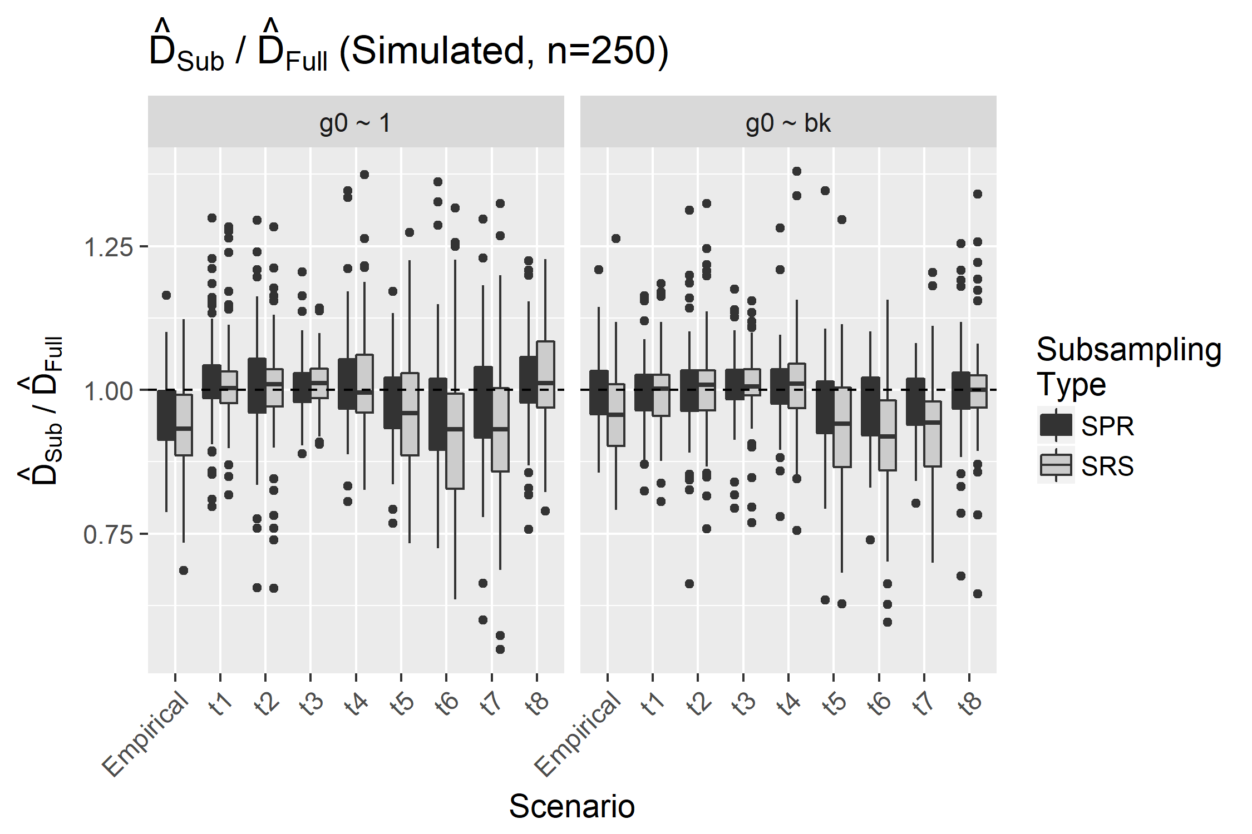

Figure 5. Ratio of density estimates obtained using subsampled simulated data sets ( ${\hat{D}}_{Sub})$ and full data sets relative to the true density of the simulated population (D), using simulation scenarios incorporating a positive trap specific behavioral effect (t2, t6, t7), individual heterogeneity in capture probability (t3, t6, t7), redundancy in sample deposition (t4, t5, t6, t7), and/or uneven distribution of activity centers (t7 and t8; Figure 4). Boxes extend to the first and third quartiles of values, and whiskers extend to 1.5 times the interquartile range in either direction from the mean value. All simulations included 30 individuals over 6 trapping periods. Data were subsampled using either Simple Random Sampling (SRS) or using an approach that gave preference to unique site-sessions, Site-Session Preferred (SPR), and fitted to both a null model ($g0 \sim 1$) and a model with a trap-specific behavior covariate ($g0 \sim b_{k}$).

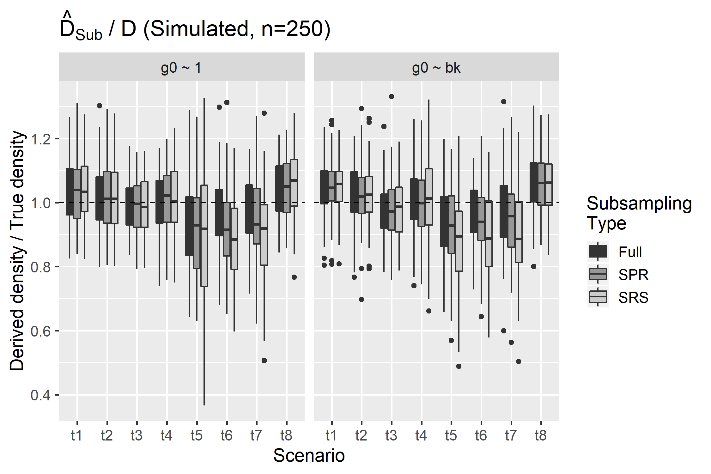

Figure 6. Proportion of non-redundant samples (contribute novel individual by site-session combinations to the capture history) vs subsampling type for each of the four simulated scenarios where redundancy is possible (t4, t5, t6 and t7; Fig 4). Boxes extend to the first and third quartiles of values, and whiskers extend to 1.5 times the interquartile range in either direction from the mean value. Simulation scenarios incorporated a positive trap-specific behavioral effect (t6, t7), individual heterogeneity in capture probability (t6, t7), redundancy in sample deposition (t4, t5, t6, t7), and/or uneven distribution of activity centers (t7; Figure 4) with 30 individuals over 6 trapping periods. Note that, as redundancy is not introduced for scenarios t1, t2, t3, or t8, the proportion of non-redundant samples is fixed at 1 for these scenarios. Data were subsampled using either Simple Random Sampling (SRS) or using an approach that gave preference to unique site-sessions, Site-Session Preferred (SPR).

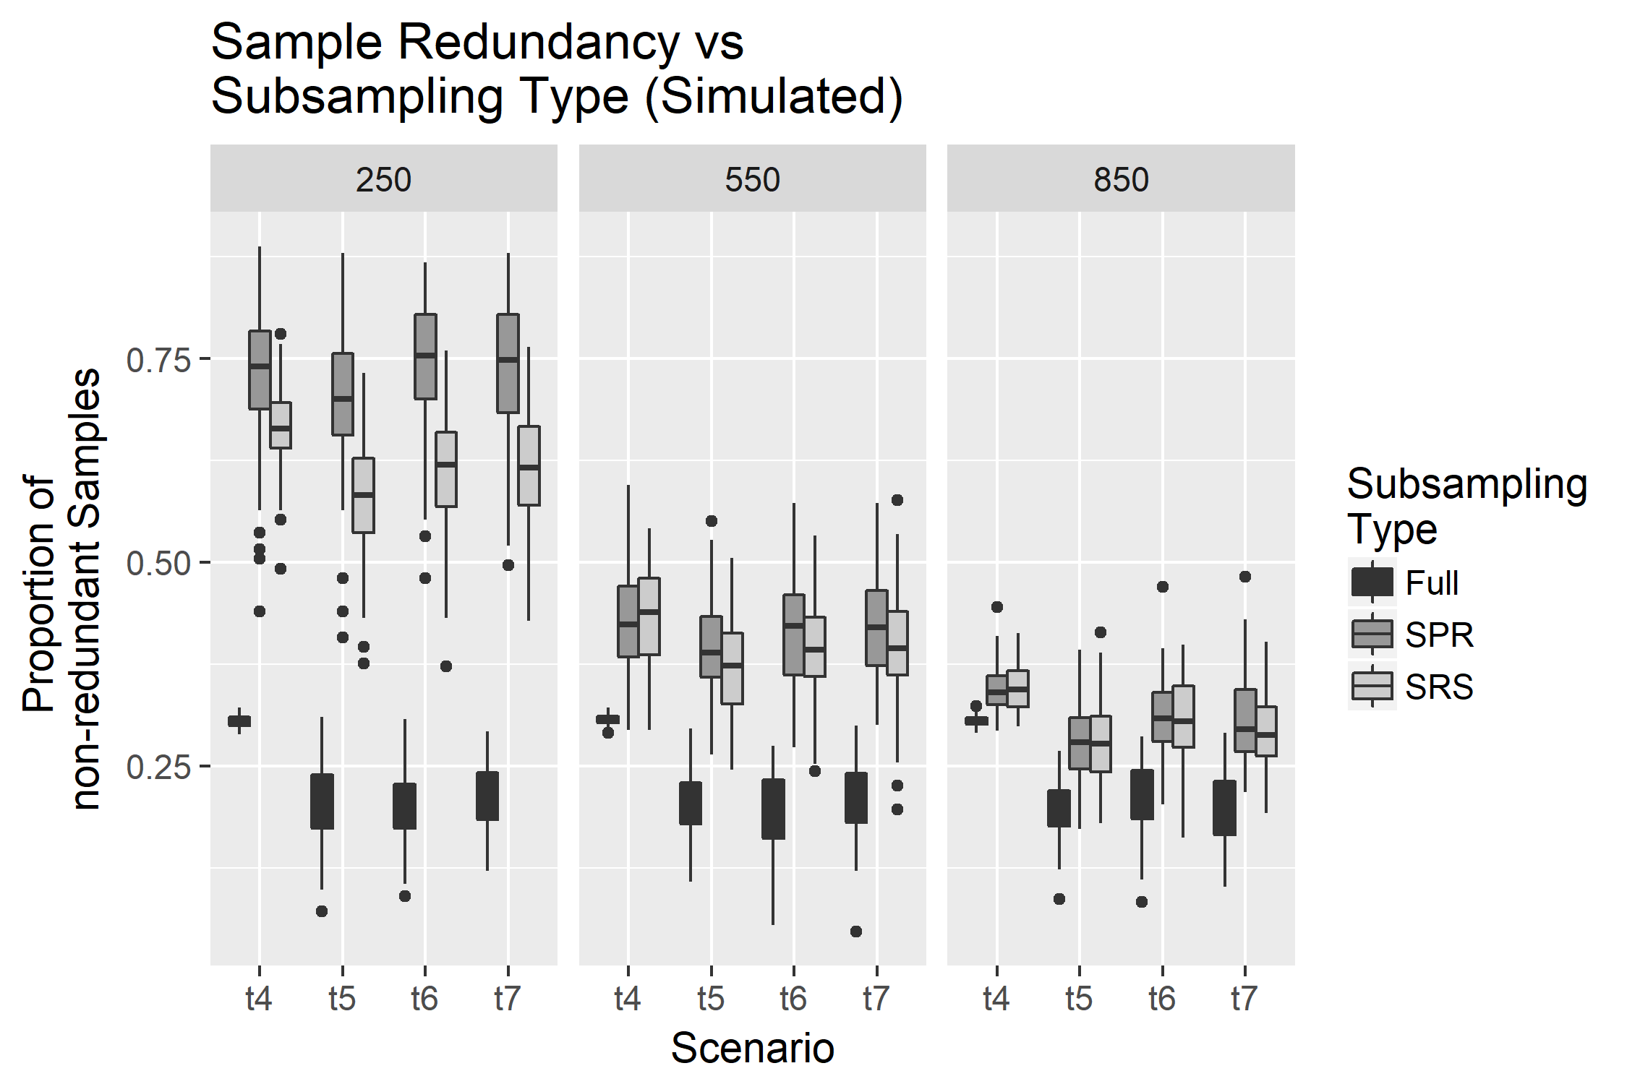

Table 1**.** Model Notation for simulation of capture histories (Eq 1-5)

|  |  |
| --- | --- |
| Term | Definition |
| *N* | Size of bear population (30 in all scenarios) |
| *K* | Number of traps on trapping grid during a single simulation (36 in all scenarios) |
| *Dk* | Location of trap *k* on trapping grid during a single simulation{*k* = 1, ..., *K*} |
| *T* | Number of trapping sessions (6 in all scenarios) |
| *Φ* | Inhibition distance between bear activity centers (200m in all scenarios) |
| *α* | Parameter describing intensity of stratification of bear activity centers (.75 in t6 and t7, 0 in all other scenarios) |
| *Ai* | Locations of bear activity centers {*i* = 1, …, *N*} |
| *Ψi,k* | Euclidean distances between the activity center for individual *i*, *Ai*, and the location of trap *k*, *Dk* |
| *g0* | Logit capture probability at a given trap for a bear whose activity center is exactly at that trap (.5 in all scenarios) |
| *b* | Difference between logit capture and recapture probabilities (1 in t2, t5, t6 and 0 in all other scenarios) |
| *σ* | Inflection point of half-normal distribution which describes capture probability as a function of *Ψ* (846m in all scenarios) |
| *δi* | Parameter describing heterogeneity in individual bears’ capture probabilities; this parameter also influences the expected number of redundant samples deposited by an individual. {*i* = 1, …, *N*} |
| *Δ* | Standard deviation of normal distribution of *δi* values (1.25 in t3, t5, t6 and t7, 0 in all other scenarios) |
| *γ* | Parameter describing log expected number of samples deposited by an individual bear after being captured. |
| *gi,t,k* | Capture probability for individual i at trap k during time period t{i = 1,…, N},{k = 1,..., K},{t = 1,..., T} |
| *ci,t,k* | Indicator variable equal to 1 if bear i was captured at trap k during time period t, and 0 otherwise. |
| *Ci,t,k* | Indicator variable equal to 1 if bear i was captured at trap k at any time before period t, and 0 otherwise {i = 1, …, N},{k = 1, ..., K},{t = 1,..., T} |
| *Ii,t,k* | Number of samples deposited and collected during a simulation {i = 1, …, N},{k = 1, ..., K},{t = 1, ..., T} |

**APPENDIX A**

Figure S1. Directed Acrylic Graph of the data simulation process. Triangle nodes represent fixed parameters, circles represent stochastic values, and squares represent deterministic values obtained using stochastic values. All values are defined in Table 1. Ii,k,t is either a deterministic or stochastic node depending on the value of γ.

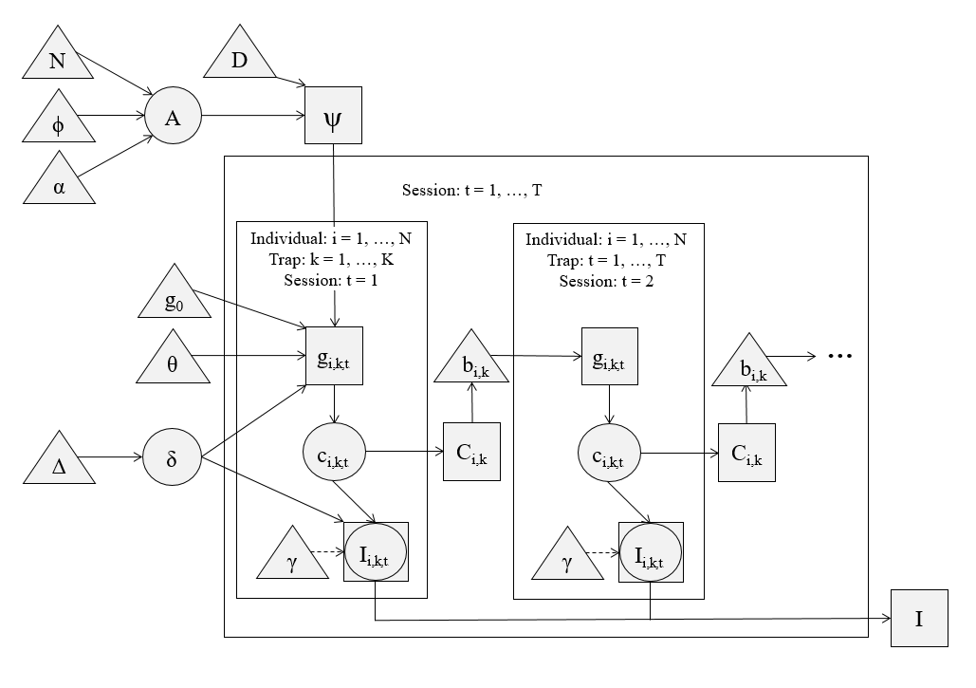

Figure S2: Ratio of density estimates obtained using subsamples of the empirical data (Sub; n = 250, 550 and 850) relative to the estimates obtained by fitting the given model on the full empirical data set (Full) for all scenario and sample size combinations explored.Boxes extend to the first and third quartiles of values, and whiskers extend to 1.5 times the interquartile range in either direction from the mean value. Empirical data were collected from individual black bears (Ursus americanus) from May through July 2012 in a genetic mark-recapture study in northern Minnesota.

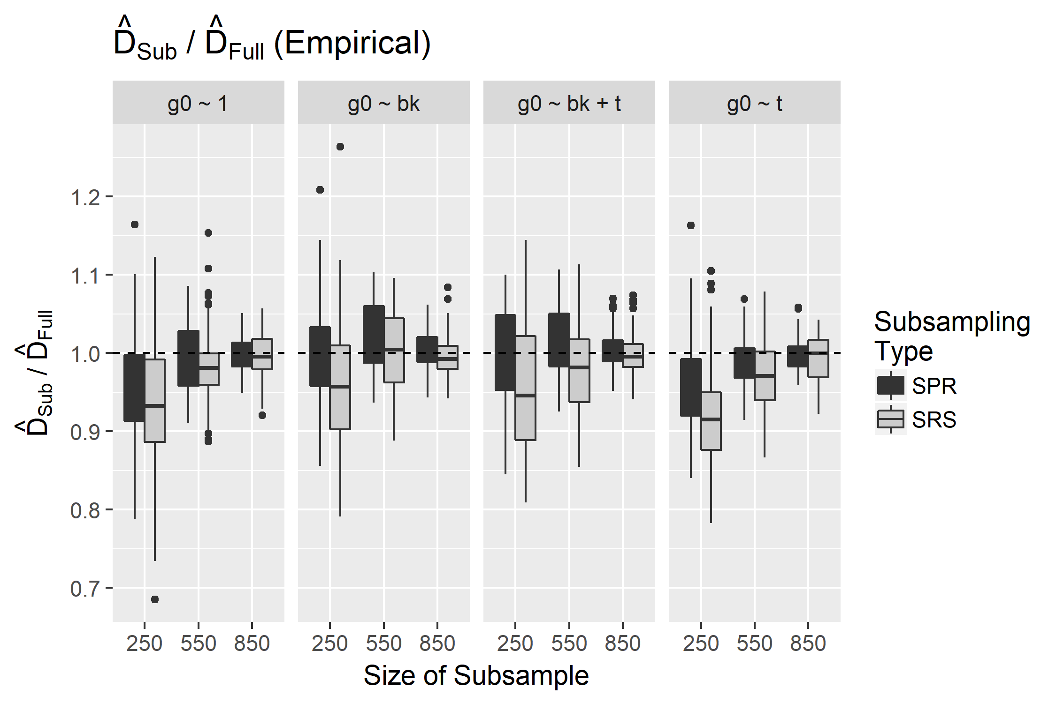

Figure S3: Ratio of density estimates obtained using subsamples of the simulated data (Sub; n = 250, 550 and 850) relative to the estimates obtained by fitting the given model on the full data set (Full) for all scenario and sample size combinations explored.Boxes extend to the first and third quartiles of values, and whiskers extend to 1.5 times the interquartile range in either direction from the mean value. Simulation scenarios incorporated trap specific behavioral effects (t2, t6, t7), individual heterogeneity in capture probability (t3, t6, t7), redundancy in sample deposition (t4, t5, t6, t7), and/or uneven distribution of activity centers (t7 and t8). Scenarios t1, t2, t3, and t8 did not include redundancy in sample deposition and did not exceed 550 samples deposited over 6 sampling periods in any simulation. All simulations included 30 individuals over 6 trapping periods. Data were subsampled using either Simple Random Sampling (SRS) or using an approach that gave preference to unique site-sessions, Site-Session Preferred (SPR).

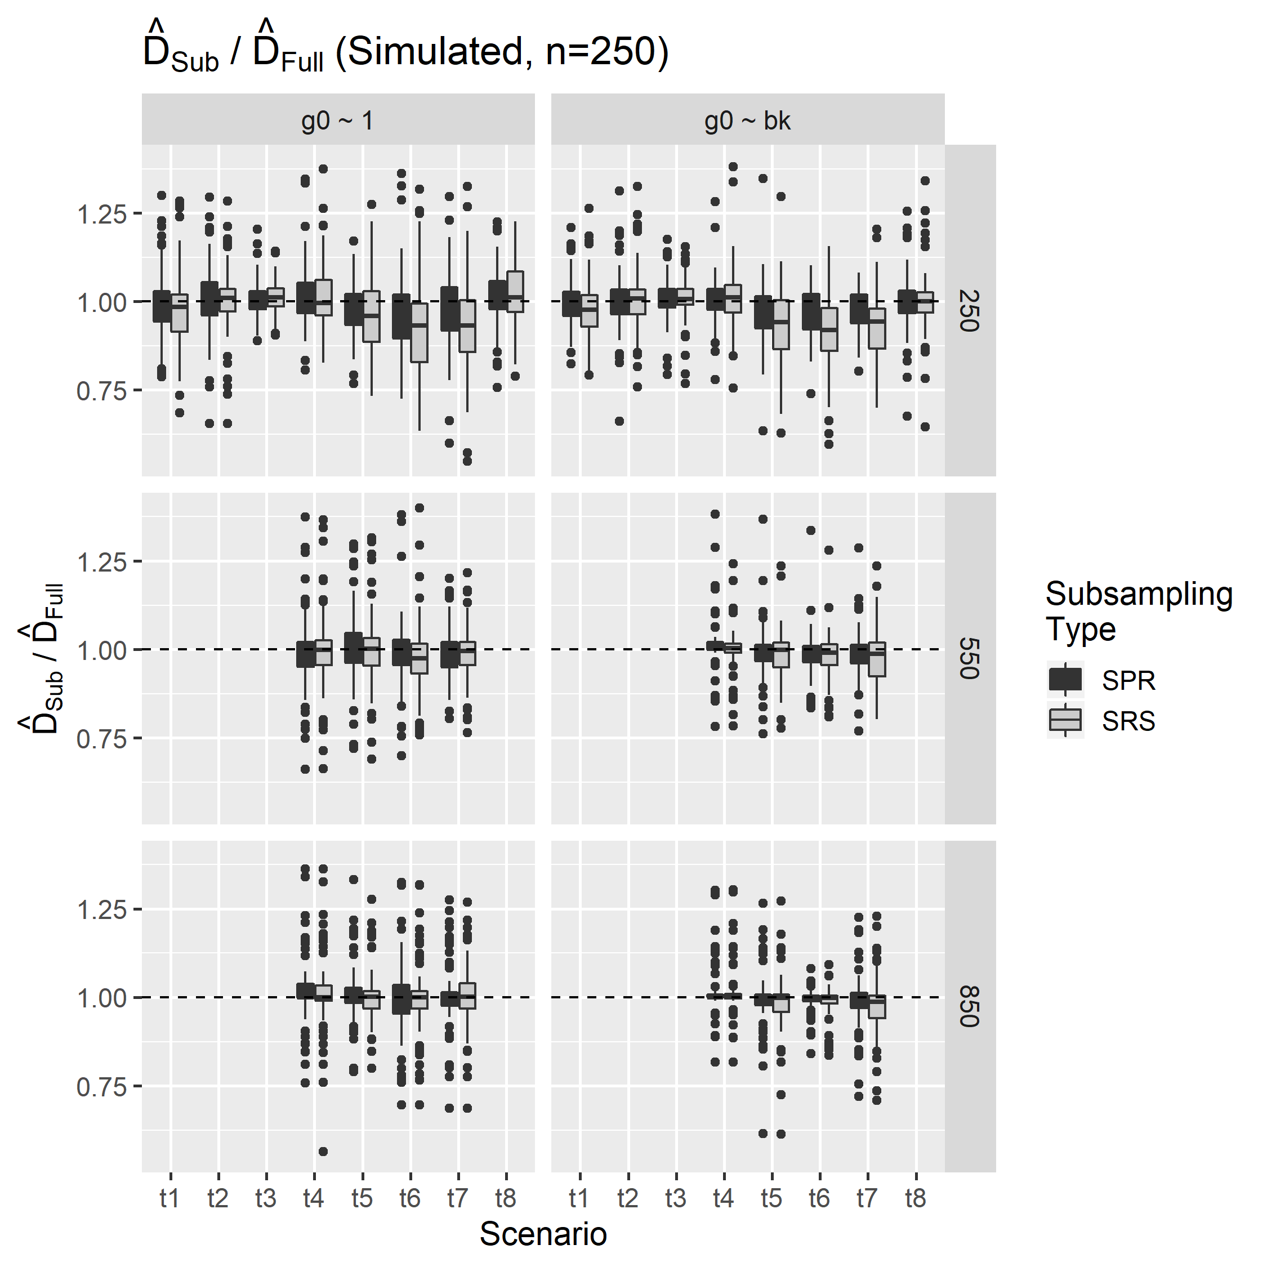

Figure S4. 0 versus subsampling type, scenario and model. Black horizontal lines indicate the parameter values used to simulate the data. Boxes extend to the first and third quartiles of values, and whiskers extend to 1.5 times the interquartile range in either direction from the mean value. These simulation scenarios incorporated individual heterogeneity in capture probability (t3, t6, t7), redundancy in sample deposition (t4, t5, t6, t7), and/or uneven distribution of activity centers (t7 and t8; Figure 4) with 30 individuals over 6 trapping periods. Data were subsampled using either Simple Random Sampling (SRS) or using an approach that gave preference to unique site-sessions, Site-Session Preferred (SPR). Scenarios t1, t3 and t8 did not include redundancy in sample deposition and did not exceed 550 samples deposited over 6 sampling periods in any simulation.

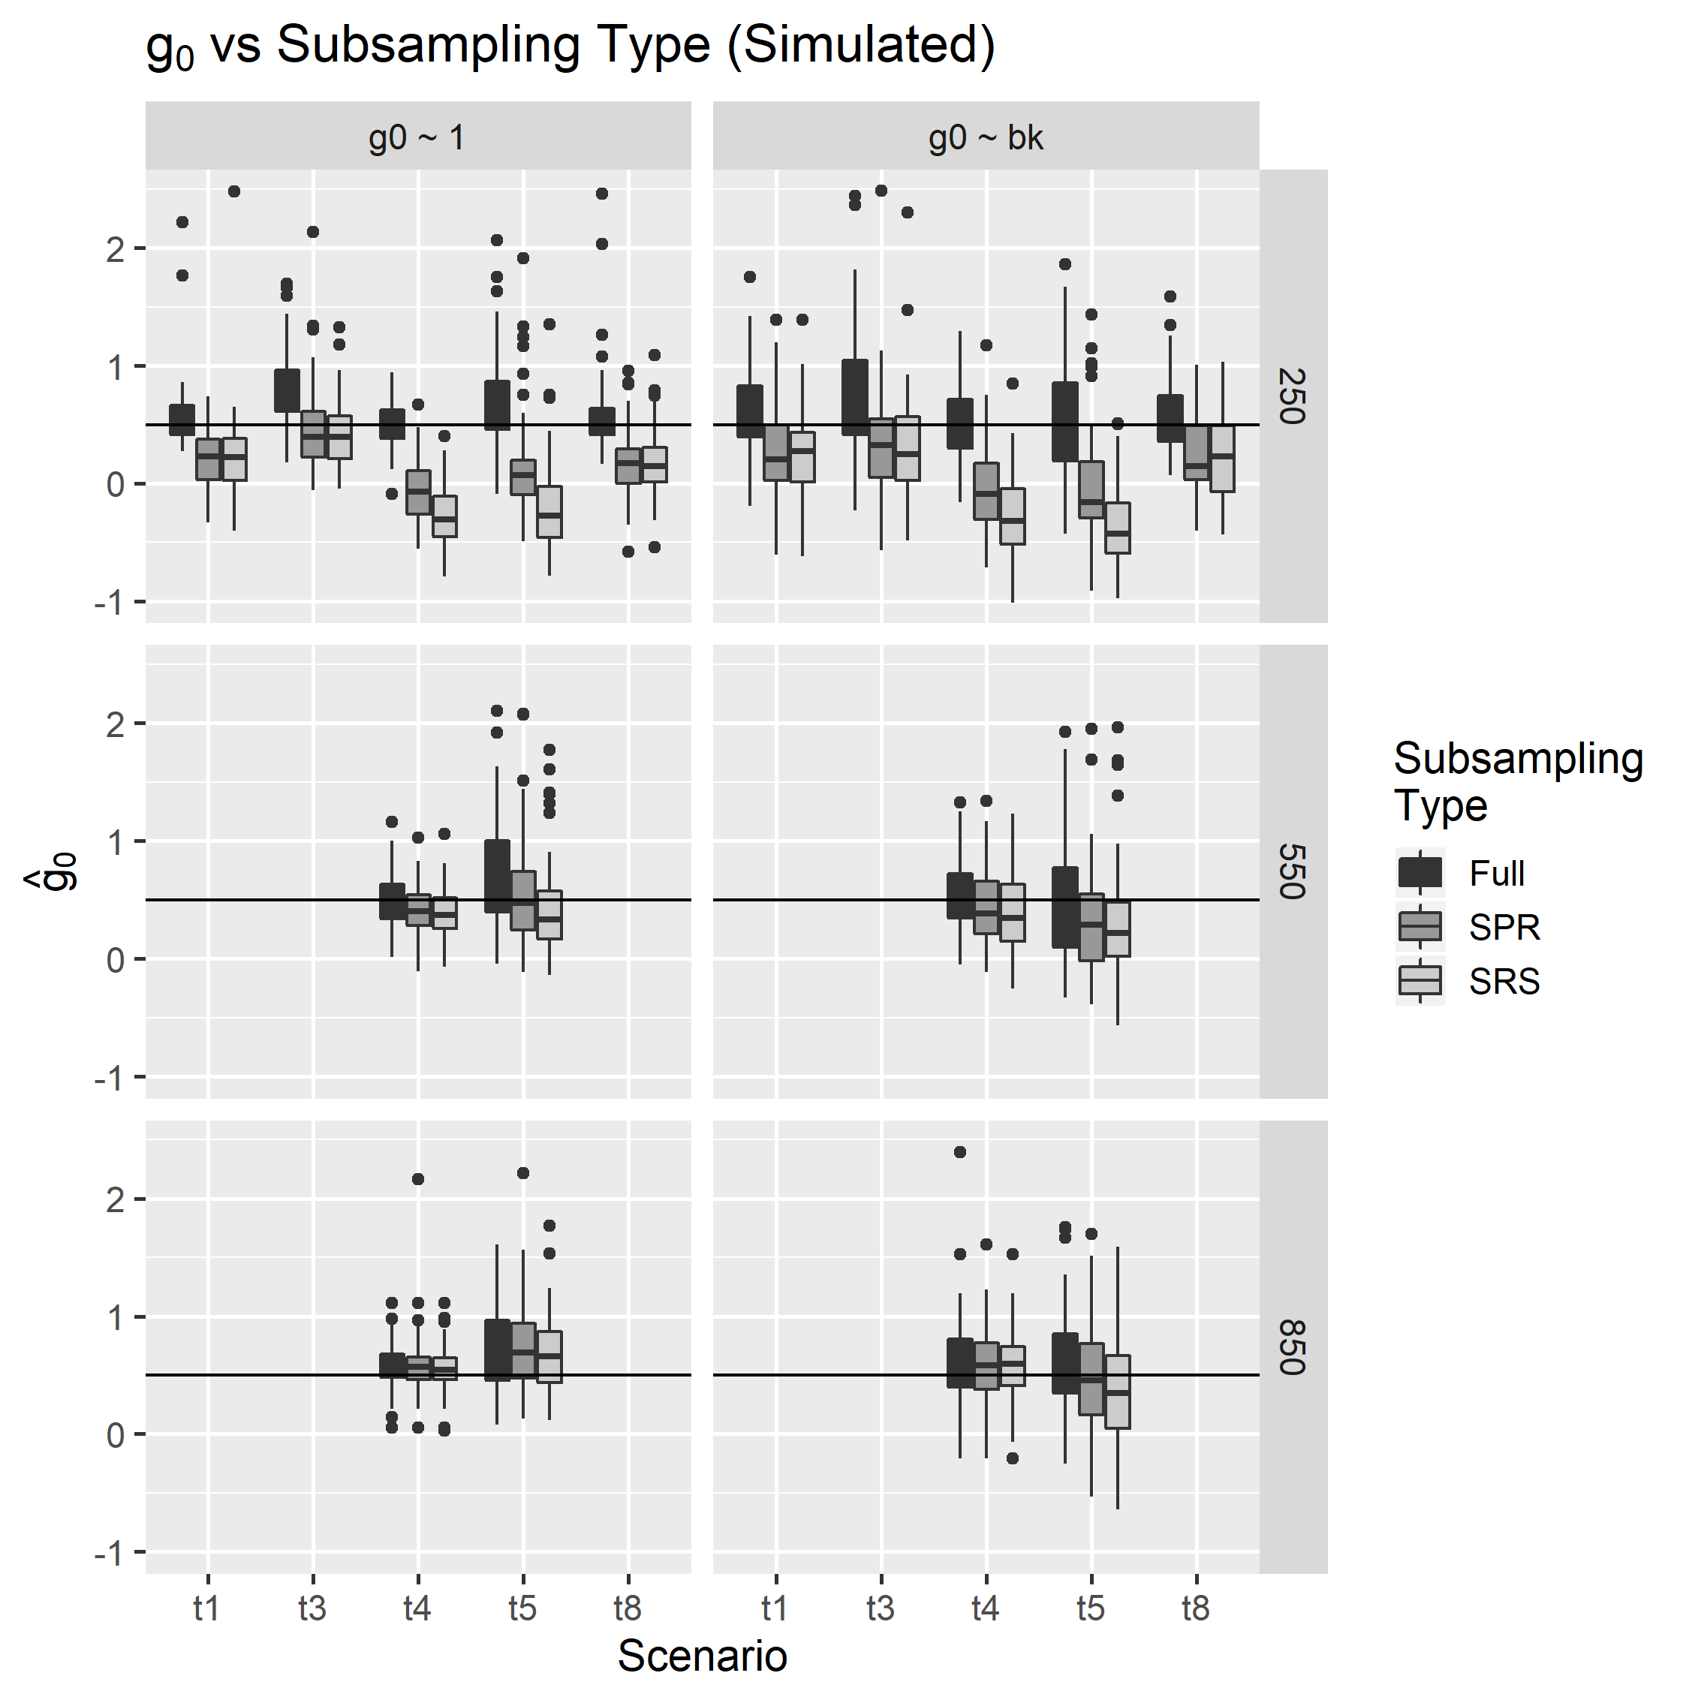

Figure S5. Sampling distributions of capture and recapture probability parameter estimators, , 0 and bk, respectively,for different subsampling types, and scenarios using model g0 ~ bk. Black horizontal lines indicate the parameter values used to simulate the data.Boxes extend to the first and third quartiles of values, and whiskers extend to 1.5 times the interquartile range in either direction from the mean value. Scenarios t2, t6 and t7 included a positive trap-specific behavioral effect (increased likelihood of capture at a specific trap after initial capture at that trap). All simulations included 30 individuals over 6 trapping periods. Data were subsampled using either Simple Random Sampling (SRS) or using an approach that gave preference to unique site-sessions, Site-Session Preferred (SPR). Scenario t2 did not include redundancy in sample deposition and did not exceed 550 samples deposited over 6 sampling periods in any simulation.

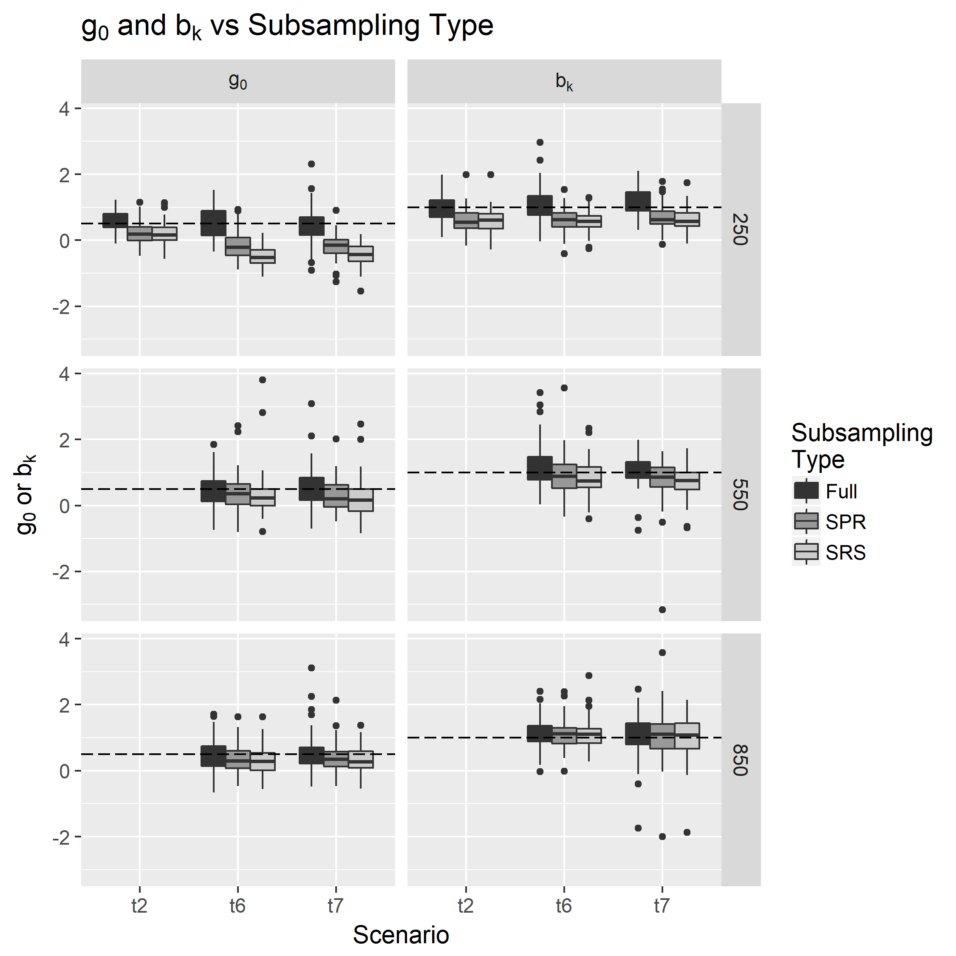

1. *Current affiliation: Conservation Metrics Inc, 145 McAllister Way, Santa Cruz, CA 95060 USA*
2. *Email*: jfieberg@umn.edu