#CodingSchool

Details of project
- Database:
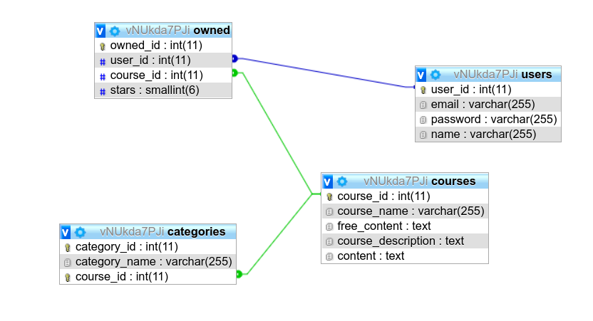

- Technologies:




- Features

1. Register and login
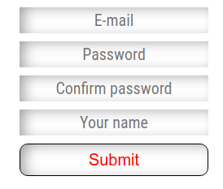
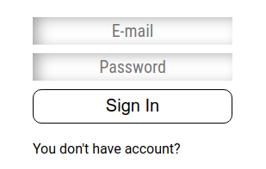

2. Interactive menu

3. Slideout menu

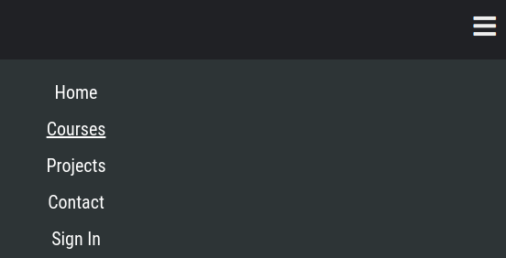

4. Content of courses only for logged in users

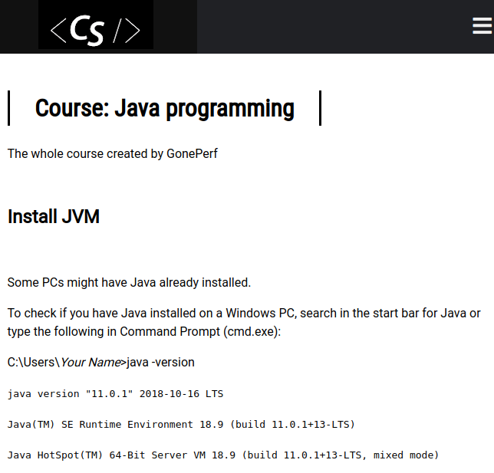

5. Content of courses for prime users

6. Option to rate the course (only for prime users)



7. Administration panel for editing courses content (Admin account)

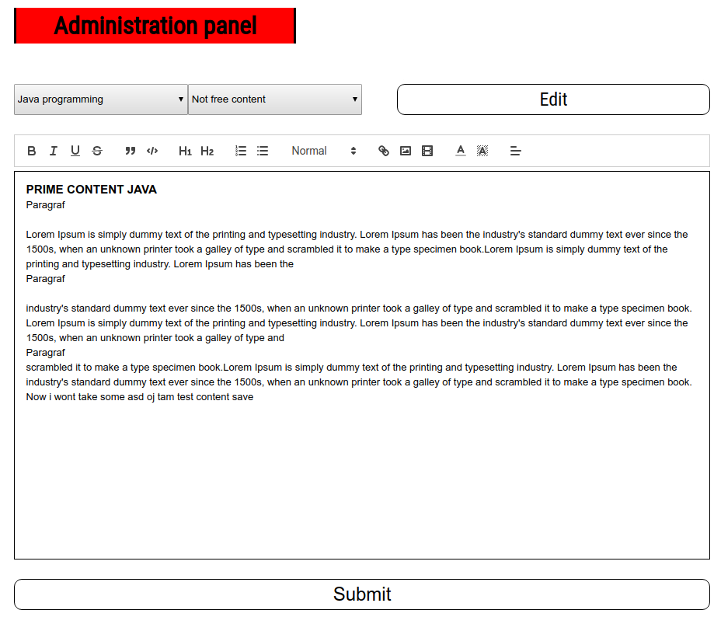
8. The ability to brag about projects

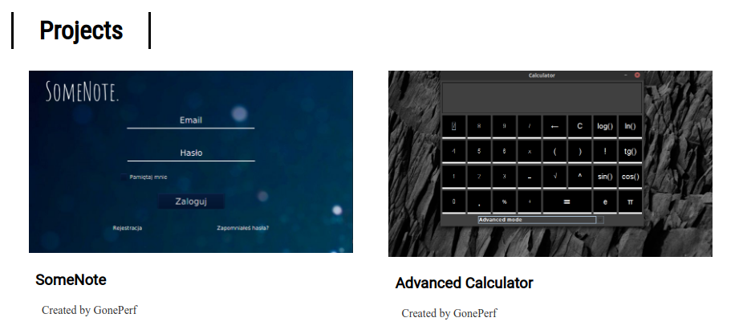

9. Average stars of course & number purashed for all visitors:
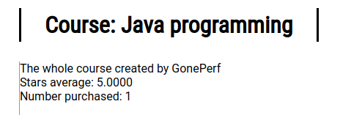
10. Recomendation (Not finished)
11. Full responsive:
