Attacking Azure Container Apps
Contents
Attacking Azure Container Apps 1
Enumerating Container Secrets 1
Connecting to Container with passwords found 2

Enumerating Container Secrets
Once we have token, get the subscription ID from the token
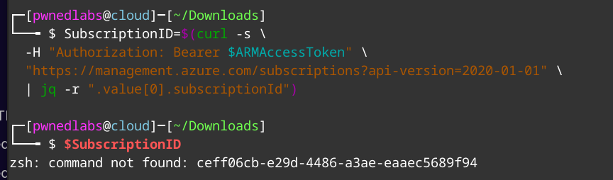

List available Resources – we can see container apps
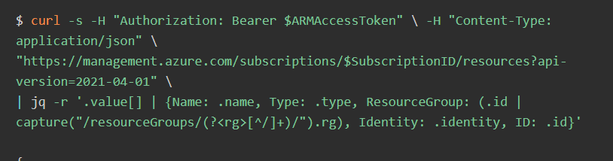
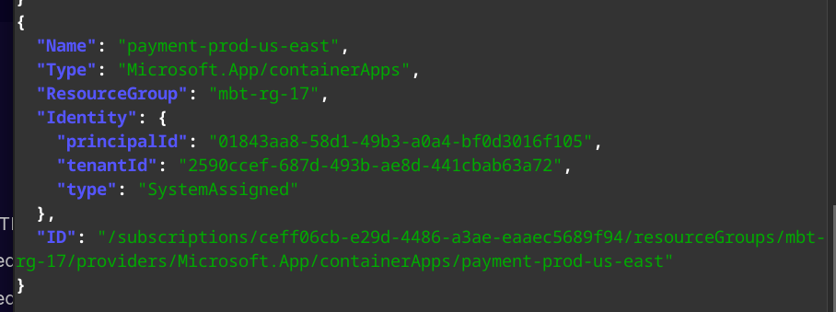

Place the container in the $Id variable. Now search for secrets in the container
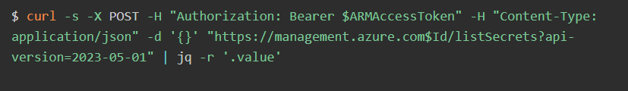
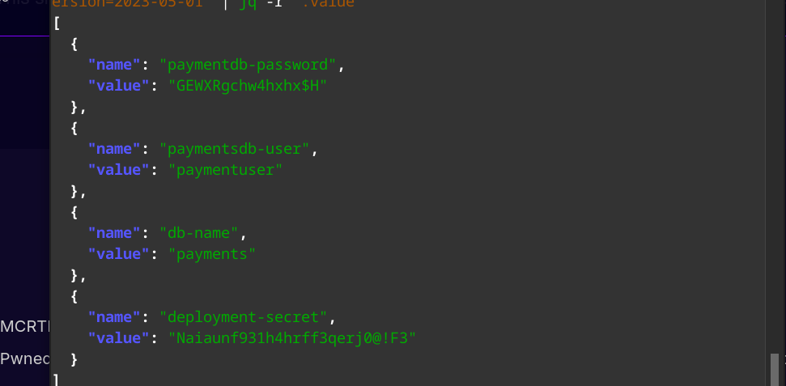

Connecting to Container with passwords found

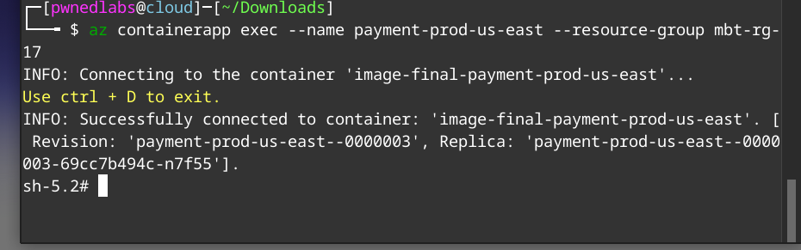

Get the IDENTITY_HEADER and IDENTITY_ENDPOINT from the environment variables
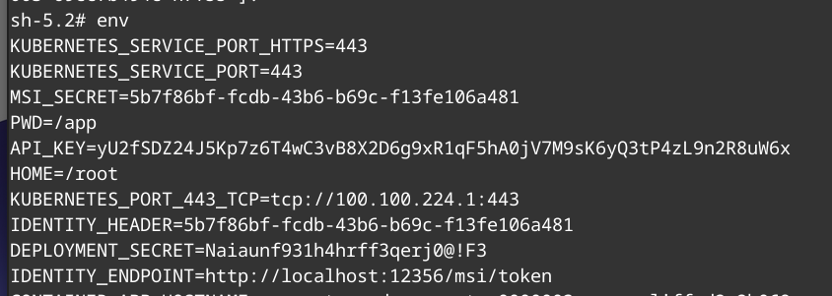

Once we get this, we can query for the token associated with this identity
curl -H "X-IDENTITY-HEADER: $IDENTITY_HEADER" "$IDENTITY_ENDPOINT?resource=https://management.azure.com&api-version=2019-08-01"
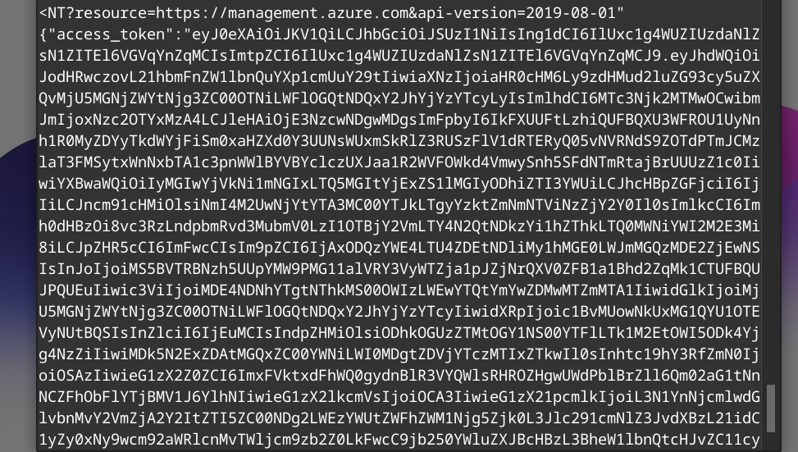

Connect with new access token and query resources
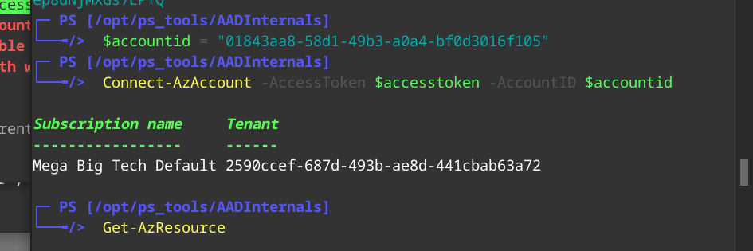

SQL and flexible SQL servers
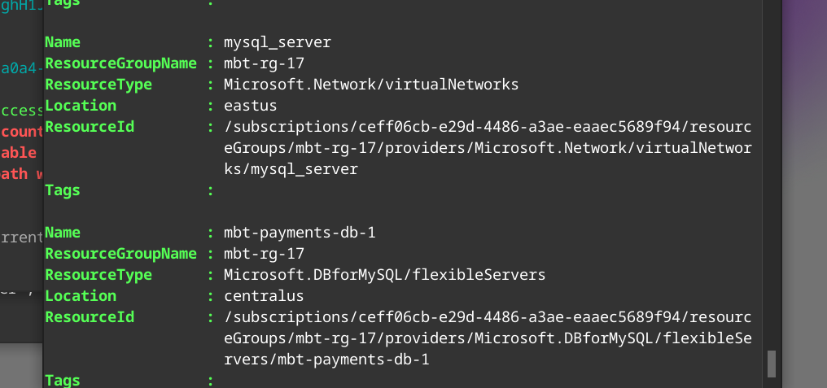

We have creds from earlier we can use from earlier to access SQL
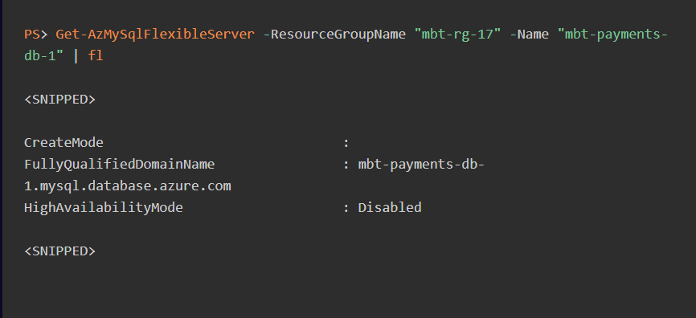

Login to SQL Server
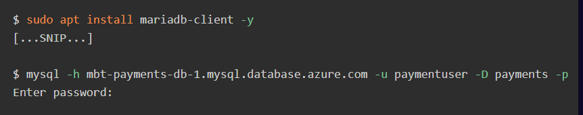
View databases in SQL
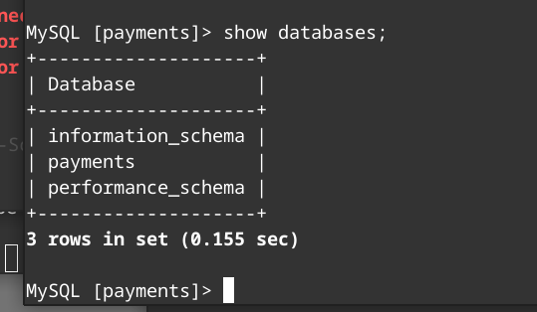
Enumerate further if you need
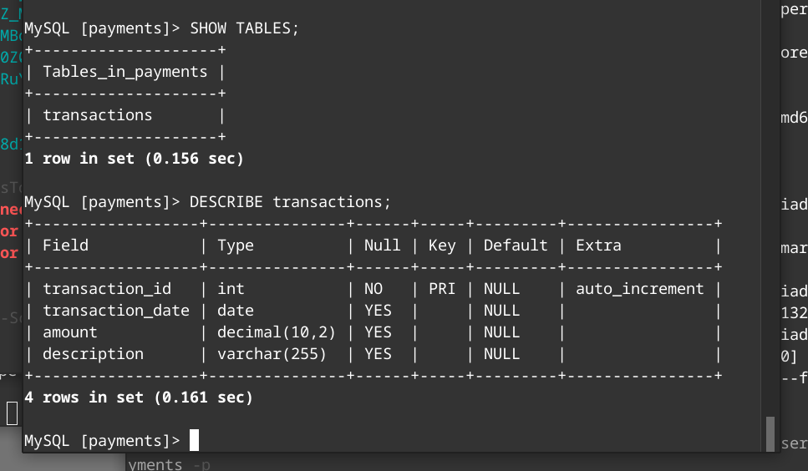
View data in the table
