Data and Methodology:
I collected data on 26 large-cap US firms across six sectors over 2018–2024. I built two signals: the gap between company-reported adjusted EPS and GAAP EPS (scaled by price), and the accrual ratio (net income minus operating cash flow, scaled by average total assets). GAAP data came from SEC EDGAR and adjusted EPS and prices from Yahoo Finance. It was expected that both signals be negatively relate to next-year returns. I winsorized both signals at the 5th and 95th percentiles, so that extreme values have less influence on the results. The final sample consists of 178 observations. Then I regressed each firm’s 12-month excess return over SPY, measured from the 10-K filing date, on both signals with year fixed effects, alongside tercile sorts. The regression is pooled OLS with standard errors clustered by firm, since each firm appears up to seven times.
Results:
1) Descriptive statistics.
Adjustments vary by sector. Healthcare firms report the largest gaps with EPS sitting 68% above GAAP EPS and 98% of Healthcare firm-year records report adjusted EPS above GAAP. Meanwhile, firms from Energy and Industrials sectors make the lowest adjustments, with medians of 3% and 5%. The accrual ratio is negative in 96% of firm-year records and on average in every sector.
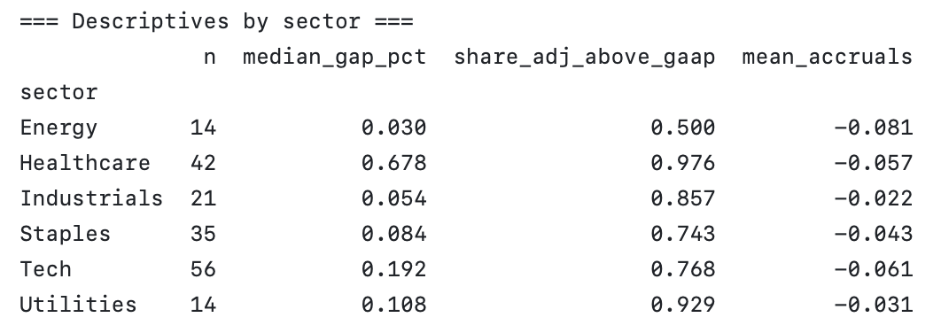
2) Tercile sorts
The tercile sorts shows average next-12-month excess returns by tercile. For accruals, the pattern follows the expectations. On average, low-accrual firms beat SPY by 5.6%, while mid- and high-accrual firms are behind by 1.5% and 2.2% respectively. The spread between 1st and 3rd tercile of −7.8 percentage points is not statistically significant (t = −1.55, p = 0.12). Regarding the gap, no clear pattern is visible. High-gap firms earned the highest returns (+5.6%) and mid-gap firms the lowest (−4.1%), and the spread between the high and low terciles is positive (+4.8 pp, t = 0.91, p = 0.36), opposite to what we expected.
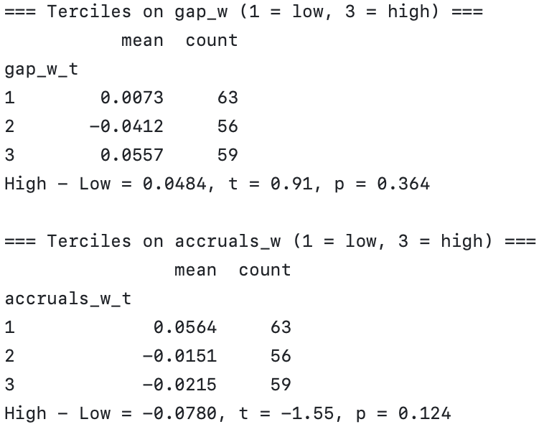

3) Pooled OLS results

The accrual coefficient is −0.97, meaning that a one percentage point increase in the accrual ratio is associated with an excess return about 0.97 percentage points lower over the next 12 months. The gap coefficient is 1.59, suggesting that a one-percentage-point increase in the gap is associated with an excess return about 1.6 percentage points higher, contradicting the theory. However, the p-values for the accrual ratio and the gap are 0.18 and 0.28 respectively, meaning that none of the variables is statistically significant at the 5% significance level. When it comes to year effects, the only statistically significant year dummy is associated with 2023 (p < 0.001).
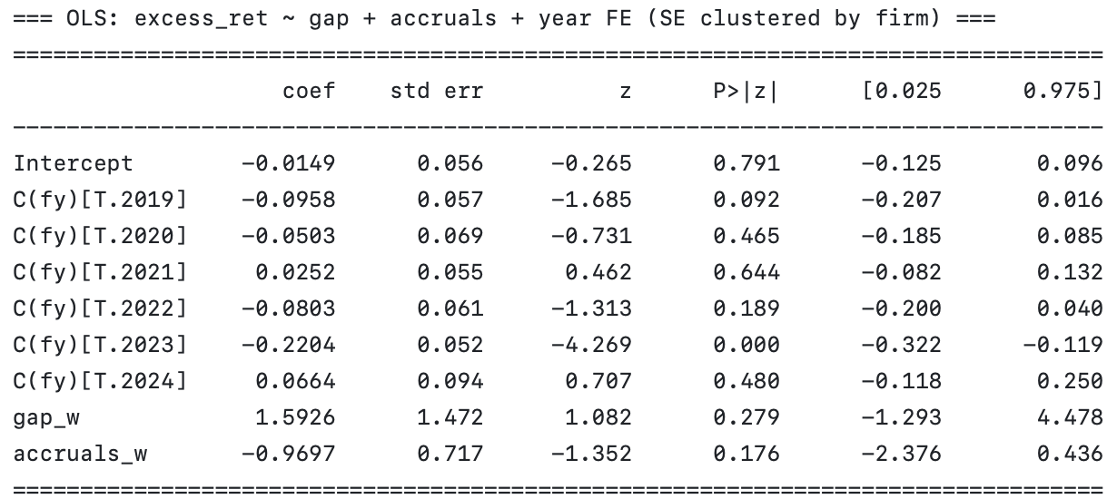
Conclusion:
Accruals show a negative relation with next-year returns, as expected, but it is not statistically significant. The adjustment gap, however, shows a positive relation with the dependent variable, but its estimates are also statistically insignificant.

