**MLSP Homework 1 Problem 1**

**Qihua Gong qgong5**

Question (1a)

Your descriptions and answers.

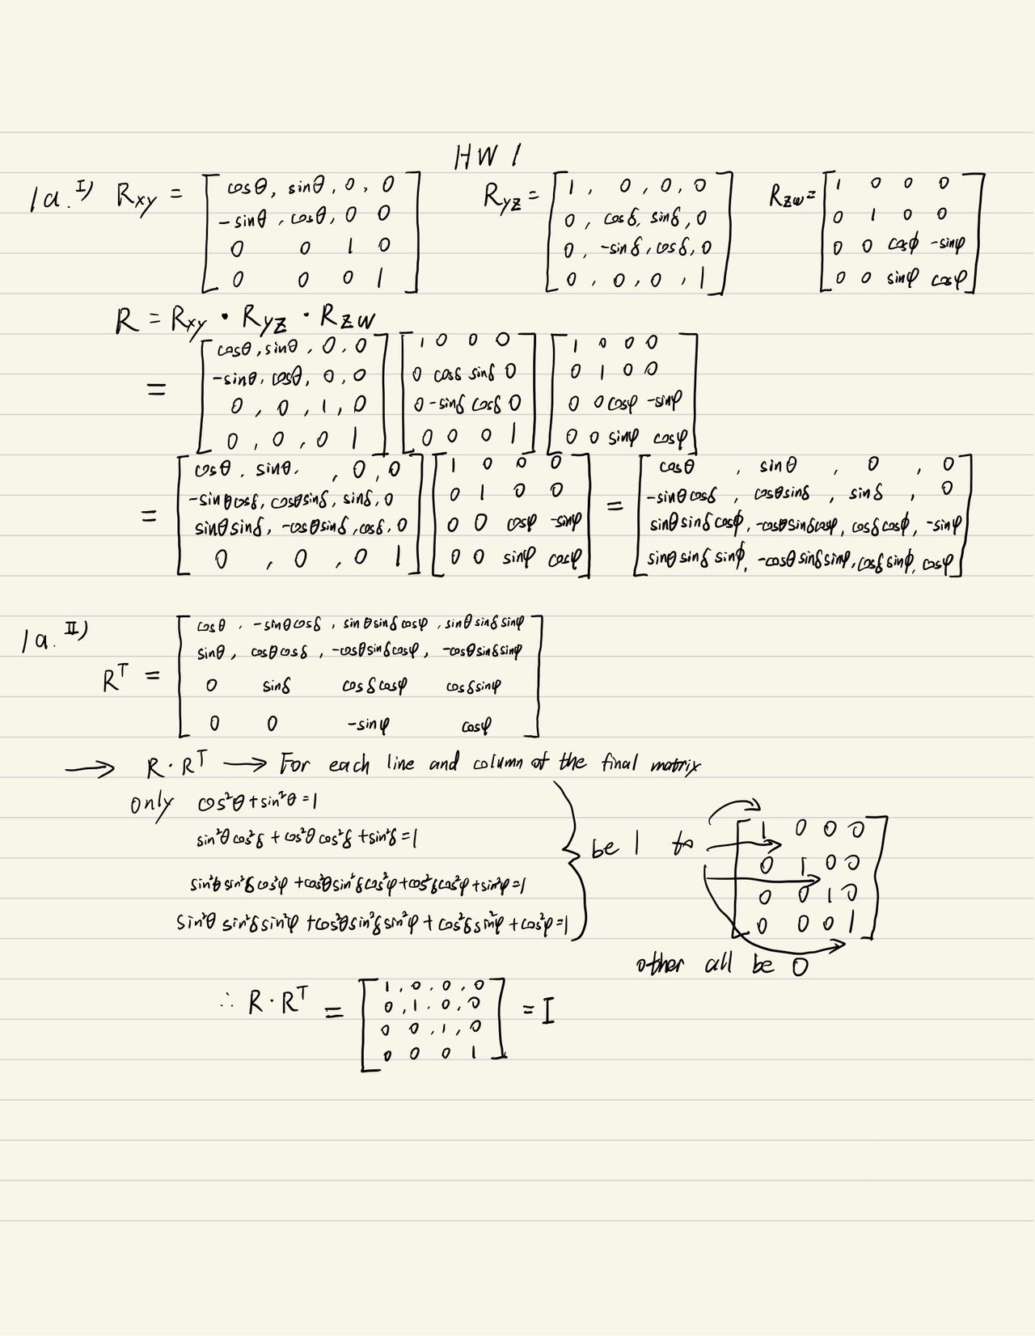

Question (1b)

Your descriptions and answers.

