**Programming project for course 200075 SE**

**[Aim]**

To practice model development, model estimation, and model selection in a real-world situation.

**[Tool]**

R/RStudio and RStan. Download all necessary files:

**[Background]**

Your colleague Lisa is currently working on a project about intertemporal decision-making. In this experiment, participants were instructed to choose from an immediate but small monetary reward (aka, small but soon option, SS) and a large but delayed alternative (aka, large but late option, LL). See Fig.1 for an example. She just finished the data collection and is now focusing on the analysis. She is aware of a commonly used delay discounting model in such tasks, that is, the Hyperbolic Discounting Model (Mazur, 1987), and would like to fit this model with hierarchical Bayesian methods (Gelman et al., 2013). Her supervisor told her that an increasing number of researchers are using a newly developed programming language Stan (Carpenter et al., 2017) for this purpose and encouraged her to try it out. She knows R already, but she has never used Stan. She spent a few days reading the Stan documentation and coded her first Stan model. As she expected, she received some errors, and she was unable to understand them. She was told that you are now taking a course on Bayesian statistics and cognitive modeling, and therefore, she came to you for some help with the Stan code.

A few days later, her supervisor sent her a paper about a new model for intertemporal choices (Ericson et al., 2015). In this paper, the authors proposed a simple heuristic model, and claimed that this model would outperform traditional delay discounting models. She read the equations a bit, but she had no clue what this paper was talking about. Therefore, she came to you again, asking if you could help her implement this model in Stan.

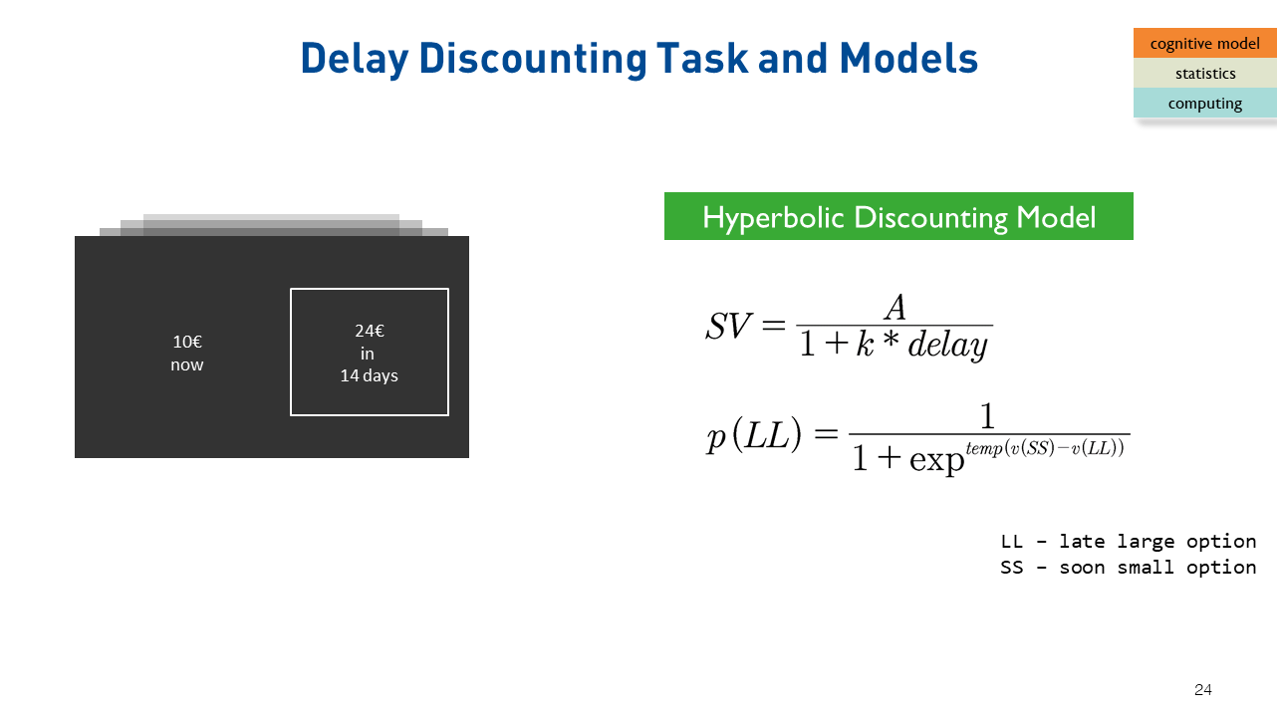

Figure1. Example trial of the intertemporal decision-making task.

*References:*

Carpenter, B., Gelman, A., Hoffman, M. D., Lee, D., Goodrich, B., Betancourt, M., ... & Riddell, A. (2017). Stan: A probabilistic programming language. *Journal of statistical software*, *76*(1).

Ericson, K. M., White, J. M., Laibson, D., & Cohen, J. D. (2015). Money earlier or later? Simple heuristics explain intertemporal choices better than delay discounting does. *Psychological science*, *26*(6), 826-833.

Gelman, A., Stern, H. S., Carlin, J. B., Dunson, D. B., Vehtari, A., & Rubin, D. B. (2013). *Bayesian data analysis*. Chapman and Hall/CRC.

Mazur, J. E. (1987). An adjusting procedure for studying delayed reinforcement. *Commons, ML.; Mazur, JE.; Nevin, JA*, 55-73.

**[Task]**

1. Fix the potential bugs/errors in the “hyperbolic. stan” model file, and fit this model.
2. Read the (Ericson et al., 2015) paper, implement this model in “heuristic.stan”, and fit this model.
3. Compare these two models using widely applicable information criterion (WAIC).

**[Format]**

Please follow the folder structure introduced during the lectures, i.e., .programming_project /{data, scripts, outputs, plots}. Put all data in “data”, all *.R and *.stan files in “scripts”, and all stanfit objects in “outputs”. In the root folder (i.e., “programming_project”), create a text file named “short_summary.txt”. In that file, write down the WAIC value for each model.

**[Submission]**

Submission can be made at any time during the semester, but BEFORE the deadline (see below). When submitting, make a zip file and name it as “lastname_matriculatenumber_200075.ZIP”.

**[Deadline]**

CET 17:00, 30.06.2019

**[Scoring]**

Ten (10) points will be given for successful results submitted in due time. Six (6) points will be given for unsuccessful results submitted in due time. 0.5 point per day will be deducted for over-due submission.