Qt Creator的OpenCV开发环境配置

一、拷贝下面三个文件夹放在同一个文件夹下，结构如下图

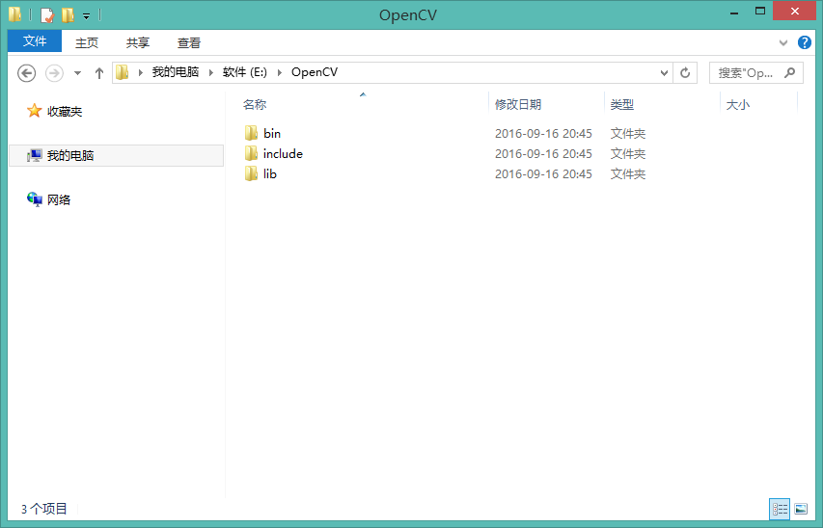

二、 将bin目录添加到系统环境变量

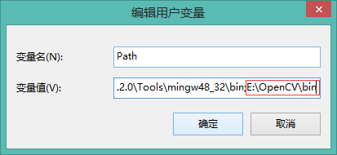

 至此Qt Creator下的OpenCV开发环境已经配置好。

三、在Qt Creator下测试是否已经配置成功

（1）打开Qt Creator，新建一个空工程，然后添加一个cpp文件，任意命名

（2） 在pro文件中添加如下OpenCV的依赖文件

INCLUDEPATH+=E:\OpenCV\include\opencv\

                    E:\OpenCV\include\opencv2\

                    E:\OpenCV\include

LIBS+=E:\OpenCV\lib\libopencv_calib3d2410.dll.a\

        E:\OpenCV\lib\libopencv_contrib2410.dll.a\

        E:\OpenCV\lib\libopencv_core2410.dll.a\

        E:\OpenCV\lib\libopencv_features2d2410.dll.a\

        E:\OpenCV\lib\libopencv_flann2410.dll.a\

        E:\OpenCV\lib\libopencv_gpu2410.dll.a\

        E:\OpenCV\lib\libopencv_highgui2410.dll.a\

        E:\OpenCV\lib\libopencv_imgproc2410.dll.a\

        E:\OpenCV\lib\libopencv_legacy2410.dll.a\

        E:\OpenCV\lib\libopencv_ml2410.dll.a\

        E:\OpenCV\lib\libopencv_objdetect2410.dll.a\

        E:\OpenCV\lib\libopencv_video2410.dll.a

备注：其实有种简单的做法，但是有个缺点是可能包含链接库较多

INCLUDEPATH+=E:\OpenCV\include\opencv\

                    E:\OpenCV\include\opencv2\

                    E:\OpenCV\include

LIBS+=E:\OpenCV\lib

 （2） main.cpp文件中内容如下

#include"cv.h"

#include"cxcore.h"

#include"highgui.h"

intmain(intargc,char*argv[])

{

    //声明IplImage指针

    IplImage*pImg;

    //载入图片

    pImg=cvLoadImage("C:/Users/Sunny/Desktop/800.jpg",1);

    //创建窗口

    cvNamedWindow("Image",1);

    //显示图像

    cvShowImage("Image",pImg);

    //等待按键

    cvWaitKey(0);

    //销毁窗口

    cvDestroyWindow("Image");

    //释放图像

    cvReleaseImage(&pImg);

    return0;

}

 （3） 编译运行

