Question 3

A/B testing framework:

1. Defining our test objective : figuring out the better margin, 15% or 18%
2. Defining our Key Performance Indicators : churn rate
3. Generating Hypothesis :



1. Run Experiment :

- The group of 15 % margin is regraded as the control group and that of 18 % margin is regarded as the experiment group.

- We segment the data by location and run experiment only on the control and experiment groups with the same location.

- compute the statistics : 

- make conclusion on the better margin value.

Question 8:

1. Define the effect size: 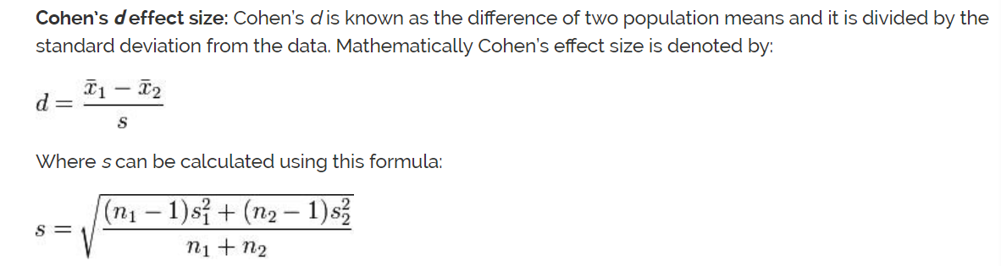
2. Example graph: http://rpsychologist.com/d3/cohend/