REPORT

PART-1:
1. syscount:
Added an array to store count of system calls (assuming max as 31 as given in spec)
In syscall function, incremented count of that particular system call.
Added function prototype and corresponding mapping to mapping array in syscall.c
Added system call number in syscall.h
Added corresponding function to sysproc.c
Initialized array to 0 in allocproc function in proc.c
Added entry to usys.pl and added function definition to user.h
2. sigalarm and sigreturn:
Added fields in struct proc for various purposes
Initialized them in allocproc function in proc.c
Added function prototype and corresponding mapping to mapping array in syscall.c
Added system call number in syscall.h
Added corresponding function to sysproc.c
Added entry to usys.pl and added function definition to user.h
The sigalarm function sets up an alarm in the current process by storing the specified interval and handler function, enabling the alarm state. The sigreturn function restores the process's previous state by copying the saved trap frame back into the current context and resets the alarm-related parameters, allowing the process to resume execution
Added code snippet to trap.c that checks if a timer interrupt has occurred while an alarm is active for the current process. If so, it saves the current trap frame, increments the tick count, and, when the tick count matches the alarm interval, sets the program counter to the alarm handler's address, disabling further alarm handling. Additionally, if the process is running, it updates its running time and calls yield() to allow the scheduler to switch to another process based on the scheduling policy.
PART-2:(scheduling)
1. Lottery Based Scheduling:
Added several fields to struct proc in proc.h
~ int tickets – to sore number of tickets a process has
~ int arrival_time – to store time at which process arrived
Added a new system call settickets to modify number of tickets a process has.
Added function prototype and corresponding mapping to mapping array in syscall.c
Added entry to usys.pl and added function definition to user.h
Added system call number in syscall.h
Initialized newly added fields in allocproc function in proc.c
Added random function to generate a random number to select a ticket from total number of tickets
After choosing a ticket randomly and get the process with corresponding number of tickets , we check if there are any other processes with same number of tickets. If yes, we compare their arrival_time to decide which will run first (one which arrived first). If no, the only process which is winner will run.
2. Multi Level Feedback Queue:
Added several fields to struct proc in proc.h
~ int priority – to keep track of priority level that the process belongs to
~ int ticks_used – to keep track of time taken by process in queue(time after which it gave up on cpu)
Defined macros for total number of queues and several other states of process
On the initiation of a process, process is pushed to the end of the highest priority queue (priority 0).
When the process completes, it leaves the system.
If the process uses the complete time slice assigned for its current priority queue, it is preempted and inserted at the end of the next lower level queue (except if it is already at the bottom queue, where it would be inserted at the end of the same queue.)
If a process voluntarily relinquishes control of the CPU, it remains in the same priority level.
To prevent starvation, implement priority boosting.
performance comparison between the default and 2 implemented scheduling policies:
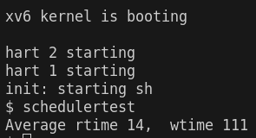
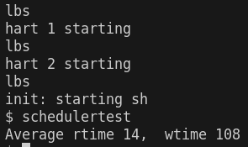
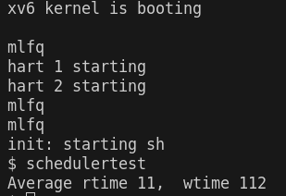

From above observation, we can conclude that mlfq scheduler has the least average time and waiting time varies among different schedulers. Considering multiple cases, we conclude that mlfq has least average waiting time and average running time.

Implications of Adding Arrival Time
- Fairness: Including arrival time could be used to ensure that newly arrived processes are considered fairly and not starved.
- Priority Aging: By integrating arrival time, you can simulate a form of priority aging, where longer-waiting processes have a better chance of being selected. This can help in avoiding starvation, particularly for processes that have been waiting in the system for a long time.

Pitfalls to Watch Out For
- Starvation: If arrival time is used to give too much preference to older processes, there is a risk that newer processes may not get enough CPU time. This is particularly an issue if many long-running processes arrive early.
- Overlapping Processes: When processes arrive at nearly the same time, the scheduler might behave unfairly if not carefully designed. In this case, arrival time might not meaningfully differentiate between processes, leading to near-random selection.

What Happens if All Processes Have the Same Number of Tickets?
If all processes have the same number of tickets, the lottery scheduling policy effectively behaves like a random scheduling algorithm. Each process will have an equal probability of being chosen for execution in every scheduling cycle.
If all processes have the same number of tickets, the system will be fair in the sense that each process has an equal chance of being scheduled, regardless of its CPU or I/O characteristics.
If your system does not differentiate processes by tickets or other factors (such as CPU burst time or I/O-bound nature), there may be inefficient use of system resources. CPU-bound and I/O-bound processes would be treated equally, which could lead to inefficient scheduling, especially in a system with mixed workloads.
The randomness may lead to unpredictable latency for individual processes.

