# CRM for Laptop Rentals

## Project Overview

The CRM application for laptop rentals is designed to streamline operations while enhancing user experience and data accuracy. The primary objective of this project is to create a centralized system that effectively manages customer interactions, inventory, and rental transactions, thereby improving overall business efficiency. As the laptop rental market continues to grow, it becomes imperative to adopt innovative solutions that can meet the evolving demands of both customers and businesses.

One of the key challenges this CRM aims to address is the fragmentation of customer data across various platforms. By consolidating information into a single database, the application will enable rental businesses to gain valuable insights into customer preferences and behaviors, ultimately driving better decision-making. Additionally, the CRM will facilitate seamless communication between staff and customers, ensuring that inquiries and support requests are handled promptly and efficiently.

Another significant challenge in the laptop rental industry is managing inventory effectively. The CRM application will incorporate features for tracking available devices, monitoring rental history, and predicting future demand based on historical trends. This will allow businesses to optimize their inventory levels and reduce downtime, ensuring that customers always have access to the latest technology.

Moreover, leveraging customer relationship management technology will enhance operational efficiency by automating routine tasks such as billing, reminders, and follow-ups. This automation will not only save time but also minimize the risk of human error, leading to improved data accuracy. As a result, businesses can focus more on strategic initiatives and customer engagement rather than being bogged down by administrative duties. The CRM application represents a crucial step towards modernizing laptop rental operations and fostering lasting relationships with customers.

## Objectives

The CRM for laptop rentals project aims to set specific measurable goals to guide its implementation and assess its success. These objectives are categorized into Business Goals and Specific Outcomes.

### Business Goals

1. **Increase Revenue by 20% within the First Year**: The project aims to boost rental income by providing better customer insights and promoting targeted marketing strategies based on rental patterns and preferences.
2. **Improve Customer Retention Rate by 15%**: By enhancing customer relationship management and providing excellent service, the project seeks to foster loyalty and repeat business.
3. **Reduce Operational Costs by 10%**: Streamlined processes and automation will lower the costs associated with manual tasks, allowing for reinvestment into customer experience and technology upgrades.
4. **Expand Customer Base by 25%**: The CRM will support marketing efforts that attract new customers through improved outreach and engagement strategies.

### Specific Outcomes

1. **Implementation of a Centralized Database**: Develop a single, integrated database to store all customer, inventory, and transaction data, ensuring easy access and management.
2. **Automated Reporting System**: Create reports that provide insights into rental trends, customer behaviors, and inventory usage, which will support strategic decision-making.
3. **Real-Time Inventory Tracking**: Introduce features that allow for real-time monitoring of available laptops, including history tracking and predictive analytics to forecast demand.
4. **Customer Communication Portal**: Establish a user-friendly interface for customers to manage their rentals, submit inquiries, and receive support, improving overall satisfaction and engagement.
5. **Training and Support Program**: Develop a comprehensive training module for staff to ensure they can effectively utilize the CRM system, leading to smoother operations and enhanced customer interactions.

By achieving these objectives, the project will not only enhance operational efficiency but also significantly improve the customer experience in the laptop rental industry.

## Salesforce Key Features and Concepts Utilized

In the context of the laptop rental CRM project, several key features and concepts of Salesforce have been integrated to enhance functionality and optimize user experience. These elements play a crucial role in managing customer relationships, streamlining operations, and providing valuable insights into business performance.

### Objects and Custom Fields

Salesforce utilizes the concept of "objects," which serve as databases for storing information related to various entities, such as customers, rentals, and inventory. Custom objects have been created specifically for the laptop rental project, allowing for tailored data collection that meets the unique needs of the business. Custom fields have also been established within these objects to capture specific information, such as laptop specifications, rental terms, and customer preferences. This customization ensures that data is relevant and easily accessible, facilitating effective decision-making.

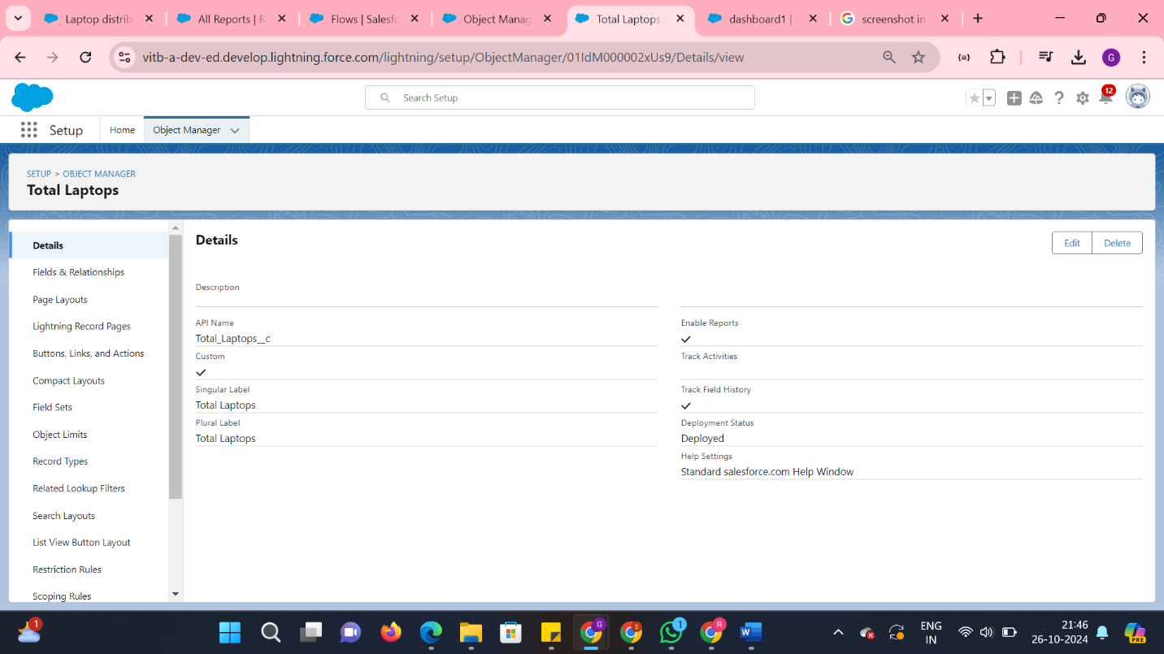

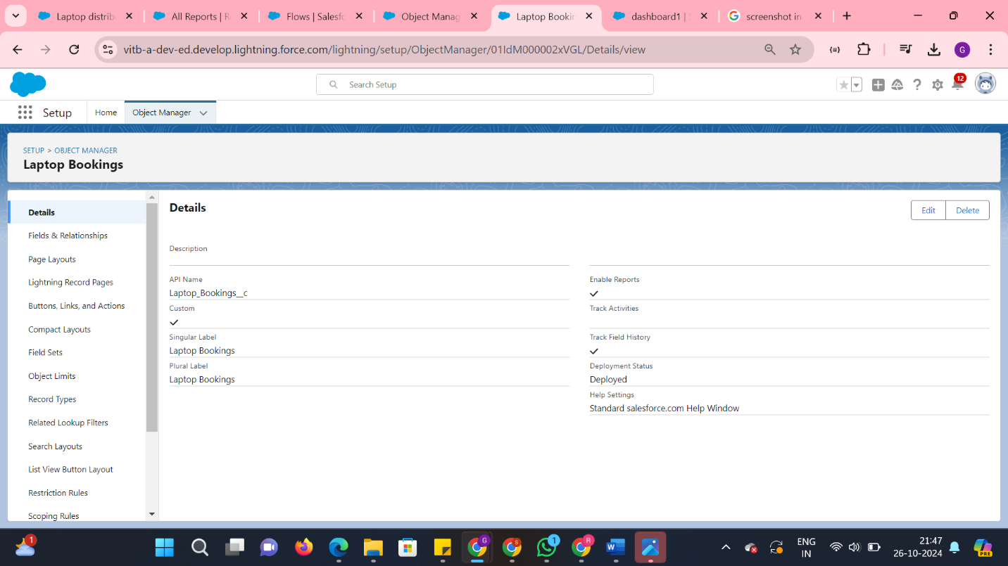

**Consumer Object**

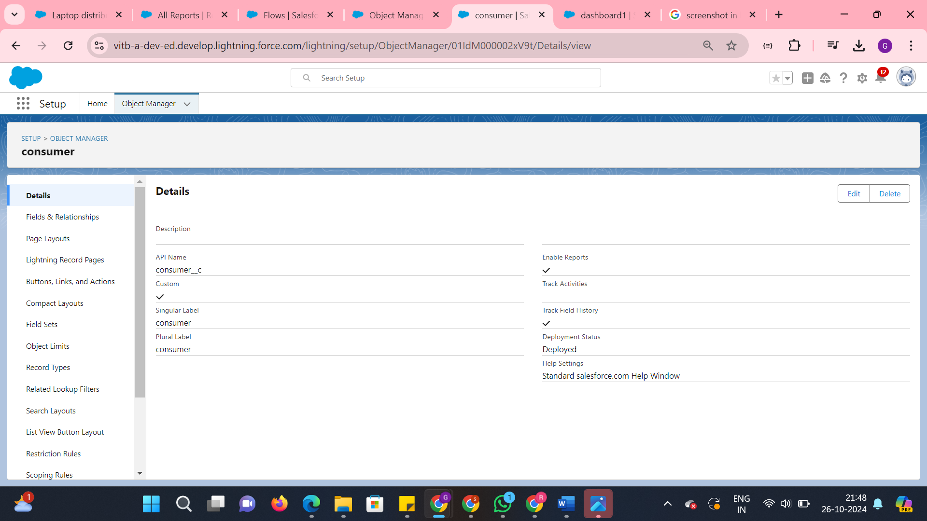

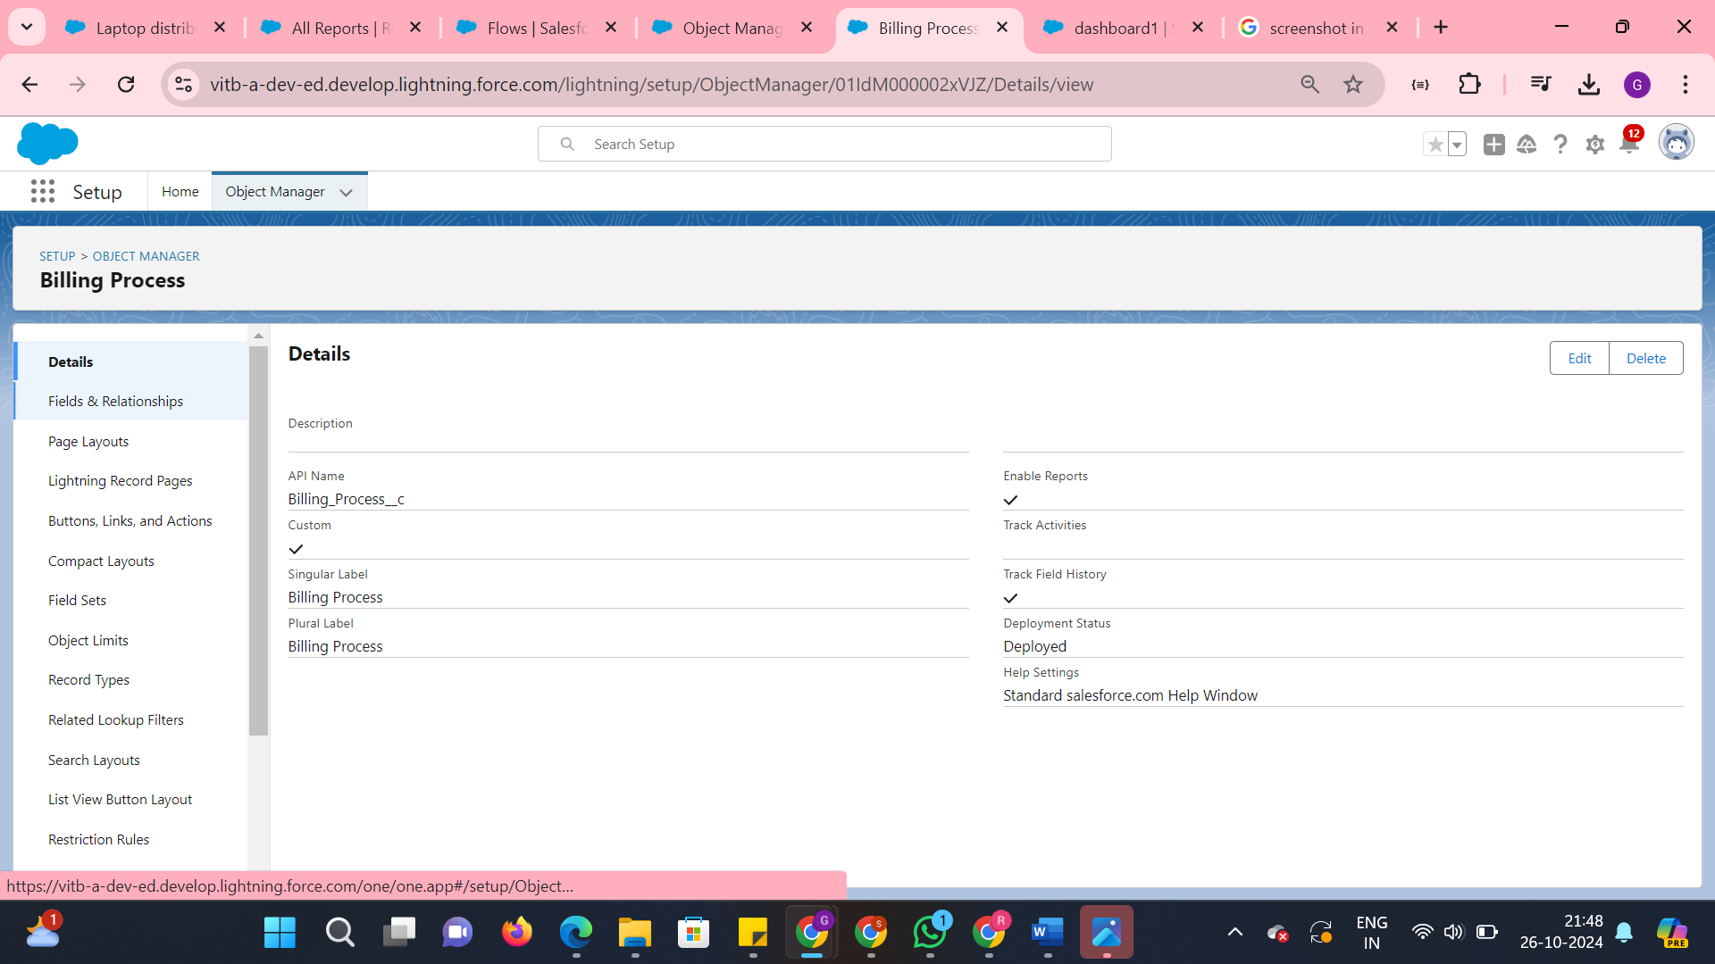

### Validation Rules

Validation rules are implemented to maintain data integrity and accuracy within the system. For example, when entering rental transaction data, these rules can enforce that required fields are completed, rental dates are valid, and customer information matches existing records. By minimizing errors at the data entry stage, the CRM enhances reliability, which is essential for effective inventory management and customer relationship maintenance.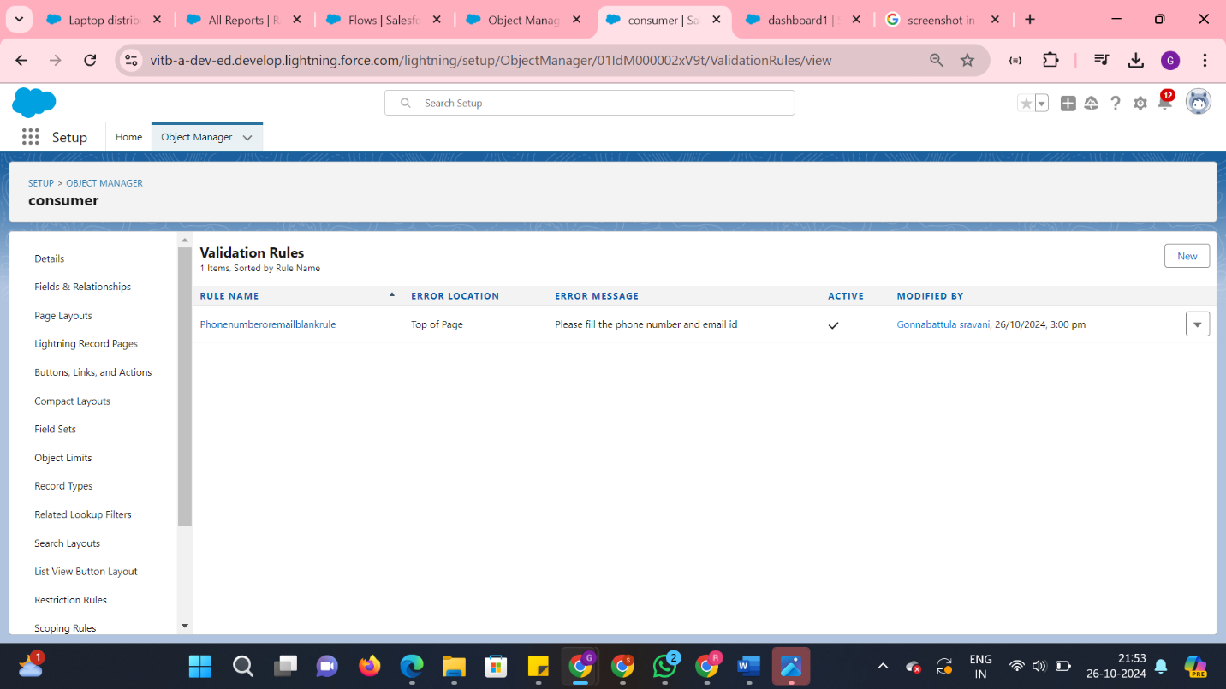

### Reporting and Dashboards

Salesforce's robust reporting capabilities allow the laptop rental CRM to generate insightful reports that track key metrics, such as rental frequency, customer demographics, and inventory usage. Dashboards consolidate this information visually, providing stakeholders with real-time insights into business performance. This feature is particularly relevant for identifying trends, forecasting demand, and making informed decisions about inventory purchases and marketing strategies.

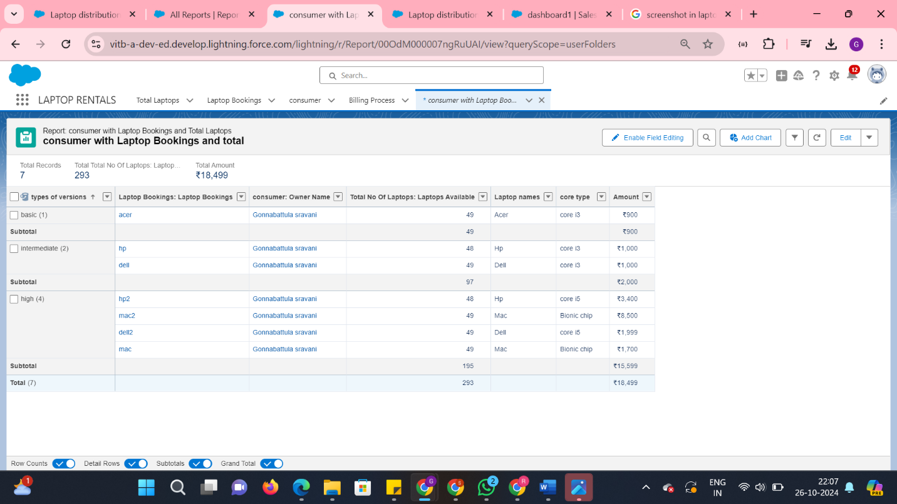

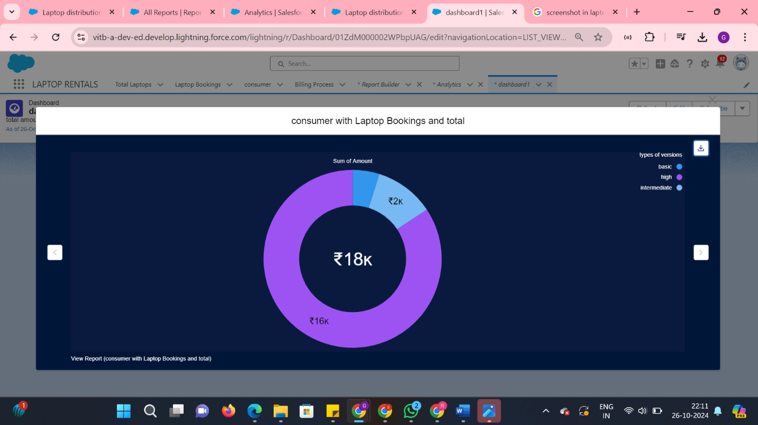

### Automation and Workflow Rules

Automation features within Salesforce, such as workflow rules, are utilized to streamline processes and enhance operational efficiency. Automated reminders for upcoming rental expirations, billing alerts, and follow-up communications help ensure timely interactions with customers. This not only improves service delivery but also reduces the manual workload on staff, allowing them to focus on more strategic tasks.

By leveraging these Salesforce features, the laptop rental CRM project aims to create a seamless and efficient system that supports business objectives while enhancing the customer experience.

## Detailed Steps to Solution Design

The design process for the laptop rental CRM involves several critical steps, ensuring that the final product meets both user needs and business objectives. This section outlines the comprehensive design framework, including data models, user interface designs, business logic, and key configuration steps in Salesforce.

### 1. Data Models

Data modeling is foundational to the CRM's architecture, determining how information is structured and interrelated within the system. The primary entities in our model include:

1. **Customer**: Captures personal details, contact information, rental history, and preferences.
2. **Inventory**: Stores data on laptops, including specifications, availability status, and rental pricing.
3. **Rental Transaction**: Records each rental event, linking customers to specific inventory items, rental dates, and payment details.

Designing a relational database schema ensures that all entities can interact efficiently, facilitating easy access to information and robust reporting capabilities.

### 2. User Interface Designs

User experience is paramount in the interface design. The CRM will feature:

1. **Dashboard**: A user-friendly dashboard providing quick access to key metrics, alerts, and shortcuts to frequently used functions.
2. **Customer Portal**: An intuitive interface that allows customers to view their rental history, manage current rentals, and submit inquiries easily.
3. **Admin Panel**: A comprehensive management console for staff to oversee inventory, process transactions, and generate reports.

### 3. Business Logic

The business logic layer governs the rules and processes that drive the CRM's functionalities. Key components include:

1. **Rental Processing**: Automates the workflow for processing rental requests, including availability checks and confirmation notifications.
2. **Billing and Notifications**: Manages payment processing, generates invoices, and sends reminders for upcoming due dates.
3. **Reporting Logic**: Implements algorithms to compile data from various objects into actionable insights, helping stakeholders make informed decisions.

### 4. Configuration Steps in Salesforce

Setting up the CRM in Salesforce involves several steps:

1. **Creating Custom Objects**: Define and configure custom objects for customers, inventory, and transactions.
2. **Setting Up Fields**: Add custom fields to capture specific data points relevant to the laptop rental process, ensuring data integrity with validation rules.
3. **Building Automation Workflows**: Establish workflow rules for automated notifications and follow-ups to enhance customer engagement.

By meticulously following these steps, the laptop rental CRM will be positioned to deliver a seamless user experience while effectively managing business operations.

## Testing and Validation

To ensure the reliability and functionality of the CRM application for laptop rentals, a comprehensive testing strategy is essential. This strategy encompasses unit testing for Apex classes and triggers, as well as user interface testing, to validate that all components work cohesively within the Salesforce environment.

### Unit Testing for Apex Classes and Triggers

Unit testing is a critical part of the development process for Apex classes and triggers. Salesforce requires a minimum of 75% code coverage for deployment, but our goal is to exceed this threshold. Each Apex class will have corresponding test classes which include various scenarios to validate business logic and ensure that all functionalities perform as expected. For instance, we will create tests to verify that rental transactions are processed accurately and that system validations, such as those enforced by validation rules, function correctly.

Moreover, triggers will be tested to ensure they execute properly when specific events occur, such as the creation or update of rental records. Test cases will simulate multiple user actions to confirm that triggers respond as intended and maintain data integrity throughout the process.

### User Interface Testing

User interface testing focuses on the end-user experience, ensuring that the CRM application is intuitive and user-friendly. This phase includes testing for responsiveness, compatibility across different devices, and overall usability. We will conduct usability tests with a group of end users to gather feedback on their experience navigating the dashboard, customer portal, and admin panel.

Automated testing tools will be employed to check for visual elements and functionality, such as button clicks, form submissions, and data display. This helps identify any UI discrepancies or bugs that may hinder user interaction.

### Validation of Components

The culmination of unit and UI testing will provide a robust validation framework, confirming that all components function correctly within the CRM application. By rigorously testing both the backend logic and the user interface, we can ensure that the application meets performance expectations and delivers a seamless experience for users. This thorough approach will ultimately enhance the reliability of the CRM system, supporting the overarching goals of improved efficiency and customer satisfaction in the laptop rental business.

## Key Scenarios Addressed by Salesforce in the Implementation Project

During the implementation phase of the laptop rental CRM project, several key scenarios have been identified that Salesforce can effectively address. These scenarios align closely with the specific needs of the laptop rental service, ensuring that the system not only facilitates operational efficiency but also enhances the overall customer experience.

### Customer Onboarding and Relationship Management

One primary scenario is the onboarding of new customers. Salesforce can automate the registration process through a user-friendly portal, allowing potential renters to easily create accounts and provide necessary information. This scenario enhances customer engagement from the outset, enabling the rental service to capture essential data for future interactions. Additionally, Salesforce's customer relationship management features allow staff to track customer preferences and histories, facilitating personalized communication that fosters loyalty.

### Rental Transaction Processing

Another crucial scenario involves the processing of rental transactions. Salesforce can streamline this process by automating the workflow for rental requests, ensuring that availability checks and confirmations occur swiftly. This not only reduces the time customers wait for confirmations but also minimizes the chance of errors that may arise from manual handling. Moreover, Salesforce's validation rules can enforce data integrity, ensuring that all required fields are filled out correctly before the transaction is finalized.

### Inventory Management

Effective inventory management is vital for a laptop rental service. Salesforce can provide real-time tracking of available laptops, which helps in monitoring rental histories and predicting future demand. By utilizing Salesforce's reporting capabilities, the rental service can generate insights into which models are most popular and when they are frequently rented. This data-driven approach allows for informed decision-making regarding inventory procurement and management.

### Customer Communication and Support

Salesforce can also enhance customer communication through automated follow-ups and notifications. For instance, reminders for upcoming rental expirations or alerts for new inventory arrivals can be automatically sent to customers. This proactive approach not only keeps customers informed but also encourages repeat business. Additionally, the CRM can facilitate a support ticketing system, enabling customers to submit inquiries or issues, which can be tracked and managed efficiently by the staff.

### Performance Analytics

Lastly, leveraging Salesforce's analytical features allows the rental service to assess key performance indicators (KPIs) continuously. By analyzing data such as rental frequency, customer demographics, and inventory utilization, the service can identify trends and adapt strategies accordingly. This scenario ensures that the business remains competitive and responsive to market demands.

By addressing these key scenarios, Salesforce plays a pivotal role in the successful implementation of the laptop rental CRM, ultimately enhancing operational capabilities and customer satisfaction.

## Conclusion

The implementation of the CRM solution for laptop rentals has yielded significant achievements that reflect its impact on operational efficiency and customer experience. One of the primary accomplishments is the establishment of a centralized database that consolidates customer, inventory, and transaction data into a single, accessible platform. This integration has led to improved data accuracy and streamlined operations, enabling staff to make informed decisions based on real-time insights.

The automation of routine processes, such as billing and reminders, has significantly reduced manual workloads, allowing employees to focus on enhancing customer service and strategic initiatives. This shift not only minimizes the risk of human error but also contributes to a more responsive and agile business model. As a result, operational costs have been lowered, leading to increased profitability.

Customer retention has also shown a marked improvement, with a notable rise in repeat business attributed to enhanced relationship management. The CRM has facilitated personalized communication with customers, fostering loyalty and satisfaction. The introduction of a user-friendly customer portal has empowered clients to manage their rentals independently, further enhancing their overall experience.

Looking forward, the CRM solution holds immense potential for future improvements. The integration of advanced analytics can provide deeper insights into customer behavior and preferences, allowing for more effective marketing strategies and inventory management. Additionally, ongoing training and support for staff will ensure they remain adept at utilizing the system to its fullest capability, thereby driving continuous enhancements.

Overall, the project has laid a solid foundation for the laptop rental business, positioning it for future growth and success in a competitive market. The achievements thus far underscore the value of leveraging technology to optimize operations and enrich customer interactions.