ReadMe

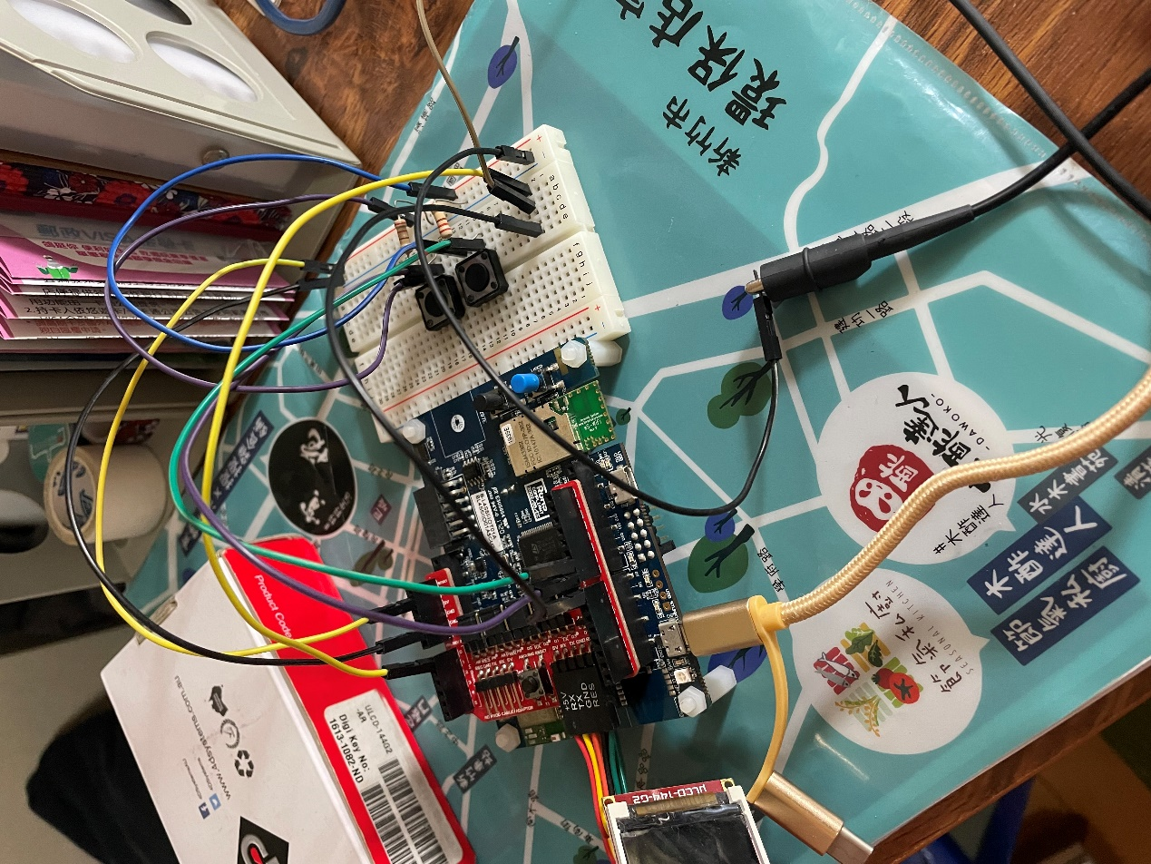

InterruptIn Start(D9);//start button

InterruptIn Stop(D8);//stop button

AnalogIn Ain(A0);

AnalogOut Aout(PA_4); //D7

uLCD_4DGL uLCD(D1,D0,D2);//like previous lab

After implemented, press start button, after 1 sec, run FFTHW_2.py, and press stop button. You can get a figure.