Assignment 2 — Software Fault-Tolerant Design
AITU Student Scholarship and Tuition Payment Processing
Astana IT University | Fault Tolerance | Academic Year 2026–2027
Context note: All operational data in this assignment are synthetic educational data. They are designed to represent a realistic Kazakhstan/Astana university context and do not describe actual AITU infrastructure, incidents, or internal systems.

Scenario
Consider a synthetic digital service used by an Astana university to process student payment-related transactions. The service must continue processing independent transactions when network, timeout, or database faults occur.
Each transaction follows: Validate → Process → Record.
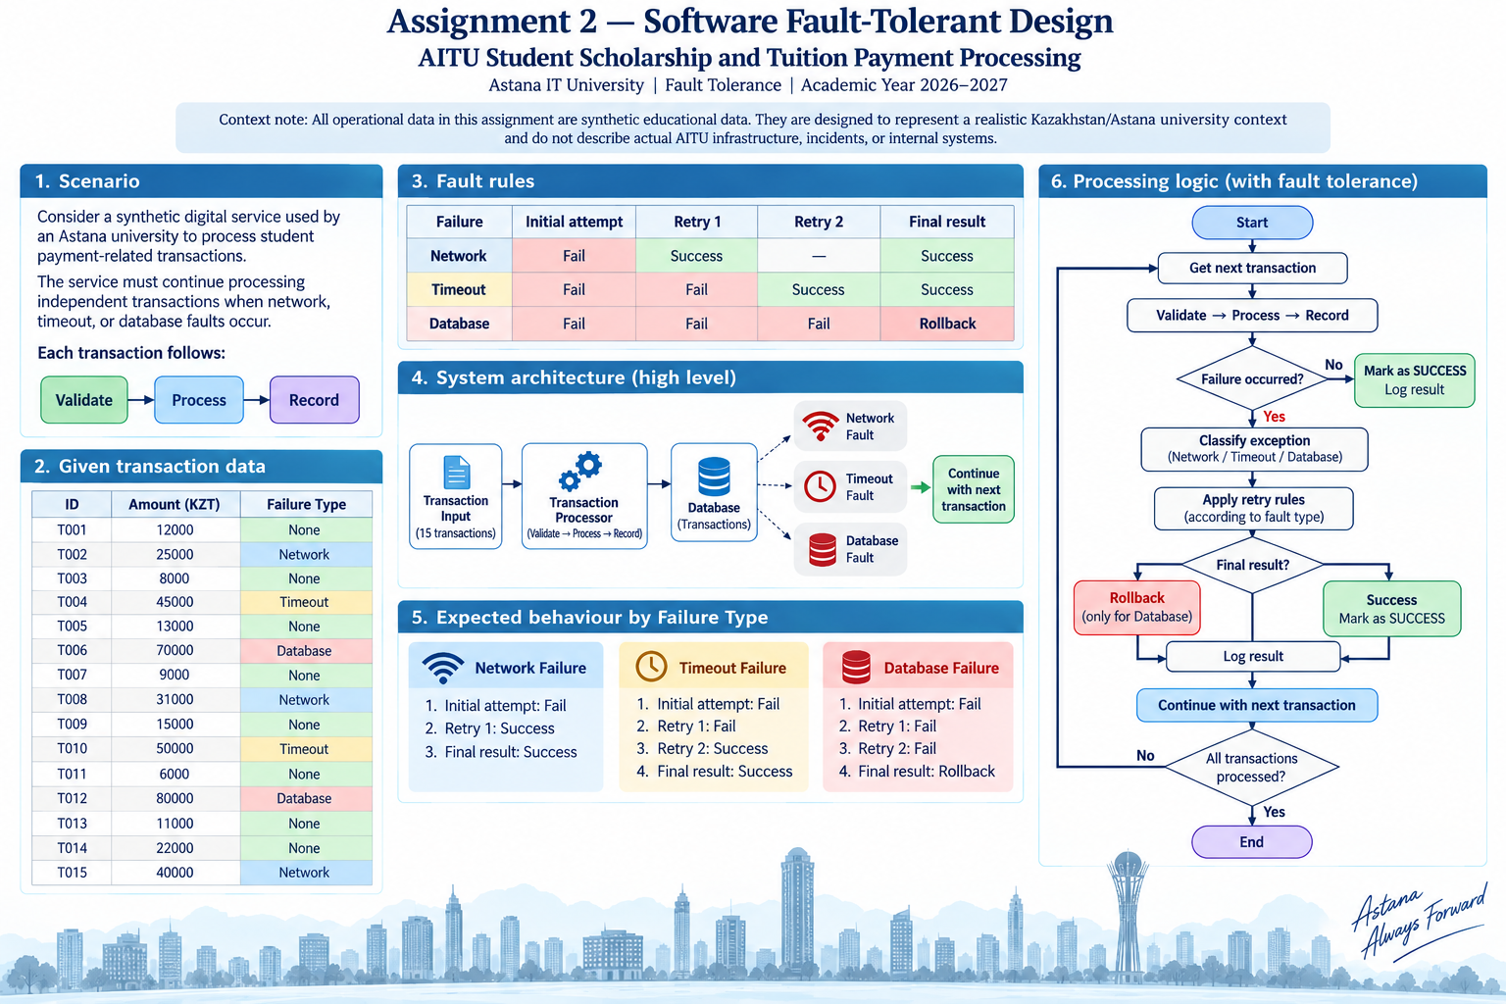

Given transaction data
ID | Amount (KZT) | Failure Type
T001 | 12000 | None
T002 | 25000 | Network
T003 | 8000 | None
T004 | 45000 | Timeout
T005 | 13000 | None
T006 | 70000 | Database
T007 | 9000 | None
T008 | 31000 | Network
T009 | 15000 | None
T010 | 50000 | Timeout
T011 | 6000 | None
T012 | 80000 | Database
T013 | 11000 | None
T014 | 22000 | None
T015 | 40000 | Network

Fault rules
Failure | Initial attempt | Retry 1 | Retry 2 | Final result
Network | Fail | Success | — | Success
Timeout | Fail | Fail | Success | Success
Database | Fail | Fail | Fail | Rollback

Part A — Baseline Implementation (5 points)
Implement a baseline Python processor without fault tolerance. It stops when a failure occurs.
Metric | Result
Transactions attempted | 2
Successful transactions | 1
Transactions lost | 14 (T002 failed + 13 never started)
Processed amount (KZT) | 12,000
Lost amount (KZT) | 425,000

Part B — Exception Handling (5 points)
Modify the program so one failed transaction does not terminate the application. Use try/except, failure classification, structured logging, and continuation.
Transaction | Failure | Exception | Recovery Action | Final Status
T002 | Network | NetworkError | Caught, logged as transient, skipped. Batch continues. | FAILED (batch continued)
T004 | Timeout | GatewayTimeoutError | Caught, logged (charge state unknown), skipped. Batch continues. | FAILED (batch continued)
T006 | Database | DatabaseError | Caught, logged, skipped. No rollback in Part B. | FAILED (batch continued)
T008 | Network | NetworkError | Caught, logged as transient, skipped. Batch continues. | FAILED (batch continued)
T010 | Timeout | GatewayTimeoutError | Caught, logged (charge state unknown), skipped. Batch continues. | FAILED (batch continued)
T012 | Database | DatabaseError | Caught, logged, skipped. No rollback in Part B. | FAILED (batch continued)
T015 | Network | NetworkError | Caught, logged as transient, skipped. Batch continues. | FAILED (batch continued)

Part C — Retry Mechanism (7 points)
Implement the exact retry policy provided in the input. Generate an attempt log automatically.
Timestamp/Step | Transaction | Attempt | Failure | Action | Result
#01 19:28:35.413 | T001 | 1 (initial) | none | record | SUCCESS
#02 19:28:35.413 | T002 | 1 (initial) | Network | retry in 0.05 s | FAIL
#03 19:28:35.463 | T002 | 2 (retry 1) | none | record | SUCCESS
#04 19:28:35.463 | T003 | 1 (initial) | none | record | SUCCESS
#05 19:28:35.463 | T004 | 1 (initial) | Timeout | retry in 0.05 s | FAIL
#06 19:28:35.513 | T004 | 2 (retry 1) | Timeout | retry in 0.10 s | FAIL
#07 19:28:35.614 | T004 | 3 (retry 2) | none | record | SUCCESS
#08 19:28:35.615 | T005 | 1 (initial) | none | record | SUCCESS
#09 19:28:35.617 | T006 | 1 (initial) | Database | retry in 0.05 s | FAIL
#10 19:28:35.667 | T006 | 2 (retry 1) | Database | retry in 0.10 s | FAIL
#11 19:28:35.768 | T006 | 3 (retry 2) | Database | rollback to CP1 | ROLLED BACK
#12 19:28:35.769 | T007 | 1 (initial) | none | record | SUCCESS
#13 19:28:35.769 | T008 | 1 (initial) | Network | retry in 0.05 s | FAIL
#14 19:28:35.820 | T008 | 2 (retry 1) | none | record | SUCCESS
#15 19:28:35.820 | T009 | 1 (initial) | none | record | SUCCESS
#16 19:28:35.821 | T010 | 1 (initial) | Timeout | retry in 0.05 s | FAIL
#17 19:28:35.872 | T010 | 2 (retry 1) | Timeout | retry in 0.10 s | FAIL
#18 19:28:35.973 | T010 | 3 (retry 2) | none | record | SUCCESS
#19 19:28:35.974 | T011 | 1 (initial) | none | record | SUCCESS
#20 19:28:35.976 | T012 | 1 (initial) | Database | retry in 0.05 s | FAIL
#21 19:28:36.026 | T012 | 2 (retry 1) | Database | retry in 0.10 s | FAIL
#22 19:28:36.128 | T012 | 3 (retry 2) | Database | rollback to CP2 | ROLLED BACK
#23 19:28:36.128 | T013 | 1 (initial) | none | record | SUCCESS
#24 19:28:36.129 | T014 | 1 (initial) | none | record | SUCCESS
#25 19:28:36.129 | T015 | 1 (initial) | Network | retry in 0.05 s | FAIL
#26 19:28:36.180 | T015 | 2 (retry 1) | none | record | SUCCESS

Part D — Checkpoint and Rollback (8 points)
Create a checkpoint after every 5 successfully processed transactions. On a database failure, rollback to the latest valid checkpoint and continue.
Checkpoint | Successful transactions | Total amount (KZT) | State saved
CP1 | 5 (last: T005) | 103,000 | success=5, total=103,000, committed T001-T005, in_flight={}, DB rows=5, gateway net=103,000 -> logs/checkpoints/CP1.json
CP2 | 10 (last: T011) | 214,000 | success=10, total=214,000, committed T001-T005 + T007-T011, in_flight={}, DB rows=10 -> CP2.json
CP3 (end of batch) | 13 (last: T015) | 287,000 | End of batch (the rule gives only 13 successes). success=13, total=287,000, DB rows=13 -> CP3.json

Processing flow of my solution
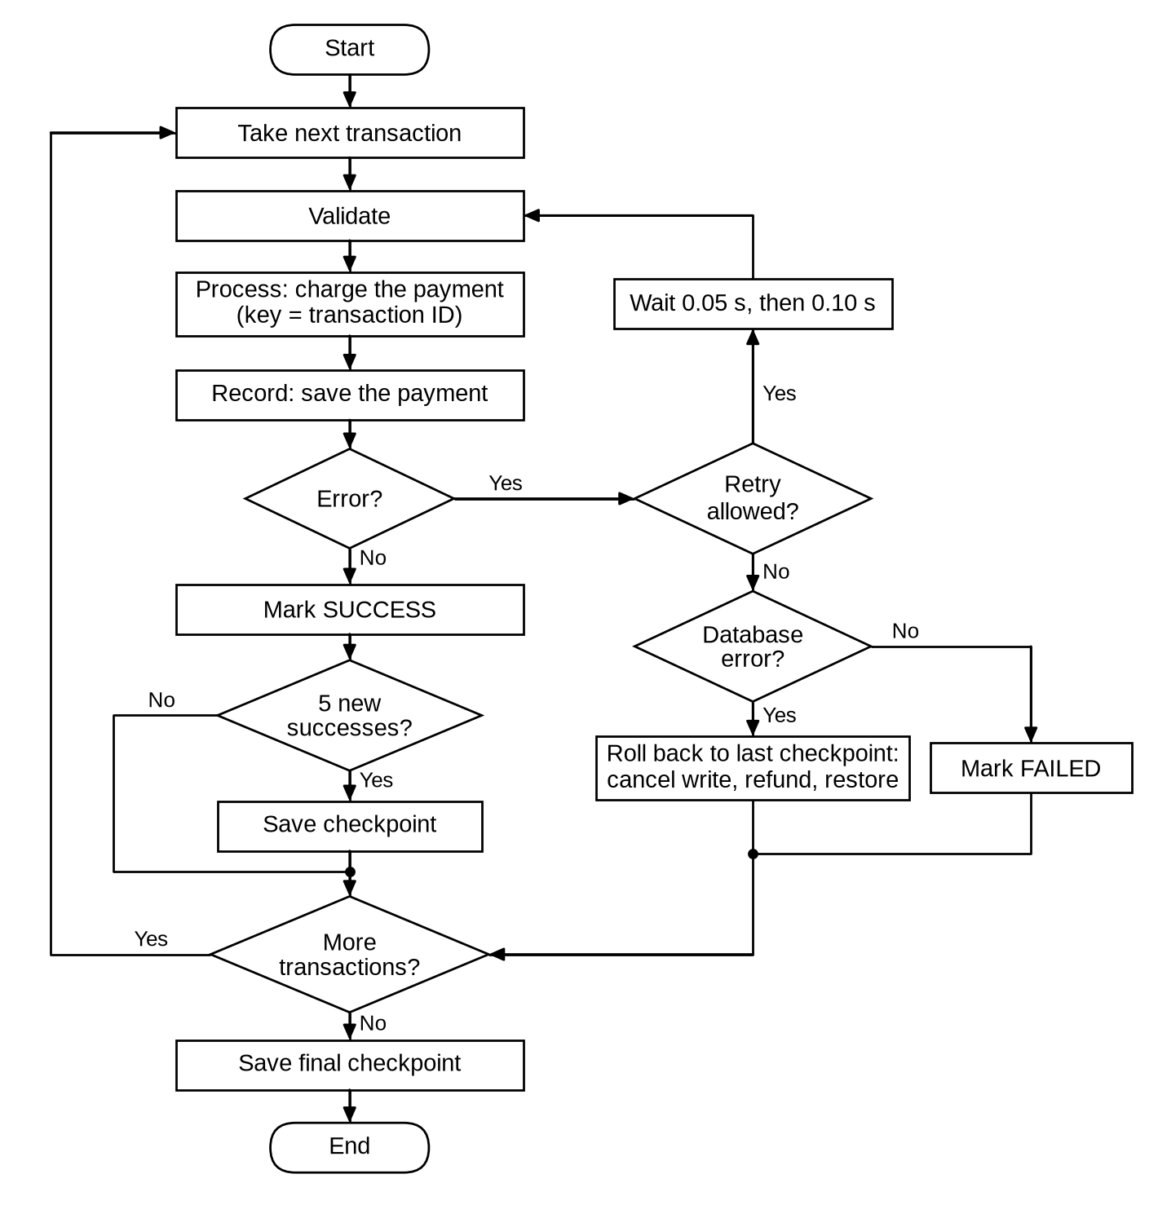
Figure 1. Processing flow of my solution. One attempt is Validate, Process and Record. A retryable error is repeated with the same idempotency key, at most 2 times. If the database still fails after that, the program rolls back to the last checkpoint.

Part E — Before/After Analysis (5 points)
Metric | Baseline | Fault-tolerant | Improvement
Successful transactions | 1 | 13 | +12 (13x more)
Failed transactions | 14 (1 failed + 13 not started) | 2 (T006, T012 rolled back) | -12 (-85.71%)
Lost amount | 425,000 KZT | 150,000 KZT | -275,000 KZT (-64.71%)
Retries | 0 | 11 | +11 (3 network, 4 timeout, 4 database)
Rollbacks | 0 | 2 | +2 (T006 -> CP1, T012 -> CP2)
Completion rate | 6.67% (1/15) | 86.67% (13/15) | +80.00 pp

- Calculate recovery improvement.
Completion rate: baseline 1 / 15 = 6.67%, fault-tolerant 13 / 15 = 86.67%. Improvement = 86.67 - 6.67 = +80.00 percentage points. Of the 7 transactions with a fault, the baseline recovered 0, and my fault-tolerant run recovered 5 (T002, T004, T008, T010, T015), so the recovery rate is 5 / 7 = 71.4%. The other 2 (T006, T012) were rolled back and refunded. At the end of the run the state, the database and the gateway all show 287,000 KZT.
- Calculate transaction-loss reduction.
Transaction-loss reduction = (14 - 2) / 14 = 12 / 14 = 85.71%. Amount-loss reduction = (425,000 - 150,000) / 425,000 = 275,000 / 425,000 = 64.71%. The amount reduction is smaller because the two rolled-back payments are big: 70,000 and 80,000 KZT.
- Which mechanism contributed most?
I used the Part B run as a middle step to see what each mechanism adds. Exception handling: 1 -> 8 successful (+7 transactions, +84,000 KZT). Retry: 8 -> 13 (+5 transactions, +191,000 KZT). Rollback: +0 transactions. By count, exception handling helps more. By money, retry helps more, because the faulty payments are bigger (341,000 / 7 = 48,714 KZT on average, clean ones 96,000 / 8 = 12,000 KZT). I think retry contributed most, because it is the only mechanism that turns a failed payment into a successful one. Rollback adds no successful payments. Its job is to keep the money and the records equal.
- When is retry unsafe or inappropriate?
Retry is unsafe when the operation is not idempotent and the result is unknown. A timeout is exactly this case: in my gateway the money is taken, and only the answer is lost. When I ran the same batch without idempotency keys, T004 and T010 were charged 3 times each, 190,000 KZT more than the database recorded. Retry is also useless for permanent errors, for example a wrong amount or a blocked account: in my code validation errors are marked as not retryable. And retry needs a limit and a pause (backoff), otherwise many clients repeat requests at the same moment and overload a service that is already slow.
- Why is rollback required for database failure?
At the moment of the database error the Process step is already done: the student's money is taken, but the payment row is not saved. This is a half-finished transaction. In Part B (no rollback) the failed INSERT stayed in the open SQLite transaction and was saved together with the next commit, so T006 and T012 are in the DB but marked FAILED. The three totals did not match: state 96,000, DB 246,000, gateway 341,000 KZT. Retry cannot fix this, because the rules say the database fails 3 times. Rollback removes the uncommitted row, refunds the charge, and restores the last checkpoint, so the three totals are equal again.
- Why is idempotency important in student payment processing?
Scholarship and tuition payments are real money of real students. If a timeout happens and the system just repeats the request, the student can pay twice and then has to ask for a refund. In my code the transaction ID is the idempotency key in three places: the gateway ignores a repeated charge with the same key, SQLite has txn_id as PRIMARY KEY with INSERT OR IGNORE, and the processor skips IDs it already recorded. Because of this, running the same batch a second time is safe: the 13 recorded payments are skipped, T006 and T012 go through, and the total is 437,000 KZT with no double charge. A unit test checks this.

Short technical conclusion
The baseline processed 1 of 15 payments (12,000 of 437,000 KZT) and stopped at T002. With exception handling, retry and checkpoint/rollback, the same data gives 13 successful payments (287,000 KZT), 11 retries and 2 rollbacks. The completion rate goes from 6.67% to 86.67%. For payments the program must survive the error and also keep the money and the records equal. In Part B the program kept running but ended with three different totals. With retry I needed an idempotency key, and with the database failure I needed a rollback that also refunds the charge. After that, all three totals were 287,000 KZT.

Submission
- Python source code
- Generated transaction and retry logs
- Completed tables
- Before/after analysis
- Short technical conclusion
- Oral defense

STUDENT TECHNICAL WORK REPORT / SUBMISSION RECORD
Assignment 2 — Software Fault-Tolerant Design
Purpose: This form is a formal submission record. The student must complete every applicable field and attach evidence of their own work. Short generic explanations are not sufficient.

1. Student and Submission Information
Required field | Student entry
Student full name | Alibek Asset
Student ID | 255175
Group / cohort | CSE-2503
Instructor | Azamat Serek
Date of submission | 27.09.2026
Git repository | https://github.com/Gontafi/university-stuff/tree/FTR-assignment-02
Attached code / file names | Python source code, unit tests, logs of the run (run log, JSON event log, attempt log, checkpoint files, summary, test results), this report

2. Work Period and Task Record
Item | Student entry
Work start date/time | 27.09.2026, 19:20
Work completion date/time | 27.09.2026, 19:33
Main task completed | Parts A-E: baseline processor, exception handling, retry policy from the fault rules, checkpoint and rollback, before/after analysis. Plus 12 unit tests and one extra experiment without idempotency keys.
Tools / technologies used | Python 3.12.3, standard library only (sqlite3, logging, json, csv, unittest). matplotlib for the flow diagram. Run in the Linux terminal.
Main technical output produced | The program prints all tables and writes the logs on every run: a readable run log, a structured JSON event log, the attempt log (26 attempts), checkpoints CP0-CP3 as JSON files and a summary with every number used in this report.

3. Report Structure to Complete
For each section below, write the requested evidence in your own words. Include calculations, diagrams, code references, screenshots, logs, or experimental evidence where applicable.

1. Baseline Implementation
Describe your baseline processor, the stopping behavior after a failure, and provide the required metrics from your own execution.
Required content | Student response / evidence
Summary | The baseline runs Validate -> Process -> Record for every transaction with no try/except. T001 passes. T002 raises a network error in the Process step, nothing catches it, and the program stops. Result: 2 attempted, 1 successful, 14 lost (T002 failed + 13 never started), 12,000 KZT processed, 425,000 KZT lost. That is 97.3% of the 437,000 KZT batch.
Evidence / calculation / artifact reference | Part A table above. The run log has the crash line: "NetworkError: T002 Process: connection reset, request did not reach the gateway". The program also has a crash mode that shows the full traceback. A unit test checks that the baseline stops after 2 attempts.
Student-specific decision or observation | The baseline uses the same attempt code as the fault-tolerant version, so the only difference between the runs is the error handling, and the comparison in Part E is fair. I count the 13 transactions after T002 as lost too, because nobody processes them until someone restarts the program by hand.

2. Exception Handling
Explain your exception classes/handling logic and show how processing continues after an individual transaction failure.
Required content | Student response / evidence
Summary | All errors share one base class with two fields: the failure kind and a retryable flag. There are four error types: validation (not retryable), network, gateway timeout and database. Each attempt is wrapped in try/except. On an error the program writes a JSON event, marks the transaction FAILED and goes to the next one. Result: 8 successful, 7 failed, 96,000 KZT processed, and the batch finished all 15 transactions.
Evidence / calculation / artifact reference | Part B table above. The JSON event log has one line per event with the transaction, attempt, exception type, retryable flag and error text. Unit tests check that the batch continues after failures and that a validation error is not retried.
Student-specific decision or observation | I called the timeout error GatewayTimeoutError, not TimeoutError, so it does not hide the built-in Python TimeoutError. I also added a consistency check at the end of the run. For Part B it printed MISMATCH: state 96,000, DB 246,000, gateway 341,000 KZT. So with exception handling alone the program keeps running, but the money and the records do not match.

3. Retry Mechanism
Document the exact retry policy, generate the attempt log, and explain how the implementation follows the provided network/timeout/database rules.
Required content | Student response / evidence
Summary | Policy: at most 2 retries (3 attempts), backoff 0.05 s and then 0.10 s (scaled down from 1 s and 2 s so the run is fast). Only retryable errors are retried. A fault injector follows the fault rules table: Network fail/success, Timeout fail/fail/success, Database fail/fail/fail. Result: 26 attempts and 11 retries (3 network x 1, 2 timeout x 2, 2 database x 2). 5 transactions were recovered.
Evidence / calculation / artifact reference | Part C table above. The program writes the same log to a CSV file (26 rows, not typed by hand). A unit test checks 2 attempts for T002, 3 for T004 and T006, and 11 retries in total.
Student-specific decision or observation | I retry the whole Validate -> Process -> Record chain, not only the failed step, so Process runs again on every retry. To make this safe, the transaction ID is the idempotency key in the gateway and the PRIMARY KEY in SQLite. I also made the gateway timeout happen after the money is taken (only the answer is lost), because in a real bank this is the case that causes double payments.

4. Checkpoint and Rollback
Show where checkpoints are created, what state is saved, and how rollback works after database failure.
Required content | Student response / evidence
Summary | A checkpoint is made after every 5 successful payments, plus CP0 at the start and a final one at the end of the batch. Saved state: success count, total, committed IDs, in-flight payments, DB row count and gateway net amount. It is kept as a deep copy in memory and as a JSON file. When the database still fails after the retries, the rollback does 4 things: it cancels the uncommitted database write, refunds the money, restores the state from the latest checkpoint, and replays rows that were committed after the checkpoint. T006 -> CP1: 173,000 -> 103,000, refund 70,000. T012 -> CP2: 294,000 -> 214,000, refund 80,000.
Evidence / calculation / artifact reference | Part D table above and the checkpoint files CP0 to CP3 in the logs folder. The rollback events in the JSON log show the total before and after, the refund and consistent=True. Unit tests check the checkpoint positions, that all three totals are equal after the rollbacks, and the replay case.
Student-specific decision or observation | The rule "every 5 successful" gives only CP1 and CP2, because only 13 payments succeed. I added a final checkpoint (CP3) so T013-T015 are saved too. I also noticed that both database failures come right after a checkpoint (T006 after CP1, T012 after CP2), so here the rollback loses nothing (replayed = 0). To check the general case, I wrote a test where the DB fails 3 transactions after a checkpoint, and the 2 committed rows are replayed correctly.

5. Before/After Analysis
Compare baseline and fault-tolerant execution using the required metrics. Show calculations for recovery improvement and transaction-loss reduction.
Required content | Student response / evidence
Summary | Successful: 1 -> 13. Failed: 14 -> 2. Lost amount: 425,000 -> 150,000 KZT. Retries: 0 -> 11. Rollbacks: 0 -> 2. Completion: 6.67% -> 86.67% (+80.00 pp). Transaction-loss reduction (14 - 2) / 14 = 85.71%. Amount-loss reduction (425,000 - 150,000) / 425,000 = 64.71%.
Evidence / calculation / artifact reference | Part E table above. The same table is printed at the end of the run log and saved in the summary file.
Student-specific decision or observation | I added Part B as a middle column (8 successful, 341,000 KZT lost), so I can see what each mechanism adds. Exception handling gives +7 payments but only +84,000 KZT. Retry gives +5 payments but +191,000 KZT. The failed payments are about 4 times bigger than the clean ones on average, so counting only transactions would undervalue retry.

6. Technical Reflection
Explain retry safety, rollback, and idempotency specifically in the context of your implementation.
Required content | Student response / evidence
Summary | Network errors happen before the request reaches the gateway, so repeating them is safe. With a timeout the charge is already done, and I can repeat it only because of the idempotency key. Database errors get 2 retries, then rollback with a refund. The key is checked in the gateway, in SQLite (PRIMARY KEY with INSERT OR IGNORE) and in the processor, which skips IDs that are already recorded.
Evidence / calculation / artifact reference | Extra run in the run log ("WITHOUT idempotency keys"): the gateway charged 477,000 KZT, the DB recorded 287,000 KZT, overcharge 190,000 KZT (T004 x3, T010 x3). Two unit tests check the double charge and a second run of the same batch.
Student-specific decision or observation | A rolled-back payment can be sent again later. When I ran the same batch a second time on the same processor, the 13 recorded payments were skipped, T006 and T012 went through (the database was back), and the total became 437,000 KZT. Nobody was charged twice.

4. Individual Work and Anti-Plagiarism Record
Because the assignment uses a common educational scenario and dataset, the submitted report must contain verifiable evidence of the individual student's work. Copying another student's wording, calculations, architecture, code, logs, screenshots, or conclusions is not acceptable.
- Submit a run-generated log, not a manually typed log.
- Include the exact source filename and commit/version used for the reported results.
- Record at least one implementation decision that differs from the simplest possible solution.
- Include one failed test/debugging issue that you personally resolved.
- During oral defense, be ready to modify or explain one recovery rule in your code.
Individual evidence | Student entry
My unique technical decision | I added a three-way consistency check. After every rollback and at the end of each run, the program compares the processor total, the SQLite total and the gateway net amount. I also made the gateway timeout happen after the money is taken, and ran the batch without idempotency keys to measure the overcharge (190,000 KZT).
My own implementation / calculation evidence | My own Python program (about 640 lines) and 12 unit tests, all of them pass. I wrote both and ran them on 27.09.2026. All tables in this report come from the summary file of that run.
Exact file, code, commit, notebook, or log reference | Git commit 8bd7c49 on branch FTR-assignment-02 (code, tests and logs). The run started 2026-09-27 19:28:35. The logs folder has the run log, the JSON event log, the attempt log, the checkpoint files and the summary.
One problem I personally encountered and how I solved it | In Part B the DB had 10 rows while only 8 payments were successful. I found that Python sqlite3 opens a transaction on INSERT. When the commit of T006 failed, the INSERT stayed open, and the commit of T007 saved it too. The same happened with T012 and T013. I fixed it in the rollback: its first step cancels the open database transaction, and I added the consistency check. Now after both rollbacks the DB has exactly 13 rows and 287,000 KZT. A unit test keeps this problem visible.
One limitation of my own solution | The faults are simulated and deterministic: the fault injector always follows the table, so the numbers are reproducible but there is no random behaviour. The backoff is scaled down to 0.05 s and 0.10 s. Checkpoints are written to JSON, but the program cannot restart from a JSON file if the process itself crashes; it only uses the copy in memory. I also assume that a refund always works; a real refund can fail too and would need its own retry.

5. Evidence Checklist
Completed required tables and calculations
Architecture / RBD / FTA / security diagram where applicable
Source code or configuration files where applicable
Execution logs / experiment results where applicable
Screenshots or other reproducible evidence where applicable
Links to code, datasets, notebooks, or artifacts
Before/after comparison where applicable
Final technical conclusion

6. Student Declaration
I confirm that this report describes my own work. I have not copied another student's report, code, calculations, diagrams, logs, screenshots, or conclusions. Any external source or reused material has been identified. I understand that I may be asked to reproduce or explain any part of this submission during the oral defense.
Role | Name | Signature | Date
Student / Executor | Alibek Asset |  | 27.09.2026
Instructor / Accepted by | Azamat Serek |  | ____________

7. Instructor Acceptance Record
Check | Status / comment
Report structure completed | ☐ Yes ☐ No Comment: __________________________________________
Evidence is sufficient | ☐ Yes ☐ No Comment: __________________________________________
Individual contribution is identifiable | ☐ Yes ☐ No Comment: __________________________________________
Oral defense completed | ☐ Yes ☐ No Comment: __________________________________________
Final status | ☐ Accepted ☐ Revision required

Appendix A. Source code excerpt
Retry loop, final decision after the retries, and rollback.
def process(self, txn):
self.attempted += 1
if txn.id in self.state["committed"]:
self.event(logging.INFO, "txn_skipped", txn=txn.id, reason="already recorded")
self.status[txn.id] = "SKIPPED (already recorded)"
return self.status[txn.id]
max_attempts = 1 + (MAX_RETRIES if self.retries else 0)
for n in range(1, max_attempts + 1):
try:
self.attempt(txn)
except PaymentError as err:
if err.retryable and n < max_attempts:
delay = self.backoff * 2 ** (n - 1)
self.retry_count += 1
self.log_attempt(txn, n, err, f"retry in {delay:.2f} s", "FAIL")
time.sleep(delay)
continue
return self.give_up(txn, n, err)
self.log_attempt(txn, n, None, "record", "SUCCESS")
self.status[txn.id] = "SUCCESS"
if self.use_checkpoints and self.state["success"] % CHECKPOINT_EVERY == 0:
self.make_checkpoint(f"{self.state['success']} successful transactions")
return "SUCCESS"
def give_up(self, txn, n, err):
if isinstance(err, DatabaseError) and self.use_checkpoints:
cp = self.rollback_to_checkpoint(txn)
self.log_attempt(txn, n, err, f"rollback to {cp}", "ROLLED BACK")
self.status[txn.id] = "ROLLED BACK"
else:
if not err.retryable:
action = "not retryable, skip"
elif self.retries:
action = "retries used up, skip"
else:
action = "skip, continue batch"
self.log_attempt(txn, n, err, action, "FAILED")
self.status[txn.id] = "FAILED"
return self.status[txn.id]
def rollback_to_checkpoint(self, txn):
cp = self.checkpoints[-1]
dirty_total = self.state["total"] + sum(self.state["in_flight"].values())
self.db.rollback() # drop the uncommitted INSERT
refunded = self.gateway.refund(txn.id) # give the money back to the student
restored = copy.deepcopy(cp["state"])
# rows committed after the checkpoint are replayed from the DB (source of truth)
rows = self.db.rows()
replayed = [t for t in self.state["committed"] if t not in restored["committed"]]
for t in replayed:
restored["committed"].append(t)
restored["success"] += 1
restored["total"] += rows[t]
self.state = restored
self.rollback_count += 1
self.event(logging.WARNING, "rollback", txn=txn.id, to=cp["name"], dirty_total=dirty_total,
restored_total=self.state["total"], refunded=refunded, replayed=len(replayed),
consistent=self.consistency()["ok"])
return cp["name"]

Appendix B. Run-generated log excerpt (logs/run.log)
Run started 2026-09-27 19:28:35. Lines are copied from logs/run.log without changes; the full log is attached.
Run started 2026-09-27T19:28:35 15 transactions, 437,000 KZT
=== Part A - Baseline (no fault tolerance) ===
19:28:35.411 ERROR baseline_crash mode=baseline exception=NetworkError error=T002 Process: connection reset, request did not reach the gateway attempted=2
=== Part B - Exception handling (no retry, no rollback) ===
Consistency check: state total 96,000, DB total 246,000, gateway charged 341,000 -> MISMATCH
Rows of failed transactions that still reached the DB (no rollback): T006, T012
=== Parts C and D - Retry + checkpoint/rollback (fault-tolerant run) ===
19:28:35.413 INFO checkpoint mode=fault-tolerant cp=CP0 success=0 total=0 last_txn=None reason=start of batch
19:28:35.616 INFO checkpoint mode=fault-tolerant cp=CP1 success=5 total=103000 last_txn=T005 reason=5 successful transactions
19:28:35.768 WARNING rollback mode=fault-tolerant txn=T006 to=CP1 dirty_total=173000 restored_total=103000 refunded=70000 replayed=0 consistent=True
19:28:35.975 INFO checkpoint mode=fault-tolerant cp=CP2 success=10 total=214000 last_txn=T011 reason=10 successful transactions
19:28:36.127 WARNING rollback mode=fault-tolerant txn=T012 to=CP2 dirty_total=294000 restored_total=214000 refunded=80000 replayed=0 consistent=True
19:28:36.181 INFO checkpoint mode=fault-tolerant cp=CP3 success=13 total=287000 last_txn=T015 reason=end of batch
Consistency check: state total 287,000, DB total 287,000, gateway charged 287,000 -> OK
=== Part E - Before/after ===
Transaction-loss reduction: (14 - 2) / 14 = 85.71%
Amount-loss reduction: (425,000 - 150,000) / 425,000 = 64.71%
Recovered by retry: 5 of 7 faulty transactions (T002, T004, T008, T010, T015)
=== Extra - same fault-tolerant run WITHOUT idempotency keys ===
Gateway charged 477,000 KZT, DB recorded 287,000 KZT, overcharge 190,000 KZT
T004: charged 3 times x 45,000 KZT
T010: charged 3 times x 50,000 KZT

Appendix C. Unit test results (logs/tests.txt)
test_stops_at_first_failure ... ok
test_checkpoint_is_not_changed_by_later_work ... ok
test_checkpoints_every_five_successes ... ok
test_rollback_keeps_state_db_and_gateway_equal ... ok
test_rollback_replays_rows_committed_after_checkpoint ... ok
test_batch_continues_after_failures ... ok
test_validation_error_is_not_retried ... ok
test_without_rollback_failed_rows_leak_into_db ... ok
test_keys_prevent_double_charge_after_timeout ... ok
test_second_run_of_same_batch_does_not_charge_again ... ok
test_attempts_follow_fault_rules ... ok
test_final_status ... ok
----------------------------------------------------------------------
Ran 12 tests in 0.010s
OK

