Assignment 3. Cloud Computing and Microservices Resilience
AITU Digital Student Services Platform
Astana IT University | Fault Tolerance | Academic Year 2026-2027
Context note: All operational data in this assignment are synthetic educational data. They are designed to represent a realistic Kazakhstan/Astana university context and do not describe actual AITU infrastructure, incidents, or internal systems.

Scenario
Design a resilient cloud-native architecture for a synthetic Astana IT University digital student-services platform. The platform supports timetable lookup, course information, registration requests, and student authentication.
Architecture: Users, Load Balancer, API Gateway, Auth / Course / Registration, Database.

Given requirements
Parameter | Requirement
Students/users | 10,000
Peak requests | 500 req/s
Availability target | 99.9%
Maximum RTO | 15 min
Maximum RPO | 5 min
Maximum API latency | 500 ms
Auth replicas | 2
Course replicas | 2
Registration replicas | 2
Database nodes | 2

Synthetic component availability
Component | Availability
Load Balancer | 99.95%
API Gateway | 99.90%
Auth instance | 99.50%
Course instance | 99.50%
Registration instance | 99.50%
Database node | 99.70%

Part A. Architecture Analysis (5 points)
Component | Failure scenario | Effect on student service | Resilience mechanism
Load Balancer | LB node down or wrong health check config | No request reaches the platform, full outage | Active and standby LB with a shared virtual IP, health checks to every gateway
API Gateway | Process crash, bad route config, overload | All APIs fail even if the services behind are healthy | At least 2 gateway replicas behind the LB, readiness probe, rate limit, config changes by rolling update
Auth | Pod crash, signing key store unreachable | New logins fail; students with a valid token keep working | 2 replicas, short-lived signed tokens checked at the gateway with cached public keys
Course | Pod crash, slow queries | Timetable and course pages fail or load slowly | 2 replicas, 500 ms timeout, gateway cache for course data (old data is acceptable here)
Registration | Pod crash, database write error, repeated submit | Students cannot register, a retry could register twice | 2 replicas on 2 nodes, readiness tied to the database, UNIQUE(student, course) so a retry is safe, PDB
Database | Primary node down, disk full, bad data written | Registration and course data unavailable, writes can be lost | Primary and standby with streaming replication, backup every 5 min on another node, restore drill

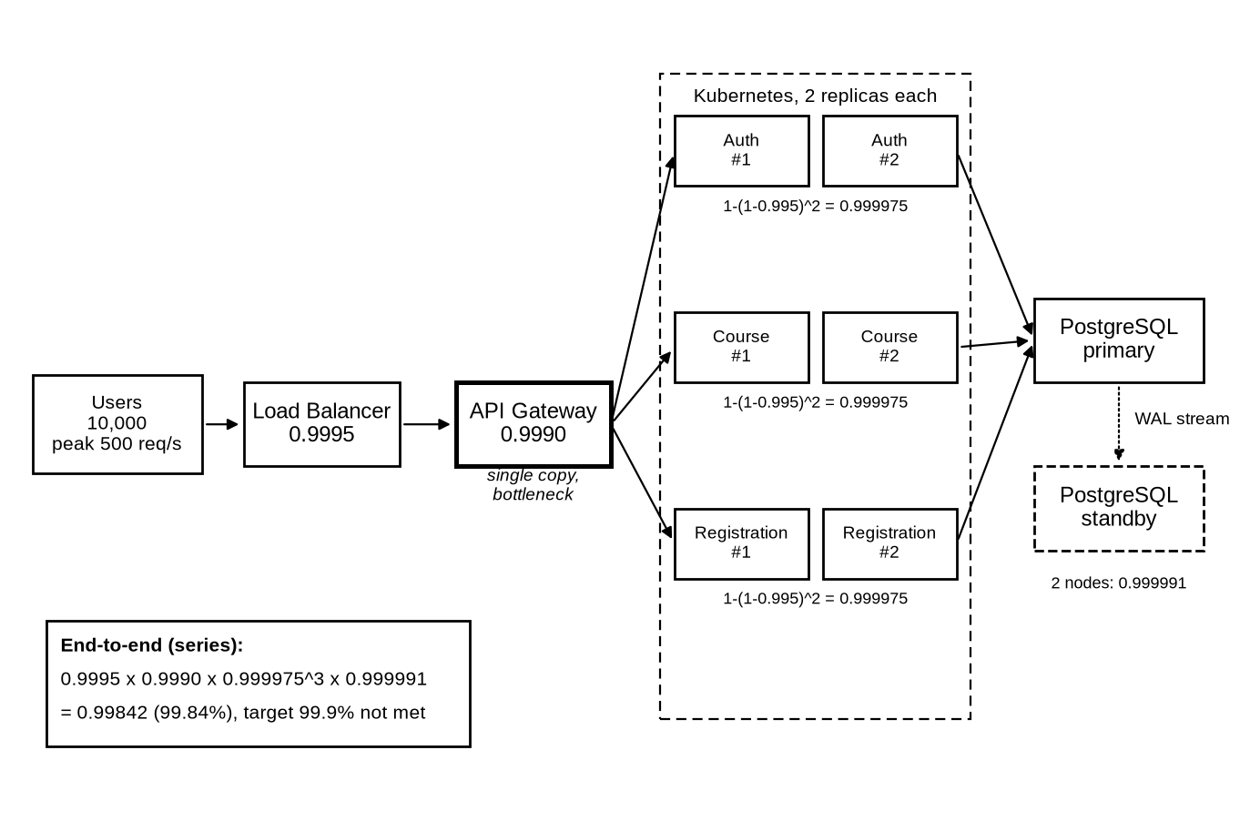
Figure 1. My architecture with the availability of every block. Only the Registration Service and PostgreSQL were deployed and tested in minikube; the standby node is part of the design.

Part B. Availability Calculation (7 points)
For two independent replicas I use R_parallel = 1 - (1 - R1)(1 - R2). Blocks in the request path are in series, so their availabilities are multiplied. The numbers are produced by scripts/availability.py.
Subsystem | Configuration | Availability
Auth | 2 replicas: 1 - (1 - 0.995)(1 - 0.995) = 1 - 0.000025 | 0.999975 (99.997%)
Course | 2 replicas: 1 - (0.005)(0.005) | 0.999975 (99.997%)
Registration | 2 replicas: 1 - (0.005)(0.005) | 0.999975 (99.997%)
Database | 2 nodes: 1 - (1 - 0.997)(1 - 0.997) = 1 - 0.000009 | 0.999991 (99.999%)
End-to-end | Series: 0.9995 x 0.9990 x 0.999975 x 0.999975 x 0.999975 x 0.999991 | 0.998417 (99.842%)

1. Does the design meet 99.9%? No. The path gives 99.842%, which is 13.9 hours of downtime per year, while 99.9% allows 8.76 hours.
2. Which component is the bottleneck? The API Gateway. It is a single copy with 99.90%, so it brings 0.100% of unavailability, 63% of the total. The Load Balancer is second with 0.050% (32%). All replicated blocks together add less than 0.01%.
3. What redundancy change would have the largest effect? A second API Gateway replica. It raises the path to 99.942% and meets the target. A second Load Balancer alone gives only 99.892%, and a third replica of every service only 99.849%.
Change (one at a time) | End-to-end availability | Meets 99.9%
Given design | 99.842% | No
Second API gateway | 99.942% | Yes
Second load balancer | 99.892% | No
Third replica of Auth, Course, Registration | 99.849% | No
Third database node | 99.843% | No
Second gateway and second load balancer | 99.991% | Yes

The formula assumes independent failures and instant failover. Two replicas on the same node fail together, so in the YAML I spread them over two nodes. The measured failover in Part D took 0 to 2 s, which fits the assumption well for pod failures but not for the database, where the outage lasted as long as the database was down.

Part C. Kubernetes Resilience Design (7 points)
The Registration Service is a small Go program (registration/main.go) with PostgreSQL. The YAML below is k8s/registration.yaml from the repository. It has 2 replicas, a readiness probe, a liveness probe, resource requests and limits, a rolling update, automatic restart and service discovery through a ClusterIP Service. The database password in k8s/postgres.yaml is a demo value; no real AITU endpoints or credentials are used.
# Registration Service of the synthetic AITU student services platform.
# Synthetic configuration only: no real AITU endpoints, credentials or infrastructure.
apiVersion: apps/v1
kind: Deployment
metadata:
name: registration
namespace: asg3
labels:
app: registration
spec:
replicas: 2
revisionHistoryLimit: 3
selector:
matchLabels:
app: registration
strategy:
type: RollingUpdate
rollingUpdate:
maxSurge: 1 # start one new pod first
maxUnavailable: 0 # never go below 2 ready pods during an update
template:
metadata:
labels:
app: registration
spec:
restartPolicy: Always
terminationGracePeriodSeconds: 20
# spread the two replicas over the two nodes, but still schedule if one node is gone
topologySpreadConstraints:
- maxSkew: 1
topologyKey: kubernetes.io/hostname
whenUnsatisfiable: ScheduleAnyway
labelSelector:
matchLabels:
app: registration
containers:
- name: registration
image: registration:asg3
imagePullPolicy: Never
ports:
- name: http
containerPort: 8080
env:
- name: DATABASE_URL
valueFrom:
secretKeyRef:
name: registration-db
key: url
startupProbe:
httpGet: {path: /health/live, port: http}
periodSeconds: 1
failureThreshold: 30
livenessProbe:
# process check only, a database outage must not restart the pods
httpGet: {path: /health/live, port: http}
periodSeconds: 5
timeoutSeconds: 1
failureThreshold: 3
readinessProbe:
# pod gets traffic only when PostgreSQL answers within 300 ms
httpGet: {path: /health/ready, port: http}
periodSeconds: 2
timeoutSeconds: 1
failureThreshold: 2
successThreshold: 1
resources:
requests:
cpu: 100m
memory: 64Mi
limits:
cpu: 500m
memory: 128Mi
securityContext:
runAsNonRoot: true
readOnlyRootFilesystem: true
allowPrivilegeEscalation: false
---
# service discovery: the API gateway calls http://registration.asg3.svc.cluster.local
apiVersion: v1
kind: Service
metadata:
name: registration
namespace: asg3
spec:
selector:
app: registration
ports:
- name: http
port: 80
targetPort: http
---
# NodePort only for the test client that runs outside the cluster
apiVersion: v1
kind: Service
metadata:
name: registration-test
namespace: asg3
spec:
type: NodePort
selector:
app: registration
ports:
- name: http
port: 80
targetPort: http
nodePort: 30090
---
apiVersion: policy/v1
kind: PodDisruptionBudget
metadata:
name: registration
namespace: asg3
spec:
minAvailable: 1
selector:
matchLabels:
app: registration
Mechanism | Implemented? | Purpose
Replicas | Yes. replicas: 2, spread over the two nodes with topologySpreadConstraints | One pod or one node can fail and the other pod keeps serving
Liveness probe | Yes. GET /health/live every 5 s, restart after 3 failures | Restart a hung process. It does not check the database, so a database outage does not cause a restart loop
Readiness probe | Yes. GET /health/ready every 2 s, 2 failures, checks PostgreSQL with a 300 ms ping | Take a pod out of the Service when it cannot serve, put it back when it can
Resource limits | Yes. Requests 100m CPU and 64Mi, limits 500m CPU and 128Mi | The scheduler knows the size of the pod; one pod cannot take the whole node
Rolling update | Yes. maxSurge 1, maxUnavailable 0, 4 s drain after SIGTERM | New version without dropping below 2 ready pods
Automatic restart | Yes. restartPolicy Always, the Deployment replaces deleted pods | A crashed container restarts, a lost pod is recreated
Service discovery | Yes. Service registration, DNS name registration.asg3.svc.cluster.local | The gateway finds ready pods by name, not by IP
Disruption budget | Yes. PodDisruptionBudget minAvailable 1 | A node drain cannot remove both pods at once

Part D. Failure Simulation (6 points)
Experiment | Injected failure | Detection time | Recovery time | User impact
1 | One Registration replica (pod killed, grace period 0) | Kubernetes 0.19 s (replacement pod created). No request failed | Replacement ready after 1.83 s; service never down | 0 of 976 requests failed, 0 of 680 writes lost
2 | All Registration replicas (both pods killed) | Kubernetes 0.23 s, first failed or slow request 1.15 s | Both pods ready 1.55 s, requests OK again 2.25 s after the kill | 1 failed and 4 slow (up to 1.05 s) of 912 (0.55%), 0 writes lost
3 | Database unavailable (PostgreSQL scaled to 0 for 20 s) | First error 0.12 s; readiness removed both pods after 3.54 s | Pods ready 3.32 s and requests OK 4.17 s after the database returned; whole outage 24.2 s | 116 of 831 requests failed (14.08%), 0 acknowledged writes lost, no failed write was saved

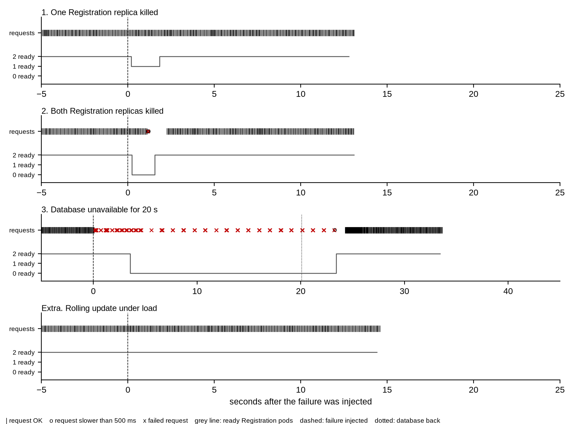
Figure 2. Request results and ready Registration pods during the experiments, drawn from results/*.json.
How the numbers were obtained. scripts/experiment.py runs 4 client threads against the NodePort Service. Every thread sends a request, waits 50 ms and repeats; half of the requests are writes with a new student ID, half are reads. A request fails on an HTTP error or after a 2 s timeout, and it is slow when it takes more than 500 ms. A second thread reads the pod list every 0.25 s. The failure is injected 5 s after the start with kubectl. Detection time is the time from injection to the first reaction (Kubernetes) or the first bad request (user). Recovery time is the time until both replicas are ready and requests succeed again. At the end the script reads the database and checks that every write that got HTTP 200 is stored and that no failed write was stored.
In experiment 3 the first 62 failures were HTTP 503 from the service itself: the pods were still in the Service but could not reach PostgreSQL. After the readiness probe failed, the Service had no endpoints and 54 requests were refused at connection. Users got a fast error and no hanging requests. As an extra test I ran a rolling update under the same load: the rollout took 4.1 s and 0 of 1096 requests failed.

Part E. RPO/RTO and Disaster Recovery (5 points)
Mechanism | Frequency | Expected RPO | Recovery time | Purpose
Database backup | pg_dump every 5 min (CronJob), stored on the other node, last 12 kept | At most 5 min | Measured: restore job 3.2 s for 2,617 rows | Bring data back after loss, corruption or a bad change
Replica | Continuous streaming replication to the standby node (design) | Seconds with async replication, 0 with sync | 1 to 2 min to promote the standby | Survive a database node failure without a restore
Configuration backup | All YAML in git, a commit for every change; etcd snapshot daily | 0 for the YAML in git | Measured: PostgreSQL recreated from YAML in 3.1 s | Rebuild Kubernetes objects after a lost namespace or cluster
Full recovery | Drill after every big change, at least once per semester | At most 5 min (last dump) | Measured: 7.3 s from deleted volume to working API, 15 min target | Prove that backup, YAML and steps really work together

High availability and disaster recovery solve different problems. High availability keeps the service running through expected component failures without a human, within seconds: in Part D one or two pods died and the service was back in 0 to 2.3 s. It works by having more copies of the same thing, so it also copies mistakes. A DELETE, a bad migration or ransomware is replicated to the standby within seconds. Disaster recovery brings back a correct earlier state after an event that high availability cannot absorb, such as a lost volume or corrupted data. It is measured by RPO and RTO and needs a procedure. In my drill (scripts/dr_drill.sh) I deleted the PostgreSQL StatefulSet together with its volume. Replicas could not help here, but the backup could: the service answered again after 7.3 s with all 2,617 rows.
My first drill attempt failed. The restore started while the new database was still initialising, and the scheduled backup ran against the empty new database and moved latest.dump to an empty dump. The fixed procedure suspends the backup CronJob, restores a named dump file and waits for a real database connection.

Submission
Architecture diagram: Figure 1
Availability calculations: Part B and results/availability.txt
Kubernetes YAML: Part C and k8s/ in the repository
Failure experiment results: Part D and results/
RPO/RTO plan: Part E and results/dr-drill.log
Oral defense

STUDENT TECHNICAL WORK REPORT / SUBMISSION RECORD
Assignment 3. Cloud Computing and Microservices Resilience
Purpose: This form is a formal submission record. The student must complete every applicable field and attach evidence of their own work. Short generic explanations are not sufficient.

1. Student and Submission Information
Required field | Student entry
Student full name | Alibek Asset
Student ID | 255175
Group / cohort | CSE-2503
Instructor | Azamat Serek
Date of submission | 12.10.2026
Individual variant / task code assigned by instructor
Git repository / project link | https://github.com/Gontafi/university-stuff/tree/FTR-assignment-03
Attached code / file names | registration/main.go, registration/Dockerfile, k8s/registration.yaml, k8s/postgres.yaml, k8s/backup.yaml, scripts/experiment.py, scripts/availability.py, scripts/dr_drill.sh, results/ (raw samples, events, drill logs), this report

2. Work Period and Task Record
Item | Student entry
Work start date/time | 12.10.2026, 14:20
Work completion date/time | 12.10.2026, 14:35 (code and results committed), report on the same day
Main task completed | Parts A to E: component analysis, availability calculation, Kubernetes YAML for the Registration Service, three failure simulations plus a rolling update test, backup and disaster recovery drill
Tools / technologies used | Go 1.26 with pgx, PostgreSQL 17, Docker, minikube v1.37 with two nodes, Kubernetes 1.37, Python 3 standard library, matplotlib for the figures
Main technical output produced | Working Registration Service on two nodes, YAML, raw request samples and pod snapshots for 4 experiments, Kubernetes events, availability tables, backup CronJob and a timed restore drill

3. Report Structure to Complete
For each section below, write the requested evidence in your own words. Include calculations, diagrams, code references, screenshots, logs, or experimental evidence where applicable.

1. Architecture Analysis
Analyze the failure scenarios for each component and explain the resilience mechanism selected for your design.
Required content | Student response / evidence
Summary | Every block in the path can stop the whole service. The LB and the gateway are single copies in the given design, so I add a second gateway first. Services get 2 replicas on 2 nodes, the database a standby and a backup every 5 minutes.
Evidence / calculation / artifact reference | Part A table, Figure 1, k8s/ folder.
Student-specific decision or observation | For Course I accept old data from a gateway cache, for Registration I do not. Instead I make retries safe with UNIQUE(student, course).

2. Availability Calculation
Show the parallel-redundancy calculations and the end-to-end series calculation. Explain whether the target is met and identify the bottleneck.
Required content | Student response / evidence
Summary | Replicated services 0.999975 each, database 0.999991, end-to-end 99.842%. Target 99.9% not met. Bottleneck: API Gateway with 63% of the unavailability.
Evidence / calculation / artifact reference | Part B tables, scripts/availability.py, results/availability.txt.
Student-specific decision or observation | I calculated every single change. Only a second gateway reaches the target (99.942%); more service replicas add less than 0.01 percentage points.

3. Kubernetes Resilience Design
Include the Registration Service YAML or a clear excerpt/reference. Explain replicas, probes, resources, rolling update, restart, and service discovery.
Required content | Student response / evidence
Summary | 2 replicas with topology spread, liveness, readiness and startup probes, requests and limits, rolling update with maxUnavailable 0, restartPolicy Always, ClusterIP Service and a PodDisruptionBudget.
Evidence / calculation / artifact reference | Part C YAML and table, k8s/registration.yaml, results/cluster-state.txt (pods on both nodes, endpoints).
Student-specific decision or observation | Readiness checks the database, liveness does not. A database outage then removes pods from traffic but never restarts them.

4. Failure Simulation
Document all three required simulations with detection time, recovery time, and user impact. Explain how each result was obtained.
Required content | Student response / evidence
Summary | One replica: 0 failed requests. Both replicas: 1 failed and 4 slow, back after 2.2 s. Database: 116 failed, outage 24.2 s for a 20 s database stop. No acknowledged write was lost in any run.
Evidence / calculation / artifact reference | Part D table and Figure 2, results/one-replica.json, all-replicas.json, database.json, rolling-update.json and the *-events.txt files.
Student-specific decision or observation | I also checked data: every write that got HTTP 200 was in the database, and no failed write was stored.

5. RPO/RTO and Disaster Recovery
Complete the RPO/RTO plan and explain why high availability and disaster recovery are different engineering objectives.
Required content | Student response / evidence
Summary | Backup every 5 minutes on the other node gives RPO at most 5 min. The full recovery drill took 7.3 s against a 15 min target. HA copies mistakes, DR restores a correct earlier state.
Evidence / calculation / artifact reference | Part E table, k8s/backup.yaml, scripts/dr_drill.sh, results/dr-drill.log, results/dr-drill-first-attempt.log.
Student-specific decision or observation | The recovery time is short only because the database is small (2,617 rows). The hard part was the procedure; the copy itself took seconds.

6. Final Architecture Decision
State the most important resilience change you made and justify it using availability, failure, or recovery evidence.
Required content | Student response / evidence
Summary | The most important change is a second API Gateway replica. It is the only single change that meets 99.9% (99.842% to 99.942%).
Evidence / calculation / artifact reference | Part B what-if table. Part D shows that a pair of replicas with probes hides a pod failure completely (0 failed requests).
Student-specific decision or observation | The same pattern I measured for Registration (2 replicas, readiness, rolling update) should be used for the gateway.

4. Individual Work and Anti-Plagiarism Record
Because the assignment uses a common educational scenario and dataset, the submitted report must contain verifiable evidence of the individual student's work. Copying another student's wording, calculations, architecture, code, logs, screenshots, or conclusions is not acceptable.
Use the instructor-assigned individual variant/task code.
Provide the exact YAML filename or repository commit used for the reported configuration.
Include evidence from your own simulation or test run.
Explain one Kubernetes setting you changed or tuned and why.
Be prepared during oral defense to explain what happens if both replicas fail.
Individual evidence | Student entry
My unique technical decision | Readiness depends on the database (300 ms ping), liveness does not, and the service fails readiness and waits 4 s after SIGTERM before it stops. With maxUnavailable 0 this gave 0 failed requests during the rolling update.
My own implementation / calculation evidence | Go service, three YAML files, experiment and drill scripts written and run by me on 12.10.2026. All numbers in Parts B, D and E come from the files in results/.
Exact file, code, commit, notebook, or log reference | Branch FTR-assignment-03, commit 84b5f84. k8s/registration.yaml, results/*.json, results/dr-drill.log.
Kubernetes setting I tuned and why | Readiness periodSeconds 2 and failureThreshold 2 instead of the default 10 s and 3, so a pod without a database leaves the Service in about 4 s. Measured: 3.5 s in experiment 3.
One problem I personally encountered and how I solved it | The first recovery drill failed. The restore job connected while PostgreSQL was still running initdb on the new volume (the pod was already Ready) and got connection refused. Meanwhile the CronJob made a dump of the empty database and latest.dump pointed to it. I suspend the CronJob during recovery, restore a named file and wait for a real connection. The second drill passed.
One limitation of my own solution | Only Registration and PostgreSQL are deployed; the standby database, gateway, Auth and Course are design only. Everything runs on one laptop and the image was already on the nodes, so the restart times are better than in a real cluster.
If both replicas fail | The Service has no endpoints, requests fail until the Deployment starts new pods. Measured: back after 2.2 s, 1 failed and 4 slow requests.

5. Evidence Checklist
Evidence | Included | Where
Completed required tables and calculations | Yes | Parts A to E
Architecture / RBD / FTA / security diagram | Yes | Figure 1
Source code or configuration files | Yes | Part C, branch FTR-assignment-03
Execution logs / experiment results | Yes | results/ in the repository
Screenshots or other reproducible evidence | Yes | Figure 2 from raw data, README commands
Links to code, datasets, notebooks, or artifacts | Yes | Section 1 of this form
Before/after comparison | Yes | Part B what-if table, Part E drill
Final technical conclusion | Yes | Section 3.6 of this form

6. Student Declaration
I confirm that this report describes my own work. I have not copied another student's report, code, calculations, diagrams, logs, screenshots, or conclusions. Any external source or reused material has been identified. I understand that I may be asked to reproduce or explain any part of this submission during the oral defense.
Role | Name | Signature | Date
Student / Executor | Alibek Asset |  | 12.10.2026
Instructor / Accepted by | Azamat Serek

7. Instructor Acceptance Record
Check | Status / comment
Report structure completed | Yes No Comment:
Evidence is sufficient | Yes No Comment:
Individual contribution is identifiable | Yes No Comment:
Oral defense completed | Yes No Comment:
Final status | Accepted Revision required

