Dev Diary

26/10/2026
Godot Project started with GDExtension, built from Godot 4.5 GDExtension Example Tutorial.

27/10/2026
VoxelCube node class created with adjustable size

28/10/2026
- Figured out how to procedurally create meshes using SurfaceArray
- Scene setup with lighting & controllable camera
- Timer setup for recording mesh generation time to compare approaches.
  - Compared: Performance test of triangle list vs triangle strip.
  - 0.1067~ ms average between both, negligible difference when indices are used for both.
  - Seemed to notice improvement when no indices were used for triangle strip, more testing required!

29/10/2026
- Mesh generation tested for a variable number of iterations. Found that the 4th time the mesh generated it seems to be much slower than all other iterations (0.06-0.007~ normally, but ~5ms on the 4th iteration).
- Test generating a quad
  - Average over 10,000 tests for Triangle List: 0.01602501 ms
  - Average over 10,000 tests for Triangle Strip: 0.01063728 ms
- Tested out voxel triangle strip. Realised the issue with triangle strip is that each face generated would need to be directly connected to the previous face, which makes it far more complicated to algorithmically generate. Ended up just using triangle list.
- Figuring out vertex order for mesh generation.
- Set up culling voxel meshing for VoxelCube node.
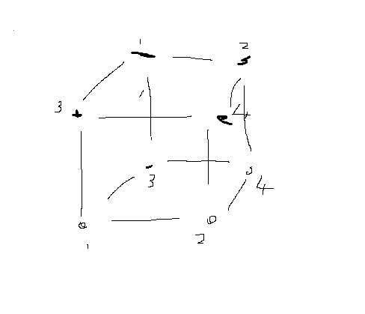

31/10/2026
- https://github.com/pkdawson/imgui-godot ImGui installed. Currently only useable in GDScript, may work on this at later date to get it working in the C++ files as well.
- Screen to world ray cast implemented. Voxels removed from collision. This will later be used to start the fracture propagation algorithm at the collided voxel.
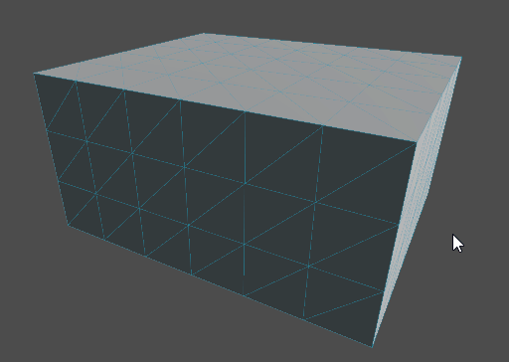
Currently uses the MeshInstance3D’s built-in functions for generating a tri-mesh collider. This is inefficient and will need to be optimized at a later point / done manually, ideally, it should take less time than mesh generation. I can reuse the same algorithm as I did for mesh generation to do this.
ALTERNATIVELY, what might be better is to have a simple cube collider that covers the whole chunk, and then I use the direction of the ray to step through the voxels manually until it hits a valid voxel (or passes through the entire grid). The downside of that is that is I would likely want the collider to match the voxels anyway for the sake of a player moving around the terrain in a game.
Computation time for collider generation is currently averaging 13.6ms whilst mesh generation is averaging 0.04ms with a 5x5x5 voxel grid and 100 tests run.

Also confirmed it works with varying scales
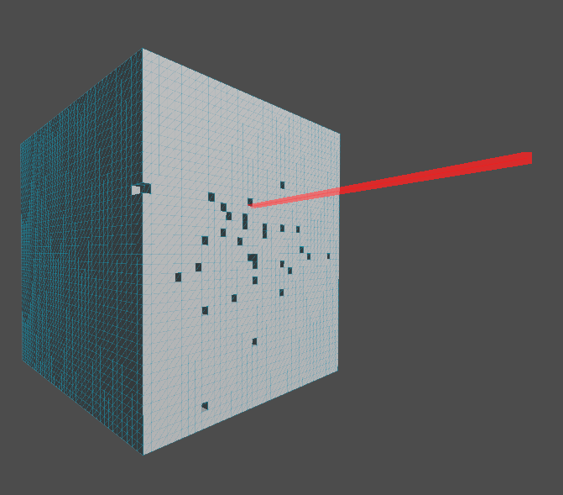

1/11/2026 & 4/11/2026
- Looked into Octree Implementation, in particular this site and the corresponding GitHub: https://eisenwave.github.io/voxel-compression-docs/svo/svo.html https://gist.github.com/eisenwave/c48bf988fc29d1c8bf0d4512d3916d22
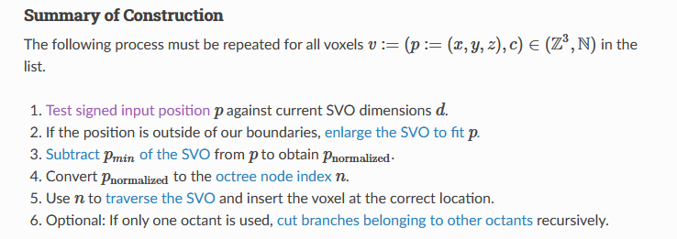
Note:
- P Normalised is a non-negative (Unsigned) position! So negative values convert into positive positions by offsetting every position in the voxel array.
- I think the maximum index (n) might be calculated by just computing the maximum depth of the octree from the dimensions (size). This would mean that there are indexes that lead to an empty node, but since the octree traversal will be recursive it will be able to have checks for this.
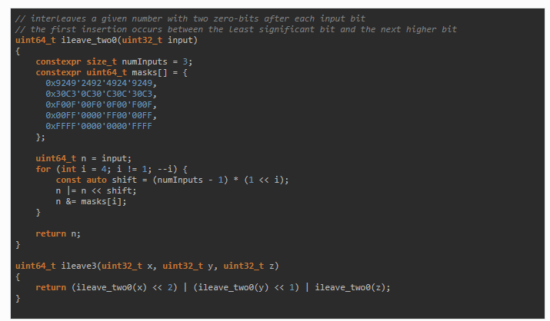
This is how they compute the Morton Position, using bit-twiddling hacks from https://graphics.stanford.edu/~seander/bithacks.html#InterleaveBMN . This converts 3D coords into Morton 1D coords. I believe this can then be used to recursively traverse the octree to find which node a voxel resides in.
Differences in my implementation:
- Compared to them, I use unsigned positions, so no negative positions for voxels.
- The centre of my octree is size/2
- I do not grow the octree, if position of a voxel is greater than the size of the octree then I will check if the terrain has an octree chunk for it, otherwise it is ignored.
- They have a position normalisation step that I can skip due to not using negative positions. It offsets all voxel positions so that there are no negative values. e.g. -2,-2,-2 becomes 0,0,0 and 0,0,0 becomes 2,2,2 in a size 4 octree.
Findings:
Morton Codes 'Z-Order Curve' - https://en.wikipedia.org/wiki/Z-order_curve
https://www.youtube.com/watch?v=8EoVmq8438A
https://www.youtube.com/watch?v=R-Suki2gD7s
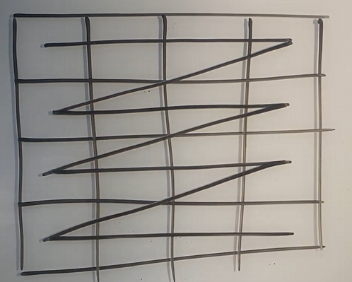
Figure 1 - Example of standard method of storing and traversing 2D array
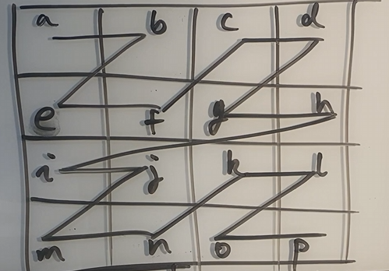
Figure 2 - Example of Morton Codes
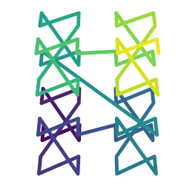
Figure 3 - Wikipedia, 3D Z-Order
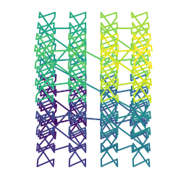
- Z-Order Curve is a form of Space-filled curves
- Space-filled curves map multi-dimensional coordinates into 1D.
- Z-Order Curve achieves this by ‘bit-interleaving’
- The benefits of space-filled curves in programming aren't just converting multi-dimensional coords to 1D, but also the locality of memory, which reduces cache misses.
- Z-Order's particular benefit in voxels is that for each voxel, it has 2 mapped 2 of the adjacent voxels locally in memory, reducing cache misses.
Brief understanding of memory locality:
- When memory is accessed, the computer tends to load adjacent memory as well, in anticipation that the program will then access that data. If the program doesn’t then this is considered a cache miss which means extra time spent trying to find and load the memory. Arrays are great for memory locality as the elements of the array are stored one after the after and therefore are contiguous in memory. So, if you loop through the array, you should have very little or no cache misses.
Currently with my Culling meshing generation, I access adjacent voxels in all 6 directions, this is likely to cause a lot of cache misses as the adjacent voxels will not be stored contiguously in memory except for the voxels on the same row. With Z Order Curve the voxel data will be much closer in memory, so ideally there will be far less cache misses!
Very rough understanding of the bit interweaving / indexing of the SVO:
- For indexing only 3 bits are needed for the index of each level of the octree, as there are only 8 children, so indices 0-7! #111 is 7 and #000 is 0. Bit interweaving maps the x y z coords into 3-bit indices for each level. On each level, we’d shift the index 3 bits to get the child index for that level.
- Once I have the index I recursively traverse the octree until I reach a leaf, which either will be partway through the Morton code or if the octree has been fully subdivided in a region then after reaching the last 3 bits of Morton.
- Don’t know how you calculate the depth yet.
05/11/2026
Recap of my understanding:
Current plan is to use a Morton Code algorithm to index 3D positions (voxels) into the octree.
The idea is that the Morton code interleaves the bits of the x,y & z into 3 bit sequences that index the node on each layer of the octree (E.g. 0-1 value for each axis to determine left-right, forward-backward, up-down for that node).
When I want to access a voxel, I would convert the position into the index using bit interleaving then traverse the octree from the root until it finds a leaf node or has fully scanned the Morton code.
The use of this octree is for terrain chunks, so I don't need growth, and my voxel positions are all in the positive range when I generate the simple voxel cube through a voxel array so I don’t need to normalise the positions.
I'm generating the array first then will convert that into the SVO at the start of the program.
My Octree uses has a node struct (empty) and then leaf and branch structs which inherit it. Branch stores 8 nodes, leaf stores 8 voxel data values (simply a byte).
My main point of confusion is that I'm not sure when traversing how I should iterate through the Morton code.
I will likely store the code in an int, and I will read 3 bits at a time, offset by 3 bits * the current depth in the octree. I can do this until I reach a leaf node or until I've reached the smallest point of data which should be 1 voxel represented as a leaf node.
However, how does the octree traversal function know that it has reached the smallest node size that should be possible, instead of continuing to traverse the Morton code, which will likely just be storing 0 value bit sequences after it has been fully read. I don't think I can just do a check for 000-bit sequences since that might happen in the octree for the child at index 0 anyway, the values go 0 to 7 so I can't have a sentinel value (as far as I'm aware) to check for.
Idea; I think I could use Log() to the base of 2 to get the maximum depth! Log base of 2 basically returns a value of how many times you would need to multiply 2 by itself to get the current value. E.g. Log(64) base of 2 would return a max depth of 6! The reason it uses a base of 2 is because for each layer of the octree, we’re dividing each axis by 2, Imagine for example a 8x8x8 voxel grid, That split into 8 regions would be 8 4x4x4 regions in each corner!
8x8x8=512 total voxels
4x4x4=64 total voxels
512/64 = 8 4^3 regions in the 8^3 voxel grid.
If you further divide it you would get 2x2x2, then 1x1x1 which would be the lowest depth. That was 3 subdivisions, so if we use Log(8) base of 2 to confirm that: the return is 3! 3 subdivisions to get the maximum possible depth of the octree.
My morton code function is now:
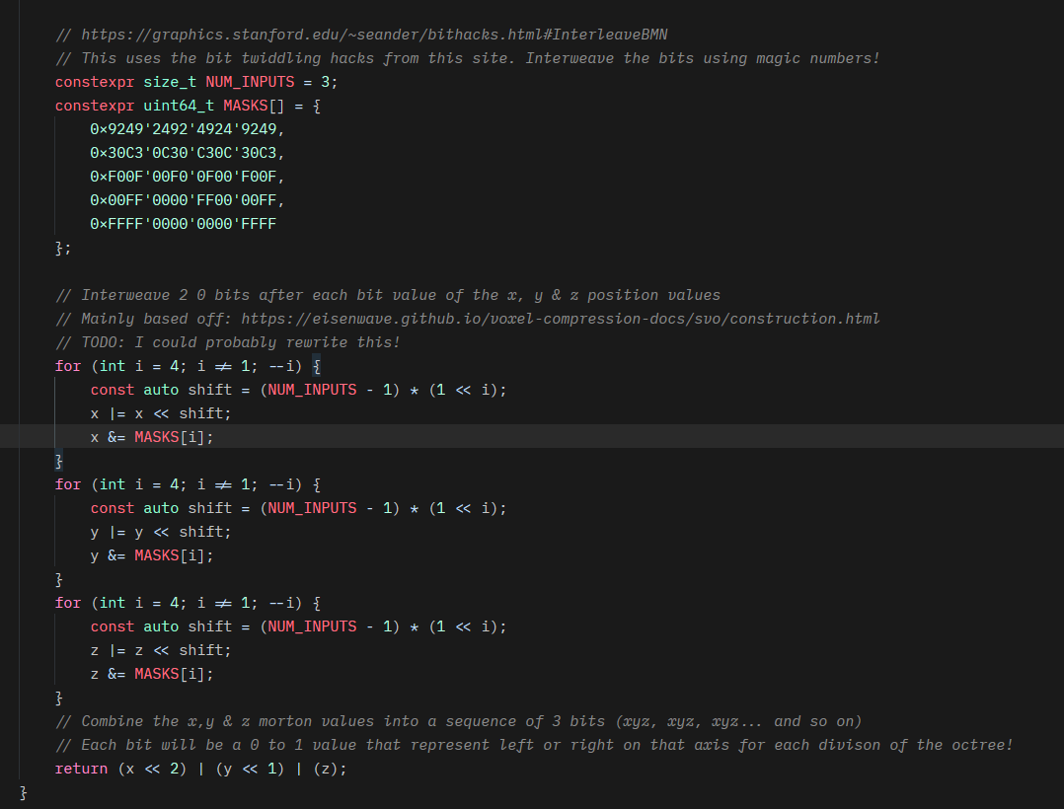
What I’m going to do now is a unit test to see what the outputs are for an 8x8x8 grid and then check for 64x64x64 and see what the Morton code values look like!
Also note going forward that I need to make sure I don’t use int but instead use very exact definitions such as int8_t or int64_t which should ensure it has the exact same number of bits across various operating systems. At least this should be enforced for the SVO data structure.
Unit Tests:
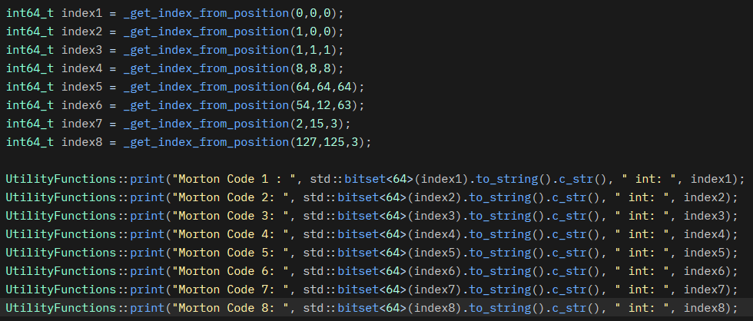
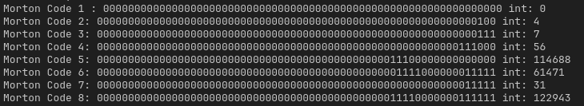

Looking closely at Wikipedias example of the binary values in a 2D grid: 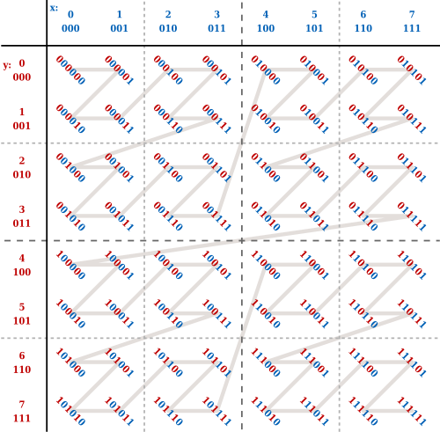
It seems to match what I was expecting… So, it seems maybe Eisenwave’s implementation did something slightly different? Or I’m reading the values wrong when outputting to the console.

Their example might be wrong:
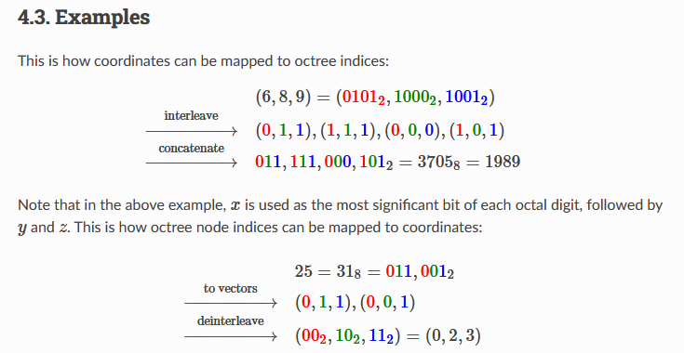
0101 is not what I expect for a value of 6, that should be 5 instead! (or if it was read the other way then it would be 10). This may be me misunderstanding their example though…
So the logic I’m expecting is:
If I have a value of 6 for x, then that means 3 possible subdivisions...
- 6 > 3 so the x bit in the first 3 bits will be 1
- 6 > 5 so the x bit in the 2nd 3 bits will be 1
- 6 < 7 so the x bit in the 3rd 3 bits will be 0
And this goes for y and z, with y looking at the 2nd bit in each group of 3 bits and z looking at the 3rd bit.
And then the integer value from each group of 3 bits will be the index (0-7) for each level of the octree.
Also:
I had another idea for how I could get the depth of a Morton Code; I could designate some bits to use at the opposite end of the Morton code to encode the number of sequences to read! (for 64 bit I believe I would need 5 bits to encode the depth from min-max).

06/11/2026
First Supervisor chat; Mentioned using LibMorton3D Library for computing the Morton codes from positions. https://github.com/Forceflow/libmorton

07/11/2026
Included LibMorton on project.
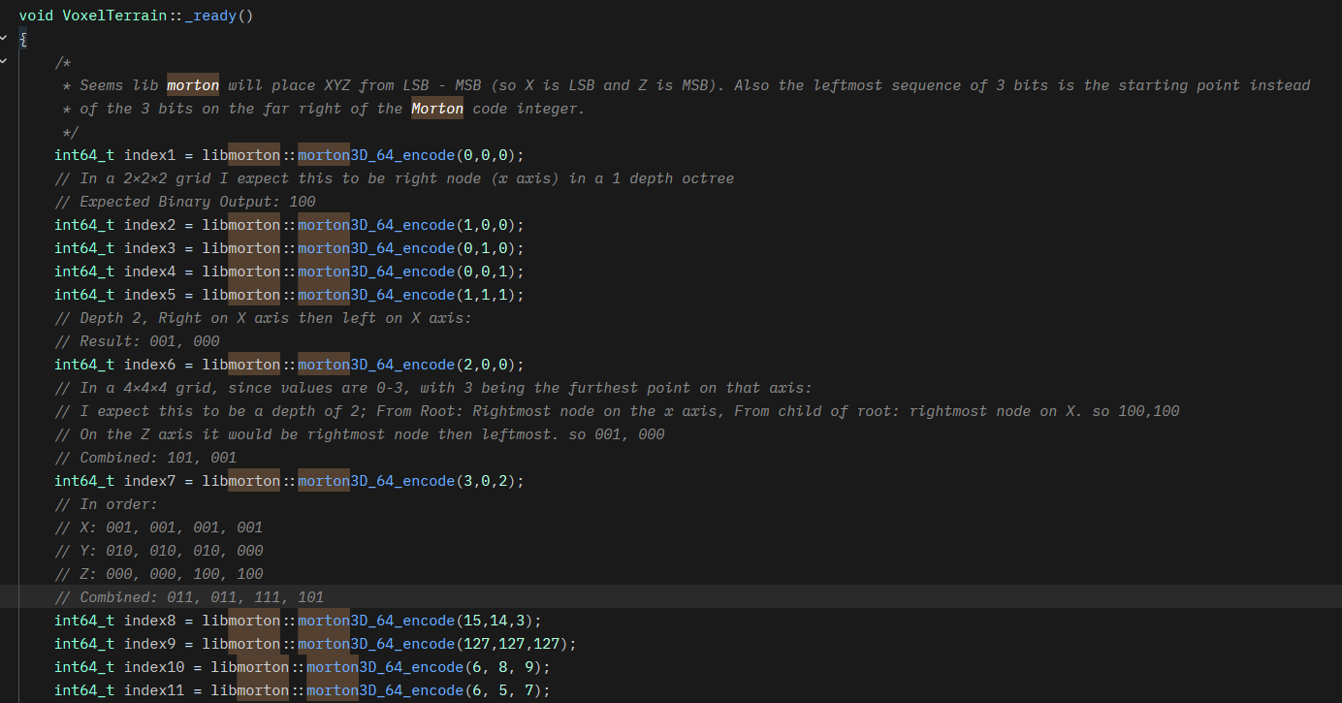
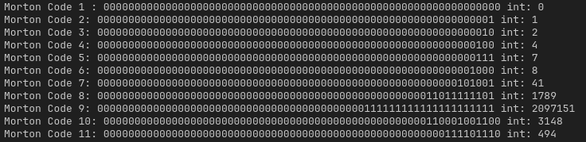
They place Z on the MSB and X on the LSB for each sequence of 3 bits. The rightmost sequence is the deepest point in the octree, and left-most is the furthest out. Depth is important so that starting point can be determined.
When determining what the expected value should be for a position when converted to morton code, think of its byte value, and append 2 0’s between each bit. E.g. 7 which is 0111 will become 000, 001, 001, 001.
Implementation of SVO find() function as well as the find and create functions:
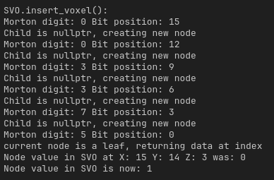
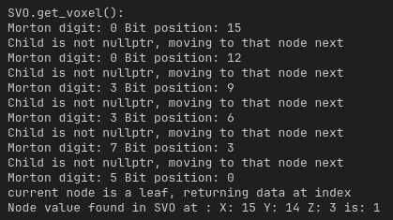
Full voxel cube, mesh and collision generation implemented for SVO.
Mesh generation and collision generation are currently the same as my voxel array based voxel cube node. Optimisations will be made later for specifically SVO, e.g. traversing the octree and only checking voxels that exist instead of looping through terrain_chunk_size x, y & z.
Current limitation is that it places leaf nodes ONLY at the deepest layer of the octree and it assumes that leaf nodes only will be at the deepest layer.
Next step is to create an optimization for the SVO so that if a branch node has only leaf nodes or nullptr nodes, and the leaf nodes have all the same data, then that branch node converts to a leaf node.
However, I’m not actually sure if that will be optimal or not, and it would mean I would need to edit the find functions logic to possibly something with more overhead. I fear I might need dynamic casts or need to add more data via the base Node struct to determine whether it is a leaf or not when traversing.
Current speeds for a 64x64x64 voxel grid solid cube:
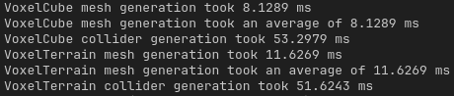
This shows that with the current implementation of the SVO it is a bit slower than the voxel array for a fully solid object. If the grid was sparser the benefits of SVO may start to appear, in terms of memory and speed due to not iterating empty voxels. However, if the SVO was optimized so that groups of identical voxels combine into leaf nodes that represent the entire structure, then in theory this should be much faster.

08/11/2026
Setup the raycast remove_voxel logic for voxel terrain.
Voxel terrain now generates with Noise, using Godot’s built-in FastNoiseLite class. Added ImGui & Editor controls for adjusting the threshold values that voxels spawn from the noise output as well as for noise generator settings.
Also implemented a function to calculate the total number of bytes of memory used by the SVO;
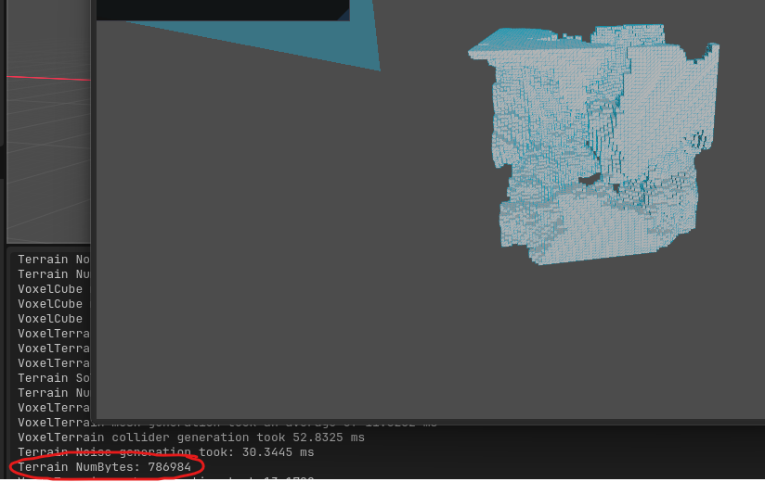
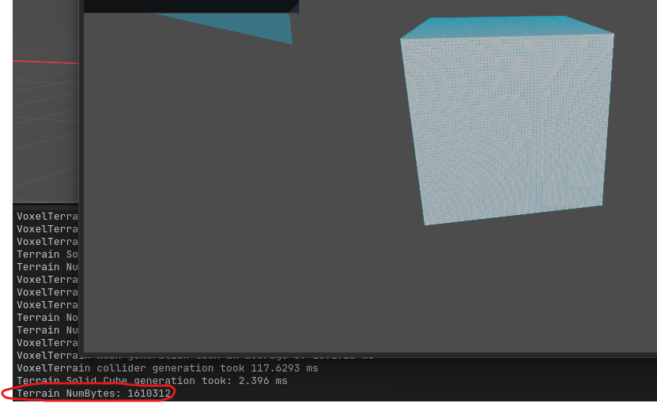
Differences in memory usage shown. And compared to a simple voxel array of the same size:
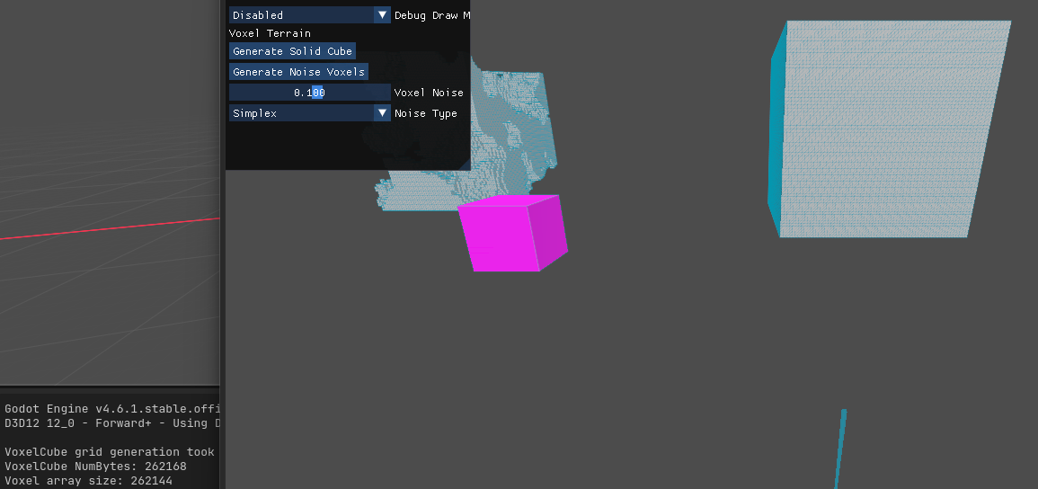
Since the octree is not storing less in memory as expected, there is likely a huge flaw with my implementation currently (Or maybe I’ve messed up the computation of the memory usage).
After looking further into it, something I did previously as a possible performance boost was increase the size of the leaf data to closer match the size of branches, but this didn’t have any noticeable benefit and massively increased the memory usage.
After making the data type match the array the memory usage in the same size of voxel grid is now:
(Also fixed an error with my memory reading function for the SVO)
At the very least for extremely sparse terrain there can be significant improvements in memory cost as the empty voxels are not included:
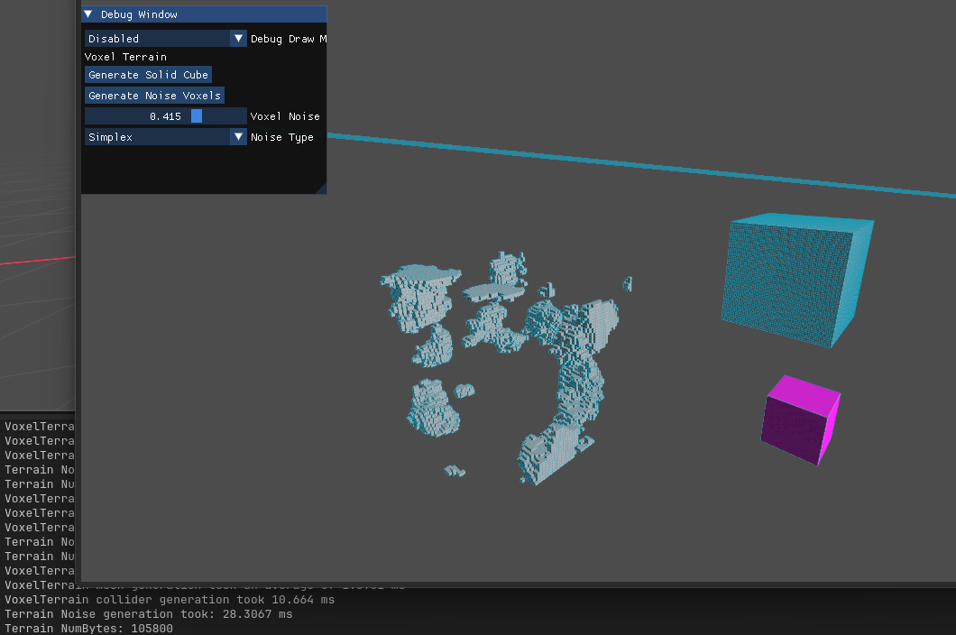
If the octree is later optimized to combine voxels then it could reap huge performance and memory benefits.

09/11/2026
Not working on honours project today, but had a couple ideas for when I next work on it:
- Instead of Node having a virtual destructor for polymorphism, instead just have a Boolean for whether it is a leaf node. Means I can static cast without the potential larger overhead of dynamic casting! This also would allow optimisations of the SVO during insertion and removal or even as a post optimisation step
- Try using Morton code for the voxel cube nodes indexing as well, it might have a large performance boost due to the memory locality. Currently due to the way I’ve setup the SVO I don’t think I’ll be getting the benefits of memory locality.

11/11/2026
Before and after for modifying the SVO to use a ‘is_leaf’ bool
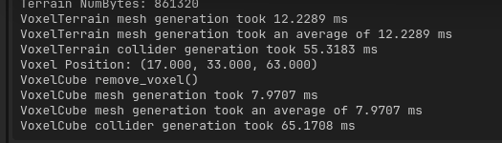
After:
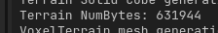
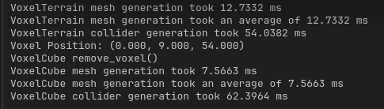
. No significant change. This should hopefully let me then apply optimisations.

I’ve implemented checks in the traversal for whether the current node is a leaf node before reaching maximum depth. There is handling for then subdividing if the new voxel data does not match the leaf node, in which it replaces the node with a Branch instead and the children are all created as leaf nodes. The traversal function then traverses to the child node index in the new branch which was created as a leaf node. The traversal function will subdivide these leaf nodes until it reaches the maximum depth.
Currently this will just inherently be slower than the implementation of the SVO before, and by a long shot. As this handling is for post-optimisation insertion. I need to implement handling for optimising the octree during insertion so that if the branch that a leaf node belongs to has matching data, then it combines (reverse of subdivision).
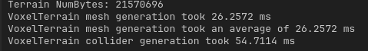
Note how in a solid cube the byte size has massively increased. I believe this will be because of the addition of a new layer; converting leaf nodes into single voxels instead of an array of 8 voxels. I did this to make optimisation easier, not sure how plausible it is to do it otherwise, possibly something to investigate in the future. I’m hoping the memory benefits of the SVO will come from the optimisation of combining nodes.

Realised mistake with my algorithm, I was checking the wrong depth for where to add new nodes (I think this would’ve been creating an extra layer!)
For a solid cube it is now:
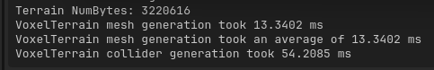
The terrain has speed benefits in the new implementation with this configuration:
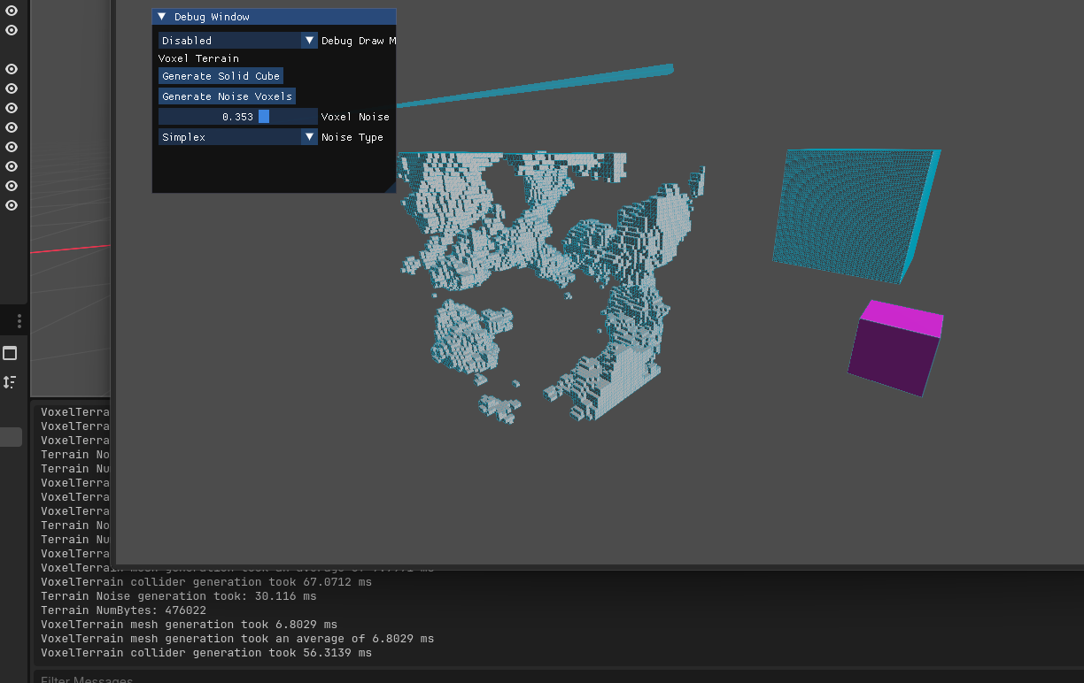
In terms of memory, it is worse currently.

Huge improvement!
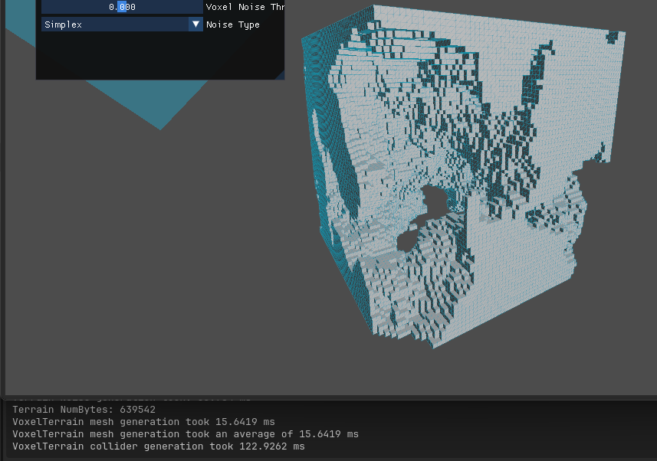
So, the max bytes now for the 64x64x64 terrain is 640,000 when at a voxel noise threshold of 0 (so 50% voxels generated from the noise more-or-less)! This is compared to the 262,000 of the Voxel Cube of the same size.
This is also only when optimising the final layer, hopefully by optimising more layers we can see large performance and memory benefits!
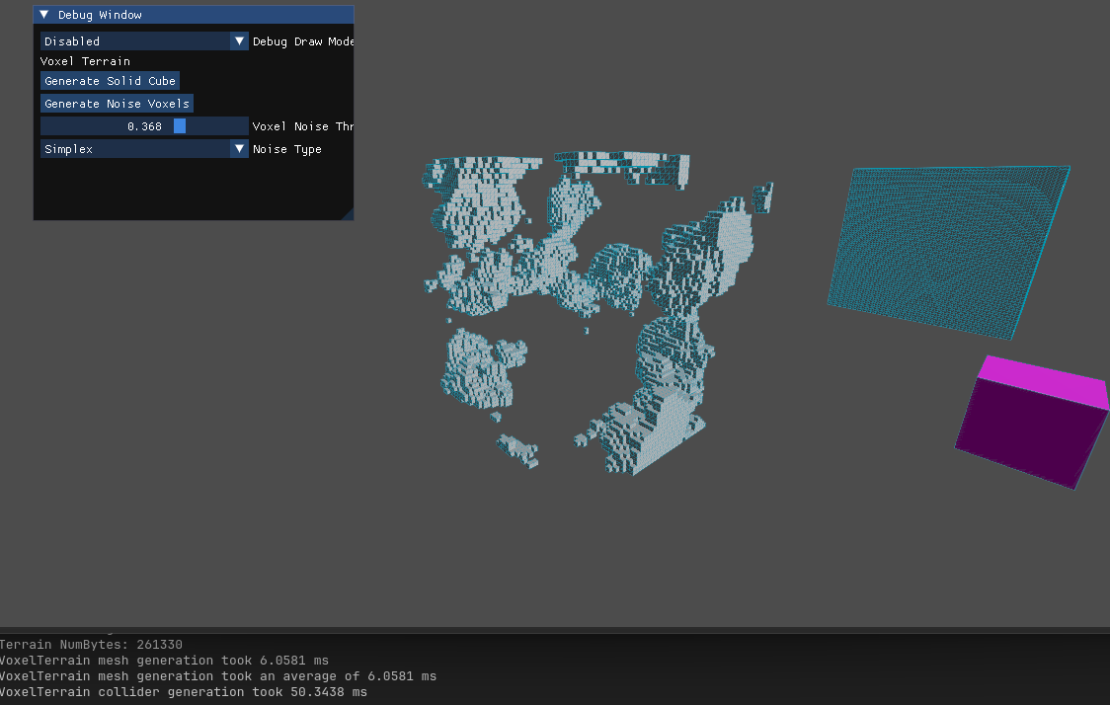
At 0.368 noise threshold, the octree terrain starts to become smaller in memory than the voxel cube.
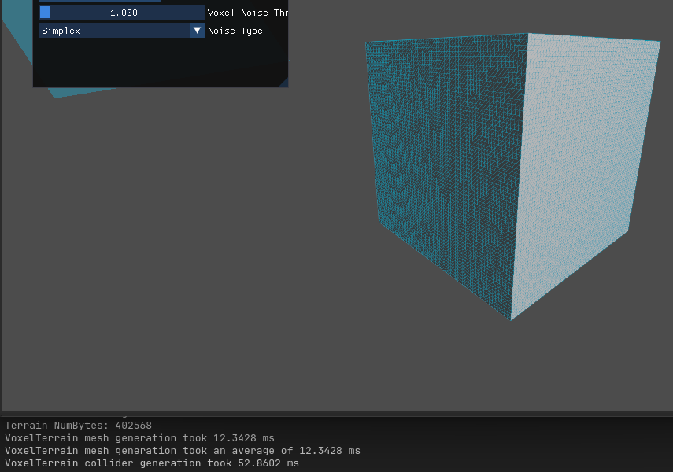
When generating a solid cube, the Octree is 1.5x the size in memory.
Implementation before using same noise threshold (0.1):
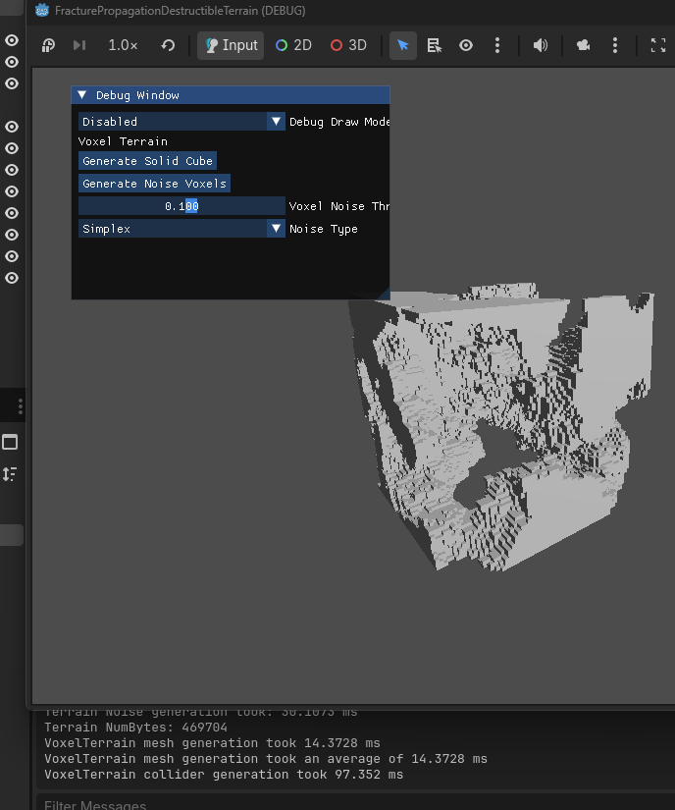
Implementation After:
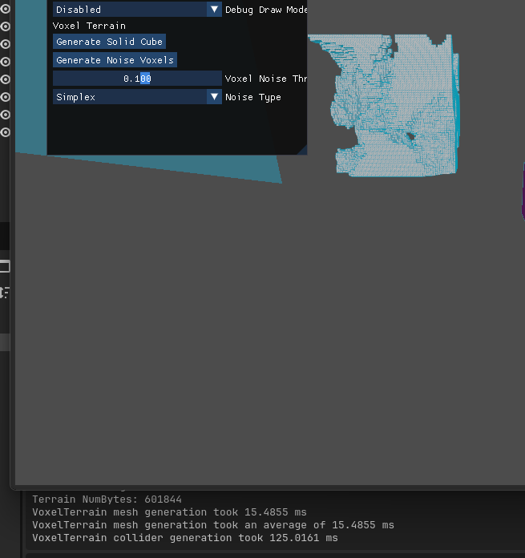

And before and after for 0.375 noise:
Before:
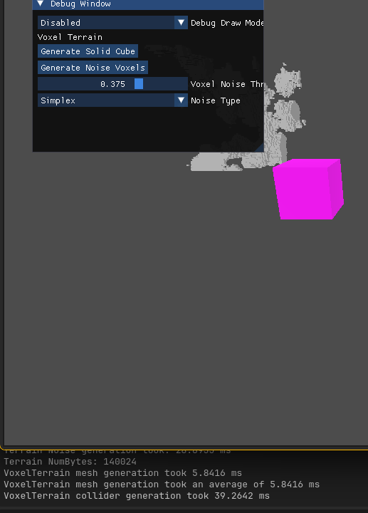
After:
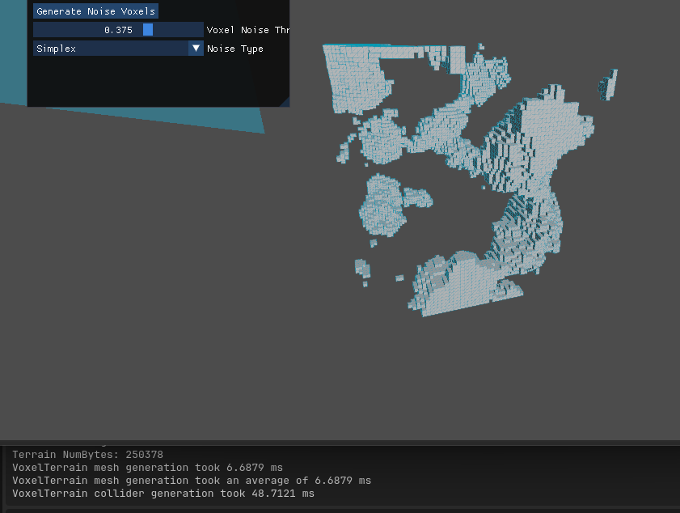

Overall, it is worse. Need to further optimise the layers before I can definitively say this will not work.

Current pseudocode for how I would handle / extend the current combination logic:
At final depth:
If each child is identical (excluding the new node) and has same value as the inserted voxel:
Convert the branch node (current node) into leaf with data = voxel
Run same check for the leaf nodes parent recursively (ISSUE: This requires each node knowing its own parent!)
Currently going to shelf this idea and place it onto a new branch, instead focussing on the connect component logic.
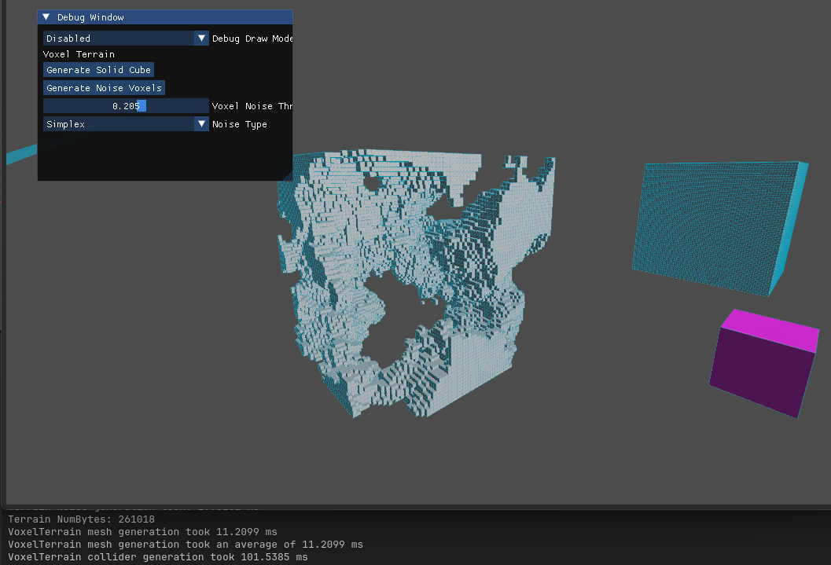

Experiment:
I used Morton codes for the voxel cube to see if I could get a performance boost, but it evidently was slower.
Using Morton codes:
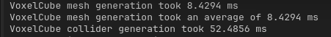
Without:
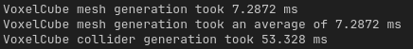

12/11/2026
First Honours Project Group Meeting today.
Programming tasks done:
- Major tidy up of the codebase, fixed naming convention and formatting across all C++ and GDScript files.
- Refactored the folder structure, ‘src’ and ‘project’ folders were named to a more descriptive ‘gdextension-source’ and ‘godot-project’. Additionally, LibMorton has been moved into an ‘external’ folder that libraries will be placed in from now on. Any documentation now will be placed in a ‘docs’ folder as well, such as my TODO list and this dev journal.
- Created an Abstract class ‘VoxelNode’ that my VoxelCube & VoxelTerrain inherit from. Any repeating functions and methods between the classes will be defined in VoxelNode instead. This will make future Voxel nodes easier to make. Notably it is to only be used via multi-inheritance. I did not want the VoxelNode to lock any derived classes to a particular Godot node, so I made it a pure C++ class to avoid the Diamond inheritance problem. To handle the boilerplate Godot method & property binding, I created a Macro for binding any VoxelNode methods & properties that should be accessible by Godot. I had to cast the methods to the derived class definition as C++ seemed to compile the methods as part of the base VoxelNode class which Godot’s binding functions did not accept.
- As part of the VoxelNode class, Mesh and Collision shape nodes are now automatically generated in the code instead of requiring placement through the editor. Albeit the collision node is not used yet due to Godot’s trimesh collider generation creating a new node anyway.

