CS – 340 README

Name Gerardo Gonzalez

SNHU CS 340 Client Server Development

Date 12/10/2023

Term 23EW2

**Purpose.**

The purpose of this project is to illustrate the usage of the dash framework and utilizing Python and associated Python libraries along with the CRUD operation that was used with MongoDB. The functionality here is to create a dashboard for a client whose organizational goals are to train rescue animals. Here we take a shelter database which is based in Austin Texas. We take the data from this shelter to find animals that meet the criteria for training for different rescue operations.

The motivation for this is to learn how to use databases to learn skills to develop and operate NoSQL databases such as MongoDB to make flexible and scalable applications. After this project, you should have a basic understanding of how to use databases and how to manage the information in the base this includes creating a database, managing the data that goes into the database, and also knowing best practices with CRUD operations. Along with learning about the dash framework.

**Getting Started.**

To get started we will start by installing MongoDB you can do this by accessing their website.

**Installation**.

**MongoDB**

After downloading MongoDB you can use MongoDB for your operating system of choice you can use the “Community Server” which is free to use. In my case, this step has already been done.

**Python**

Next, you can install Python 3 which has also been installed, and other tools such as pandas and the dash framework.

**Jupyter**

Jupyter notebooks were also used.

**Usage**.

The following libraries were used in this project these include Jupyter, Dash, Pandas, and Dash.

An example of all the imports from this project is shown here.

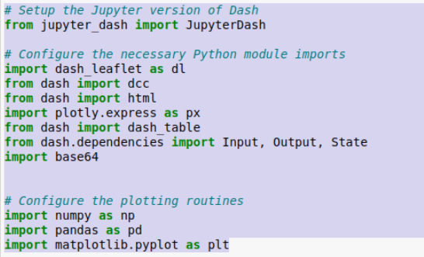

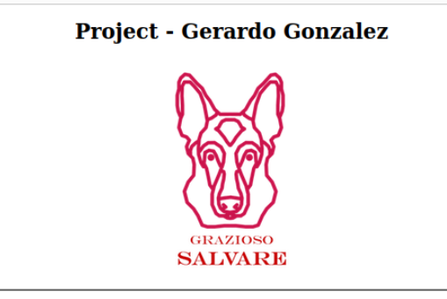With this project, the dashboard shows the client's Name along with a unique identifier from the developer in this case that is me.

Next, the user will be able to view the whole database upon the initial start.

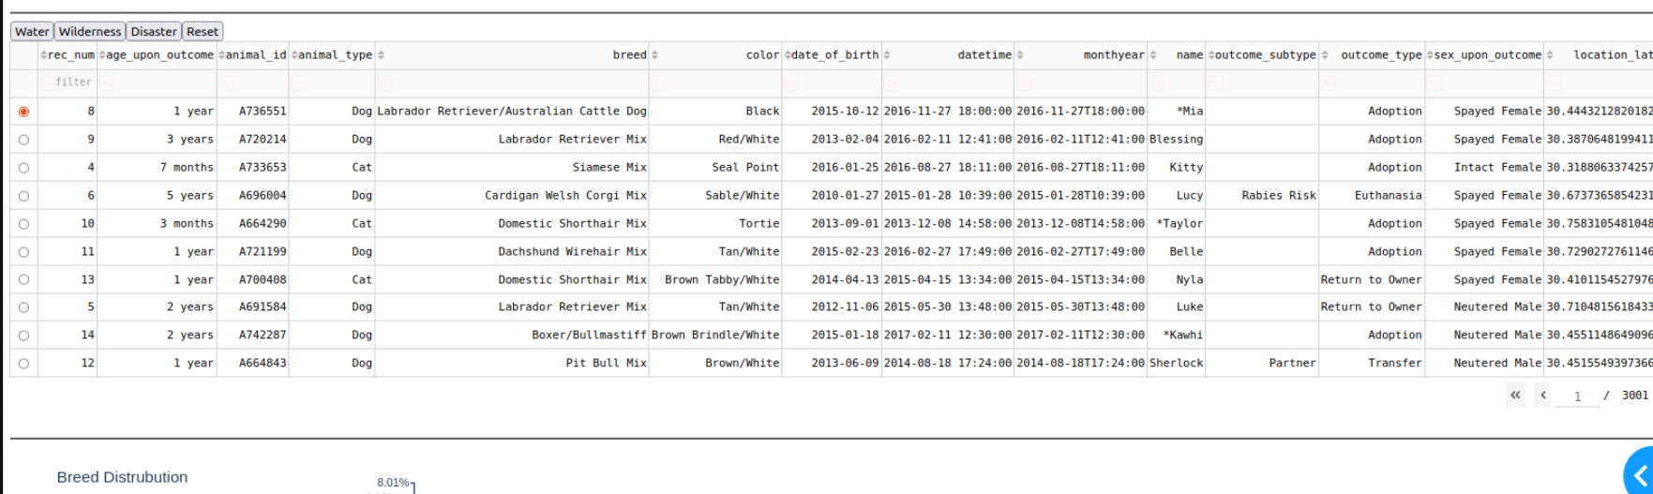

The user will also be able to filter the result with developer filter shortcuts.

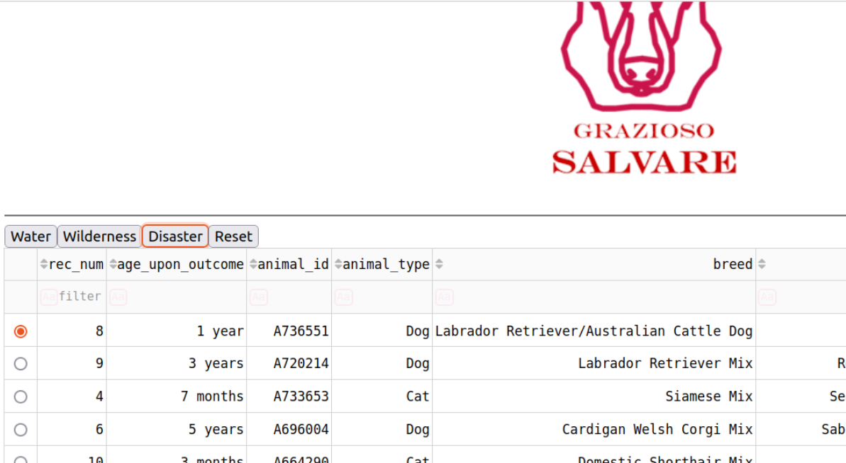

Once selected a filter the data table will update accordingly based on what the client is looking for. In this case, the client is looking for breeds of dogs that meet ideal training criteria such as age, sex, and condition. An updated table of this is shown below after selecting the disaster filter.

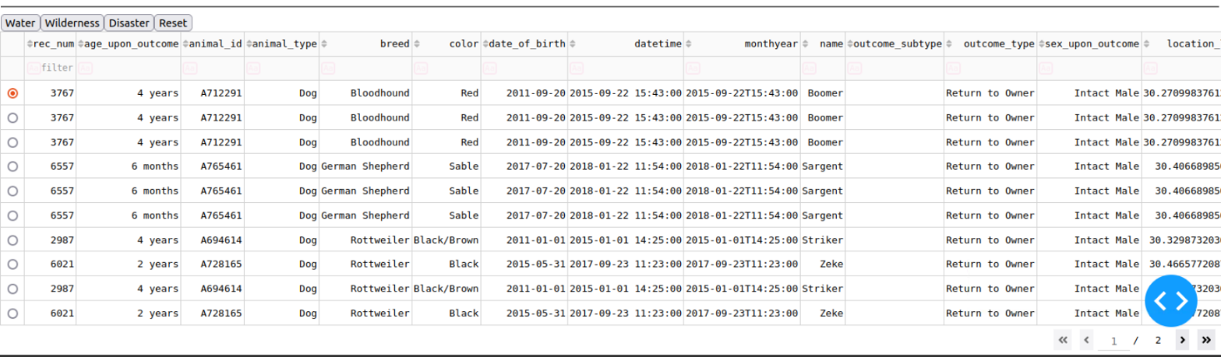

Finally, we have two widgets at the bottom of the page that show the location and the percentage of breeds of dogs that are available in that location, in this case, it shows the percentage of breeds of dogs that make up all the available dogs in Austin TX.

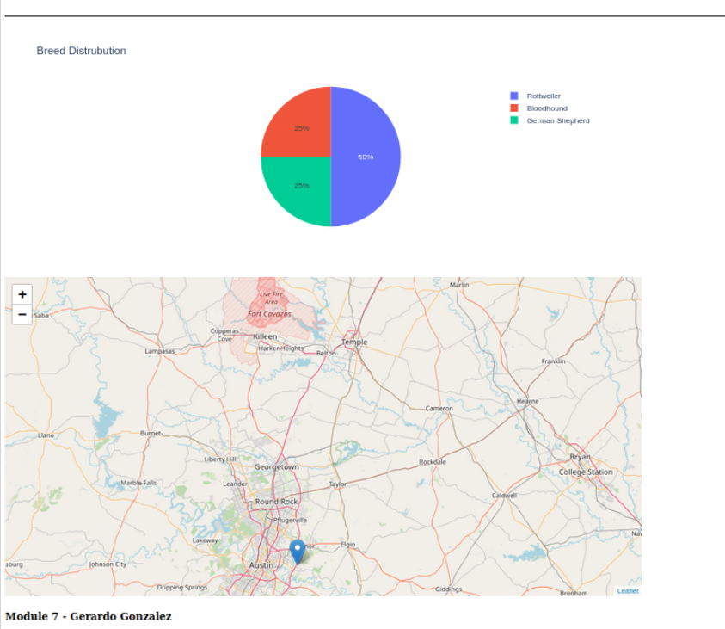

**Functionality**

**MongoDB**

MongoDB was selected for its flexible data storage structure this lets us create a database where each animal can have sub-data criteria, this because useful as it creates more scalable databases in which animals can be categorized accordingly along with having subcategories such as breeds of dogs, and whether that breed of dog is neutered or not. This Database also works with Python which is a language that is one of the more popular programming languages for data manipulation of databases.

**Dash Framework**

The Dash framework is used for its accessibility for data retriable along with creating data visuals such as the chart shown in the usage portion of this project by using tools such as Plotly ecosystems.

Here are some resources used in this project if you get stuck or need more information for a project of your own.

**Resource**

[PyMongo 4.6.1 documentation](https://pymongo.readthedocs.io/en/stable/)

[MongoDB Documentation](https://www.mongodb.com/docs/)

[Dash Documentation & User Guide | Plotly](https://dash.plotly.com/)

**Road Map.**

**Challenges**

One challenge I encountered was understanding and using Jupyter Notebooks and the Dash framework with the time frame given I plan on reading and experimenting later on to develop and improve this project. More specifically I plan on solving an issue I had to develop the filter Button which will need to be changed with check marks or checklists, this way the user can see what filter is being applied.

Another challenge I faced was using the widgets for the data visualization and plan to explore different ways to display data.

I overcame the time constraint by using previously used code from a previous milestone and modifying the code to meet the criteria in the time frame I had.   
  
**Contact.**

Email gerardo.gonzalez3@snhu.edu

**Screenshots**

