**Winning Lottery Ticket Binary Search**

**Guadalupe Gonzalez**

# Design Approach

Using professor’s code, I just modified main(). I printed out the winning tickets unsorted and sorted to see that the requirements for the assignment were met, and also to pick one of the tickets so I can see if it prints out the congratulations comment.

# Screen Shots

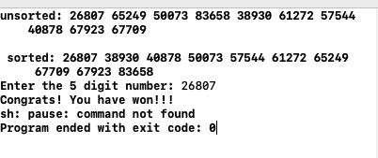

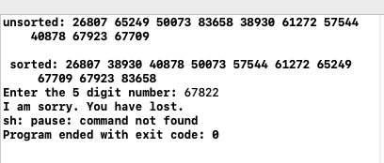

# Source Code

#include <iostream>

#include <string>

#include <vector>

#include<ctime>

**using** **namespace** std;

//from professor's notes

**void** swap(**int** &a, **int** &b)

{

**int** temp = a;

a = b;

b = temp;

}

**int** binarySearch(**int** numbers[], **int** size, **int** key)

{

**int** min = 0;

**int** max = size - 1;

**while** (min <= max)

{

**int** mid = (min + max) / 2;

**if** (numbers[mid] == key)

**return** mid;

**else** **if** (numbers[mid] > key)

max = mid - 1;

**else**

min = mid + 1;

}

**return** -1;

}

**void** bubblesort(**int** numbers[], **int** size)

{

**for** (**int** pass = 0; pass < size - 1; pass++)

{

**for** (**int** i = 0; i < size - 1; i++)

{

**if** (numbers[i] > numbers[i + 1])

swap(numbers[i], numbers[i + 1]);

}

}

}

**void** generateData(**int** numbers[], **int** size)

{

//srand(time(0)); // "seed the random number generator"

**for** (**int** i=0;i<10;i++)

{

numbers[i] = 10000 + rand () % 90000;

}

}

**void** display(**int** numbers[], **int** size)

{

**for** (**int** i = 0; i < size; i++)

cout << numbers[i] << " ";

cout << endl;

}

**int** main() {

**const** **int** array_SIZE=10;

**int** tickets[array_SIZE];

**int** winning_ticket;

generateData(tickets, array_SIZE);

cout<<"unsorted: ";

display(tickets, array_SIZE);

//sorted

bubblesort(tickets, array_SIZE);

cout<<"\n sorted: ";

display(tickets, array_SIZE);

//prompting user

cout<<"Enter the 5 digit number: ";

cin>>winning_ticket;

**int** index=binarySearch(tickets, array_SIZE, winning_ticket);

**if** (index == -1)

cout << "I am sorry. You have lost. " << endl;

**else**

cout << "Congrats! You have won!!!"<<endl;

system("pause");

}