Hapi

Mostafa Farrag

2. Installation 3

2.1. Create an Environment 3

2.2. Install Required packages 4

1.1.1. Numpy 4

1.1.2. Pandas 5

1.1.3. Scipy 6

1.1.4. Gdal 7

1.1.5. Shapely 10

1.1.6. Geopandas 10

1.1.7. Fiona 12

1.1.8. Pyopt 13

1. Heading 1. 14

1.1. Heading 2 14

List of Figures

List of Tables

# Installation

## Create an Environment

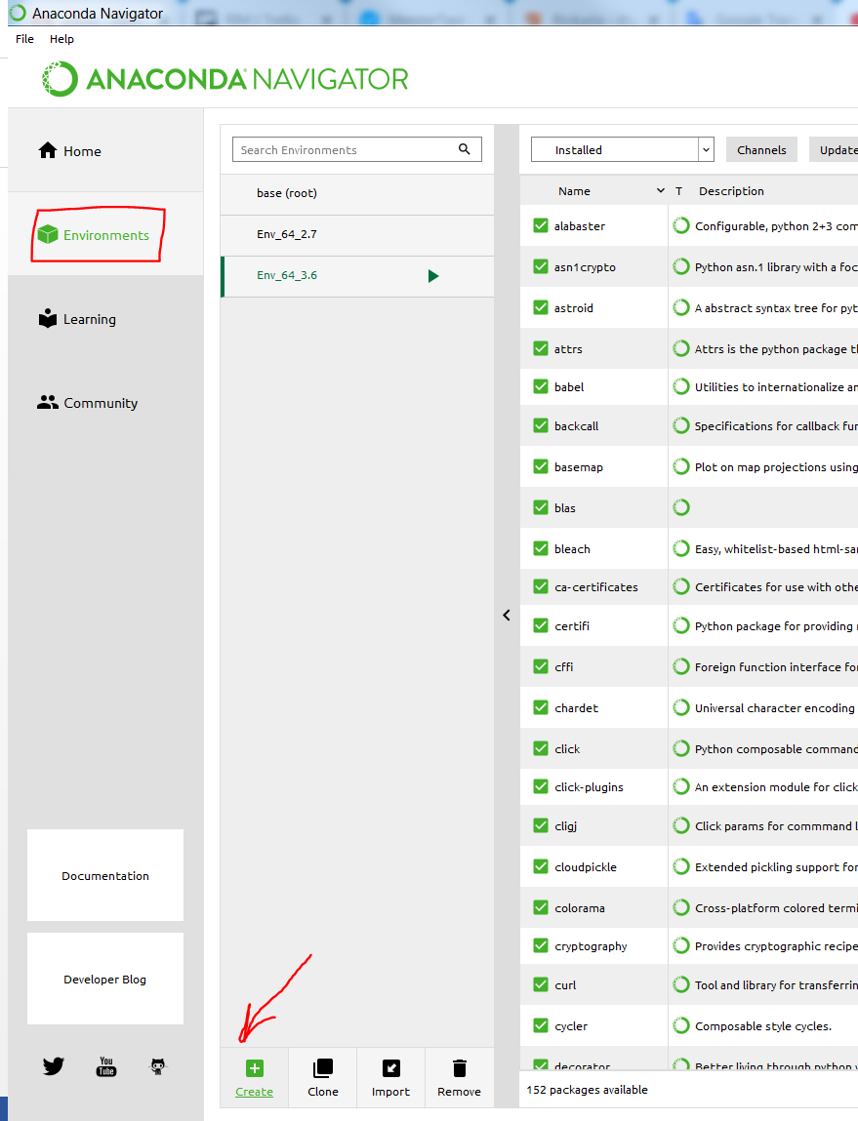

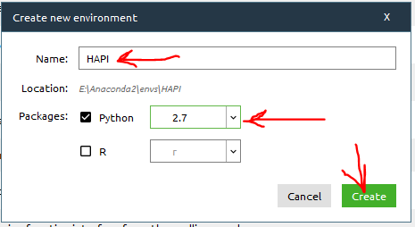

## Install Required packages

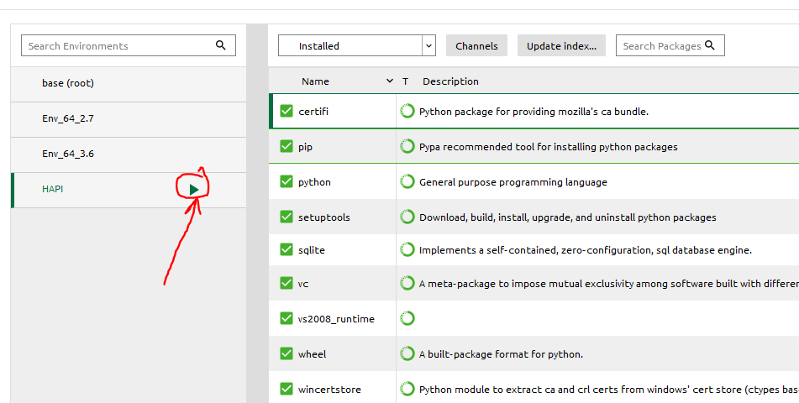

### Numpy

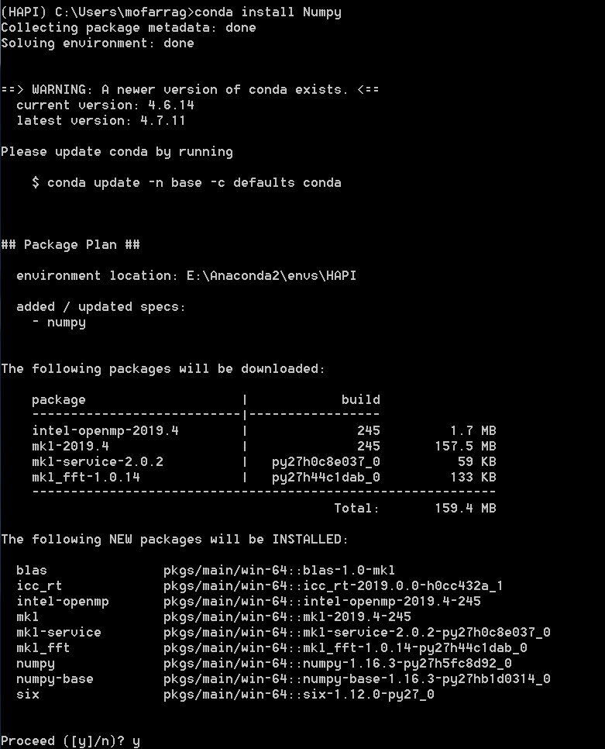

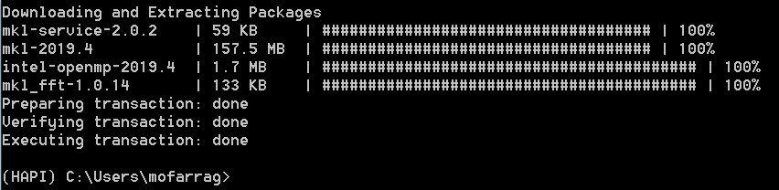

### Pandas

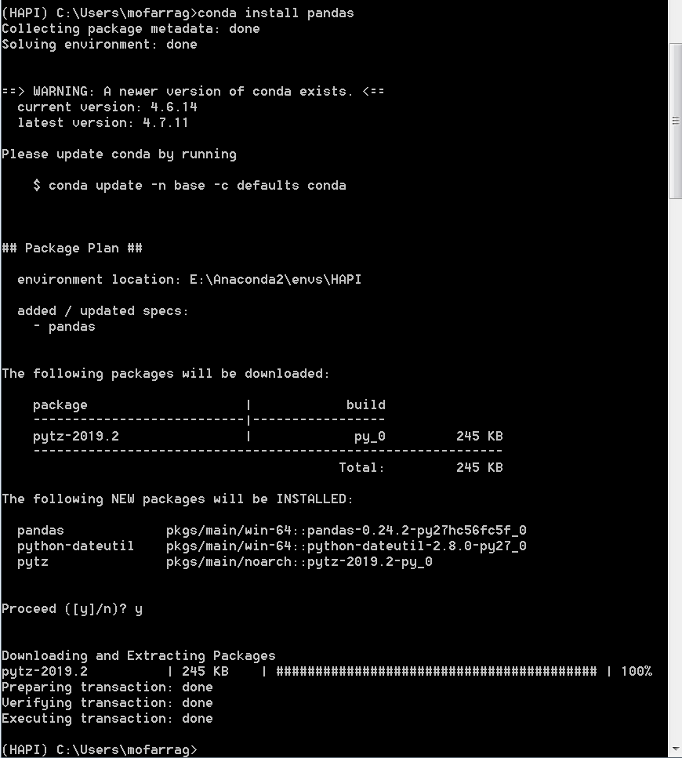

### Scipy

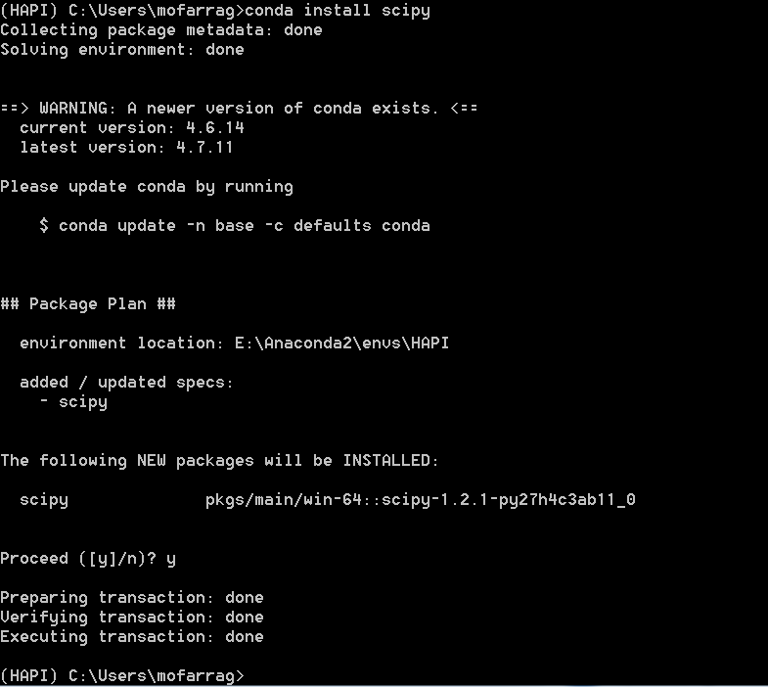

### Gdal

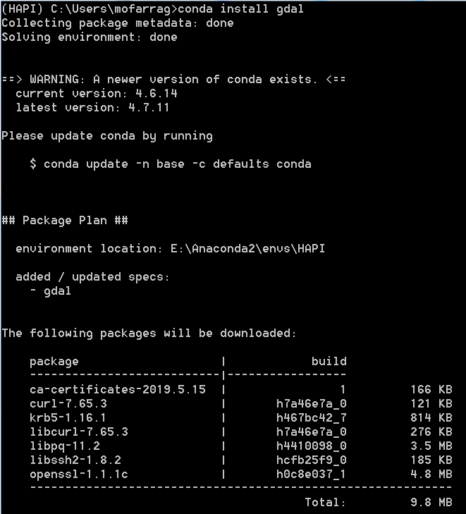

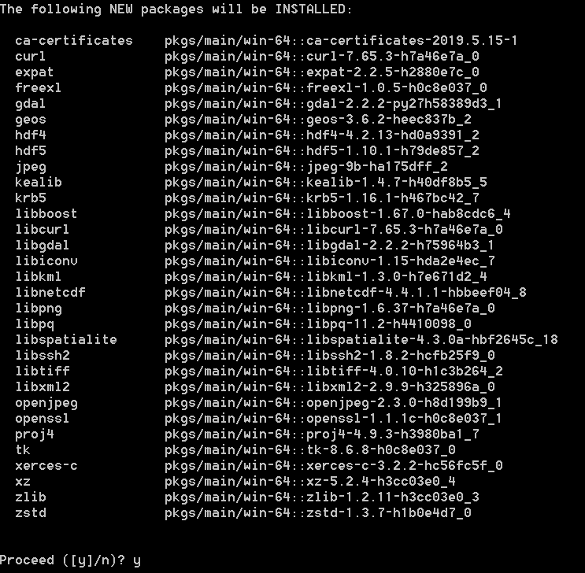

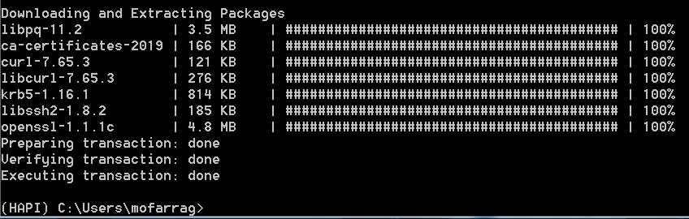

### Shapely

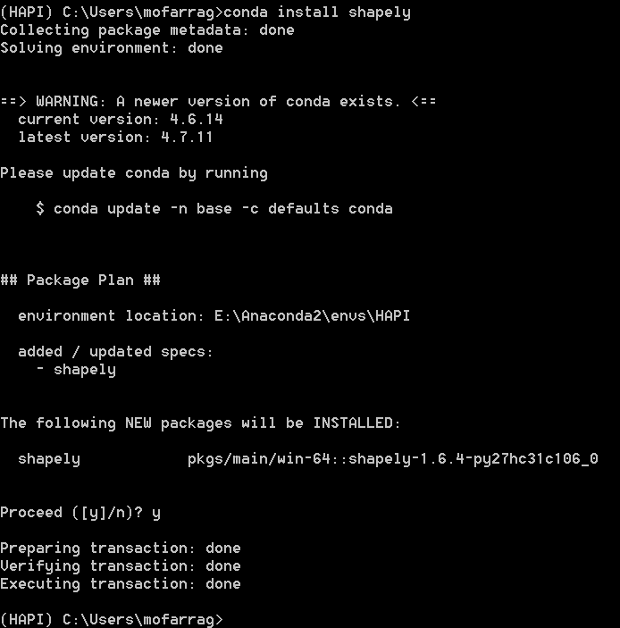

### Geopandas

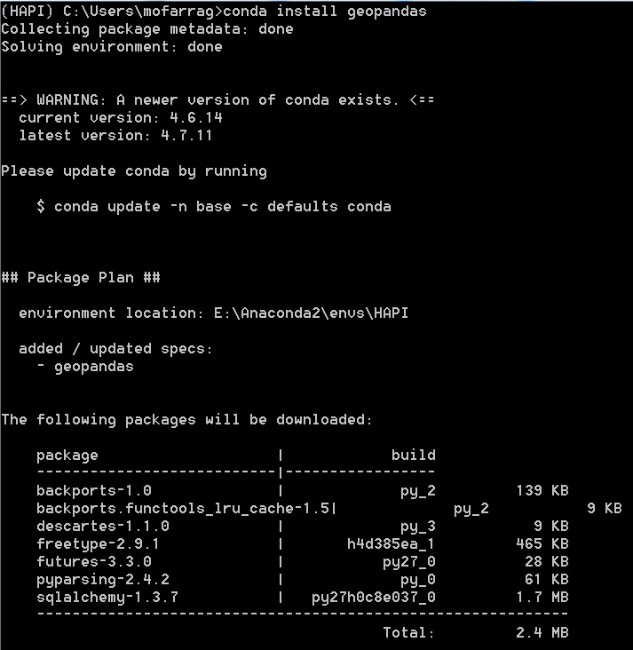

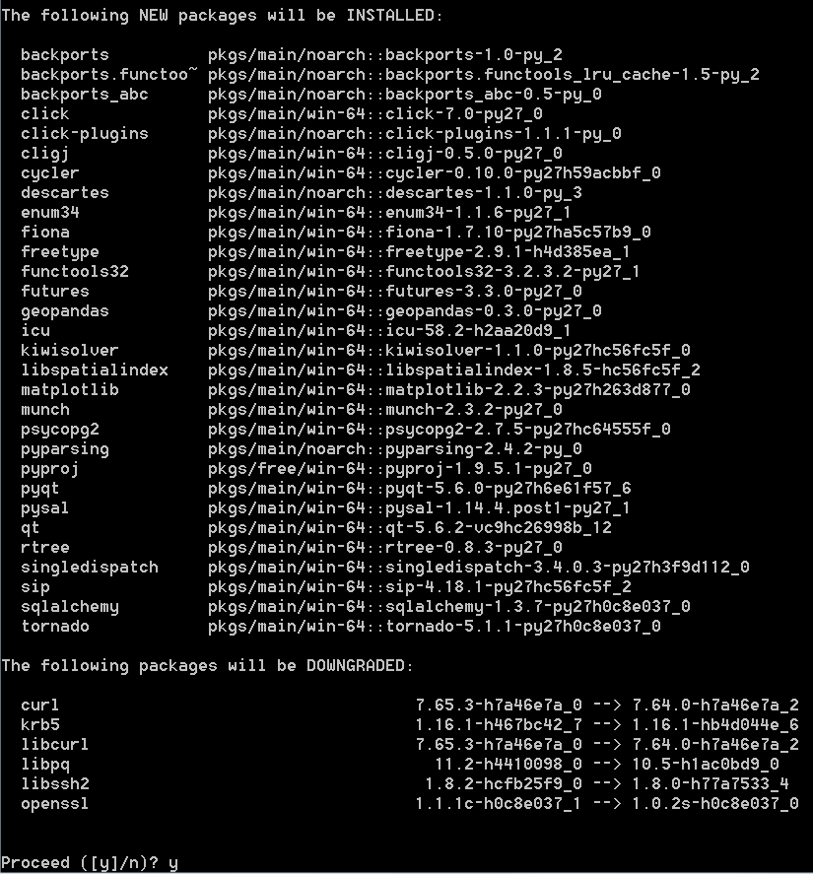

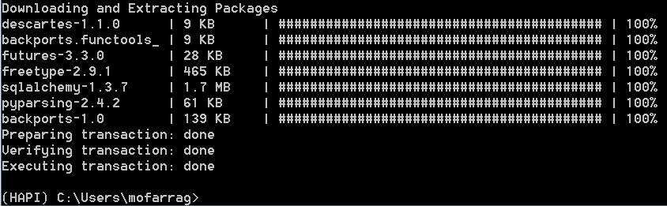

### Fiona

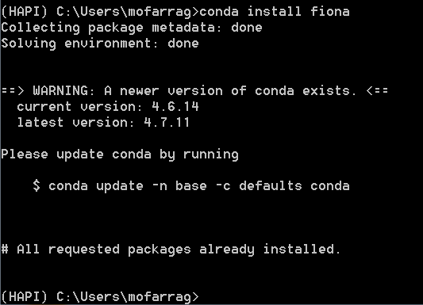

### Pyopt

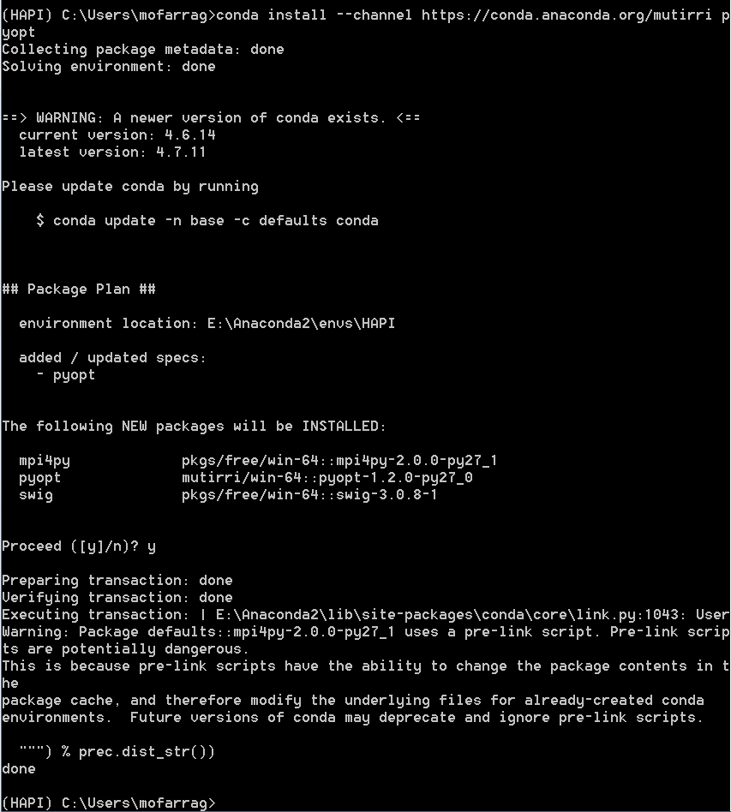

## Installing Hapi

### Getting the path to your Python

First get the path to your environment then inside the folder of the emvironment you will find “python.exe”

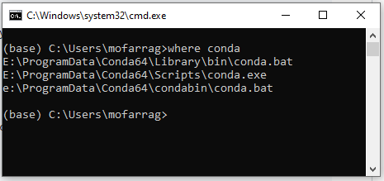

Then open command prompt and change the directory to the folder where you cloned Hapi Library

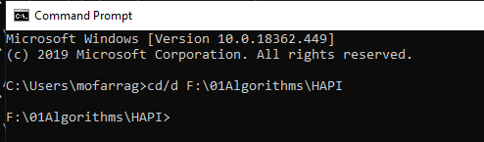

Then type

Path where python exist\python setup.py install



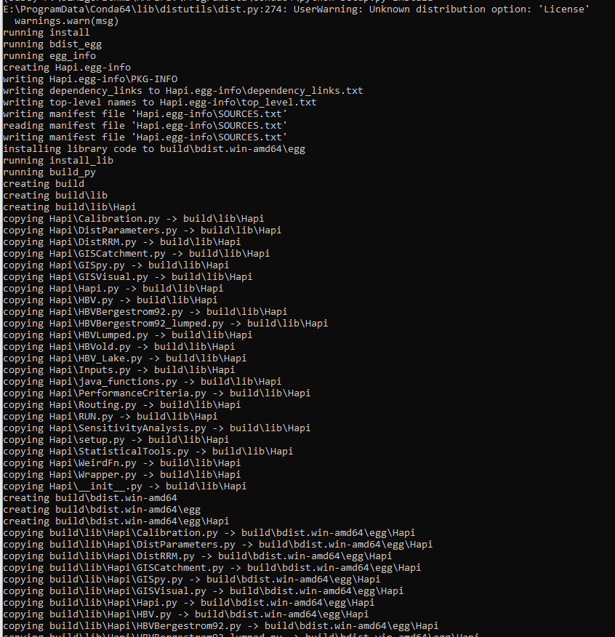

### For Python2.7

The compiled files will appear inside the library folder in the site-packages path inside the environment



### For Python 3.7

Still error

Heading 1.

Heading 1 text

* Python is a high-level programming language

## Heading 2

Heading 2 text

* + 1. Heading 3

Heading 3 text

Heading 3 text

#### Heading 4

Heading 4 text

* Heading 4 text

##### Heading 5

Heading 5 text

code or higthlighted equation