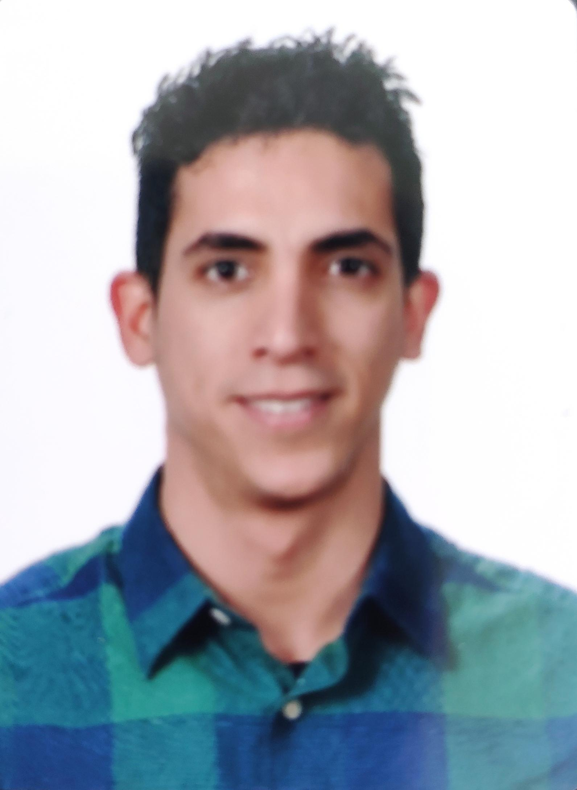
Gonzalo Pabón Flores
zalo.pabon@gmail.com |www.zalospace.com| github.com/GonzaloGPF
+34695437869

I am a Fullstack developer very specialized in Laravel and VueJS.

I have carried out numerous projects from scratch, addressing all phases of software development, from requirements gathering and technical analysis, through programming to server configuration and project and team management systems.

I am passionate about Laravel and its ecosystem, an active member of Laracast for more than 8 years. I keep myself constantly updated for each new that arises in the community, through different developments, both personal and professional.

I strive to program following good practices and respecting methodologies, design patterns, TDD, and rigorous technical analysis to ensure optimal implementation.

Job Experience

Senior Front End with Vue 3 (+2 years - current job) - Bauer Media Group
We built a new system from scratch with TypeScript using Vue 3 and NuxtJs.
I am part of a multidisciplinary group where we migrated an old system based on PHP and Angular to a much more complex and modern one with current technologies.
We used many different technologies, where the main stack is Node and VueJS.
All projects are Dockerized and structured in microservices.
My role was that of FrontEnd developer and TechLead.
As a developer, my main role was to optimize processes and refactor developments by versions as simple and maintainable as possible.
As TechLead, I contributed to task planning and project structuring.

FullStack Leader (SPA) with Laravel and VueJS (4 years) - Mobius Group
Migration from an old PHP system to a new modern and optimal application based on Laravel and VueJS.
Using a TDD methodology (+ 2200 tests), I played a role as Analyst, DevOps and FullStack developer to assemble everything necessary in the creation of the new system.
Following good practices and in tune with the Laravel and Laracast community, the development always maintained a strict and academic technical level, respecting all the standards of the different technologies involved in order to guarantee good optimization and the maximum possible scalability.

The development consisted of the creation of an internal ERP, indeed to manage all the resources of all the departments involved in the main business process of the company (Operations, Billing, Administration and Systems), deployed in AWS environments.
It was always kept updated with the latest versions of all the technologies used (both language and external integrations) and was constantly refactoring and improving.
At the development team level, a homogeneous stack was maintained among developers through Homestead and PhpStorm. The task management was carried out with Jira and the Continuous Integration carried out with Laravel Forge and Bitbucket allowed automatic and secure deployments, both in Development and Production, transparent to developers.

Tech Stack
- PHP 8 Language
- MySQL Database
- Front development with VueJS
- Laravel Sanctum for authentication
- ElementUI and Tailwind for UX
- Laravel Mix as the asset compiler
- Sass styling
- Code control with Linters PHP-CS, Eslint and StyleLint
- Testing Backend with Phpunit
- Testing Front with Laravel Dusk
- WebSockets with Laravel WebSockets
- Queue system with Laravel Horizon y Redis
- Continuous Integrations with Bitbucket Pipelines
- Deployment System with Laravel Forge
- API docs generations with Laravel Scribe

FullStack developer with Laravel and AngularJS (4 months) - Evalua
FullStack development using Laravel and MySQL together with AngularJS.
Maintaining a continuously growing application for insurance companies.
The development separates the front-end application in AngularJS from the back-end in Laravel in different projects.

The front Application is in AngularJS 1.5.8 and uses Angular Material for styling and layout of the entire visual aspect.
Laravel 5.3 is used for the backend and it consists of exposing an API. It generates PDF's, invoices, documents, images, etc. that consume both the web application and mobile applications.
Automatic unit and integration tests, documentation generation and Git version control are also developed. All integrated with BitBucket and Jira.

PHP Developer with Drupal 7 - (2 months) - Boream
I worked as a php developer at Boream, maintaining and developing new functionalities for a web application for the CSIC. It was an application inherited from Indra, with a very poor performance and a very poorly structured development. Correction of errors, testing, proposals for improvement, etc.

Junior Consultant (12 months, 2016) - Indra Sistemas
One-year contract at Indra. Autonomous development of complete and customized web applications. Back-end using Laravel with PHP and MySQL. Front-End using the Blade and VueJS template engine. Design of MySQL DB and API Rest. Protection of access to specific sections of the application (login and user registration).
Projects composed and managed by Composer, NPM and Bower. Construction using Gulp and Webpack (Sass compilation, minification, etc). Using virtual environments with Vagrant.
Git and SVN version control systems. In conjunction with JIRA. Deployment on Linux servers (CentOS)

Some projects developed:
- Bankia Layout: I joined a front team to do the layout of a user registration process. We use gulp, npm, and sass. Responsive designs with browser and accessibility requirements.
- BBVA Web Application: Fullstack autonomous development for internal projects. Using Laravel, I made a small application consisting of representing through interactive graphics with HighChart, information from Excel documents. I did the documentation and deployments in development and production servers.
- Real Madrid Web Application: Fullstack autonomous development for Real Madrid Commitment Members. Application developed in Laravel and VueJS. The application consisted of creating views for PCs and mobiles where the results of the votes that were being carried out in the Real Madrid Assemblies were represented in real time, through graphics. I also did the setup and deployment of the application on my own servers.
- ELAL application: Front development in a Senior team using Angular 2. The development consisted of creating the entire ELAL Booking Engine (airline company) to allow users to make flight reservations. We carry out all the functionality of the different screens, dividing the work into components and typology (adaptation, refactoring, services, integration and testing).

Testing and Certification (4 months, 2016) - Sopra
Internship contract at Sopra. I carried out Testing tasks performing estimates, designs and exploratory and functional tests of different web applications. I also performed Code Statics Certification activities for Java and PLSQL code as well as for SAP systems.

Fullstack Web Developer (6 meses, 2015) - Startup SalseroApp
Working as a trainee for Telefónica's Talentum Startups, I developed a complete CMS, as well as a Database and the necessary API to feed a mobile Application (Android and IOS) using Laravel (PHP and MySQL).

Specific Knowledge
- Back-end development (Laravel and ExpressJS)
- TDD with phpunit (Integration and unitary)
- Front-end development (VueJS and Angular2)
- TDD with Mocha for VueJS
- Web layout
- Hardware Development (Arduino)
- Databases (MySQL and MongoDB)
- Version Control (Git and SVN)
- Programming Languages (Java, PHP, javascript)
- Deployment on Linux servers

Academic training

Universidad de Sevilla (2010 – 2015)
Computer Engineer - Computer Engineering at the Escuela Técnica Superior de Ingeniería Informática.

Formación Adicional
- Annual subscription on Laracast. With more than 850 lessons, I am constantly training and in tune with this fullstack community, specialized in Laravel. My profile here.
- Udemy Courses
  - VueJS 2 – The complete guide
  - Introducction to TypeScript
  - Docker Mastery

- Curso Bases de Datos (formación Talentum presencial)
- Curso Git, GitHub y SourceTree (formación Talentum online)
- Curso Fundamentos de AngularJS (formación Talentum online)
- Curso de Verano de Inglés en Escocia en St Andrew's College Summer Schools (2008)
- Curso de HTML5 y Hojas de estilo CSS3 Básico de 90h (2014)
- Curso de Flash Professional de 80h (2014)
- Curso Experto en Informática I: Montaje, reparación, y actualización de equipos informáticos de 100h (2014)

Additional Information
Languages: English (High Level)
Own vehicle: Driving License B and A1.

