Experiment plan and Documentation.

Introduction:

Hemianopsia is a visual condition where in a section of one’s visual field is blank or blurry. We are testing program that compresses a full visual field into the usable visual field of a person with Hemianopsia.

Setting up. Establishing terminology.

To make it easier to talk about the subject of perception and VR.   
- The object of perception.

* The object(s) of perception. They are what the user is looking at outside of his or herself. This term will mostly be used to refer to the screens on the virtual reality headset that the user is presented in the experiment and the content represented in them. [1]
* Mental content. The visual experience the user has when he or she looks at the objects of perception.
* Field of view. A measurement of the vertical amplitude of the lens of a VR headset.
* Visual Field. A measurement of the area that a user is able to see. Someone with Hemianopsia would therefore have a field of view that is different from people without it.
* Left and right homonymous hemianopsia.
* Binasal Hemianopsia
* Bitemporal Hemianopsia

Objectives

1. Ideal outcome: Rearranging images in such a way that the user with Hemianopsia has a mental content identical or akin to the mental content someone without it would have when looking at the same images.
   1. I can only speculate about the possibility of doing this. It may be possible for the brain to adapt the image into a representation that is more uniform. From a naïve perspective it would not be impossible. From a naïve perspective the parts of the brain intended to receive information from neurons in the parts of the primary visual cortex that are no longer usable could now be connected to the the parts that still are. Thus the visual pathways could be in a sense complete.
   2. Alternatively all the image processing could occur in the pathways that are not impaired of disabled and these could merely adapt to be able to process the compressed image.

A’. Alternative goal: Rearranging images in such a way that is useful for the user but is not necessarily akin to the mental contents someone without it would have.

1. Making VR accessible to people with Hemiaopia.
2. Making digital tools more accessible to people with hemiaopia. VR environments designed as workspaces may provide accessibility to people with hemiaopia.

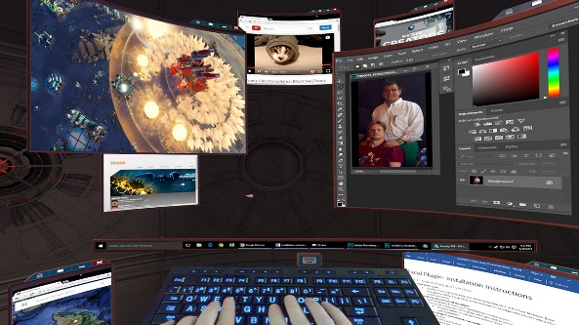

Figure . Virtual Reality Worspace

**Challenges**

Subjects will neeed time to adapt.

Subjects will need time to adapt to the way in which images are presented to them. It’s important to distinguish the cases where the program does not work from the cases where the user just needs more time to adapt.

It may be overwhelming.

VR often is, and putting more information into less space is likely to make it worse. This makes the experiment longer because participants need time to adapt before we can tell if they can use technology.

Subjects are likely to feel overwhelmed.

Participants feeling overwhelmed is a tricky issue because on the one hand it should b

**Ethical Considerations.**

VR can be very intense and confusing for some people. Special care should be taken to select participant who are not mentally fragile.

**Methodology.**

**Variables**

Dependent: The ability of the participants to perform tasks on the VR headset.

Dependent: Whether the participant can ‘see normally’ using the headset.

Dependent: Whether the participant can ‘see fully’ using the headset.

Dependent:

Independent ‘Adapted VR display’:Variations in the display of images in the VR headset.

Level 1. Compressing the whole FOV of the VR set into the participants visual field

Level 2. Compressing the whole FOV of the VR set into the participants visual field and blur out peripheral sections.

Level 3.Compressing part of the whole FOV of the VR set into the participants visual field.

Independent: The kind of hemianopia of the participant.

Level. Homonymous

Level. Bitemporal

Level.Binasal.

*See the appendix for illustrations.*

Constant: Participants have full (not partial) vision loss of part of their visual field.

Control Variable: How overwhel

**The interface**

The interface will be identical to a regular VR interface (if there is such a thing) with two degree movement of the head and controllers for grabbing and moving things. There will be a 3d interactive environment consisting of a room and some props.

Images will be displayed in the lense of the headset adapted as explained.

There will be two games (game1(easy), game2(hard)) designed using the props, whose success will be measured by the program. Thus the program will have a database or some other method for the program to store the data in.

Adjustments should be made in pretesting to make the program as pleasant as possible (i.e. adding transitions, soft sounds, etc).

A measurement interface is used in pretesting to measure the coordinates of the visual field of the participant.

**Testing on participants.**

Participants begin their participation by registering and completing the GUI test of their visual field. After that they should be introduced to the VR setup with the adapted display to allow them to get used to it.

Option 1. The simplest version. Duration: one day.

This is the simplest and fastest option.

Participants play game 2 twice. One time using the Adaptation, another without it. The order is randomized.

**If** the participants perform better in the game while using the adaptiation, that would be evidence of it’s usefulness.

Option 2. Extended experiment.

This option gives participants all the time they m ay need to get used to the VR environment. It is the preferred option because it minimises the possibility of false negatives since it could be that participants are unable to use the VR set not because it cannot be useful but because there is a learning curve.

Participants play game one every day for a period of one week.

After the week of practice, Participants play game 2 twice. One time using the Adaptation, another without it. The order is randomized.

**If** the participants perform better in the game while using the adaptiation, that would be evidence of it’s usefulness.

**The questionnaire(draft)**

*The questionarire is meant to (i) measure the dependent variables that do not have to do with ability but with the visual experience of the user.(ii)Measure control variables that could produce false negatives like stress, confusion and inexperience with technology.

**Question 1.** *Which one of these pictures represents what you were seeing while you were using the adapted display most accurately?*

1. *A picture of the display as it is shown, with blank areas and the images compressed into the visual field.*
2. *A picture of display as it would be without the adaptation (ie. A full visual field).*

**Question2.** *When I first put on the VR headset I felt____.*

*a.Shoked*

*b. Dizzy*

*c. All of the above*

*d. None of the above.*

Appendix



Homonymous left

<https://en.wikipedia.org/wiki/File:Paris_as_seen_with_left_homonymous_hemianopsia.png>

Binasal

Bitemporal

1. In cases where the VR headset acts as a screen in between the user with Hemiaopsia and the real world, the objects the VR headset is representing, not the screens of the headsets, would be the objects of perception. This idea is explored at the end of this paper.