**IMPORTANT:** **Never make ANY assumptions** about parts or the build process! Read through this doc first before making any build plans!!

**Mechanical Keyboard Overview**

The TEC-1G Mechanical Matrix Keyboard is electrically compatible with the Tactile Matrix Keyboard design while adding both mechanical switches (including full-sized stabilised Space, Enter and Shift keys) for comfortable typing and LED lighting circuits for customisation. It also features two Reset switches wired in series to prevent accidental resets.

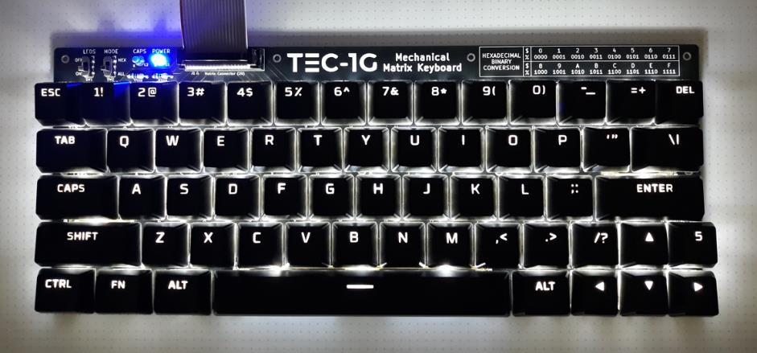

The PCB can be built into two very different configurations:

1) Cherry-MX switches with Cherry screw-in stabilisers and optional LED lighting, or

2) Gateron Low-Profile (LP) plate-mounted switches with plate-mounted Gateron L.P. stabilisers and optional LED lighting.

Both of these variants have separate sections to highlight important warnings and build advice. Please read the respective section for the version you plan to build.

1. **Cherry Variant**

The Cherry variant is a more standard and affordable mechanical keyboard, designed to be built with:

* Any 5-pin(**Note 1.1) Cherry-compatible mechanical switch (tactile, linear or clicky)
* Cherry-compatible PCB screw-in stabilisers
* Any Cherry-compatible keycap set

Most off-the-shelf mechanical keyboards are Cherry-compatible, allowing users to borrow keycaps from other keyboards for more customisation and cost reduction.

**NOT ALL CHERRY (OR CHERRY CLONE) SWITCHES ARE COMPATIBLE WITH THROUGH-HOLE LEDS!!** Here are some examples of switch variations that may affect LED compatibility. Note that the first two switches won’t work because they are designed strictly for use with SMD LEDs only:

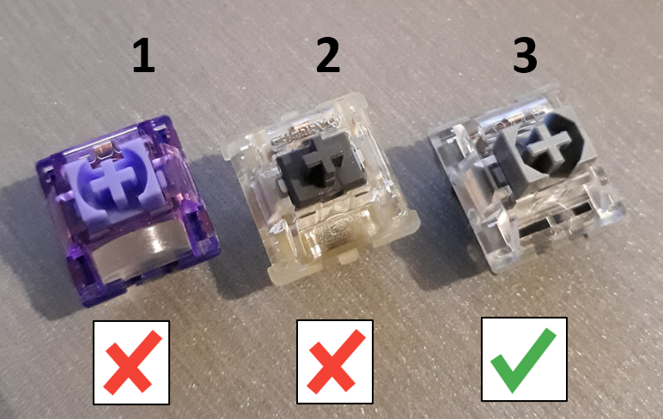

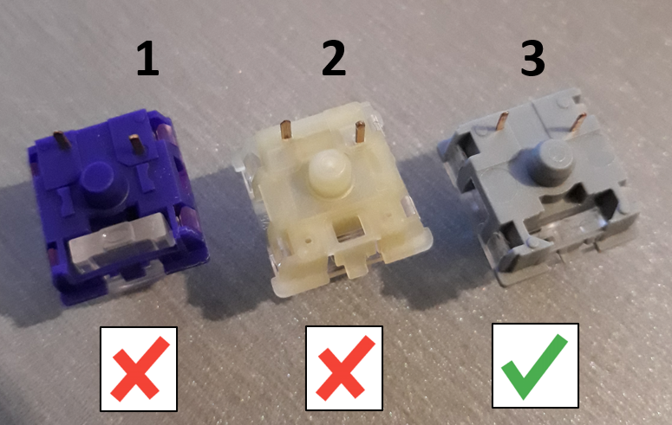

(NOTE: 3-pin switches shown, but the comparison here is regarding LED compatibility)

The appropriate build steps for a Cherry variant keyboard are:

1. Solder on the R3 – R64 0805 SMD resistors on the back of the PCB (ONLY if adding the optional LEDs).

NOTE: This is preferably done with a hotplate or hot-air station. However if using a standard soldering iron, this is done by holding the SMD resistor with tweezers and dabbing solder on one end, then soldering the other end when it is securely held in place.

1. Solder in the two through-hole resistors, matrix 20-pin connector and LED Power/Mode switches.
2. PRO TIP: Test all your LEDs now! By applying +5V/GND to the board, you can one-by-one loosely position each LED in place and check they lights up. Put them aside and don’t solder them just yet! Also use this technique to verify that the SMD resistors and mode switches are all working properly.
3. Position and solder all switches EXCEPT the Shift, Enter and Space switches (which coincidentally use stabilisers).
4. Screw in the stabilisers(**Note 1.2).
5. Use the stabilised keycaps to locate and solder in the Shift, Enter and Space switches. This is to ensure these switches are aligned properly and don’t have “sticking” issues.
6. Solder in the through-hole LEDs from the top side of the switches.
7. Plug in the keyboard and check that the switches and LED lights are working.
8. Finally, add the complete keycap set.

**NOTE 1.1 – 3-pin switches may be substituted however they are very difficult to position individually due to intentionally very wide design tolerances.

**NOTE 1.2 – Lubricating your stabilisers is optional, but can significantly reduce rattle. Some stabilisers may be supplied with inadequate lubricant, or even none at all. Many guides are available online that discuss what lube is most suitable and how to apply it. Even if your keyboard is already built, screw-in stabilisers can be easily removed and lubed afterwards.

1. **Gateron Low-Profile Variant**

The Gateron LP variant is a higher-end low profile keyboard, designed to be built with:

* Gateron KS-33 low profile switches (tactile, linear or clicky)
* Gateron low profile plate-mounted stabilisers
* The TEC-1G mechanical matrix keyboard plate (specifically for Gateron LP variant)
* Gateron LP compatible keycaps

Users MUST be aware that the Gateron LP variant is both higher cost and more difficult to build/repair, as such it is less suitable for beginners, however it provides the benefits of a low-profile design and a higher-end plate-mounted typing experience.

The appropriate build steps for a Gateron LP variant keyboard are:

1. Remove the PCB stabiliser cutouts by clipping the mousebites and removing the inserts as shown. This mod is done so that the stabiliser housings can protrude through the PCB (test fitting as shown to check clearances is recommended).

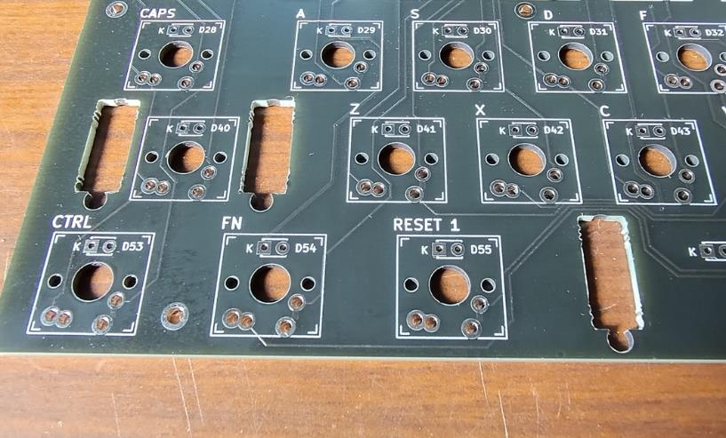

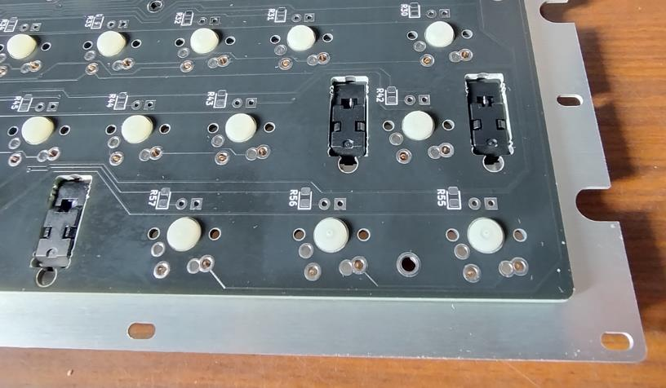

1. Solder on the R3 – R64 0805 SMD resistors on the back of the PCB (ONLY if adding the optional LEDs).

NOTE: This is preferably done with a hotplate or hot-air station. However if using a standard soldering iron, this is done by holding the SMD resistor with tweezers and dabbing solder on one end, then soldering the other end when it is securely held in place.

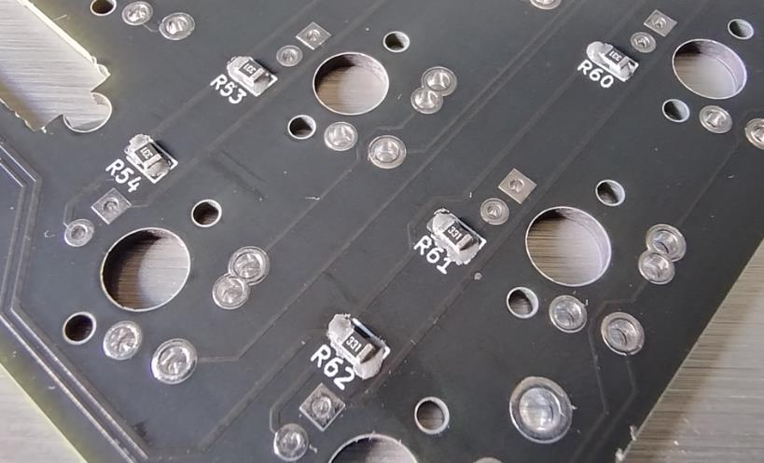

1. Solder in the two through-hole resistors, matrix 20-pin connector and LED Power/Mode switches.
2. PRO TIP: Test all your LEDs now! By applying +5V/GND to the board, you can one-by-one loosely position each LED in place and check they lights up. Put them aside and don’t solder them just yet! Also use this technique to verify that the SMD resistors and mode switches are all working properly.
3. Clip the three plate-mount Gateron LP stabilisers into the plate.

NOTE – The stabilisers will not be coming back out again after this step!!! It is highly recommended that you do any stabiliser modifications (including lubricating) BEFORE the plate is in position over the PCB. Once the switches are soldered, the stabilisers are no longer accessible without desoldering at least the stabilised switch.

1. Solder in one switch (with LED) at each corner to hold the plate into its final position.
2. Doing one LED + switch at a time, snap in and solder each switch into position.

NOTE – Solder all switches EXCEPT the Shift, Enter and Space switches (which use stabilisers).

1. Install the stabilised keycaps and solder in the Shift, Enter and Space switches. This is to ensure these switches are aligned properly and don’t have “sticking” issues.
2. Plug in the keyboard and check that the switches and LED lights are working.
3. Finally, add the complete keycap set.

**Pro Tips For Best Results:**

* Top-mounted LEDs are more effective at making keycap characters shine bright. Under-switch LEDs will still work but the contrast isn’t as strong.
* Spend plenty of time making sure the switches are aligned perfectly before soldering, since any slight rotation will become obvious with the keycap clearances.
* Cheap keycaps often have very inconsistent clearances, which can still make the keys look misaligned even if the switches are perfectly aligned.