# **Visual Stress Strategies**

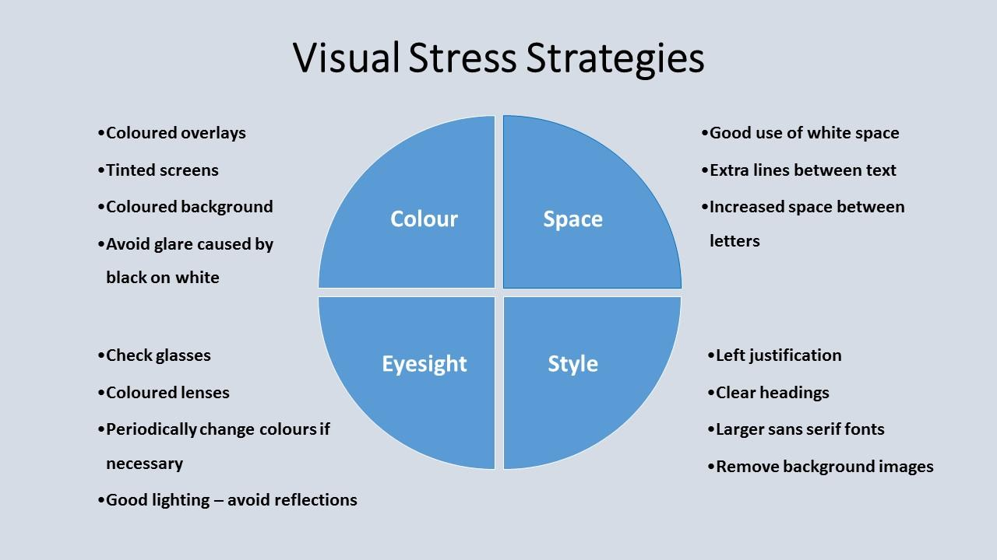

## Colour

* Coloured overlays
* Tinted screens
* Coloured background
* Avoid glare caused by black on white

## Space

* Good use of white space
* Extra lines between text
* Increased space between letters

## Eyesight

* Check glasses
* Coloured lenses
* Periodically change colours if necessary
* Good lighting – avoid reflections

## Style

* Left justification
* Clear headings
* Larger sans serif fonts
* Remove background images

## License Terms, Acknowledgment & Disclaimer

Author/copyright: E.A. Draffan, University of Southampton, 2015

This resource is hereby made available to the public under the terms of the Creative Commons by Attribution ([CC-BY 4.0](https://creativecommons.org/licenses/by/4.0/)) license. For the included images, see the corresponding footnotes for their license terms.

The creation of this resource has been partially funded by the ERASMUS+ grant program of the European Union under grant no. 2014-1-DE01-KA203-000679 ([MOOC Accessibility Partnership](http://gpii.eu/moocap/)). Neither the European Commission nor the project's national funding agency DAAD are responsible for the content or liable for any losses or damage resulting of the use of these resources.





## Additional Metadata[1]

|  |
| --- |
| Copyright of text (name of university): |
| © University of Southampton |

Images in the article

|  |
| --- |
| Filename of image: visual stress strategiesfinal.jpg |
| Image title: Summary of Visual Stress Strategies for reading screen based text |
| Caption for image: Summary of Visual Stress Strategies for reading screen based text |
| Alternative text for the image for screen readers: Summary of Visual Stress Strategies for reading screen based text |
| Copyright for the image: © |
| Have they filled out a Copyright Release Agreement? Yes |

|  |  |
| --- | --- |
| Title of file name of resource: visual stress Strategies.docx | |
| Description of resource: Text from the image | |
| Key words: Digital Accessibility, visual stress, dyslexia | |
| Author/Contributor: E.A. Draffan | |
| File type: Text Document | |
| Length (pages, actual length of audio or video): 3 pages | |
| Copyright Holder: University of Southampton | |
| Other related pedagogical assets: | |
| Related subject or skill area: Disability, dyslexia, visual stress, Accessibility, | |
|  | |
| publisher | MOOCAP |
| format | TEXT MS WORD |
| issued | 12-12-2015 |
| language | ENGLISH |
| license | CC BY 4.0 |

1. Additional Metadata is included here using a scheme format derived from <https://www.elanguages.ac.uk/l2o_documents.php>, which is based on the Dublin Core Metadata Model.