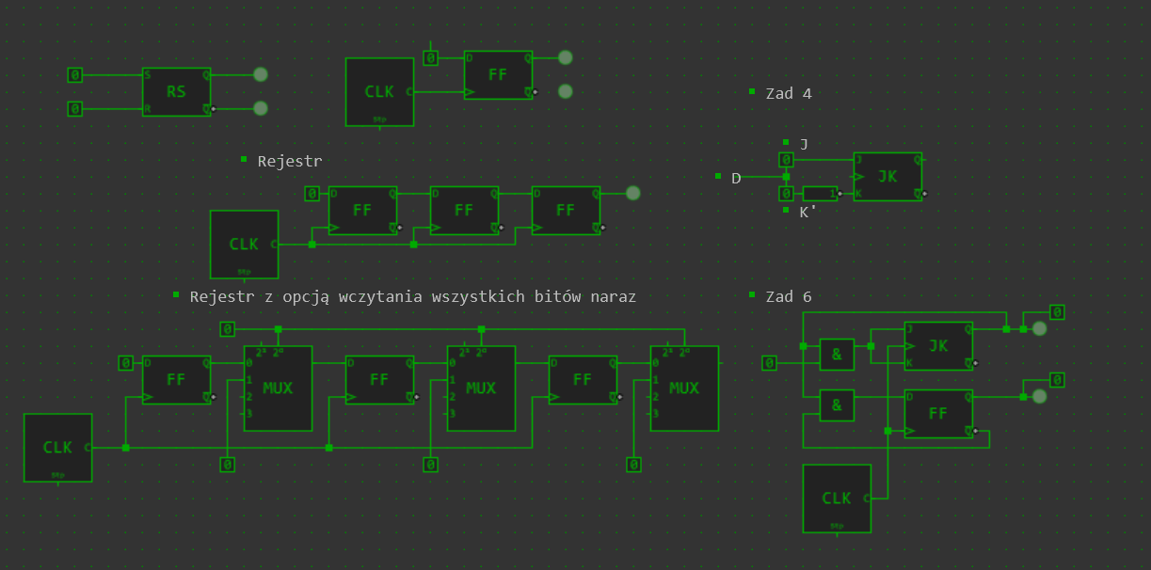

Zadanie 1
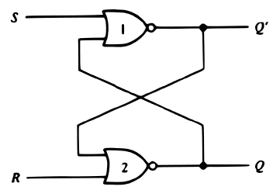
S | R | Q(t) | Q’(t) | Q(t+1) | Q’(t+1) | Co robi
0 | 0 | 0 | 1 | 0 | 1 | Nic (hold)
0 | 0 | 1 | 0 | 1 | 0
0 | 1 | 0 | 1 | 0 | 1 | Q = 0 (reset)
0 | 1 | 1 | 0 | 0 | 1
1 | 0 | 0 | 1 | 1 | 0 | Q = 1 (set)
1 | 0 | 1 | 0 | 1 | 0
1 | 1 | 0 | 1 | 0 | 0 | Niedozwolone
1 | 1 | 1 | O | 0 | 0

Zadanie 4
J | K | Q(t) | Q(t+1) | Co robi
0 | 0 | 0 | 0 | Nic (hold)
0 | 0 | 1 | 1
0 | 1 | 0 | 0 | Q = 0 (reset)
0 | 1 | 1 | 0
1 | 0 | 0 | 1 | Q = 1 (set)
1 | 0 | 1 | 1
1 | 1 | 0 | 1 | Zamiana (toggle)
1 | 1 | 1 | 0
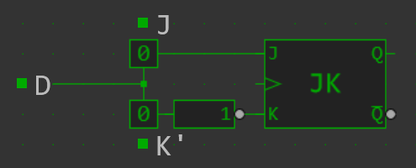
J | K’ | Q(t) | Q(t+1) | Co robi
0 | 1 | 0 | 0 | Nic (hold)
0 | 1 | 1 | 1
0 | 0 | 0 | 0 | Q = 0 (reset)
0 | 0 | 1 | 0
1 | 1 | 0 | 1 | Q = 1 (set)
1 | 1 | 1 | 1
1 | 0 | 0 | 1 | Zamiana (toggle)
1 | 0 | 1 | 0

Zadanie 5
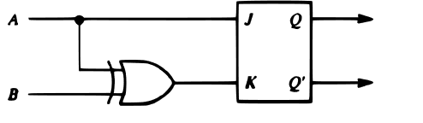
A (J) | B | A XOR B (K) | Q(t) | Q(t+1) | Co robi
0 | 0 | 0 | 0 | 0 | Nic (hold)
0 | 0 | 0 | 1 | 1
0 | 1 | 1 | 0 | 0 | Q = 0 (reset)
0 | 1 | 1 | 1 | 0
1 | 0 | 1 | 0 | 1 | Zamiana (toggle)
1 | 0 | 1 | 1 | 0
1 | 1 | 0 | 0 | 1 | Q = 1 (set)
1 | 1 | 0 | 1 | 1

Q\AB | 00 | 01 | 11 | 10
0 | 0 | 0 | 1 | 1
1 | 1 | 0 | 1 | 0
Q(t+1) = AQ’ + AB + A’B’Q = A(Q’B) + A’B’Q

Zadanie 6
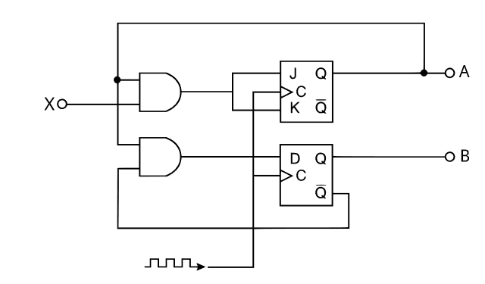
A | B | X | A(t+1) | B(t+1)
0 | 0 | 0 | 0 | 0
0 | 0 | 1 | 0 | 0
0 | 1 | 0 | 0 | 1
0 | 1 | 1 | 0 | 1
1 | 0 | 0 | 1 | 1
1 | 0 | 1 | 0 | 1
1 | 1 | 0 | 1 | 0
1 | 1 | 1 | 0 | 0

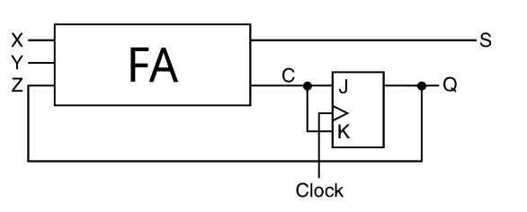
Zadanie 7
Z (Q(t)) | X | Y | Q(t+1) | S | C (J, K)
0 | 0 | 0 | 0 | 0 | 0
0 | 0 | 1 | 0 | 1 | 0
0 | 1 | 0 | 0 | 1 | 0
0 | 1 | 1 | 1 | 0 | 1
1 | 0 | 0 | 1 | 1 | 0
1 | 0 | 1 | 0 | 0 | 1
1 | 1 | 0 | 0 | 0 | 1
1 | 1 | 1 | 0 | 1 | 1
Jeśli przed wejściem K do JK dodamy bramkę NOT to otrzymamy sekwencyjny sumator (w JK przechowuje carry dla następnego bitu)

