1.

select *

from business

where business_info->'$.city'="Tampa"

order by business_info->'$.review_count' desc

limit 10;

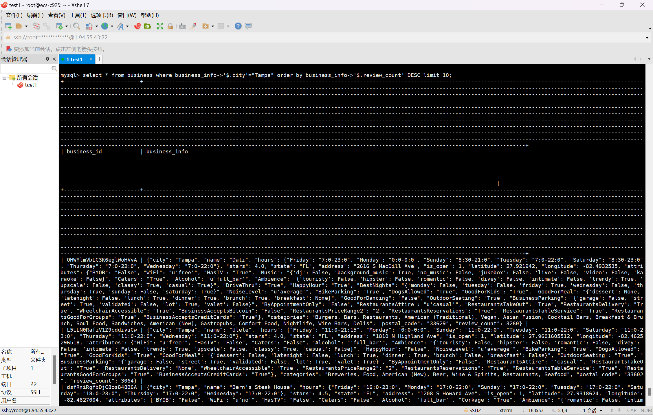

2.

select

json_keys(business_info) as keys_info,

json_length(business_info) as key_num_info,

json_keys(business_info, '$.attributes') as keys_attr,

json_length(business_info, '$.attributes') as key_num_attr

from business

limit 5;

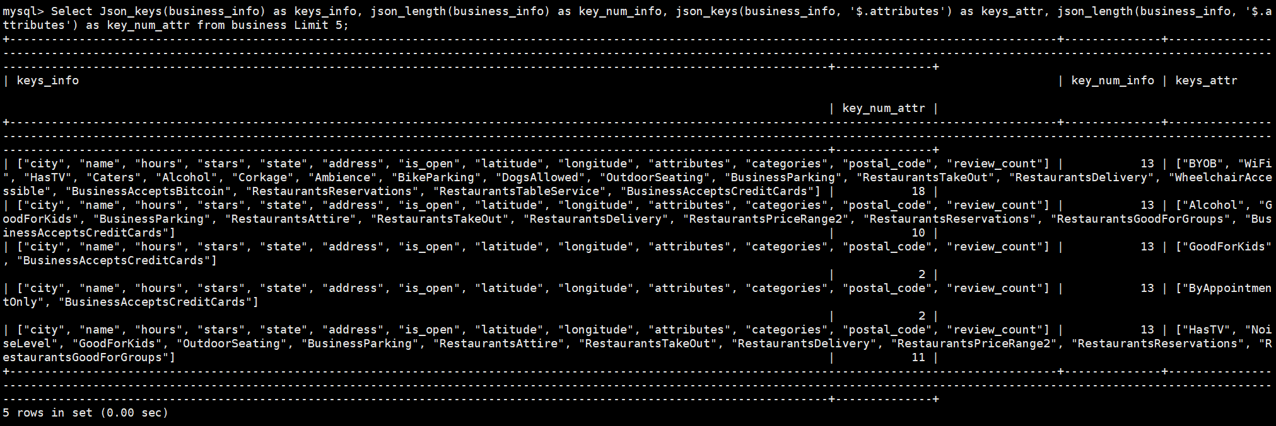

3.

select

business_info->'$.name' as name,

json_type(business_info->'$.name') as name_type,

business_info->'$.stars' as stars,

json_type(business_info->'$.stars') as stars_type,

business_info->'$.attributes' as attributes,

json_type(business_info->'$. attributes') as attributes_type

from business

limit 5;

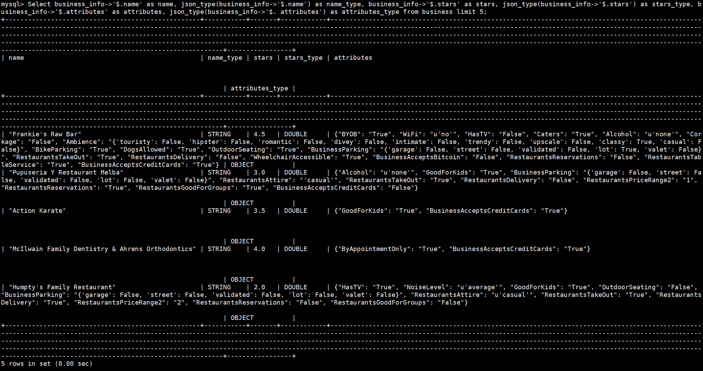

4.

select

json_unquote(business_info->'$.name') as name,

business_info->'$.attributes' as attributes,

business_info->'$.hours' as open_time

from business

where business_info->'$.attributes.HasTV'="True"

and (business_info->'$.hours' is null or business_info->'$.hours.Sunday' is null)

order by name

limit 10;

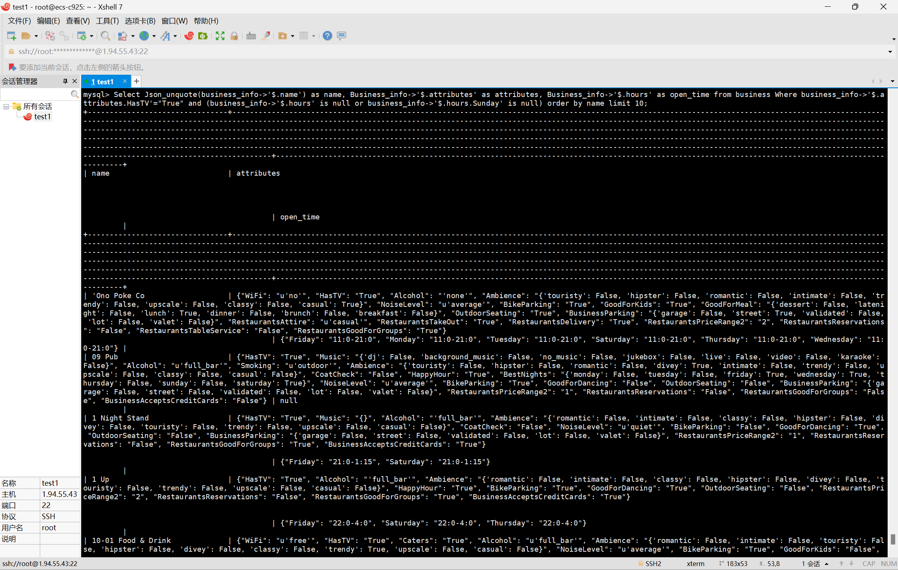

5.

explain format=json

select * from user where user_info->'$.name'='Wanda';

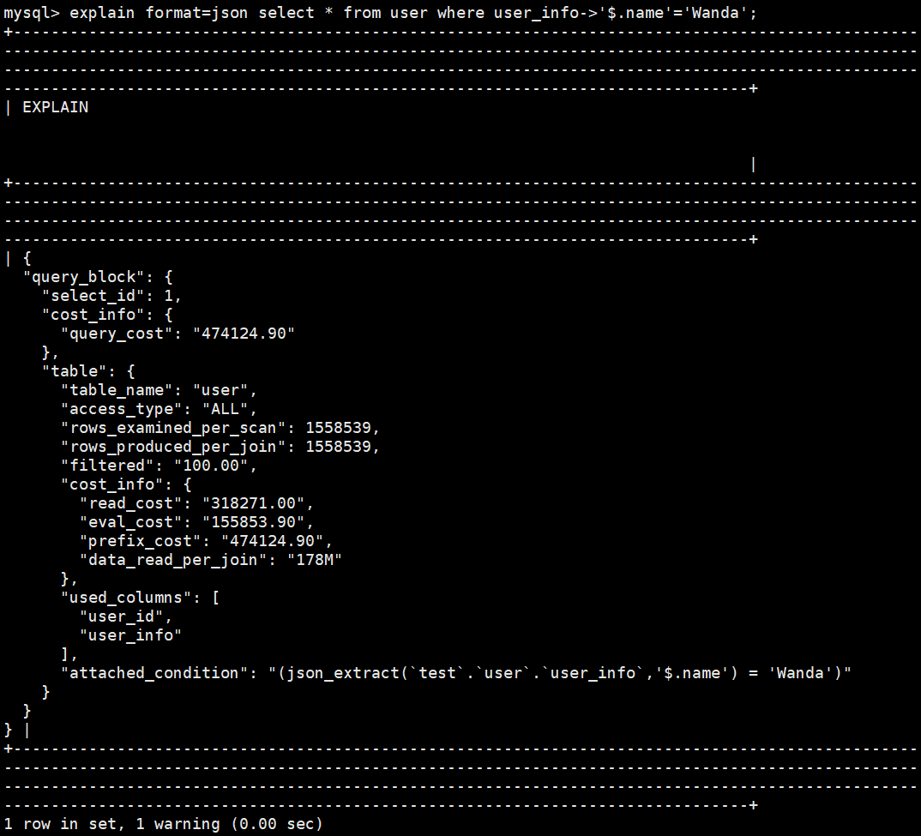

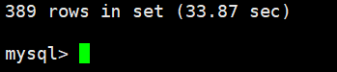

使用MongoDB查询同样的语句，并使用explain查看查询计划：

db.user.find({'name':"Wanda"}).explain("executionStats")

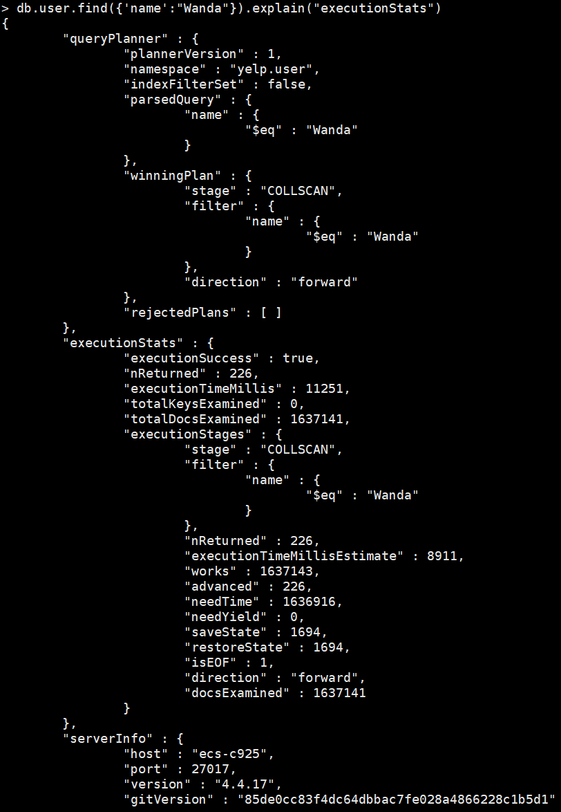

6.

select json_pretty(business_info)

from business

where business_id="4r3Ck65DCG1T6gpWodPyrg";

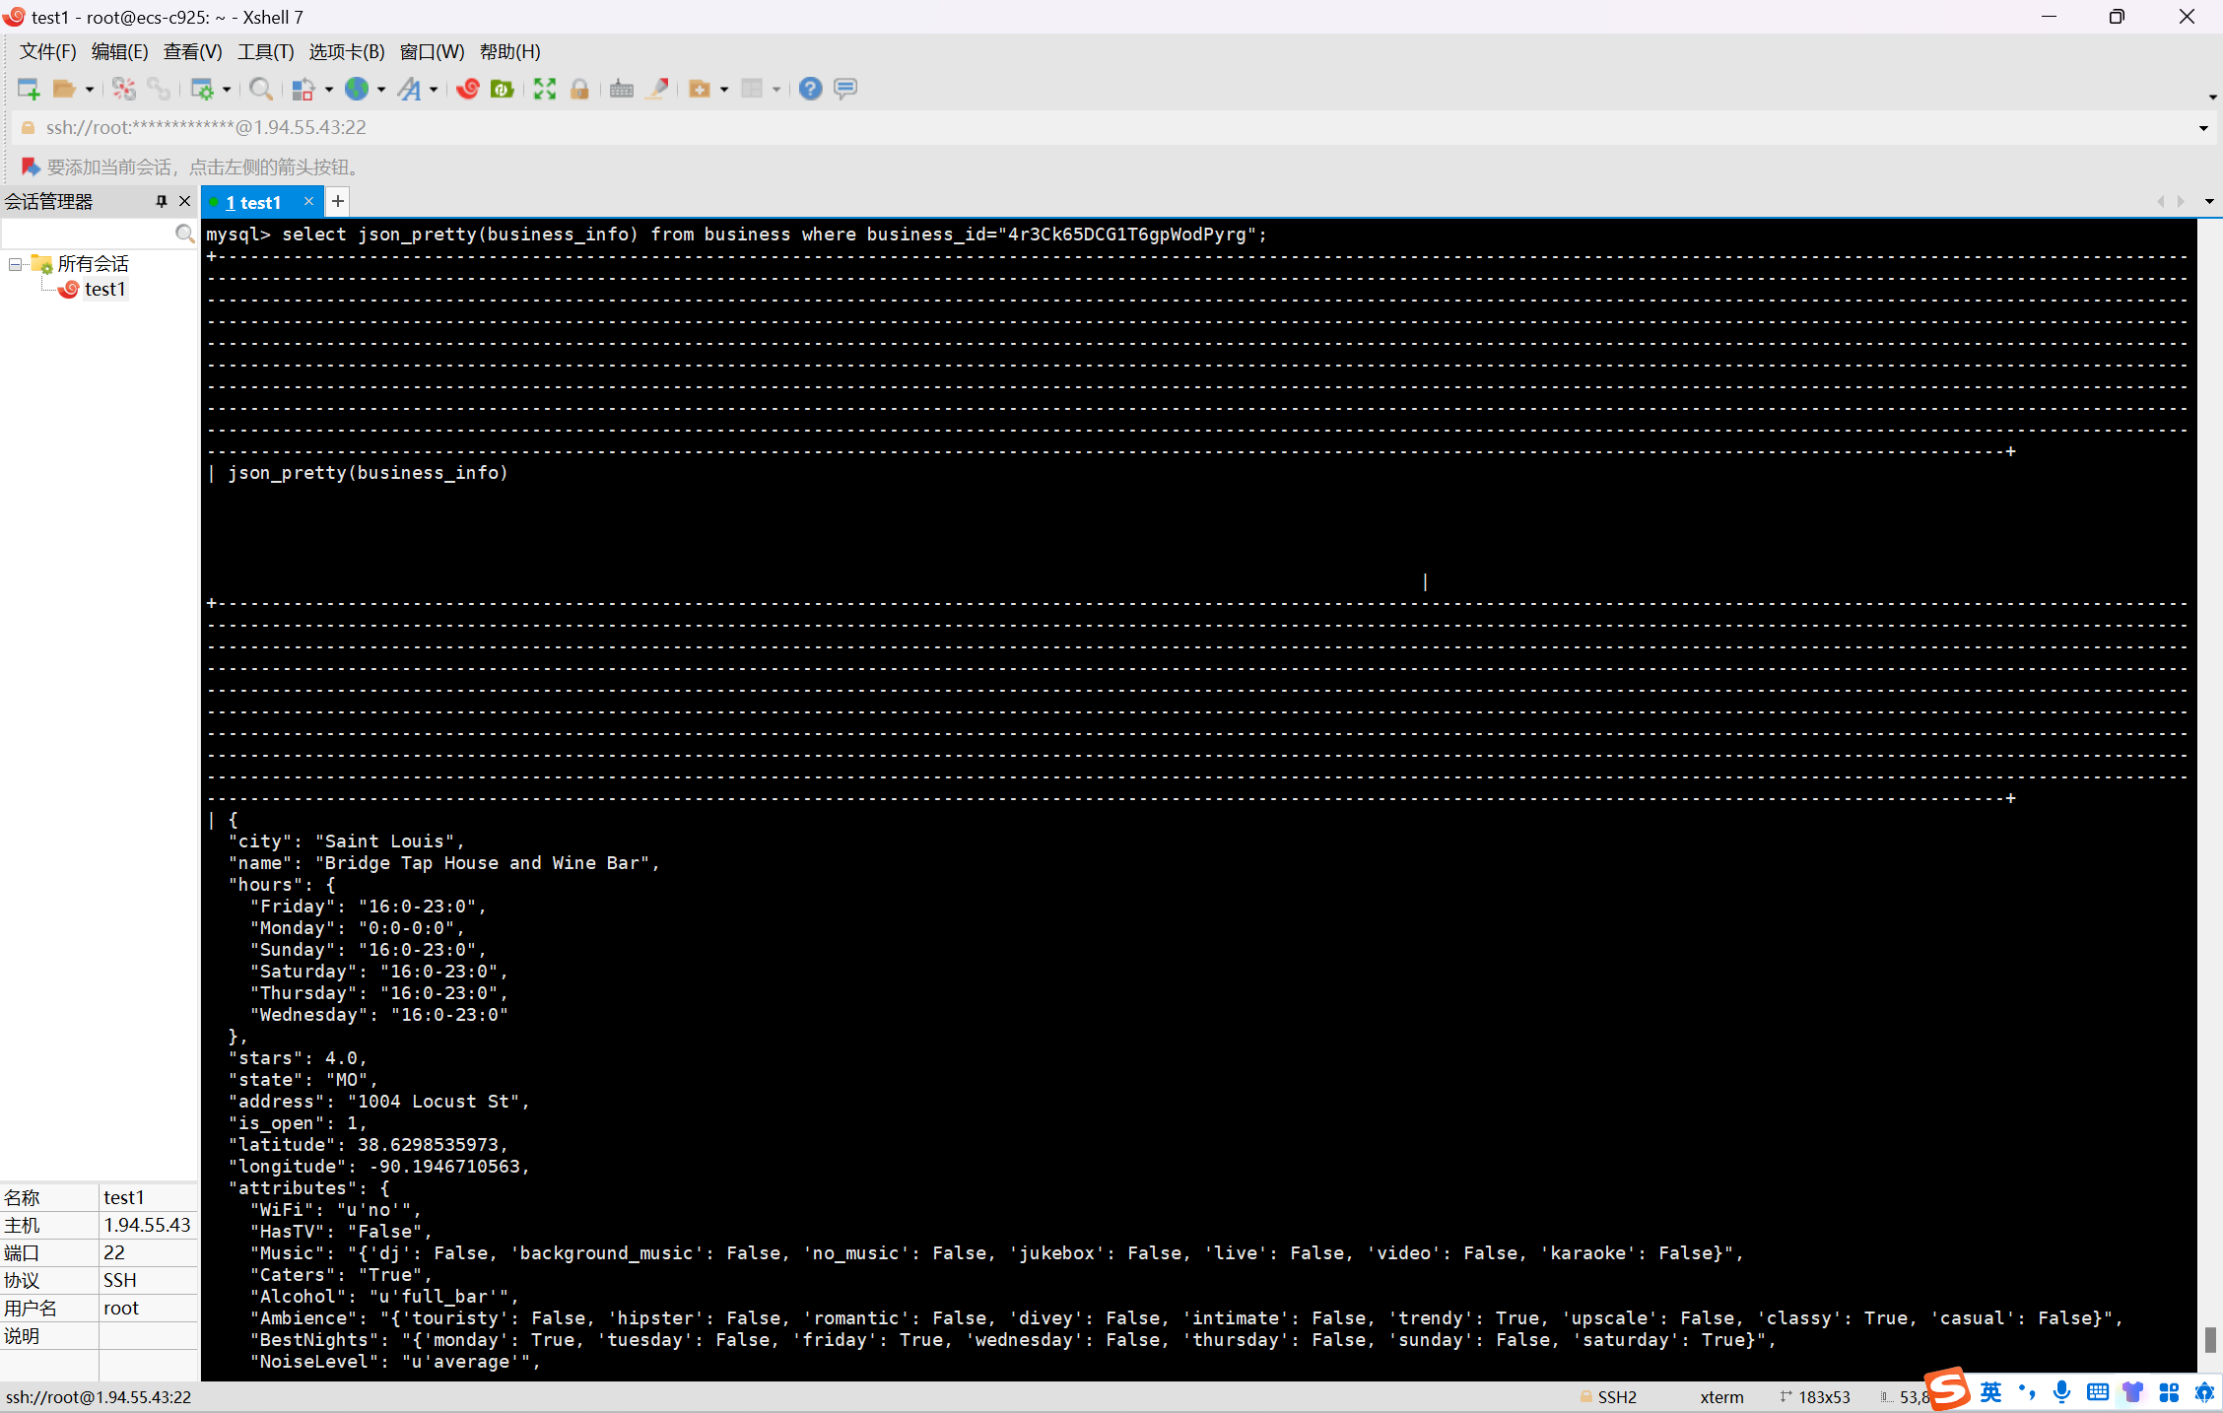

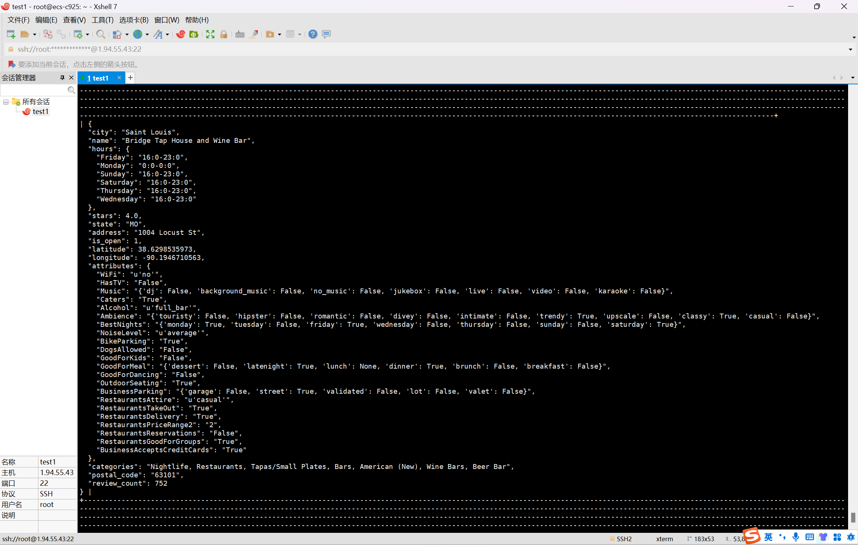

更新操作：

update business

set business_info=json_set(business_info, '$.hours.Tuesday', "16:0-23:0", '$.stars', 4.5, '$.WiFi', "Free")

where business_id="4r3Ck65DCG1T6gpWodPyrg";



再次查询：

select json_pretty(business_info)

from business

where business_id="4r3Ck65DCG1T6gpWodPyrg";

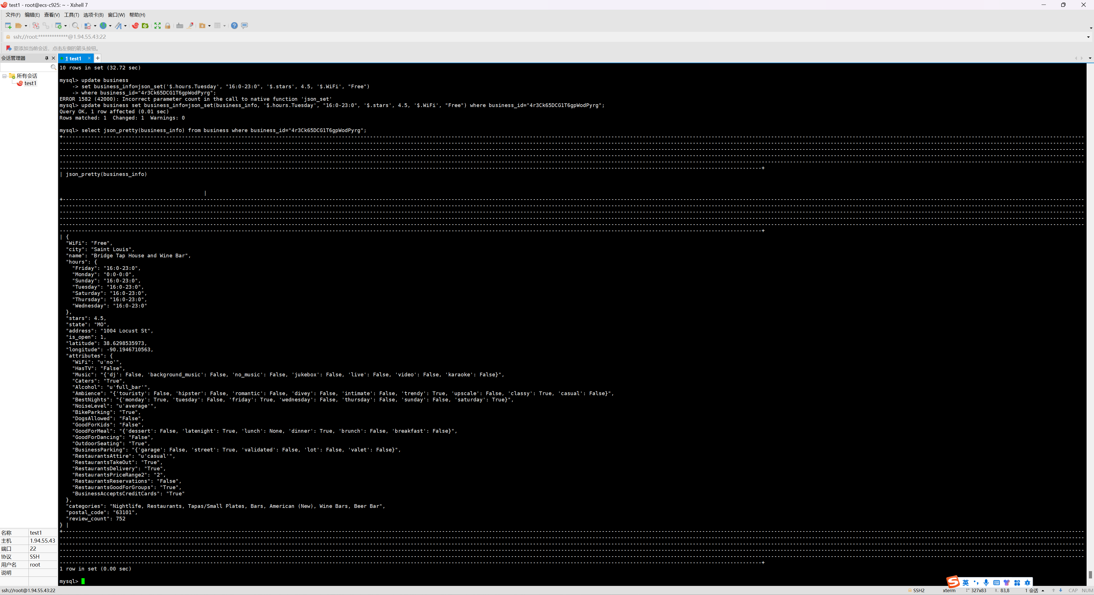

7.

insert into business(business_id, business_info)

select "aaaaaabbbbbbcccccc2023", business_info from business where business_id='5d-fkQteaqO6CSCqS5q4rw';



update business

set business_info=json_remove(business_info, '$.name')

where business_id="aaaaaabbbbbbcccccc2023";

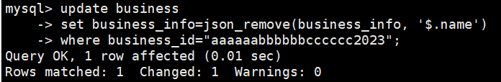

查询：

select json_pretty(business_info)

from business

where business_id="aaaaaabbbbbbcccccc2023";

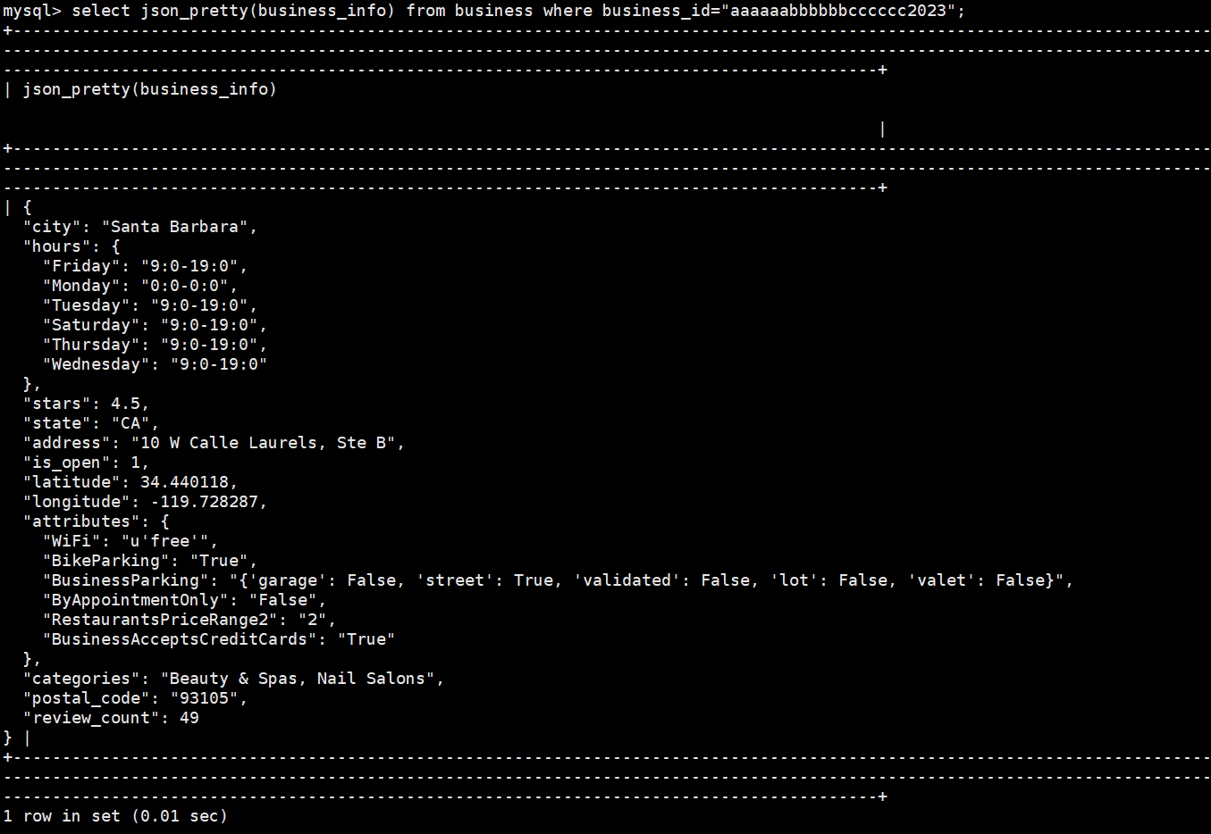

8.

select

state,

json_objectagg(city, count) as city_occ_num

from

(

select

business_info->'$.state' as state,

json_unquote(business_info->'$.city') as city,

count(*) as count

from business

group by state, city

) as sub

group by state

order by state;

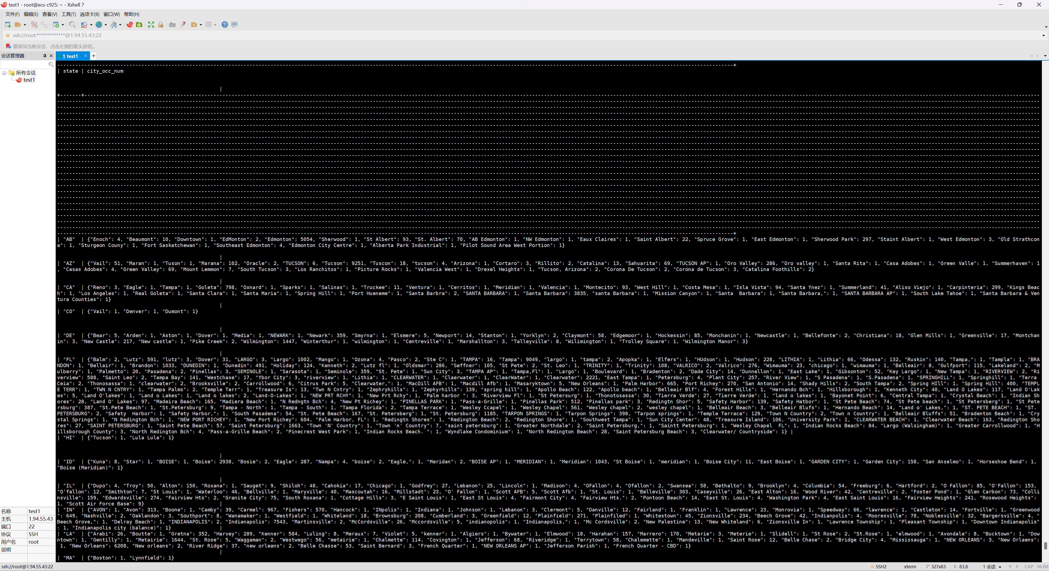

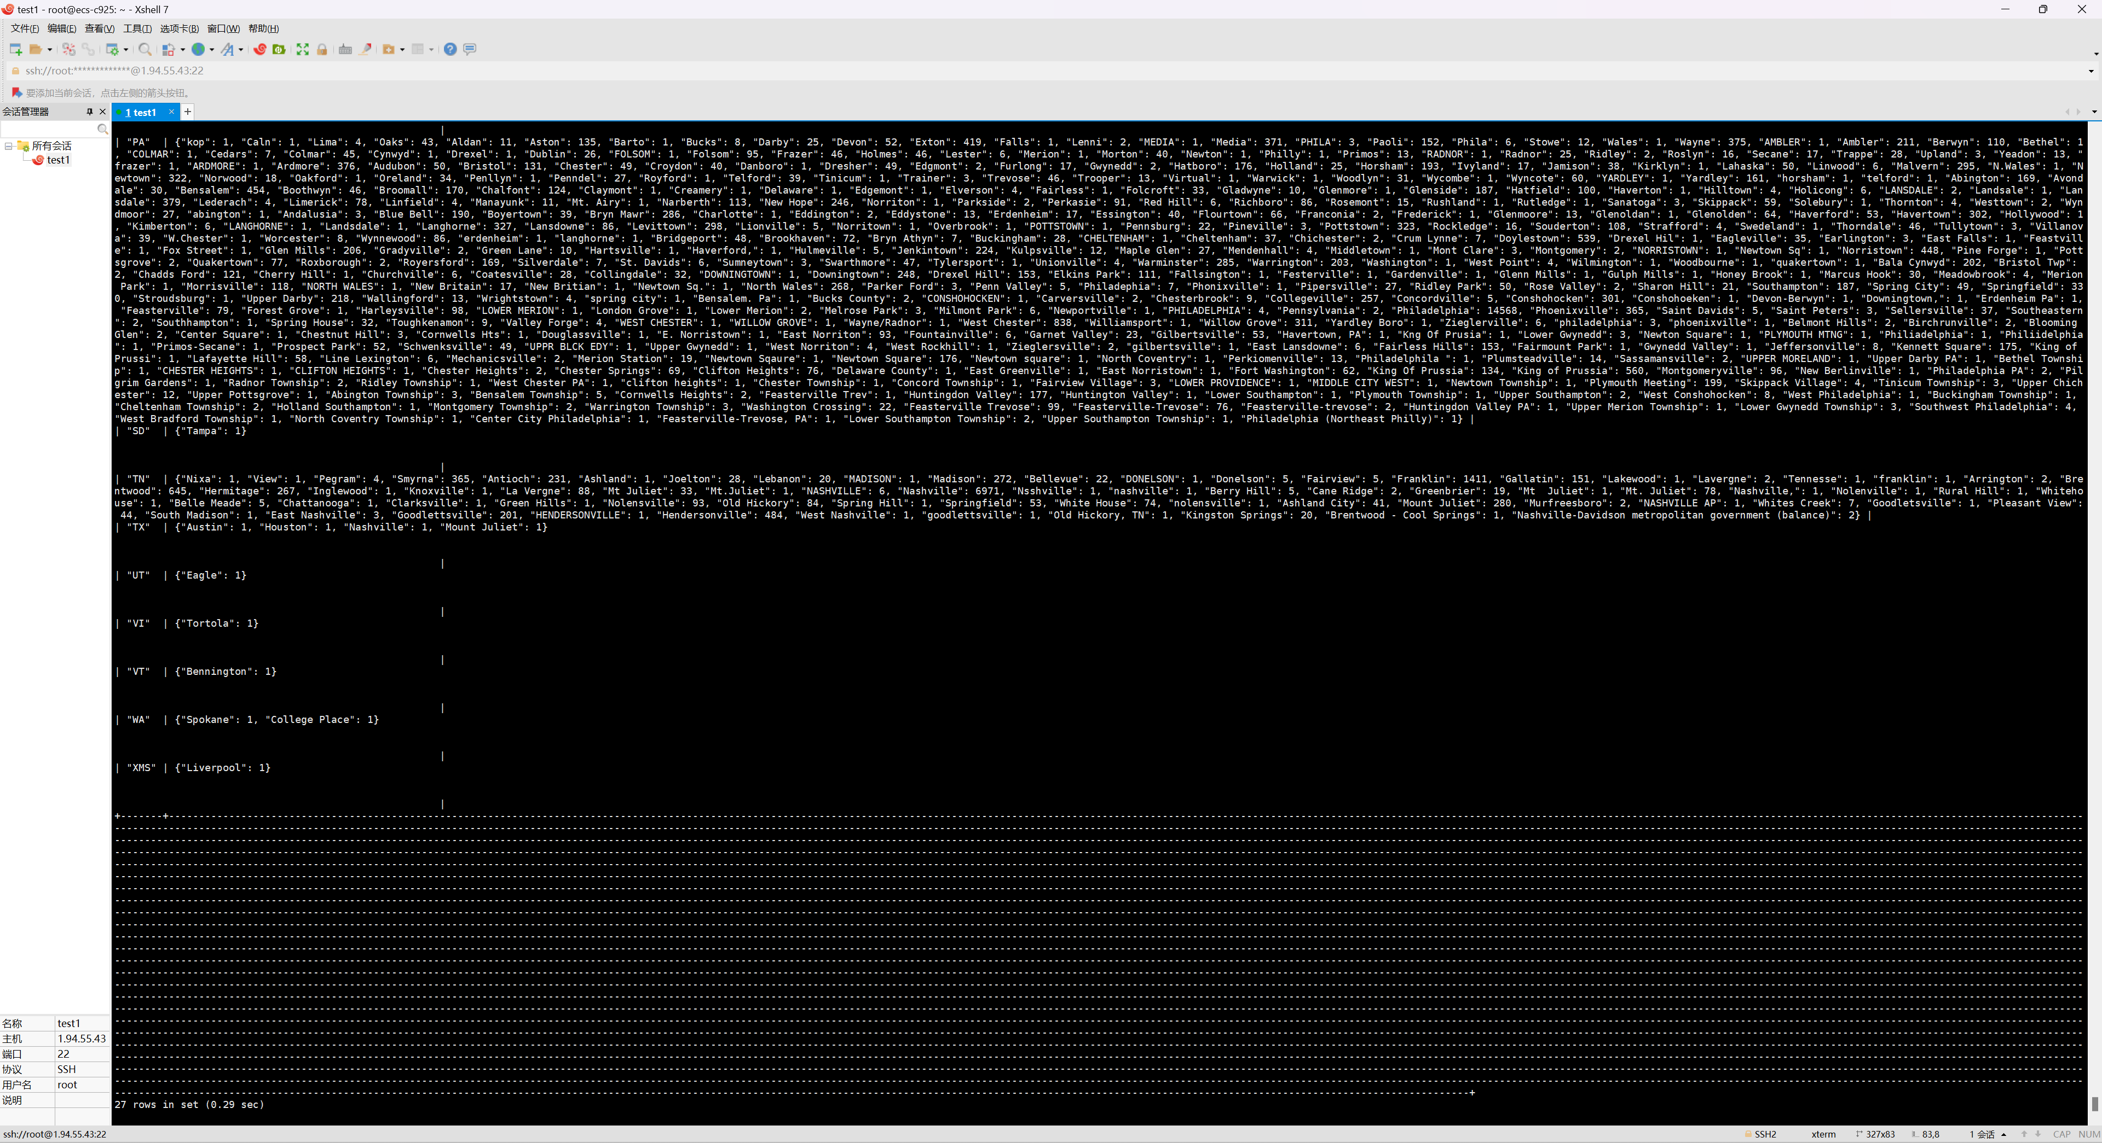

9.

select sub.userid as user_id,

uu.user_info->'$.name' as name,

sub.textarray as text_array from

(

select t.user_id as userid,

json_arrayagg(t.tip_info->'$.text') as textarray

from tip t

join user u on REGEXP_LIKE(u.user_info->'$.friends', t.user_id)

where u.user_id='__1cb6cwl3uAbMTK3xaGbg'

group by t.user_id

) as sub, user uu

where uu.user_id = sub.userid

order by name;

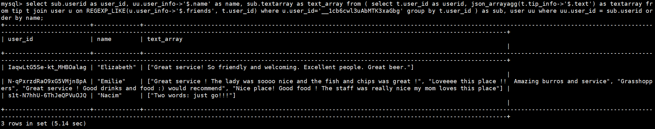

10.

select

a.business_info->'$.name' as name1,

a.business_info->'$.city' as city1,

b.business_info->'$.name' as name2,

b.business_info->'$.city' as city2,

a.business_info->'$.hours' as hours1,

b.business_info->'$.hours' as hours2,

JSON_OVERLAPS(a.business_info->'$.hours', b.business_info->'$.hours') as has_same_opentime

from business a

join business b

on a.business_info->'$.city' = 'EdMonton' and b.business_info->'$.city' = 'Elsmere';

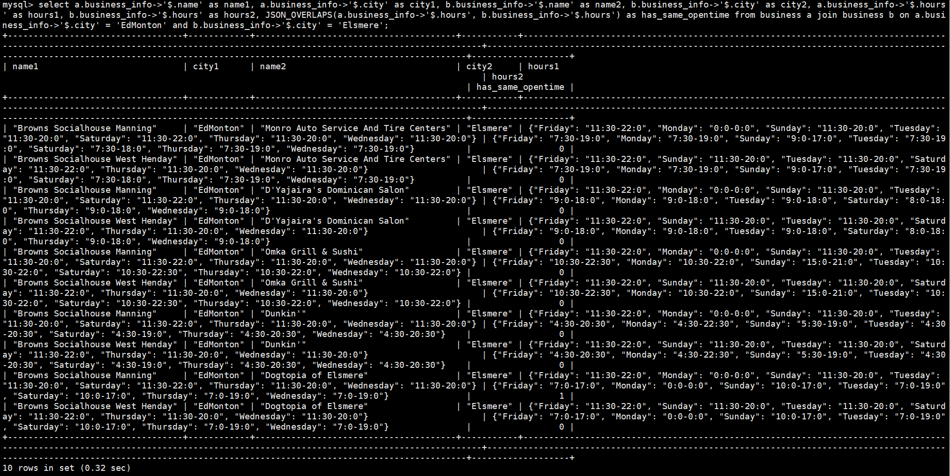

11.

select

user_info->'$.name' as name,

user_info->'$.average_stars' as avg_stars,

JSON_ARRAY(user_info->'$.funny', user_info->'$.useful', user_info->'$.cool', user_info->'$.funny'+user_info->'$.useful'+user_info->'$.cool') as '[funny,useful,cool,sum]'

from user

where user_info->'$.funny'>2000

and user_info->'$.average_stars'>4.0

order by user_info->'$.average_stars' desc

limit 10;

报错：

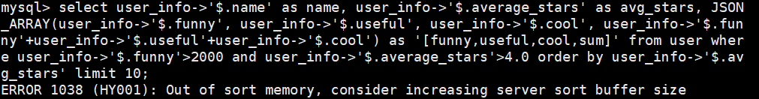

手动修改缓存池大小即可

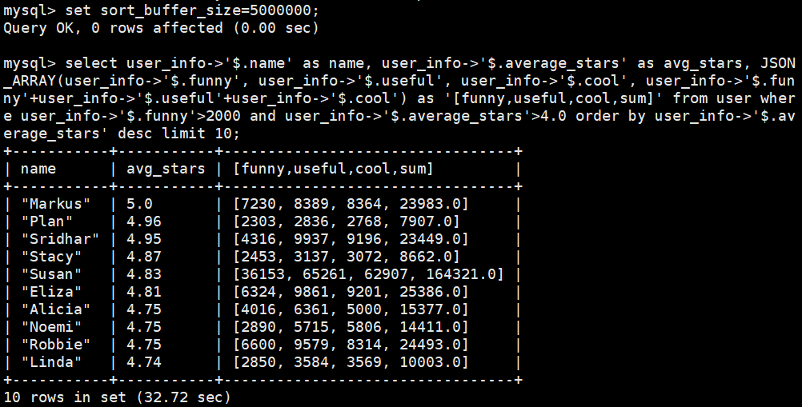

在前面加上explain format=json

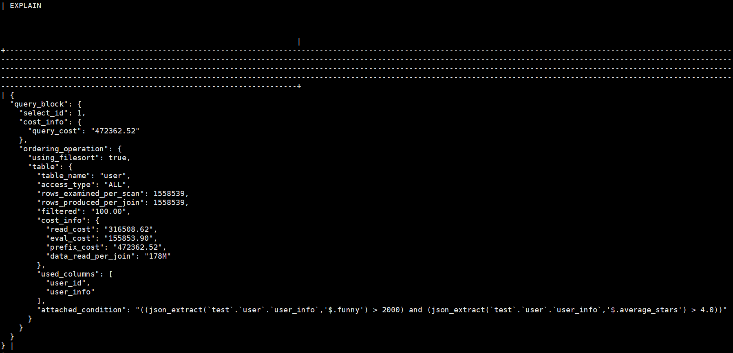

和第一题对比：

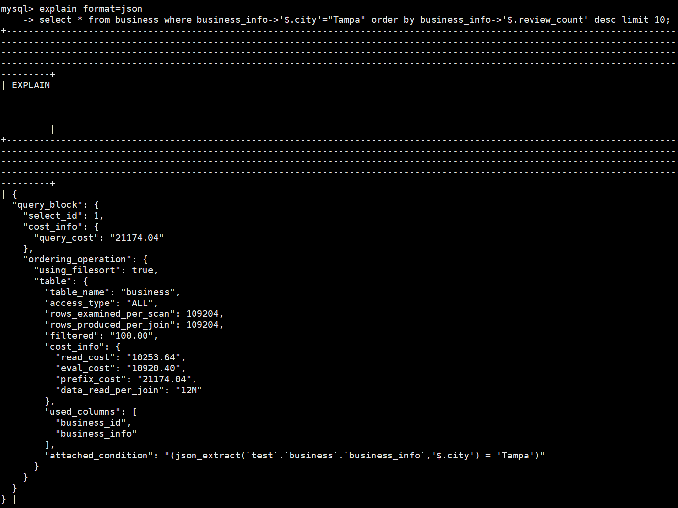

12.

select

json_merge_preserve(b.business_info, u.user_info)

from

(

select business_id,

count(*) as count

from tip

group by business_id

order by count desc

limit 1

) as tb

join

(

select user_id,

count(*) as count

from tip

group by user_id

order by count desc

limit 1

) as tu

join business b on tb.business_id=b.business_id

join user u on tu.user_id=u.user_id;

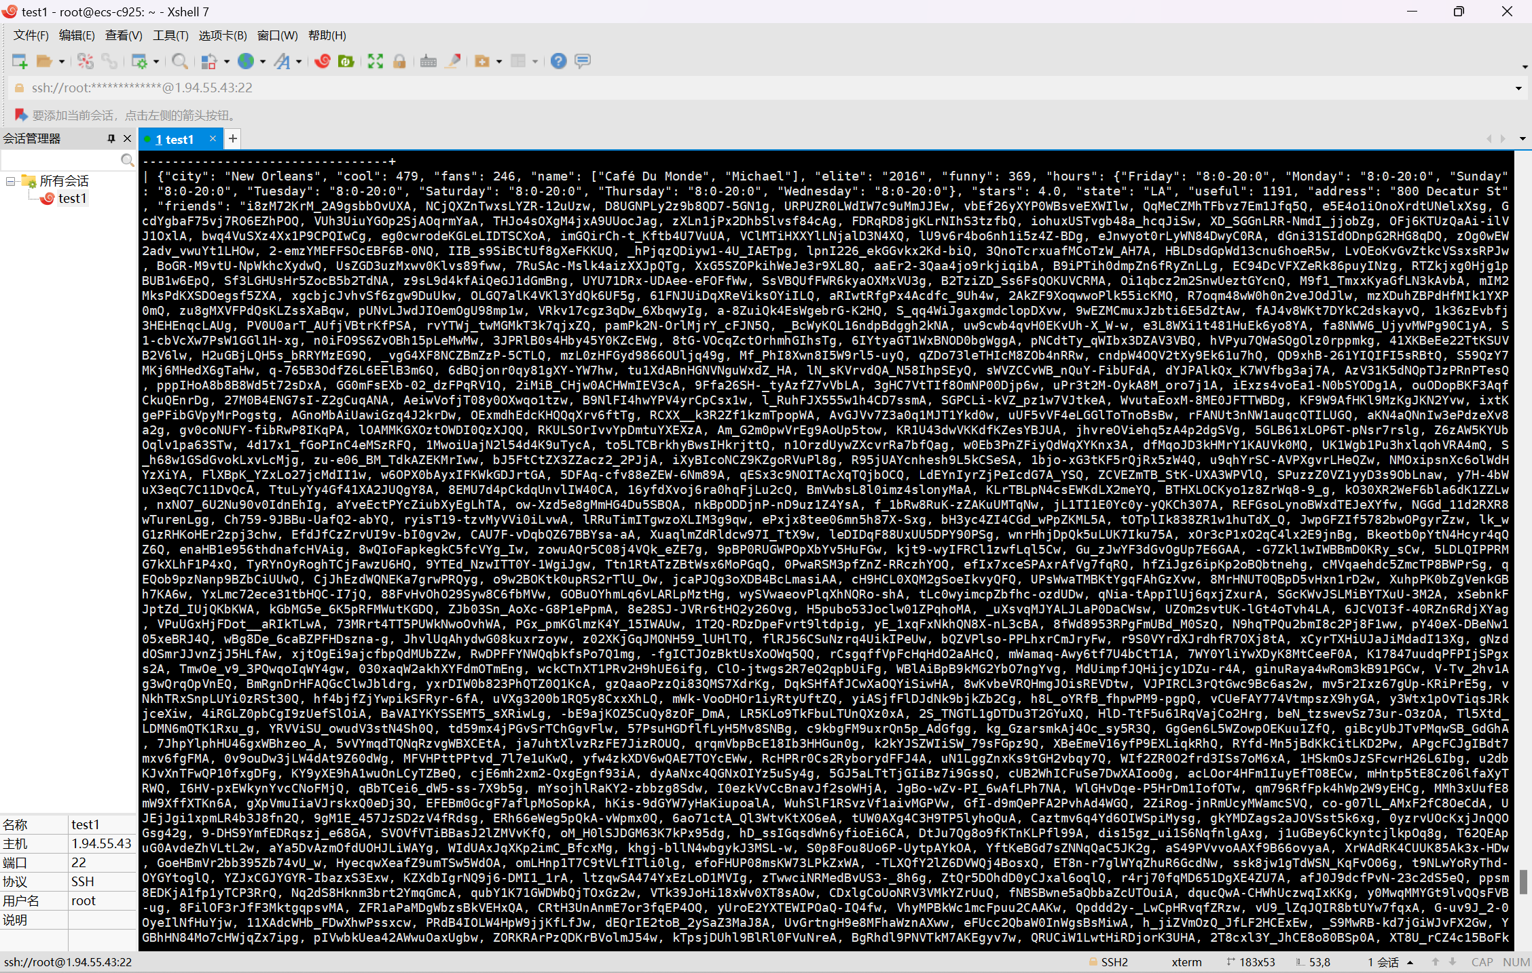

13.

select

sub.business_name,

sub.review_count as business_review_count,

case when sub.hours->'$.Tuesday' is null then 0 else 1 end as business_open_on_Tuesday,

jt.time_slot

from

(select

business_info->'$.name' as business_name,

business_info->'$.review_count' as review_count,

business_info->'$.hours' as hours

from business

order by business_info->'$.review_count' desc

limit 3) as sub

join json_table(

sub.hours,

"$.*" columns (

time_slot VARCHAR(255) PATH '$')

) as jt on 1=1

order by sub.business_name;

