Assignment 1
(Due Sep 28, 2023)

Q1:
Consider a circuit-switched network as shown below.
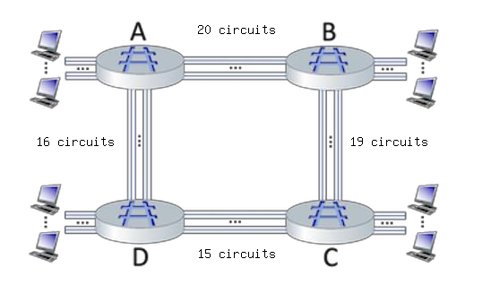
- What is the maximum number of connections that can be concurrently admitted in the network?
70 connections.
- Suppose that these maximum number of connections are all ongoing. What happens when another call connection request arrives to the network, will it be accepted? Explain your answer.
The connection will be denied because the circuit is at maximum capacity. Thus, it will be queued until there is capacity for that connection.
- Suppose that every connection requires 2 consecutive hops, and calls are connected clockwise. For example, a connection can go from A to B, from B to C, from C to D, and from D to A. With these constraints, what is the is the maximum number of connections that can be ongoing in the network at any one time?
34 connections.

Q2:
Two hosts, A and B, are separated with a distance of 300 𝑘𝑚. Host A sends a packet of size 3 𝑀𝑏𝑖𝑡 to Host B via a link of rate 100 𝑀𝑏𝑝𝑠.
Suppose that the propagation speed along the link is 3 × 108 meters/sec.

- Calculate the propagation delay, 𝑑𝑝𝑟𝑜𝑝.
Propagation delay = (300000 m) / (3E8 m/s) = 0.001 s
- Determine the transmission time of the packet, 𝑑𝑡𝑟𝑎𝑛𝑠.
Transmission delay = (3 Mbit) / (100 Mbps) = 0.03 s
- Calculate the end-to-end delay, ignoring processing and queuing delays.
End-to-end delay = 0.001 s + 0.03 s = 0.031s
Q3: As shown in the figure below, a server sends packets to two different clients via a router.
Assume that 𝑅1 = 250 𝑀𝑏𝑝𝑠, 𝑅2 = 𝑅3 = 50 𝑀𝑏𝑝𝑠, and each packet is 5 Mbit in size. The propagation delay is 2 msec per link.

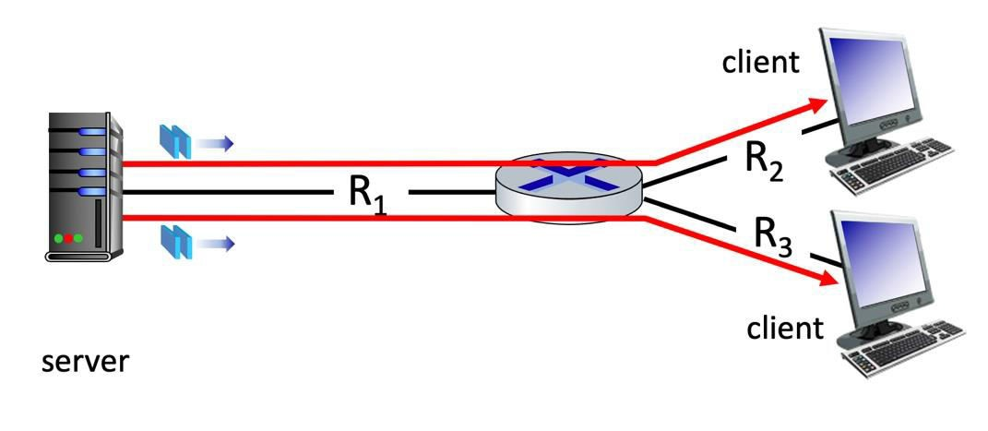

- How long does it take the server to transmit a packet into its link?
Delay = (5 Mbit / 250 Mbps) + 0.002 s = 0.022 s
- When the sender begins sending a packet to one of the two clients, what is the end-to- end delay until it is received by the client (the answer is the same for both
clients)? Consider store-and-forward packet transmission with zero queueing delay and processing delay.
Delay = 0.022 s + [(5 Mbit / 50 Mbps) + 0.002 s] = 0.124 s

- Assume that the link with capacity 𝑅1 is fairly shared between the two sessions. What is
the maximum end-to-end throughput achieved by each session, assuming both sessions
are sending at the maximum rate possible?
Max throughput = 50 Mbps

- Assume that the link with capacity 𝑅1 is fairly shared between the two sessions, and
𝑅2 = 200 𝑀𝑏𝑝𝑠 and 𝑅3 = 70 𝑀𝑏𝑝𝑠. What is the maximum end-to-end throughput achieved by each session, assuming the sender is sending to receivers at the maximum
rate possible?
Max throughput (R2) = 125 Mbps
Max throughput (R3) = 70 Mbps

