**Assignment 5**

**Liam Cardenas, CSIL: liamcardenas, Perm: 7159965**

**Steven Cabral, CSIL: scabral, Perm: 6801179**

Program instructions: Compile program using normal makefile. Run program by the following command: ./life r <filename> <number of rows/columns> <number of iterations>

Make sure that n is some number divisible by the number of processors or the program will not work.

*Time was measured using the real time from the unix/bash “time” command.*

This shows what happens when n is scaled from 100 to 900 on 2 workers, and with 1000 iterations:

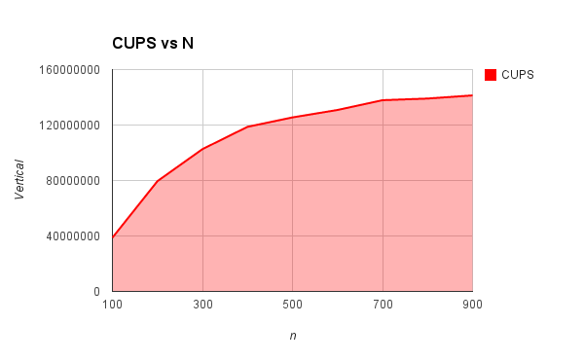

|  |  |  |
| --- | --- | --- |
| n | time | CUPS |
| 100 | 0.258 | 38759689.92 |
| 200 | 0.503 | 79522862.82 |
| 300 | 0.877 | 102622577 |
| 400 | 1.348 | 118694362 |
| 500 | 1.992 | 125502008 |
| 600 | 2.751 | 130861504.9 |
| 700 | 3.553 | 137911624 |
| 800 | 4.601 | 139100195.6 |
| 900 | 5.73 | 141361256.5 |

This shows what happens when the workers are scaled from 1 to 16 with n = 1600 and 1000 iterations:

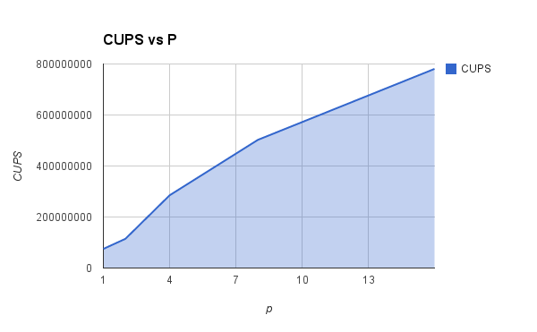

|  |  |  |  |
| --- | --- | --- | --- |
| p | time | CUPS | Parallel Efficiency |
| 1 | 34.165 | 74930484.41 | 1 |
| 2 | 22.344 | 114572144.6 | 0.7645229144 |
| 4 | 8.98 | 285077951 | 0.9511414254 |
| 8 | 5.094 | 502552022 | 0.8383637613 |
| 16 | 3.279 | 780725831 | 0.6512084477 |

And last, but not least, parallel efficiency vs p, on the previous data set:

