Can a stored procedure return an output value to its caller?

Yes. By assigning the output value to an output parameter.

Yes. By issuing a return statement with the output value.

Yes. By using a read-only table-valued parameter.

No. A caller of a stored procedure call cannot get any output value from it.

Give the correct logical model for this ERD.  
 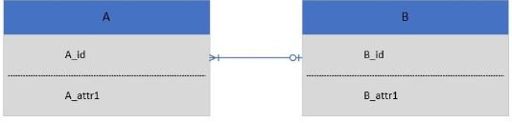

i.     A(A_id, A_attr1) with primary key (A_id)

ii.    A(A_id, B_id, A_attr1) with primary key (A_id) and foreign key B_id

iii.   B(B_id, A_id, B_attr1) with primary key (B_id) and foreign key A_id

iv.   B(B_id, B_attr1) with primary key (B_id)

i and iii

i and iv

ii and iii

ii and iv

 Give the correct logical model for this ERD.  
 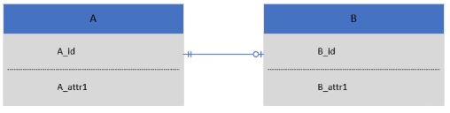

i.     A(A_id, A_attr1) with primary key (A_id)

ii.    A(A_id, B_id, A_attr1) with primary key (A_id) and foreign key B_id

iii.   B(B_id, A_id, B_attr1) with primary key (B_id) and foreign key A_id

iv.    B(B_id, B_attr1) with primary key (B_id)

Group of answer choices

i and iii

i and iv

ii and iii

ii and iv 

Give the correct logical model for this ERD.  
 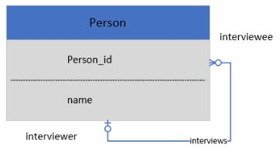

Group of answer choices

Interviewer(Person_id, name) with primary key (Person_id)  and  
Interviewee(Person_id, name) with primary key (Person_id)

Person(Person_id, name, interviewer, interviewee) with primary key (Person_id)

Person(Person_id, name,  interviewee_id) with primary key (Person_id)  and foreign key interviewee_id

Person(Person_id, name,  interviewer_id) with primary key (Person_id)  and foreign key interviewer_id

Which is the minimum isolation level that can prevent the lost update problem?

Read uncommitted

Read committed

Repeatable read

Serializable

Which scenario requires the use of a cursor?

Given a list of product code, display the products whose product code is in the list, and the products have been ordered at least twice. The products must also cost at least 50 dollars.

Given a list of customer id, insert the ids in the list if they are not in the customer table yet.

Given a list of student id, module code, and an assignment score and an exam score for the module, display the student id, module code and final score for the module. Assume that assignment score contributes 30% and exam score contributes 70% to the final score.

None of the above.

Which SQL statement adds a new column, newColumn to the table, aTable?

create table aTable add newColumn char(10)

alter table aTable add column newColumn char(10)

alter table aTable add newColumn char(10)

create table aTable add column newColumn char(10)

Which statement about a view is false?

A view can be created from another view

A view can contain computed or derived columns

An inline view is a temporary view

None of the above is false

You need to ensure that only inactive student can be removed from the database.  Which type of module is most suited for this task?

Stored procedure

Function

Trigger

Any of the specified modules

You need to ensure that there is at least one ordered item inserted for every new customer order. Which type of module is most suited for this task?

Stored procedure

Function

Trigger

Any of the specified modules