Q1a)

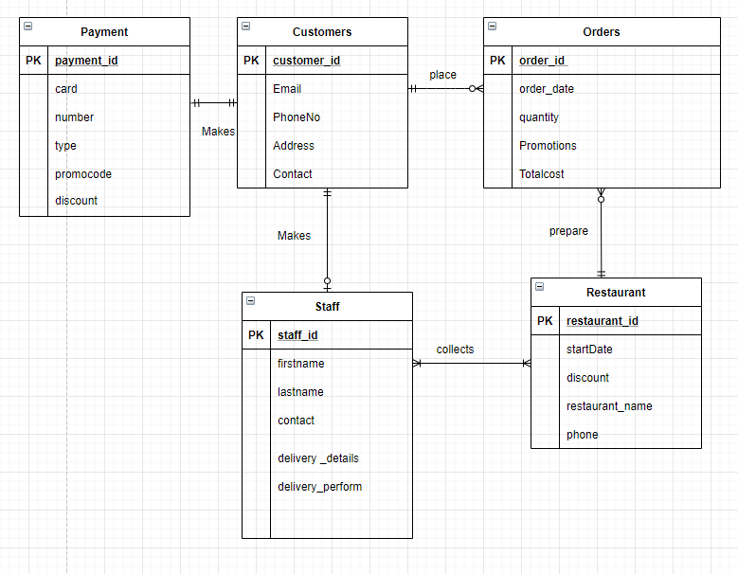

Q2a)

|  |
| --- |
| Functional Dependency |
| patientId -> patientName, dateOfBirth, visitDate,  dentistId -> dentistName, designation, consultationRate |

|  |
| --- |
| Multi Valued Dependency |
| ItemCode ->-> cost, isDiscountable  ItemCode ->-> paymentStatus, ItemCostIncurred  patientId ->-> isSubsidised  patientId ->-> paymentStatus |

3a)

4a)

i)

ii)

b)

Q4b)