Forecasting China's Quarterly Retail Sales With a Lunar New Year Adjustment
⟨Member 1 Name / Student ID⟩ ⟨Member 2 Name / Student ID⟩ ⟨Member 3 Name / Student ID⟩ ⟨Member 4 Name / Student ID⟩
1. Forecasting Question
Can the quarterly total retail sales of consumer goods in China (社会消费品零售总额) be forecast reliably two quarters — six months — ahead, and does explicitly accounting for the moving position of the lunar New Year improve out-of-sample accuracy relative to a standard seasonal model? We address three sub-questions: (i) how accurate are simple benchmarks — the historical mean, the naive and the seasonal-naive forecast — at the two-quarter horizon?; (ii) does a seasonal ARIMA model outperform these benchmarks once the series is appropriately transformed and seasonally differenced?; and (iii) does adding a continuous calendar variable for the lunar New Year's position improve accuracy near the January–February boundary? Quarterly retail sales are a headline indicator of household consumption and an input for retailers' inventory and staffing decisions, consumption-policy assessment and short-term demand analysis, so accurate six-month-ahead forecasts with honest uncertainty measures have direct practical value.
2. Data
The primary series is the national quarterly total retail sales of consumer goods, published by the National Bureau of Statistics of China (NBS) and accessed through the official National Data platform (https://data.stats.gov.cn). In the underlying monthly series NBS published distinct January and February values through 2011, but from 2012 onward it publishes January and February only as a combined “Jan–Feb” total. We therefore work at quarterly frequency: Q1 is the published Jan–Feb total plus March, and Q2–Q4 are recovered by differencing the official cumulative series. This construction reproduces the published annual totals exactly. The quarterly series runs 1994Q1 to 2026Q2, giving 130 observations across 32 complete seasonal cycles plus the first two quarters of 2026 — far above the guideline of at least 60 observations and 4 complete cycles. A secondary quarterly series, the manufacturing PMI (2005Q1–2026Q2, 86 observations), is obtained by averaging the monthly survey reading and is retained as a candidate explanatory variable. The dataset table below documents source, coverage, variables and known data-quality issues.
Item | Detail
Original source and link | National Bureau of Statistics of China, National Data (国家数据), https://data.stats.gov.cn  (monthly data ⇒ domestic trade ⇒ retail sales; other ⇒ purchasing managers index). Retrieved 28 Sep 2026.
How the data were collected | Monthly statistical reports by wholesale/retail enterprises above a turnover threshold, aggregated by NBS; PMI from NBS’s monthly survey of purchasing managers. Construction validated against published annual totals.
Time period and frequency | Retail 1994Q1 to 2026Q2 at quarterly frequency (built from official monthly releases); PMI 2005Q1–2026Q2.
Number of observations | 130 quarterly retail observations; 86 quarterly PMI observations.
Variable(s) available | Quarterly nominal retail sales (亿元, log-transformable) and quarterly manufacturing PMI (%); lunar New Year calendar position per year (metadata).
Missing values / known data-quality issues | Since 2012 Jan–Feb published only as a combined total (handled by quarterly aggregation); current-month vs cumulative series disagree in 2005 (≈5%) and 2011 (≈0.2%) — the cumulative vintage equals official annual totals and is used for 2000+; COVID-19 outliers in 2020Q1 and 2022Q2 retained and interpreted.
Seasonality check | Stable 4-quarter cycle; 32 complete annual cycles; Q4 always the strongest quarter.
Legal / ethical suitability | Public statistical releases by a national statistics office; suitable for non-commercial academic use.

3. Main Features of the Series
⟨INSERT Figure 1: time plot of logged quarterly retail sales, 1994Q1–2026Q2, with 2020Q1 and 2022Q2 annotated.⟩

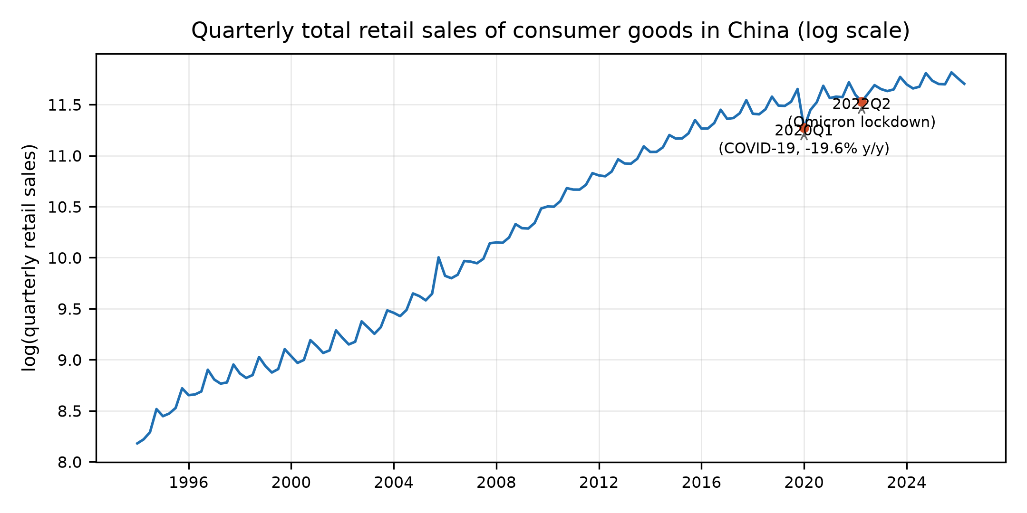

Figure 1. Quarterly total retail sales of consumer goods in China (seasonal period 4), log scale.
Level and trend: retail sales rise almost monotonically from ¥0.36 trillion per quarter in 1994Q1 to ¥12.10 trillion in 2026Q2, and the spread widens with the level — this motivates a log (Box–Cox) transformation. The COVID-19 disruptions of 2020Q1 (−19.6% year-on-year) and 2022Q2 stand out as sudden, genuine events.
Within-year seasonality: the seasonal swing is large, and the ranking is remarkably stable — Q4 (28.5% of the yearly total on average) is the strongest quarter in every one of the 32 complete years, followed by Q1 (23.7%); Q2 is the most common trough (23.4%).
Stability of the seasonal pattern: the January–February balance shifts with the lunar New Year, whose date moves between late January and mid-February. In the 1994–2011 monthly data, February’s share of the combined Jan–Feb retail total averages 0.909 when CNY falls in January but 0.949 when it falls in February; at quarterly level, Q1’s share of the annual total rises correspondingly from 23.4% (CNY in January) to 23.9% (CNY in February). Because January and February are published jointly from 2012, this drift enters our models as a continuous CNY-position covariate rather than through fixed monthly seasonal factors.
4. Potential Data-Quality Issues
Missing or combined months: since 2012 January and February exist only as a combined Jan–Feb figure; we aggregate to quarterly totals so no observation is dropped and no value is imputed.
Duplicated dates: none. Every series comes from a single NBS endpoint and a consistency script verifies that monthly periods are unique (no duplicates) and reports any absent months before aggregation.
Irregular timing: the lunar New Year shifts the effective season between January and February, so fixed seasonal factors are only approximate; the CNY-position covariate is designed to capture exactly this.
Outlying observations: 2020Q1 (−19.6% year-on-year) and 2022Q2 reflect COVID-19 control measures; they are real events and are retained and interpreted rather than removed.
Handling principle: retain genuine outliers with interpretation; never impute absent months; validate every construction step against the officially published cumulative totals.
5. Analysis Goals and Preliminary Analysis Plan
Analysis goals: (i) understand the temporal structure through plots, ACF/PACF and stationarity tests, with transformation and differencing choices that are statistically justified; (ii) construct and compare suitable forecasting models — benchmarks, seasonal ARIMA, and a dynamic-regression extension with the lunar New Year and PMI — on out-of-sample accuracy; (iii) produce two-quarter-ahead (six-month) point forecasts with prediction intervals and discuss their uncertainty.
Preliminary plan: (a) identification — log-transform, then ACF/PACF, ADF/KPSS stationarity tests and seasonal differencing at period 4; (b) candidate models — historical mean, naive and seasonal-naive benchmarks; a seasonal ARIMA (p,d,q)×(P,D,Q)₄ on log retail with orders chosen by ACF/PACF, AICc and residual diagnostics; and a dynamic-regression (ARIMAX) specification adding a CNY-position covariate (fraction of Q1 elapsed before CNY) and the quarterly PMI, with one supplementary method (ETS or Theta) as a robustness check; (c) evaluation — rolling-origin out-of-sample assessment at horizon h = 2 quarters using MAE, RMSE and MASE on a common test window (2005Q1 onward, the PMI sample), residual diagnostics via Ljung–Box and residual ACF/PACF, and final two-quarter forecasts with 80% and 95% intervals, with a discussion of interval width and practical usability.
References
National Bureau of Statistics of China. National Data (国家数据) — retail sales and purchasing managers index datasets. https://data.stats.gov.cn. Retrieved 28 September 2026.
National Bureau of Statistics of China (2025). 社会消费品零售总额统计指标说明及第五次全国经济普查修订说明 (indicator annotation retrieved from the National Data platform).
National Bureau of Statistics of China. 采购经理指数编制加工说明. http://www.stats.gov.cn.
Hyndman, R. J., & Athanasopoulos, G. (2021). Forecasting: Principles and Practice (3rd ed.). OTexts.
Shumway, R. H., & Stoffer, D. S. (2017). Time Series Analysis and Its Applications (4th ed.). Springer.

一句话版本
「我们想知道：中国的消费品零售总额（大家买东西的总金额）未来半年怎么走，能不能预测准，顺便看看——如果把春节在 1 月还是在 2 月考虑进去，预测会不会更准。」
1. 预测什么、为什么有意义（§1）
- 预测对象：全国每个月/每季度大家在零售上花了多少钱（社零，统计局发布的官方数）。
- 为什么有人在乎：零售商要备货、招聘；政府要看消费政策有没有用；做短期经济分析的人需要前瞻。
- 具体要回答三个小问题：
1. 最简单的「无脑预测」（历史平均、去年同月、跟着上月走）能做到多准？
2. 正规的季节性 ARIMA 模型能不能超过这些无脑预测？
3. 引入春节位置这个变量后，会不会更准？
2. 数据（§2）
- 用国家统计局的官方数据（国家数据平台），全国加总。
- 两个变量：
- 社零（主变量，要预测的）：季度值，1994 Q1 ~ 2026 Q2，共 130 个数，一个不差。
- 制造业 PMI（辅助变量）：每个季度制造业经理对未来景气度的打分，2005 年起 86 个数，用来当「外生解释变量」——因为消费景气通常跟着制造业/经济景气走。
3. 数据本身有三个坑，我们怎么处理的（§2 表格 + §4）
1. 2012 年起 1 月和 2 月合并发布：统计局不再分别告诉你 1 月和 2 月各卖了多少，只给「1-2 月合计」。→ 所以我们不做月度、做季度，把 1-2 月当一个整体，正好绕开这个缺口，一个数据都不用编。
2. 「当月值」和「累计值」两个版本在个别年份对不上（2005 年差 5% 左右）。→ 我们核对后采用和官方年度总和完全一致的那个版本，并在报告里写明。
3. 2020 Q1、2022 Q2 出现断崖：是疫情/封控的真实冲击。→ 不删、不修，当真实事件解释，顺便拿它展示方法的稳健性。
4. 我们发现了什么（§3，最有故事性的部分）
看图（Figure 1）能直接看到三件事：
1. 长期涨：从 1994 年每季度 ¥0.36 万亿涨到 2026 年 ¥12.1 万亿，涨了 30 多倍——量级变大，方差也变大，所以建模时要取对数，让数据更平稳。
2. 季节性超强：每年 Q4（双十一/年末购物季）几乎都是全年最猛的一个季度——32 年里年年如此，占全年约 28.5%；Q2 通常最弱。
3. 春节会漂移（这是我们的差异化卖点）：春节要么在 1 月、要么在 2 月，导致每年的「1 月 vs 2 月」消费配比不一样。用 1994–2011 年有逐月数据的年份验证：春节在 1 月时，2 月/1 月零售比约 0.909；春节在 2 月时升到 0.949。→ 固定季节因子不够，必须把「春节在哪个月」当变量放进去。
5. 接下来打算怎么做（§5）
几步递进，像盖楼：
1. 打地基：取对数、画 ACF/PACF、做单位根检验，决定要不要差分——都是为让数据长得像「可预测的平稳序列」。
2. 起跑线：三个简单的基准模型（历史均值、naive、seasonal-naive）。
3. 主力模型：季节性 ARIMA(p,d,q)×(P,D,Q)₄——就是假设「今年 Q4 跟往年 Q4 有关、最近一季度跟上一季度有关」这类规律的模型。
4. 升级版：在主力模型上加入两个外部变量——春节位置（Q1 过了百分之多少才轮到春节）和 PMI。
5. 考试环节：用「滚动预测」——不断用过去的数据建模、预测未来 2 个季度，拿 MAE/RMSE/MASE 比谁错得最少；最后给出未来半年的预测和 80%/95% 置信区间，并讨论预测到底有多可信。
一句话：「我们想在统计局官方数据上，预测中国零售总额半年后的走势，并且测试一个更聪明的做法——把每年移动的春节考虑进模型。数据都是公开官方数据，我们发现了几个别人容易忽略的数据陷阱（1-2 月合并、口径差异），都用核实过的办法处理了。最后会比几个模型谁预测得更准，并给出带区间的预测。」

