General information
A framework that simplifies the creation of simple reports using Apache POI.
This version of the builder is designed to support legacy code; the library is compiled for Java 1.5 and uses Apache POI 3.8. This combination can only be used to generate reports in the old Excel .xls format (using org.apache.poi.hssf).

Report entities
General report outline:
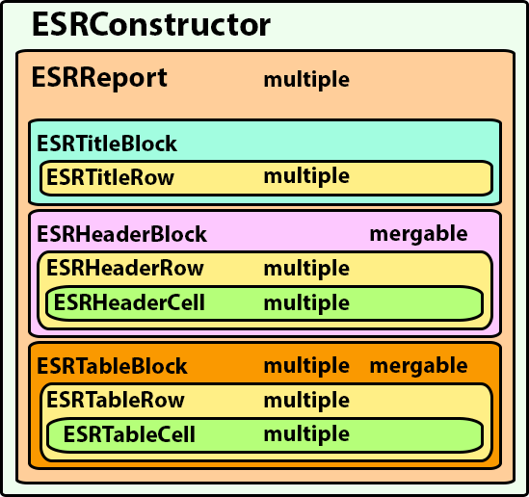
Object | Description | Objects that can be added
ESRConstructor | The main object to which the HSSFWorkBook object must be passed | ESRReport (multiple)
ESRReport | Report object. May consist of descriptive information, a header block, and a main table composed of blocks | ESRTitleBlock  ESRHeaderBlock  ESRTableBlock (multiple)  ESRSingleRowBlock (multiple)
ESRTitleBlock | Descriptive information block.  It combines the maximum number of columns available in the report. | ESRTitleRow (multiple)
ESRTitleRow | Row of descriptive information section
ESRHeaderBlock | Header block  Repeats on every new page of the report | ESRHeaderRow (multiple)  ESRMerge
ESRHeaderRow | Row of header block | ESRHeaderCell (multiple)
ESRHeaderCell | Cell of header section row
ESRTableBlock | Table block of main information.  Row numbering in each block starts at 0, which makes it easier to define merger regions. | ESRTableRow (multiple)  ESRMerge
ESRSingleRowBlock | A block of main information consisting of a single row.  This makes it easier to create reports that do not require row merging.  Please note that adding a row will always overwrite the only row currently in the block that may already exist. | ESRTableRow
ESRTableRow | Row of main information block | ESRTableCell (multiple)
ESRTableCell | Cell of main information block row
ESRMerge | An object containing a list of cell merges within a block.  Note that row numbering in each block starts at 0.

General procedure for creating a report:
1. Create a new ESRConstructor5 report builder and pass the created HSSFWorkbook to it;
2. Create an ESRReport. The report may contain a preliminary information block (ESRTitleBlock), a header block (ESRHeaderBlock), and multiple information blocks (ESRTableBlock) that hold the report data. Note that you can combine multiple reports within a single constructor. Each report will start on a new sheet relative to the previous one.
3. The ESRTitleBlock is used to add information at the beginning of a report (for example, a row describing the report and other introductory information). This block can contain multiple rows. It will always be positioned at the very beginning of the report. It will always span the maximum number of columns used in the report. The block can contain multiple text rows, which are added using the addTitleRow(String titleRow) method. You can apply the HSSFCellStyle style to the block.
4.

