Tạo trang index.html và trang story.html như hình bên dưới, các hình ảnh cần thiết được đặt trong thư mục images, các đoạn text được cung cấp bên dưới.

Thực hiện các yêu cầu như sau:

* Tạo liên kết cho trang index.html (Figure 1) như sau:
  + Bấm nút [Our Story] liên kết tới trang story.html (Figure 2)
  + Nút [product] và [this week] liên kết rỗng
  + Color: #ca9b33
* Tạo liên kết cho trang story.htm như sau:
  + Bấm vào nút [Home] liên kết tới tập tin index.htm
  + Bấm vào banner liên kết tới phần “what makes SCAAL the best coffee?”
  + Bấm chữ [>>top] liên kết về đầu trang
  + Bấm iMedia.com mở trang web www.imedia.com
  + Bấm webmaster@imedia.com gởi thư theo địa chỉ đó.
  + Color: #cccc9a, #999968, #7e8200, #ff1493

Figure : index.html

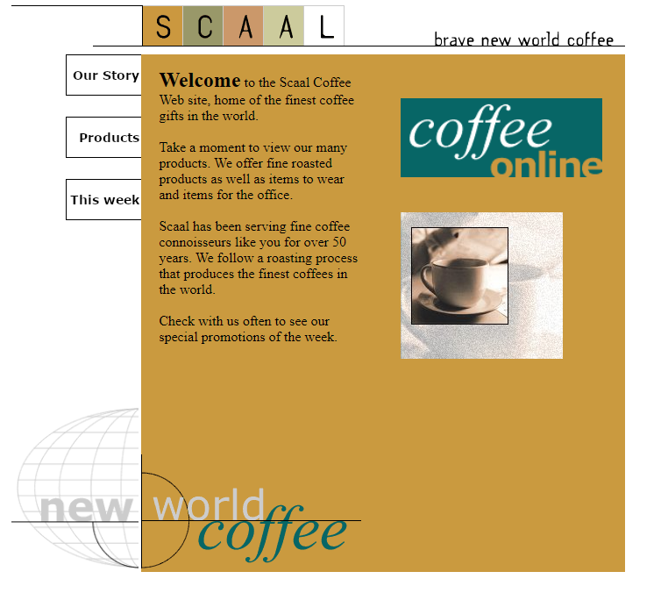

Figure : story.html

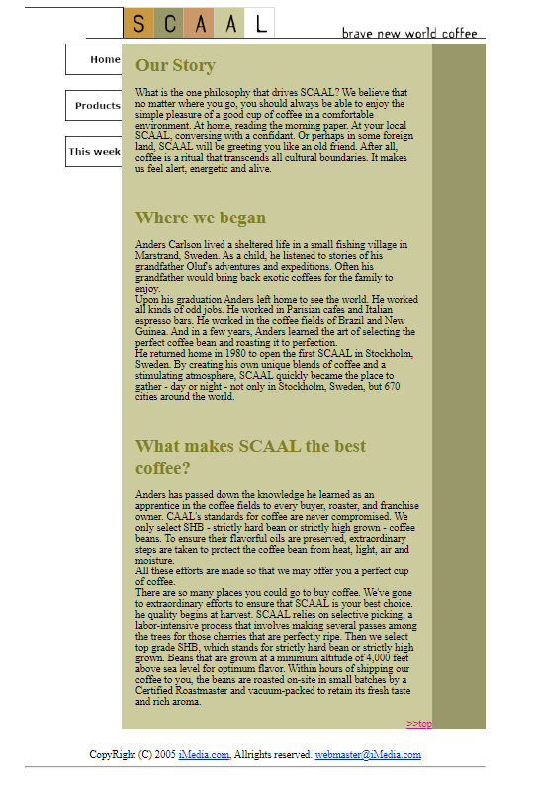

Welcome to the Scaal Coffee Web site, home of the finest coffee gifts in the world.

Take a moment to view our many products. We offer fine roasted products as well as items to wear and items for the office.

Scaal has been serving fine coffee connoisseurs like you for over 50 years. We follow a roasting process that produces the finest coffees in the world.

Check with us often to see our special promotions of the week.

Our Story

What is the one philosophy that drives SCAAL? We believe that no matter where you go, you should always be able to enjoy the simple pleasure of a good cup of coffee in a comfortable environment. At home, reading the morning paper. At your local SCAAL, conversing with a confidant. Or perhaps in some foreign land, SCAAL will be greeting you like an old friend. After all, coffee is a ritual that transcends all cultural boundaries. It makes us feel alert, energetic and alive.

Where we began

Anders Carlson lived a sheltered life in a small fishing village in Marstrand, Sweden. As a child, he listened to stories of his grandfather Oluf’s adventures and expeditions. Often his grandfather would bring back exotic coffees for the family to enjoy.

Upon his graduation Anders left home to see the world. He worked all kinds of odd jobs. He worked in Parisian cafes and Italian espresso bars. He worked in the coffee fields of Brazil and New Guinea. And in a few years, Anders learned the art of selecting the perfect coffee bean and roasting it to perfection.

He returned home in 1980 to open the first SCAAL in Stockholm, Sweden. By creating his own unique blends of coffee and a stimulating atmosphere, SCAAL quickly became the place to gather – day or night – not only in Stockholm, Sweden, but 670 cities around the world.

What makes SCAAL the best coffee?

Anders has passed down the knowledge he learned as an apprentice in the coffee fields to every buyer, roaster, and franchise owner. SCAAL's standards for coffee are never compromised. We only select SHB – strictly hard bean or strictly high grown – coffee beans. To ensure their flavorful oils are preserved, extraordinary steps are taken to protect the coffee bean from heat, light, air and moisture.

All these efforts are made so that we may offer you a perfect cup of coffee.

There are so many places you could go to buy coffee. We've gone to extraordinary efforts to ensure that SCAAL is your best choice. The quality begins at harvest. SCAAL relies on selective picking, a labor-intensive process that involves making several passes among the trees for those cherries that are perfectly ripe. Then we select top grade SHB, which stands for strictly hard bean or strictly high grown. Beans that are grown at a minimum altitude of 4,000 feet above sea level for optimum flavor. Within hours of shipping our coffee to you, the beans are roasted on-site in small batches by a Certified Roastmaster and vacuum-packed to retain its fresh taste and rich aroma.

CopyRight (C) 2005 iMedia.com, Allrights Reserved. Webmaster@iMedia.com