E213: Engineering Cost Decisions
Workshop additional exercises
Question 1
A company purchased its current machine model XX 10 years ago for $300,000. The current market value is $50,000. The company is intended to use this machine for another 5 years. At the end of 5 years, the model XX will have a salvage value of $0.
A new model YY of the machine is available in the market at $500,000. The service life of the new model YY is 8 years and the salvage value at the end of 8 years is $20,000. The company is thinking of replacing the model XX with model YY.
Table below provides the operating cost for the two machine models over the next 5 years. Assume MARR is at 16.67%.
Year | Model XX ($) | Model YY ($)
1 | 120,000 | 10,000
2 | 125,000 | 15,000
3 | 130,000 | 20,000
4 | 135,000 | 25,000
5 | 140,000 | 30,000

- Identify defender and challenger. Justify your answer.

- Assume straight line depreciation. Should the model XX be replaced with model YY?

Question 2
Three mutually exclusive public project alternatives are currently under consideration. The Present Worth of the respective costs and benefits are included in the table below.
 | Project A | Project B | Project C
Present Worth of Cost | $15,936,111 | $17,188,241 | $18,940,370
Present Worth of Benefit | $21,316,851 | $22,475,055 | $24,787,036
Benefit-Cost (B-C) Ratio | BC1 | BC2 | BC3

- Calculate the BC1, BC2 and BC3. Which project has the highest Benefit-Cost ratio?

- To conduct the Incremental Benefit-Cost Ratio analysis, which project is to be selected as the baseline alternative? Explain.

- Which project is to be selected to compare with the baseline project? Compare it with the baseline project and identify which project should be selected.

- Complete the Incremental Benefit-Cost Ratio analysis by comparing the remaining project with the baseline project selected in c) above. State which project should be selected.

- What are the differences between public and private projects? Why Benefit-Cost Ratio analysis is preferred in public project evaluation? What are disadvantages of applying Benefit-Cost Ratio analysis when evaluating public projects?
 | Public Projects | Private Projects
Purpose
Funding
Beneficiaries
Type of Cash flow
Selection Criteria
Project Life

Question 3

Show all your workings clearly with at least four decimal places for factor notation used and round off all answers to two decimal places. MS Excel functions (eg NPV(),IRR()) are not acceptable as workings.

Jenny is considering an investment with the following estimated information given in Table 4. There will be no salvage value for the investment at the end of the project.

Table 4: Estimated information of the investment project
Initial Investment ($) | 680,000
Annual Revenue ($) | 266,000
Annual Expense ($) | 102,000
Useful Life (Years) | 12
Minimum Attractive Rate of Return (MARR) | 20%

However, she is worried that the feasibility of the investment might be sensitive to the 4 key factors: Initial Investment, Annual Revenue, Annual Expense and Useful life.

- She performed a sensitivity analysis to see how the Net Present Worth changes as each of the 4 factors changes. Table 5 below shows the results of the sensitivity analysis.

Table 5: Table of Net Present Worth for Varied Factor Values
% Change in Factor | Useful Life | Annual Revenue | Annual Expense | Initial Investment
-30% | -$37,292.92 | -$306,217.95 | $183,871.57 | $252,031.54
-20% | -$2,453.75 | -$188,134.79 | $138,591.56 | $184,031.54
-10% | $25,539.30 | -$70,051.62 | $93,311.55 | $116,031.54
0% | (A) | $48,031.54 | $48,031.54 | $48,031.54
10% | $66,103.92 | $166,114.71 | $2,751.53 | -$19,968.46
20% | $80,624.96 | $284,197.87 | (B) | -$87,968.46
30% | $92,292.53 | $402,281.04 | -$87,808.49 | -$155,968.46

- Without calculation, determine (A) as indicated in Table 5. (1 mark)

- Calculate (B) as indicated in Table 5. (5 marks)

- Jenny plotted the sensitivity graph to show how the Net Present Worth changes as each of the 4 factors changes as shown in Figure 1.

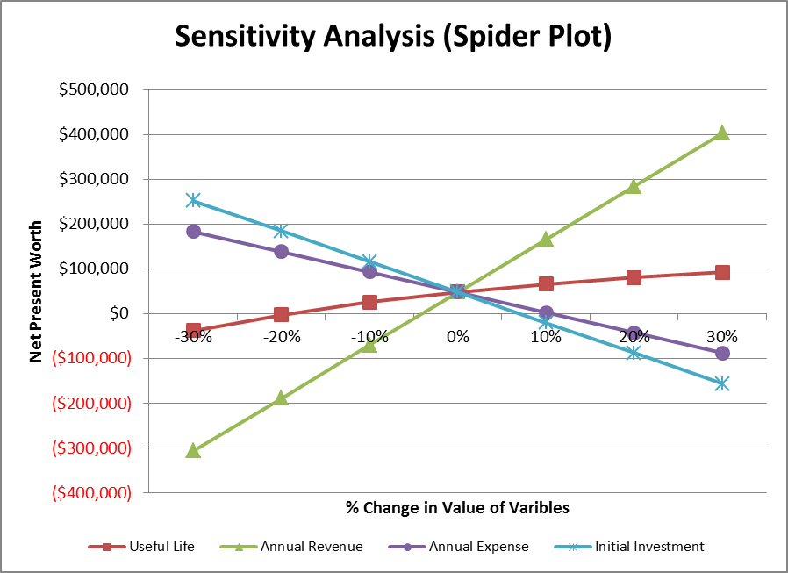

Figure 1: Sensitivity Graph

- Which factor is more sensitive, Initial Investment or Annual Expense? Explain. (2 marks)

- Identify the most sensitive and the least sensitive factors of the investment. (2 marks)

- Jenny realized that the annual revenue is $230,000 instead of the current estimate of $266,000. Based on the Spider Plot in Figure 1, determine whether the investment will still be feasible if all the other factors remain unchanged. Explain clearly with workings. (4 marks)

