**Section: Question 1**

**Multiple Choice Question (only ONE answer is required)**

Top of Form



|  |  |  |
| --- | --- | --- |
| **Q1:** | “This strategy receives orders from customer prior to assembly but pulls the required components to assemble the order”.  Which of the following production strategies best describes the above statement? | **Mark (1)** |
|  | Engineer-To-Order (ETO) | |
|  | Configure-To-Order (CTO) | |
|  | Build-To-Stock(BTS) | |
|  | Build-To-Order (BTO) | |

Bottom of Form

Top of Form



|  |  |  |
| --- | --- | --- |
| **Q2:** | Which of the following statements is NOT TRUE about the production strategies? | **Mark (1)** |
|  | CTO is a pure-pull system | |
|  | CTO assembles the product based on a configurable order | |
|  | BTO builds the product upon placement of customised order | |
|  | BTO is a push-pull system | |

Bottom of Form

Top of Form



|  |  |  |
| --- | --- | --- |
| **Q3:** | The key considerations for designing distribution network is to meet customer _________ while managing the associated _________ of meeting the expectations. | **Mark (1)** |
|  | service, risks | |
|  | demand, processes | |
|  | needs, costs | |
|  | satisfaction, operations | |

Bottom of Form

Top of Form



|  |  |  |
| --- | --- | --- |
| **Q4:** | By the codification standards of the SCOR Version 12.0, which process level is **sD3.15**? | **Mark (1)** |
|  | 4 | |
|  | 2 | |
|  | 1 | |
|  | 3 | |

Bottom of Form

Top of Form



|  |  |  |
| --- | --- | --- |
| **Q5:** | Which of the following strategic roles is NOT a valid classification for supply chain facility? | **Mark (1)** |
|  | Contributor | |
|  | Outsource | |
|  | Offshore | |
|  | Server | |

Bottom of Form

Top of Form



|  |  |  |
| --- | --- | --- |
| **Q6:** | Which of the following factors is NOT a key consideration when expanding business into a foreign country? | **Mark (1)** |
|  | Political | |
|  | Geographical | |
|  | Exchange rate | |
|  | Demand | |

Bottom of Form

Top of Form



|  |  |  |
| --- | --- | --- |
| **Q7:** | The followings list the steps involved in transportation route planning except ONE. | **Mark (1)** |
|  | Maximise vehicle load capacity on each route option | |
|  | Build the distance matrix | |
|  | Sequence the route | |
|  | Calculate the distance saving | |

Bottom of Form

Top of Form



|  |  |  |
| --- | --- | --- |
| **Q8:** | When using the Savings Matrix Method, what could be considered as an alternative to Distance saving? | **Mark (1)** |
|  | Capacity | |
|  | Fuel cost | |
|  | Travel time | |
|  | Manpower | |

Bottom of Form

Top of Form



|  |  |  |
| --- | --- | --- |
| **Q9:** | From operation perspective, one of the followings will NOT be a consideration in any disaster response and relief project. | **Mark (1)** |
|  | Transportation | |
|  | External environment | |
|  | Internal operational requirements | |
|  | Labour market | |

Bottom of Form

Top of Form



|  |  |  |
| --- | --- | --- |
| **Q10:** | The time interval between raw materials payment and sales collection of finished goods is known as the: | **Mark (1)** |
|  | Cash conversion cycle | |
|  | Accounts Receivable cycle | |
|  | Inventory cycle | |
|  | Accounts Payable cycle | |

Bottom of Form

Top of Form



|  |  |  |
| --- | --- | --- |
| **Q11:** | Which of the followings is NOT a SCOR performance attribute? | **Mark (1)** |
|  | Cost | |
|  | Reliability | |
|  | Agility | |
|  | Responsibility | |

Bottom of Form

Top of Form



|  |  |  |
| --- | --- | --- |
| **Q12:** | One of the following statements is TRUE about Bullwhip effect. | **Mark (1)** |
|  | It occurs due to over reacting to order backlog | |
|  | It cannot be minimised | |
|  | It can be eliminated | |
|  | It is a result of over-stocking | |

Bottom of Form

Top of Form



|  |  |  |
| --- | --- | --- |
| **Q13:** | Which of the following statements is NOT TRUE about “Profit & Loss” account. | **Mark (1)** |
|  | It includes all expenses and taxes incurred for a period of time | |
|  | It can only be reported annually | |
|  | It is also known as Income Statement | |
|  | It presents all revenues for a specified period | |

Bottom of Form

Top of Form



|  |  |  |
| --- | --- | --- |
| **Q14:** | Based on table “Product Characteristics & Customer Preferences”, which one below is an appropriate distribution network option for the product with “Medium Demand, High Product Value and Quick Desired Response Time.” | **Mark (1)** |
|  | Manufacturer Storage with Merge In-Transit | |
|  | Distributor Storage with Package Carrier Delivery | |
|  | Retail Storage with Customer Pickup | |
|  | Manufacturer Storage with Direct Shipping | |

Bottom of Form

Top of Form



|  |  |  |
| --- | --- | --- |
| **Q15:** | Which of the following is NOT a valid type of risk pooling? | **Mark (1)** |
|  | Capacity | |
|  | Lead Time | |
|  | Product | |
|  | Cost | |

Bottom of Form

**Section: Question 2**

Robo-Vac is a popular brand of robotic vacuum cleaners in South East Asia. Their financial figures for FY2016 to 2018 have been consolidated in Table 2.1, Table 2.2, Table 2.3 and Table 2.4 respectively. (Note, one financial year is equal to 365 days.)

**Table 2.1. Extracts of Income Statement (Figures in Million $)**

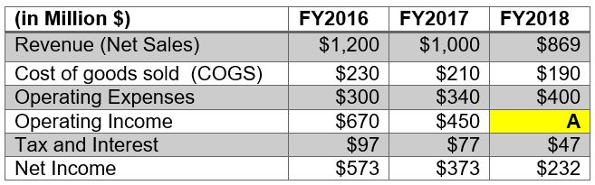

**Table 2.2. Extracts of Balanced Sheet (Figures in Million $)**

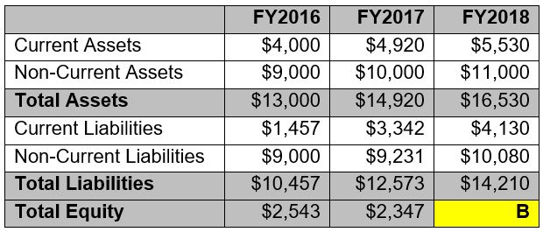

**Table 2.3. Inventory, A/R and A/P (Figures in Million $)**

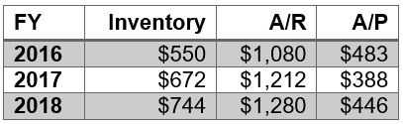

**Table 2.4. Simplified Balanced Sheet (Figures in Days)**

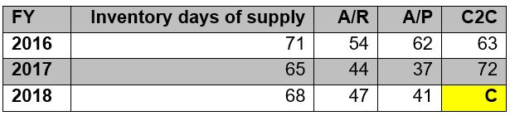

Top of Form



|  |  |  |
| --- | --- | --- |
| **Q16:** | Find the value of **A** as shown in Table 2.1. Round up your answer to the nearest integer. Show the formula and working. | **Mark (2)** |
|  |  | |
|  | Word Count: 13 | Max Words: 1000 |

Bottom of Form

Top of Form



|  |  |  |
| --- | --- | --- |
| **Q17:** | Find the value of **B** as shown in Table 2.2. Round up your answer to the nearest integer. Show the formula and working. | **Mark (2)** |
|  |  | |
|  | Word Count: 8 | Max Words: 1000 |

Bottom of Form

Top of Form



|  |  |  |
| --- | --- | --- |
| **Q18:** | Find the value of **C** as shown in Table 2.4. Show the formula and working. Using the C2C value as reference, which year did the company perform the worst? Provide **ONE (1)** reason as justification. | **Mark (4)** |
|  |  | |
|  | Word Count: 66 | Max Words: 1000 |

Bottom of Form

Top of Form



|  |  |  |
| --- | --- | --- |
| **Q19:** | Calculate the Return on Assets (ROA) of FY 2018 in percentage term. Show your working and round up your answer to 1 decimal place. Explain how inventory reduction may impact the ROA. | **Mark (3)** |
|  |  | |
|  | Word Count: 87 | Max Words: 1000 |

Bottom of Form

Top of Form



|  |  |  |
| --- | --- | --- |
| **Q20:** | Calculate the Return on Capital Employed (ROCE) of FY 2018 in percentage term. Show your working and round up your answer to 1 decimal place. | **Mark (4)** |
|  |  | |
|  | Word Count: 22 | Max Words: 1000 |

Bottom of Form

**Section: Question 3**

HomPal is a well-established consumer brand of smart devices in Asia. As they plan to expand their market into the European Union (EU), they engaged a consultancy firm to design the distribution network for EU markets. Table 3.1 and 3.2 below are the results of the quantitative analysis based on simple scoring method by the consultancy firm.

Table 3.1 Product Characteristics and Customer Preferences

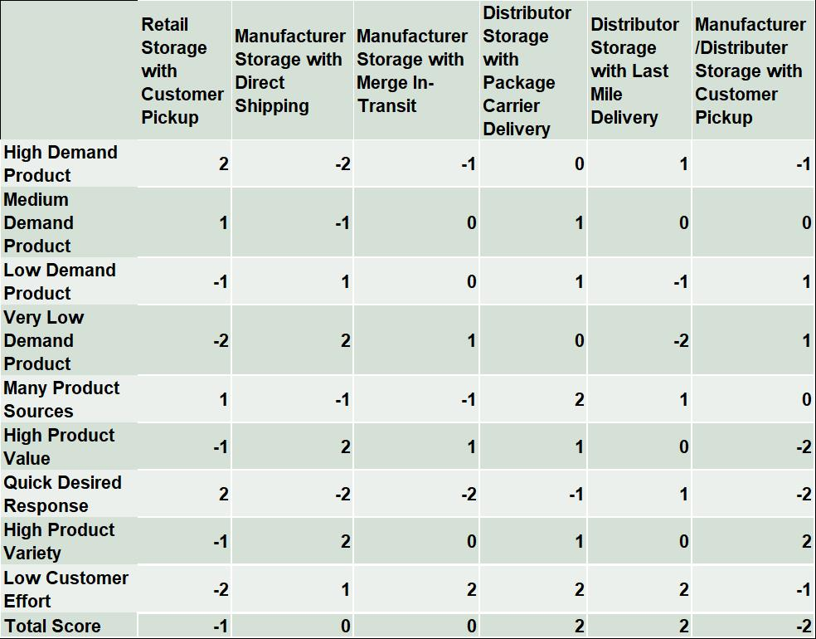

Table 3.2 Customer Services and Supply Chain Costs

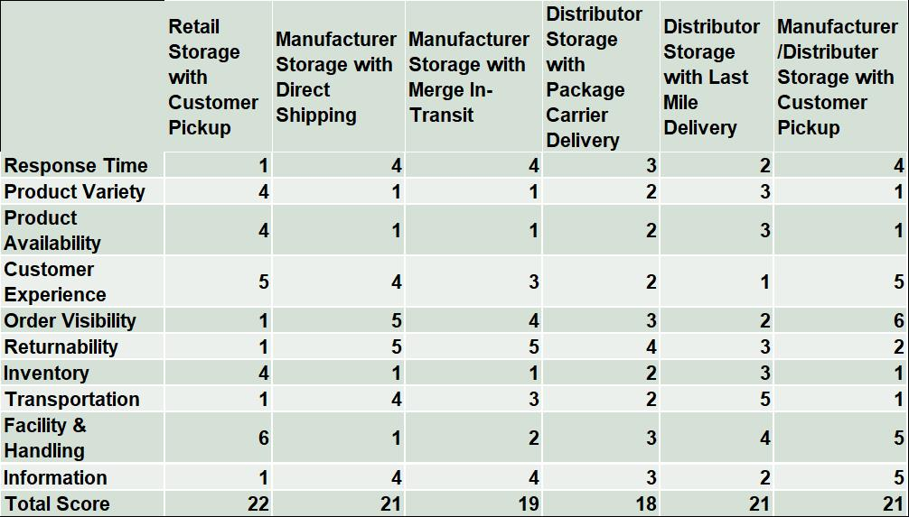

HomPal reviews their supply chain performances regularly. Table 3.3 below is the SCORcard from their benchmarking analysis.

Table 3.3 SCORcard

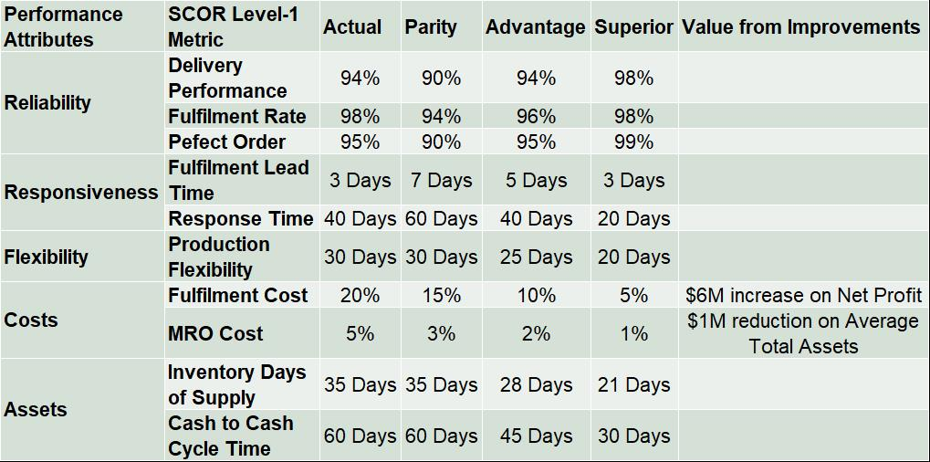

Top of Form



|  |  |  |
| --- | --- | --- |
| **Q21:** | Identify **TWO (2)** distribution networks in Table 3.1 that you would shortlist for consideration. | **Mark (2)** |
|  |  | |
|  | Word Count: 13 | Max Words: 100 |

Bottom of Form

Top of Form



|  |  |  |
| --- | --- | --- |
| **Q22:** | Based on Table 3.2, which distribution network would you recommend? | **Mark (1)** |
|  |  | |
|  | Word Count: 6 | Max Words: 100 |

Bottom of Form

Top of Form



|  |  |  |
| --- | --- | --- |
| **Q23:** | List **TWO (2)** key factors that company needs to consider before recommending the final distribution network design. | **Mark (2)** |
|  |  | |
|  | Word Count: 26 | Max Words: 100 |

Bottom of Form

Top of Form



|  |  |  |
| --- | --- | --- |
| **Q24:** | From Table 3.3, **identify** the SCOR Level-1 Metric for the following respectively.  **i.   ONE (1)** metric that shows HomPal is on par with industry.  ii.  **ONE (1)** metric that shows HomPal is in favourable position.  iii.  **ONE (1)** metric that shows HomPal is the best in class. | **Mark (3)** |
|  |  | |
|  | Word Count: 9 | Max Words: 100 |

Bottom of Form

Top of Form



|  |  |  |
| --- | --- | --- |
| **Q25:** | If HomPal wants to increase the Return On Assets (ROA) with the same sales revenue, select **ONE (1)** metric with value from improvement that will provide the highest ROA. **Explain** your answer. | **Mark (2)** |
|  |  | |
|  | Word Count: 71 | Max Words: 100 |

Bottom of Form

**Section: Question 4**

Samle is an emerging Chinese company and one of the most popular brands in Asia producing premium smart phones and mobile devices. Samle started to expand their business internationally and recently set up their first facility overseas in the United States (US) to leverage on the knowledge and skills in the country.

Top of Form



|  |  |  |
| --- | --- | --- |
| **Q26:** | What was the strategic role of the facility in the US? | **Mark (1)** |

Bottom of Form

Top of Form



|  |  |  |
| --- | --- | --- |
| **Q27:** | As part of the planning for this facility, the company needs to identify a location in US with good infrastructure. List **THREE (3)** infrastructure factors for consideration. | **Mark (3)** |
|  |  | |
|  | Word Count: 13 | Max Words: 1000 |

Bottom of Form

Top of Form



|  |  |  |
| --- | --- | --- |
| **Q28:** | As their products gained popularity worldwide, the company is considering setting up more facilities in other countries to support the growing demand. If Samle has a flexible production technology and is also able to leverage on the economies of scale, will you recommend them to add more facilities? Give **TWO (2)** reasons for your answer. | **Mark (3)** |
|  |  | |
|  | Word Count: 47 | Max Words: 1000 |

Bottom of Form

Top of Form



|  |  |  |
| --- | --- | --- |
| **Q29:** | Samle expanded into South East Asia markets in 2010. In order to provide faster delivery than its competitors, Samle set up 3 distribution centres (DC) in Indonesia, Malaysia and Vietnam respectively. Over the years in operation, the following data were collected and presented in Table 4.1.  Table 4.1. Average and Standard Deviation of Weekly Demand for 3 DC    i.  Which DC has the highest demand uncertainty? Explain your answer.  ii.  Recommend **ONE (1)** strategy to reduce the overall uncertainty and provide the reason behind your recommendation. | **Mark (4)** |
|  |  | |
|  | Word Count: 157 | Max Words: 1000 |

Bottom of Form

Top of Form



|  |  |  |
| --- | --- | --- |
| **Q30:** | To help Samle’s decision on the DC centralisation, list **ONE (1)** advantage and **ONE (1)** disadvantage of a centralised DC from transportation costs’ perspective as compared to decentralised DC. | **Mark (2)** |
|  |  | |
|  | Word Count: 25 | Max Words: 1000 |

Bottom of Form

Top of Form



|  |  |  |
| --- | --- | --- |
| **Q31:** | With the DC centralisation, based on your understanding of distribution network design, suggest **ONE (1)** distribution network for order fulfilment in this setup. Explain your suggestion. | **Mark (2)** |
|  |  | |
|  | Word Count: 50 | Max Words: 1000 |

Bottom of Form

**Section: Question 5**

Star Living is an international manufacturer which produces and distributes modern furniture and furnishing products. They have a local distribution centre that supplies to the local retailer shops. Their products are very popular in the market and sales are so good that the deliveries to their 7 retail shops are arranged on a weekly basis.

Due to rising operation costs, the transportation manager wonders if it is possible to apply Milk Run concept in the delivery planning.

Top of Form



|  |  |  |
| --- | --- | --- |
| **Q32:** | Describe the **THREE (3)** objectives of implementing Milk Run in the delivery planning. | **Mark (3)** |
|  |  | |
|  | Word Count: 20 | Max Words: 100 |

Bottom of Form

Top of Form



|  |  |  |  |  |  |  |  |  |  |  |  |  |  |  |  |  |  |  |  |  |  |  |  |  |  |  |  |  |  |  |  |  |  |  |  |  |  |  |  |  |  |  |  |  |  |  |  |  |  |  |  |  |  |  |  |  |  |  |  |  |  |  |  |  |  |  |  |  |  |  |  |  |  |  |  |  |  |  |  |  |  |  |  |
| --- | --- | --- | --- | --- | --- | --- | --- | --- | --- | --- | --- | --- | --- | --- | --- | --- | --- | --- | --- | --- | --- | --- | --- | --- | --- | --- | --- | --- | --- | --- | --- | --- | --- | --- | --- | --- | --- | --- | --- | --- | --- | --- | --- | --- | --- | --- | --- | --- | --- | --- | --- | --- | --- | --- | --- | --- | --- | --- | --- | --- | --- | --- | --- | --- | --- | --- | --- | --- | --- | --- | --- | --- | --- | --- | --- | --- | --- | --- | --- | --- | --- | --- | --- |
| **Q33:** | Currently Star Living has 2 trucks with a capacity of 300 standard carton boxes each. The delivery order for each retailer and the saving matrix are given in Table 5.1.  Table 5.1. Distance Saving Matrix   |  |  |  |  |  |  |  |  |  | | --- | --- | --- | --- | --- | --- | --- | --- | --- | |  | **Retailer** | | | | | | | **Order Size** | | **Retailer** | **1** | **2** | **3** | **4** | **5** | **6** | **7** | **Boxes** | | **1** | 0 |  |  |  |  |  |  | 50 | | **2** | 2.4 | 0 |  |  |  |  |  | 67 | | **3** | 6 | 5.2 | 0 |  |  |  |  | 57 | | **4** | 7.2 | 3.9 | 10.3 | 0 |  |  |  | 75 | | **5** | 5.3 | 6.8 | 12.3 | 8.9 | 0 |  |  | 63 | | **6** | 8.9 | 6.6 | 14 | 15.5 | 13.4 | 0 |  | 54 | | **7** | 10.8 | 9.9 | 15.6 | 15.4 | 18.8 | 21.6 | 0 | 80 |   Help the transportation manager by applying the Saving Matrix Method to find the routes for both trucks as well as total truck loads. | **Mark (4)** |
|  |  | |
|  | Word Count: 279 | Max Words: 1000 |

Bottom of Form

Top of Form



|  |  |  |
| --- | --- | --- |
| **Q34:** | If the truck capacity is decreased from 300 to 200 carton boxes, how many trucks are required to deliver to all 7 retail shops? | **Mark (1)** |

Bottom of Form

Top of Form



|  |  |  |
| --- | --- | --- |
| **Q35:** | The current order size from the retailer is determined weekly. If the retailers don’t want to keep too much inventory and also to reduce their daily order size, list **TWO (2)** possible changes to Star Living’s current Milk Run operations. | **Mark (2)** |
|  |  | |
|  | Word Count: 78 | Max Words: 100 |

Bottom of Form

**Section: Question 6**

*The following questions are related to the SAP Sales Distribution (SD) module.*

GoSpeed manufactures and distributes scooters and accessories. It has three production plants in China and two factories in America. All facilities have separate storages for raw materials, Work-In-Progress (WIP) and finished goods. The New York office centrally manages the sales operations and the distribution channels consist of wholesalers, distributors and retailers.

Top of Form



|  |  |  |
| --- | --- | --- |
| **Q36:** | As the New York office is in charge of creating sales documents in SAP for all the factories. List any **THREE (3)** key information that they need to create a sales order. | **Mark (3)** |
|  |  | |
|  | Word Count: 8 | Max Words: 100 |

Bottom of Form

Top of Form



|  |  |  |
| --- | --- | --- |
| **Q37:** | Based on the description given above, name any **THREE (3)** organizational units that need to be configured in SAP SD module. | **Mark (3)** |
|  |  | |
|  | Word Count: 7 | Max Words: 100 |

Bottom of Form

Top of Form



|  |  |  |
| --- | --- | --- |
| **Q38:** | List any **TWO (2)** data elements in the Condition Master that need to be included in the sales order creation. | **Mark (2)** |
|  |  | |
|  | Word Count: 3 | Max Words: 100 |

Bottom of Form

Top of Form



|  |  |  |
| --- | --- | --- |
| **Q39:** | What are the **TWO (2)** key information required to create a delivery order with reference to a sales order? | **Mark (2)** |
|  |  | |
|  | Word Count: 4 | Max Words: 100 |

Bottom of Form

Top of Form



|  |  |  |
| --- | --- | --- |
| **Q40:** | What are the **TWO (2)** key information required when updating the delivery order with picking information? | **Mark (2)** |
|  |  | |
|  | Word Count: 9 | Max Words: 100 |

Bottom of Form

Top of Form



|  |  |  |
| --- | --- | --- |
| **Q41:** | Name the function that provides an overview of how far a sales document has progressed as well as the follow-on documents related to the transaction? | **Mark (1)** |

Bottom of Form

**Section: Question 7**

*The following questions are related to the SAP Materials Management (MM) module*.

Pusar, an electric bicycle brand, has a production plant in rural Taipei and a R&D facility in Taipei’s suburb area. In each of these facilities, designated areas were reserved to store finished products and the assembly parts. The company produces 2 models of electric bicycle – Cyclone and Typhoon. Pusar sells both models through channel of distributors and dealers across Asia. Both Pusar’s sales office and purchasing department are located in Taipei city. The purchasing officer handles all purchases for the company and would raise purchase requisitions (PR) first before creating the purchase orders (PO).

Recently, their R&D department completed the prototype testing of a new electric scooter model. It now needs to acquire more new materials for a wider trial production which means sourcing from new vendors. The company has already implemented a SAP system as part of the company’s long term business strategies.

Top of Form



|  |  |  |
| --- | --- | --- |
| **Q42:** | What is the “Master Data” required to create a purchase order? What will be the “Item Category” used in the purchase order? | **Mark (3)** |
|  |  | |
|  | Word Count: 26 | Max Words: 100 |

Bottom of Form

Top of Form



|  |  |  |
| --- | --- | --- |
| **Q43:** | What are the **THREE (3)** information required when creating a purchase requisition? | **Mark (3)** |
|  |  | |
|  | Word Count: 10 | Max Words: 100 |

Bottom of Form

Top of Form



|  |  |  |
| --- | --- | --- |
| **Q44:** | List **THREE (3)** effects of performing Goods Receipt in SAP system. | **Mark (3)** |
|  |  | |
|  | Word Count: 26 | Max Words: 100 |

Bottom of Form

Top of Form



|  |  |  |
| --- | --- | --- |
| **Q45:** | Name the transaction code used to monitor the inventory level as the stock overview. | **Mark (1)** |

Bottom of Form

Top of Form



|  |  |  |
| --- | --- | --- |
| **Q46:** | While performing the goods receipt, what is the mandatory organisational unit to be maintained? Why? | **Mark (2)** |
|  |  | |
|  | Word Count: 19 | Max Words: 100 |

Bottom of Form

**Section: Question 8**

Mantis Co. is a life science company based in New Zealand which places their focus on health care products for both men and women. Their products have gained recognition and certification around the world for their quality and business operating standards. However, on the social responsibility aspect, the company still has plenty to work on to improve their image.

Top of Form



|  |  |  |
| --- | --- | --- |
| **Q47:** | The company recently launched its global environmental protection program in hope of minimizing the environmental impacts from its business operations.List **THREE (3)** environmental impacts that this program can possibly minimize**.** | **Mark (3)** |
|  |  | |
|  | Word Count: 14 | Max Words: 100 |

Bottom of Form

Top of Form



|  |  |  |
| --- | --- | --- |
| **Q48:** | Describe **THREE (3)** practices that can help the company to green its product designs. | **Mark (3)** |
|  |  | |
|  | Word Count: 43 | Max Words: 100 |

Bottom of Form

Top of Form



|  |  |  |
| --- | --- | --- |
| **Q49:** | The company constantly tracks the carbon emissions associated with the handling and transport of every product delivery. List **TWO (2)** green practices that could help the company to reduce carbon emission. | **Mark (2)** |
|  |  | |
|  | Word Count: 21 | Max Words: 100 |

Bottom of Form

Top of Form



|  |  |  |
| --- | --- | --- |
| **Q50:** | The company began using recyclable materials to reduce the environmental impact of its packaging activities. Suggest **TWO (2)** other practices that could green the packaging. | **Mark (2)** |
|  |  | |
|  | Word Count: 25 | Max Words: 100 |

Bottom of Form