**Section A (6 Questions)Maximum Marks for This Section: 100**

**Q1.**

Samy works as a lab engineer in a clinical research institute in Singapore. He is tasked to ship a vial containing 60 ml of Marburg virus to Hanoi in Vietnam via air. The virus is classified as an infectious substance which affects humans and needs to be maintained between +2°C to +8°C.

**Q1a.**

To prepare for the shipment, Samy packed the virus into a box, labeled and marked it as shown in **Figure 1.1**. Gel Packs are used as refrigerants. Identify **FOUR (4)**errors regarding the labeling / marking on the box.

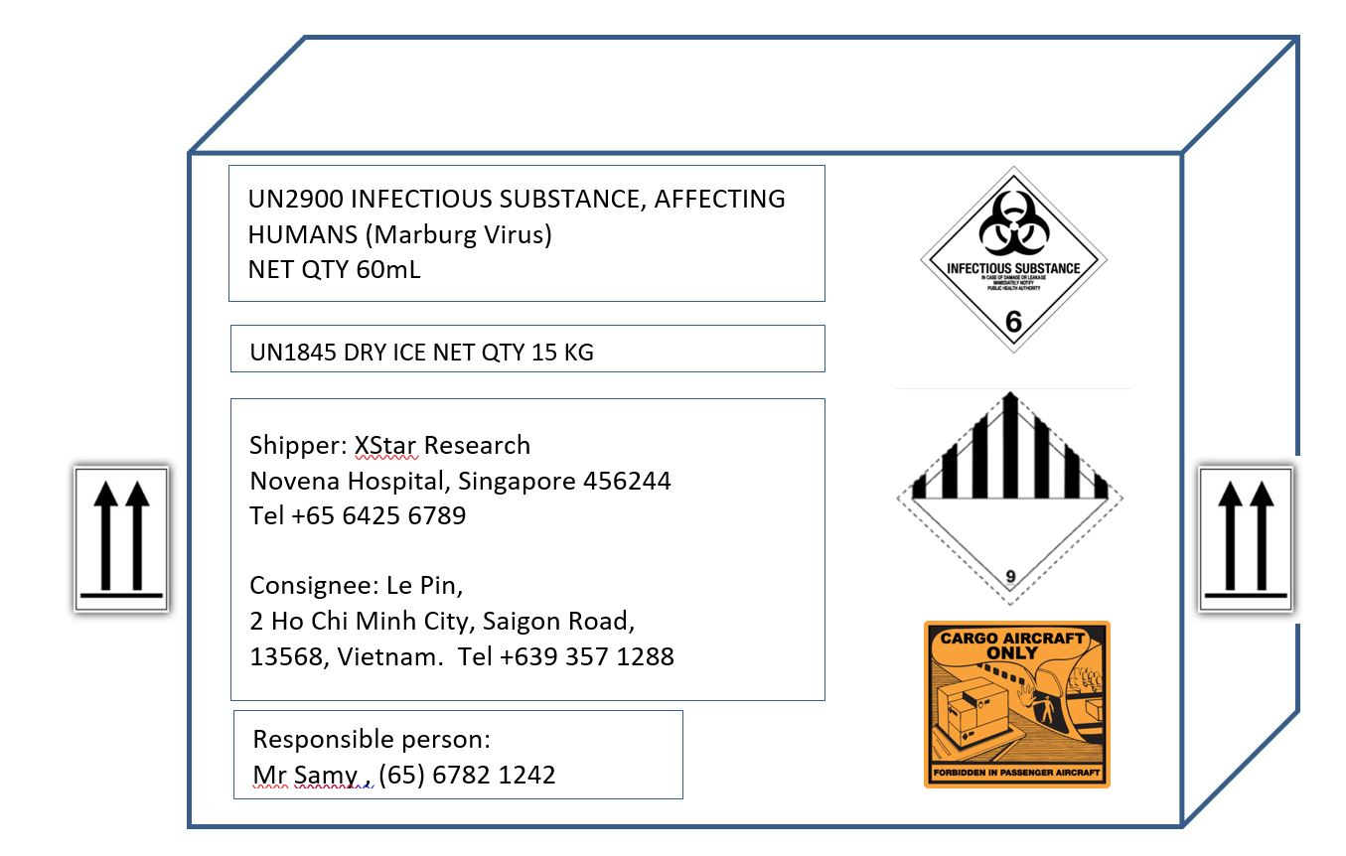﻿﻿﻿

Figure 1.1

The first mistake is that the package has the wrong UN number printed. UN 2900 is for an infectious substance affecting animals only, however, UN 2814 should be used indtead which is for an infectious substance affecting humans.  
The second mistake is that although gel packs are used as refrigerants, dry ice is indicated on the package. These are two completely different types of refrigerants.  
The third mistake is that the city name/town name/district name should be written in the first line of the consignee information just after the name but it is missing.  
The fourth mistake is that the UN Specification marking and labelling is missing. Ths should be present on below one of the orientation arrows.

**Marks: 4**

**Q1b.**

As a shipper, Samy also needs to fill up the DGD form as shown in Figure 1.2 for the 60 ML Malburg virus which is packed in a UN certified fiberboard box. The shipment will be from Changi International Airport (airport code SIN) to Noi Bai International Airport at Hanoi (airport code HAN). After the errors in a) are fixed, you also need to ensure that the DGD form is correct.  
Identify any **FOUR (4)** errors found in the DGD form and correct them.

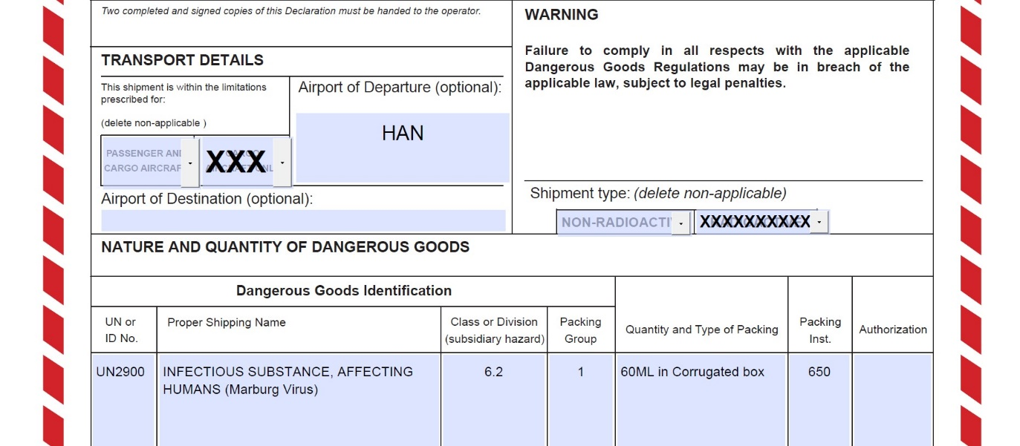﻿﻿﻿﻿﻿

Figure 1.2

The first mistake is that the package has the wrong UN number printed. UN 2900 is for an infectious substance affecting animals only, however, they should be using UN 2814 which is for an infectious substance affecting humans.  
The second mistake is that packing instruction 620 should be used for Category A infectious substances instead.  
The third mistake is that the airport of departure is wrong, Noi Bai International Airport at Hanoi (airport code HAN) is the airport of destination and should be stated in that field. Changi International Airport (airport code SIN) should be stated in the airport of departure field instead.  
The last mistake is the packing group does not apply to infectious substances or dry ice. This part should be left blank.

**Marks: 4**

**Q1c.**

Besides the outer packaging as show in figure 1.1, what are the other main components of the package inside the box for all infectious substances?

The Primary receptacle which is a primary watertight, leak-proof receptacle containing the specimen and the Secondary packaging which is a second durable, watertight, leak-proof packaging to enclose and protect the primary receptacle(s).

**Marks: 2**

**Q1d.**

Samy is required to ship a biological substance with a quantity of 1.9L. What is the UN number of this biological substance? What is/are the minimum number of box/boxes needed for this shipment? Explain your choice clearly.

The UN number of this biological substance is UN3373. Quantities exceeding 50 ml or 50 g per package must be shipped using cargo aircraft. The minimum number of box/boxes is 1 and this is because the Max Net Quantity/Package for cargo aircraft is 4 litres or 4 kilograms and 1.9 litres is within the requirements for a single package.

**Marks: 4**

**Q1e.**

Samy now needs to ship blood or blood components which have been collected for the purposes of transfusion. Does Samy need to make a declaration for this type of infectious substance? Justify.

No, blood transfusions are specified as exceptions. Under IATA standards, blood or blood components which have been substance collected for the purposes of transfusion or for the preparation of blood products to be used for transfusion or transplantation and any tissues or organs intended for use in transplantation as well as samples drawn in connection with such purposes are not subject to these regulations.

**Marks: 2**

**Marks: 16**

**Q2.**

The following is an extract from the list of controlled hazardous substances published by NEA.

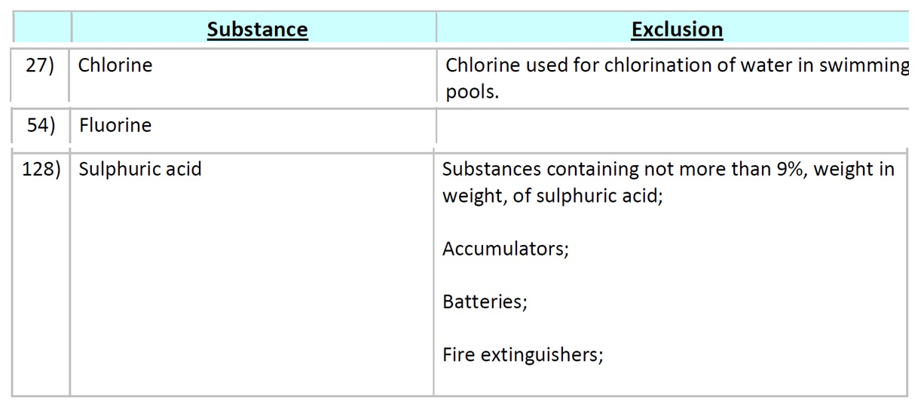﻿﻿﻿  
Figure 2.1

**Q2a.**

Karen’s company wanted to import and sell   
i) Chlorine for swimming pools  
ii) Fluorine for water treatment  
iii) Sulphuric acid for laboratories which is 9.0% in weight in weight of sulphuric acid  
  
Which item(s) does she need to apply for hazardous substances license? Why?

Based on Figure 2.1, she needs to apply for the hazardous substances license for the Fluorine. This is because Chlorine used for chlorination of water in swimming pools and substances containing not more than 9%, weight in weight, of sulphuric acid are excluded. On the other hand, there are no exemptions for Fluorine as shown in Figure 2.1.

**Marks: 2**

**Q2b.**

Karen is responsible for arranging the transportation of 2 metric tonnes of Hydrocyanic Acid from Pasir Panjang Port to Seletar Logistics Park. Hydrocyanic Acid is classified as Class 6 and Class 3 Dangerous Goods.  
Are the following labels in Figure 2.1 the correct ones to be attached on the vehicle carrying the Hydrocyanic Acid? Give**TWO (2)** reasons to explain your answer.   
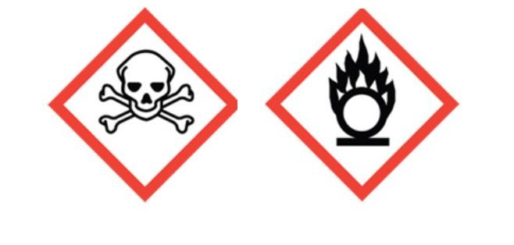﻿

No, the labels are incorrect. If Hydrocyanic Acid belongs to Class 3: Flammable Liquids and Class 6:Toxic and Infectious Substances, the labels needed are he one on the left shown above (Toxic Substances) which is correct, however, the one on the left is for Oxidizng Gases which is wrong. She would need to replace the label on the left with the correct (Flammable Liquids) label.

**Marks: 5**

**Q2c.**

In the preparation of Transport Emergency Response Plan (TERP) for the transportation of Hydrocyanic Acid from Pasir Panjang Port to Seletar Logistics Park, name **THREE (3)** types of information to be included in the TERP.

Three types of information to be included in the TERP are the Transport Routes for the vehicle, Technical experts to contain emergency and Emergency equipment available on vehicle.

**Marks: 3**

**Q2d.**

You decided to conduct a compliance check on the vehicle and drivers transporting Hydrocyanic Acid. What type of certification, permit or license would you expect the vehicle and driver to have? Indicate the issuing authority.

Hazardous Substances, exceeding 1000 kg limit in NEA’s Table 2 requires:   
Hazardous Materials Transport Driver Permit (HTDP) for driver issued by SCDF  
Transport Emergency Response Plan (TERP) approval issued by SCDF)  
HS Transport Approval issued by NEA  
HAZMAT Transport Vehicles Tracking System (HTVTS) by SCDF

**Marks: 4**

**Q2e.**

State **TWO (2)** types of pharmaceutical product that are more frequently transported by sea instead of by air despite the fact that they are not hazardous. Explain why this is so.

2 types of pharmaceutical product that are more frequently transported by sea instead of by air are products that are relatively insensitive to time which means they can last long extended periods of transportation time by sea and low value products that make shipping via Air unjustified.

**Marks: 4**

**Marks: 18**

**Q3.**

The following Figure 3.1 is an extract from HSA website regarding the recall of a pharmaceutical product in 2019.

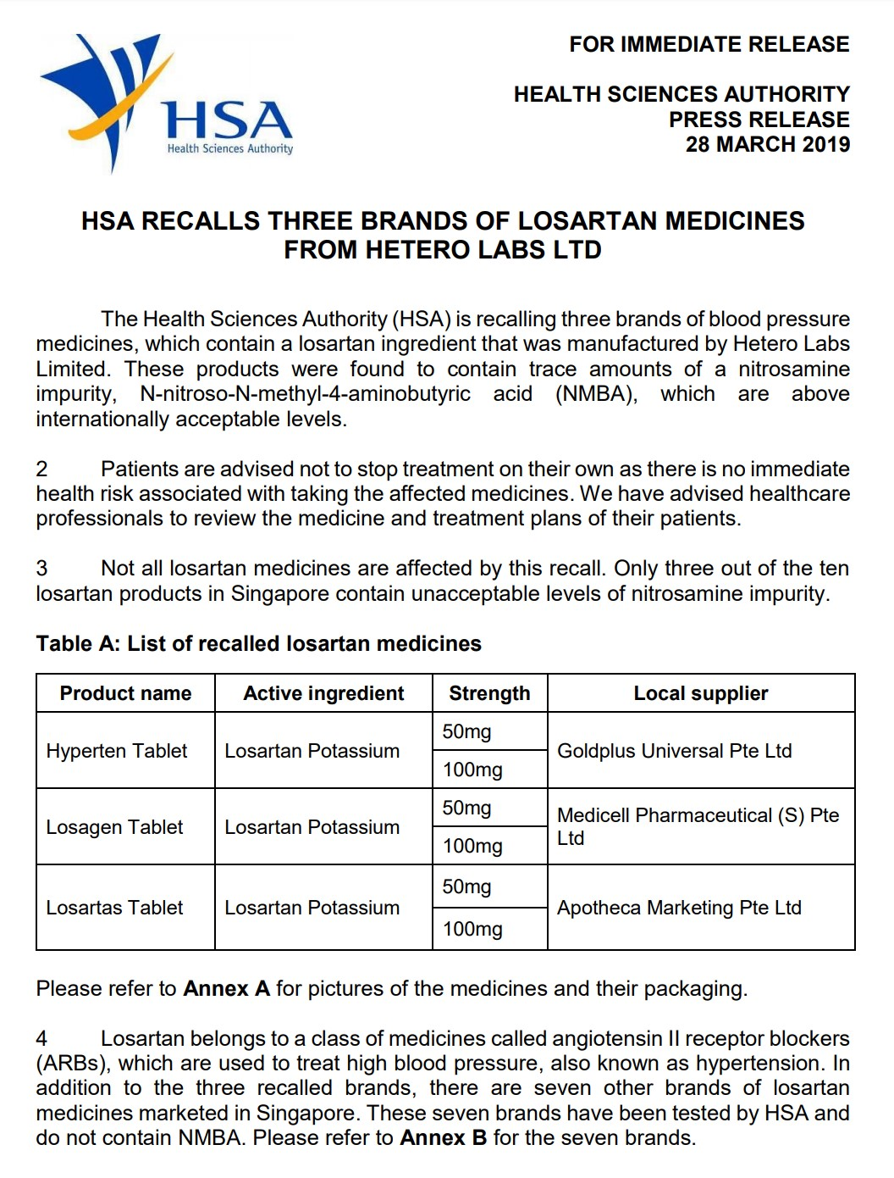﻿  
Figure 3.1

**Q3a.**

Based on the article, which class of recall is this? Give a reason.

This is a class 2 recall. This is because the information indicates that there is only a non-critical defect where there is no immediate health risk associated with taking the affeted medicines.

**Marks: 2**

**Q3b.**

What are the **TWO (2)** levels of recall initiated by this case and the parties involved?

Recall to Retail level and Recall to Wholesale level.

**Marks: 2**

**Q3c.**

There was a call from the drug manufacturer who informed Goldplus supplier that a drug Xanto was found to be defective. Would the product be recalled? **Justify** your answer with reasons.

Yes, the the product will be recalled. This is because Companies the manufacturers is responsible for the safety, quality and efficacy of their therapeutic products and should have adequate systems and appropriate procedures in place to investigate, review and report the product defects to HSA, and if necessary, to promptly recall the affected products

**Marks: 3**

**Q3d.**

Can a recalled product be returned to market for sale? Explain.

Yes, there is a possibility that it can be returned. For example after a temporary removal for product correction, after which the corrected products may be returned to the market for sale.

**Marks: 3**

**Q3e.**

In SKCH Hospital, there are different types of healthcare waste to be disposed. The following are the types of waste:

|  |  |
| --- | --- |
| **Healthcare Waste** | **Class** |
| i) Used Chiba needles after surgery |  |
| ii) Amputated limbs |  |
| iii) Faeces, vomits, nasal discharge |  |
| iv) Drugs used to treat cancer during chemotherapy and to be disposed immediately after treatment |  |

State the type of waste as classified by WHO (World Health Organisation) and fill in the blanks.

*(Note: If you want to resize the text box, drag the  icon on the lower-right corner.)*

**Marks: 4**

**Q3f.**

Figure 3.2 shows a box for disposal of healthcare waste to medical incinerator.

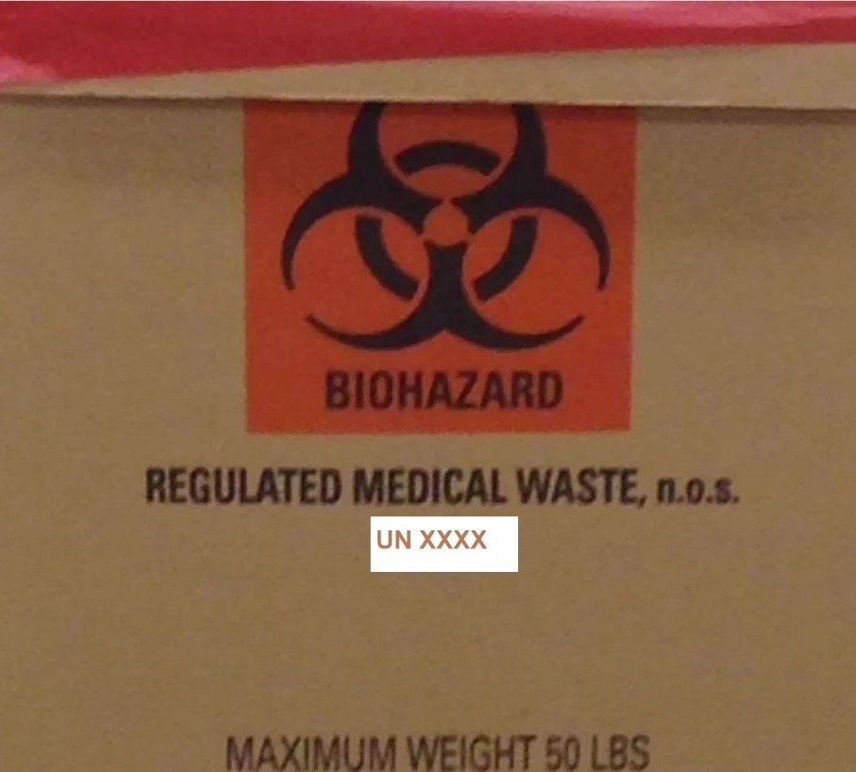﻿

Figure 3.2

State the UN number for this disposal of healthcare waste and fill in the blank.  
UN Number = []﻿

*(Note: If you want to resize the text box, drag the  icon on the lower-right corner.)*

**Marks: 1**

**Q3g.**

During transportation of the box to off-site incinerator, list **THREE (3)** things you must take note for the vehicle to prevent any accidental contaminations or dispute.

Three things that need to be made sure are:  
Transportation properly documented and vehicle should carry consignment note at all times.  
Vehicle used for carrying this waste should never be used for other purposes.   
No sharp edges on the vehicle, easy to load and unload by hand, easy to clean/disinfect, fully enclosed to prevent spillage.

**Marks: 3**

**Q3h.**

Due to shortage of space, healthcare waste are stored together with other waste in SCKH Hospital before sending to incinerator. They are stored up to 38 hours before being disposed and only authorized personnel are allowed to access the wastes storage area.  
  
Based on the context, state **TWO (2)** issues in the storage of waste and suggest **TWO (2)**corrective measures.

One issue is that healthcare waste are stored together with other waste, however, you cannot store hazardous waste with non-hazardous and general waste which is done to avoid cross contamination. Another issue is that waste is stored up to 38 hours before being disposed, however, on site storage should only provide temporary storage that should not exceed 24 hours.

**Marks: 4**

**Marks: 22**

**Q4.**

There is an increasing awareness about stroke in Singapore. According to Ministry of Health (MOH), Cerebrovascular diseases (including stroke) is the number 4 killer in Singapore.   
BeckPifish Health Supplies finds that it is an opportunity to import more medical devices for treatment of stroke. One medical device is Electro-Neuro Stimulator Device. They are active therapeutic devices. 

**Q4a.**

Identify the risk classification of medical device that the Electro-Neuro Stimulator Device falls in and the rule according to HSA. Justify your answer.

The risk classification of medical device that the Electro-Neuro Stimulator Device falls in is class B. This is because under rule 9(i) for,Active Devices) all therapuetic products thata re intended to adminsiter or exchange energy with the human body which includes the Electro-Neuro Stimulator are in class B.

**Marks: 3**

**Q4b.**

BeckPifish Health Supplies also feels that some of these patients having stroke have difficulty in walking, and is planning to supply wheelchairs to them. What is the risk classification for a manual wheelchair, which rule does it follow? Justify your answers.

Wheelchairs are in class A. This is because under wheelchairs fall under rule 12 which statres that all other devices not mentioned or described in the other rules are in class A.

**Marks: 3**

**Q4c.**

If BeckPifish Health Supplies decides to import electrically powered wheelchair, what is the risk classification of this wheelchair and the rule which it falls under according to HSA? Explain your answer with justifications.

Electrically powered wheelchairs are in class A. This is because under wheelchairs which includes those that are powered fall under rule 12 which statres that all other devices not mentioned or described in the other rules are in class A. Furthermore, this is because Class A medical devices are exempted from product registration as they are considered to be of low risk.

**Marks: 3**

**Q4d.**

Under what circumstances does BeckPifish Health Supplies not need to be GDPMDS certified if it were to bring in medical devices into Singapore?

Circumstances include Ii they are dealing with medical devices that are solely for export or re-export and the medical device will not be supplied in Singapore or if they are dealing with medical devices for non-clinical use whereby the medical device will not be used on any patient.

**Marks: 2**

**Q4e.**

Tetranitromethane is classified as an explosive precursor (EP) by the Arms and Explosive Act within Singapore. BeckPifish Chem Supplies, a subsidiary company of BeckPifish, would like to import the chemicals for laboratories and research institutes in Singapore. If BeckPifish Chem Supplies wants to import, store and sell Tetranitromethane in Singapore, what are the criteria on application for licenses to deal and store? State and explain.

The applicant, directors/ partners and staff who will be directly involved in the handling explosive precursors must be a fit and proper person e.g. free from criminal record; and have the relevant experience and knowledge in the handling of explosive precursors. Additionally, there must be proper and secured facilities for storing of the explosive precursors.

**Marks: 5**

**Q4f.**

BeckPifish Chem Supplies also handles class 2.1 dangerous goods. Can both Tetranitromethane and class 2.1 dangerous goods be transported together? Explain.

Yes, he can do this. In the Dangerous Goods Segregation Table, the cell whereby Class 1 Explosives (Tetranitromethane) and class 2.1 Flammable Gases meet indicates that these materials may not be loaded, transported, or stored together in the same transport vehicle or storage facility during the course of transportation.

**Marks: 2**

**Q4g.**

BeckPifish Chem Supplies would like to import portable gas lighter as shown below for barbeque.  
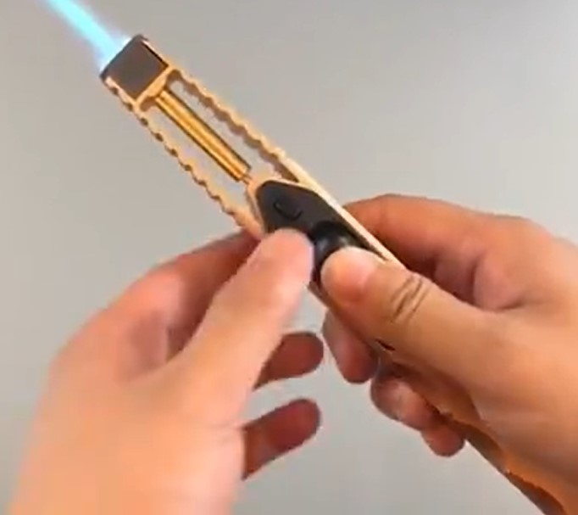﻿  
Is BeckPifish Chem Supplies required to apply for P&F license? Explain

No, they are not required to apply for P&F license. This is because portable gas lighters such as the one shown is exempted from P&F license application.

**Marks: 2**

**Marks: 20**

**Q5.**

Answer the questions that follow:

**Q5a.**

Identify the types of pharmaceutical distribution to end customers for the following scenarios and fill in the blanks.

|  |  |
| --- | --- |
| How customer purchase their medication | Types of Pharmaceutical Distribution |
| Purchase of medication from polyclinic pharmacies such as NHG Healthcare Pharmacies |  |
| Purchase of medication from retail pharmacy such as Guardian Pharmacy. |  |
| Purchase of Activated Charcoal Pills from convenience stores such as Cheers |  |
| Purchase of medication over the  internet from web pharmacists |  |

*(Note: If you want to resize the text box, drag the  icon on the lower-right corner.)*

**Marks: 4**

**Q5b.**

Is it possible to buy controlled drugs from any pharmacies? Explain with **TWO (2)** justifications

Yes. Pharmacy Only Medicines whereby certain therapeutic products that can be obtained from a pharmacist at a retail pharmacy with a prescription.

**Marks: 3**

**Q5c.**

L*Star, a medical institute has discovered an effective drug for an acute virus infection, and the drug has received an approval from US Food and Drug Administration (FDA). L*Star has sold the patent to Joksin Medical under the patent brand name Gadasila.  
Joksin Medical engaged Oap Drugs Inc. to manufacture and supply the Active Pharmaceutical Ingredient (API) for Gadasila, where Joksin Medical would carry out the final product manufacturing of the drug in capsule form.   
Fill in the blanks below: 

|  |  |
| --- | --- |
| Company doing Primary Manufacturing |  |
| Company doing Secondary Manufacturing |  |
| Authority approving the sales or distribution of Gadasila in Singapore |  |

*(Note: If you want to resize the text box, drag the  icon on the lower-right corner.)*

**Marks: 3**

**Q5d.**

If Gadasilais classified as a prescriptive drug in Singapore, how can a patient purchase Gadasila? List down **TWO (2)** ways.

Prescription Only Medicines (Gadasila) can only be obtained from a doctor or a dentist, or from a pharmacist with a prescription from a doctor or a dentist.

**Marks: 2**

**Q5e.**

Joskin Medical put in place a mPedigree for product authentication to fight against counterfeit Gadasila,andeach box of Gadasila is being assigned with unique random code which is covered by scratch off label.   
  
List down **TWO (2)** steps on how a patient can authenticate whether the drug is genuine after purchase.

mPedigree works by placing a scratch-off label on products, and then when consumers purchase a product, the first step they need to do is they scratch off the label to reveal a unique, random code. The code is then sent via SMS to a country-specific short code, and the consumer receives a reply almost instantly indicating whether the product is genuine or not.

**Marks: 2**

**Marks: 14**

**Q6.**

Figure 6.1 is an advertisement for participants for a clinical trial.

﻿﻿﻿﻿﻿

Figure 6.1

**Q6a.**

Identify the type of clinical trial and give a reason to support your answer.

This is a prevention trial. They are looking for better ways to prevent disease in people who have never had the disease or to prevent a disease from returning and this is indicated in the statement where they mention they want the participant to help them understand how the vaccine works and prevents dengue infection.

**Marks: 2**

**Q6b.**

The clinical trial is also extended to participating countries such as Thailand. CXH Clinical Trials unit outsourced the delivery of the clinical trials to a 3PL solution provider, Global Handler. Suggest **TWO (2)** requirements for the 3PL solution provider that CXH must ensure.

The 3PL should be GDP certified and have all the necessary expertise and they should also have the knowledge and equipement to handle pharmaceutical products.

**Marks: 2**

**Q6c.**

Clinical trial equipment are transported by Global Handler and it is considering using the following type of data loggers/Temperature indicator to monitor the temperature of the shipment. Figure 6.2 shows Tag Sensors and Figure 6.3 shows Time Strip data logger respectively.

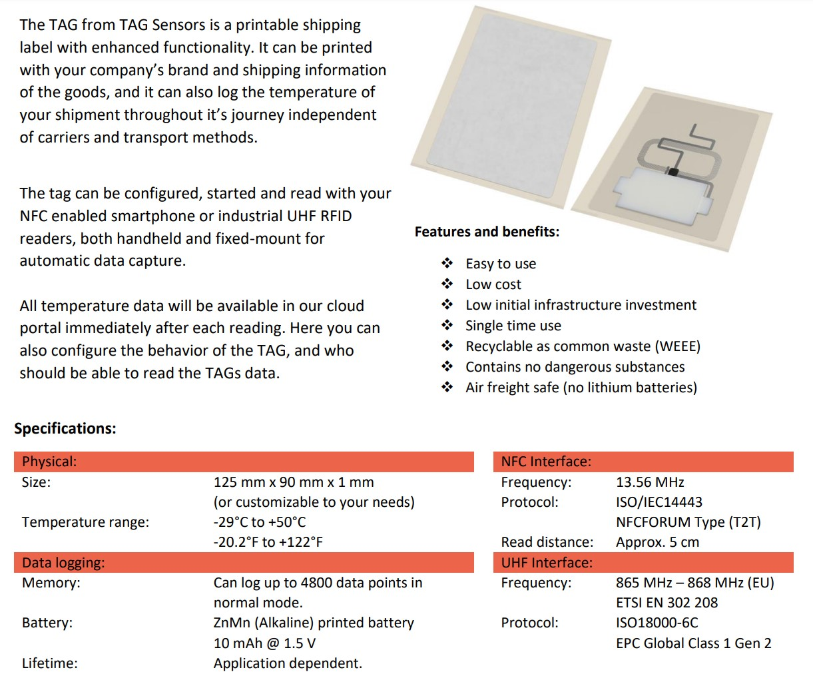﻿﻿  
Figure 6.2

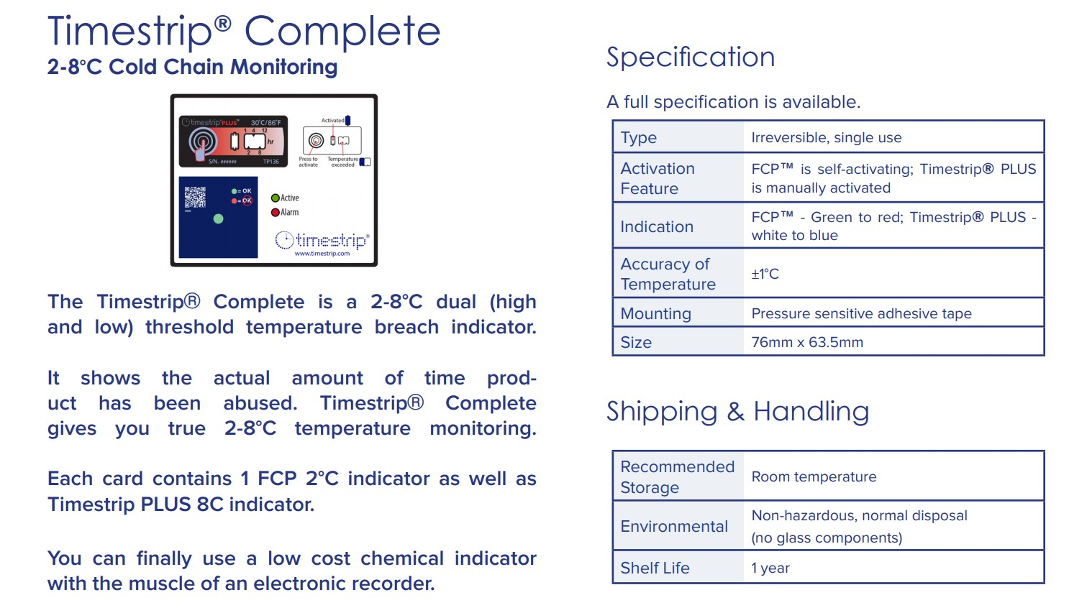﻿  
Figure 6.3﻿

**Q6c(i).**

Suggest **TWO (2)** advantages of using the single-use data logger/temperature indicator as compared to multiple-use one.

The single-use data logg is disposable so you do not need to go through all the hassle of collecting them for future use. Single-use disposable temperature loggers also tend to be a lot smaller that the multiple-use ones which may be useful if you are working with a lot space constraints and concerns.

**Marks: 2**

**Q6c(ii).**

Which data logger/temperature indicator would be most suitable for the shipment from Singapore to Thailand? Give**ONE (1)** reason.

The single use data logger/temperature indicator would be most suitable. This is because the allowed temperature range is 2℃ to 8℃ and in summary from Figure 6.3, the Time Strip data logger will show on display if there has been an exposure above 8℃.

**Marks: 2**

**Marks: 4**

**Q6d.**

Is the practice of using the data logger conform to Good Distribution Practice (GDP)’s Stock Handling & Control? Explain.

Yes. This is because during deliveries to customer they need to control the storage condition; Protection of the quality of materials during transportation to customers and the data logger can be used to record that assurance.

**Marks: 2**

**M**