**Section Question 1 (1 Question)Maximum Marks for This Section: 12**

**Q1.**

Amira works in a polyclinic pharmacy. She helps her manager to prepare the following questions for new hires in the company so as to ascertain their readiness to take up the job role in the pharmacy.

**Q1a.**

For the pharmaceutical products shown below, identify the consumer packaging and the pharmaceutical form that it contains and fill in the blanks. Please select your answers from the list below.

|  |
| --- |
| ﻿﻿ |

|  |  |  |
| --- | --- | --- |
| Pharmaceutical product | Consumer Packaging | Pharmaceutical Form |
| ﻿ |  |  |
| ﻿ |  |  |
| ﻿ |  |  |
| ﻿ |  |  |

*(Note: If you want to resize the text box, drag the  icon on the lower-right corner.)*

**Marks: 8**

**Q1b.**

For the product below, classify them as pharmaceutical, nutraceutical, medical device or combination product.

|  |  |
| --- | --- |
| Product | Classification |
| ﻿ Seaweed Capsules |  |
| ﻿ Insomia Tablet |  |

*(Note: If you want to resize the text box, drag the  icon on the lower-right corner.)*

**Marks: 2**

**Q1c.**

Besides special storage requirements, state **ONE (1)**other unique requirements that pharmaceutical or bio-chemical logistics might have.

Other requirements are tracking of pharmaceuticals are necessary by batch / lot and the products may need to conform to special regulatory control and  
documentation for controlled drugs.

**Marks: 2**

**Marks: 12**

**Section Question 2 (1 Question)Maximum Marks for This Section: 9**

**Q2.**

The pictures below show **TWO (2)** anti-counterfeiting features used on pharmaceutical packaging. Identify the types of anti-counterfeiting feature used and fill in the blanks below.

**Q2a.**

|  |  |
| --- | --- |
| ﻿ | ﻿﻿ |
| Anti-Counterfeiting Technology 1 | Anti-Counterfeiting Technology 2 |
|  |  |

*(Note: If you want to resize the text box, drag the  icon on the lower-right corner.)*

**Marks: 2**

**Q2b.**

State **ONE (1)** advantage of using anti-counterfeiting technology 1 and **ONE (1)** advantage of using anti-counterfeiting technology 2 respectively.

Overt features are user verifiable.  
Covert features can be simple and low cost to implement.

**Marks: 4**

**Q2c.**

Assume a counterfeit medicine has the same ingredients (including active ingredients) as the authentic version. State **TWO (2)**possible ways to differentiate this counterfeit medicine from the authentic version.

One way is to use Product Authentication with Serialization/Track & Trace to find the documentation information of the origin. Another way is to analyse the overt features which will enable to identify a counterfeit product. For overt features, an example is if the brand has metallized substrates/blisters with unique/distinct color options.

**Marks: 2**

**Q2d.**

If you were to make use of ePedigree for drug authentication, suggest **ONE (1)** type of information that must be collected along the supply chain from manufacturers to retail pharmacy.

One type of information is the date of all the transactions and the names and addresses of all the parties to them.

**Marks: 1**

**Marks: 9**

**Section Question 3 (1 Question)Maximum Marks for This Section: 8**

**Q3.**

VC Pharma runs a healthcare distribution centre in Singapore, it provides storage facilities of pharmaceutical products for its customers and helps them distribute the products to local hospitals, retail pharmacies and clinics. Apart from storing the pharmaceutical items, VC Pharma also provides value-added services such as adding and changing instructions inserts.

**Q3a.**

Besides adding and changing instructions inserts, name **TWO (2)** other value-added services that are commonly provided by healthcare distributors.

Two other value-added service are labeling of vial, bottle or carton and secondary repackaging / redressing.

**Marks: 2**

**Q3b.**

Based on the description of the services provided by VC Pharma, explain if VC Pharma needs to conform to any quality assurance systems such as GDP and/or GMP. Explain each of your answer clearly.

They needs to conform to the quality assurance systems which is GDP. This is because they distribute the products to local hospitals, retail pharmacies and clinics. Good Distribution Practice (GDP) is a vital component of Quality Assurance and the guide is intended for those involved in the storage, transportation and distribution of starting materials and medicinal products.

**Marks: 4**

**Q3c.**

**“Complaints and Product Recall”** is listed as one of the main principles under GMP. Explain how VC Pharma can handle returned goods and disposal properly to **minimise complaints** and **minimise improper waste disposa**l.

For returned goods, they can establish SOP and keep records and establish assessment criteria. For disposal, they should be a written procedure and evidence of  
disposal.

**Marks: 2**

**Marks: 8**

**Section Question 4 (1 Question)Maximum Marks for This Section: 8**

**Q4.**

Jacob works in JOS Biotech as a Logistics Specialist. Recently Jacob is managing a new shipment from Singapore to Cape Town, South Africa for further testing. The batch of vaccine has to be maintained between +2°C to +10°C throughout the process.

**Q4a.**

Before being packaged in the cold box, the vaccines were stored in a controlled room temperature for 12 hours. Is this the proper way to store the vaccines? Explain your answer clearly.

No, this is wrong. This is because Controlled Room Temperature is from 15 degrees celcius to 25 degrees celcius while as the requrement is that it should be stored at 2 degrees celcius to 10 degrees celcius.

**Marks: 2**

**Q4b.**

Prior to shipment, how do you ensure the packaging maintains the required temperature?

For biological substances that must be maintained between at +2 degrees celcius to +8 degrees celcius and +15 degrees celcius to +25 degrees celcius, packaging must be properly pre conditioned prior to shipment. Pre conditioning helps the packaging maintain its rated temperature for the optimum amount of time.

**Marks: 2**

**Q4c.**

JOS Biotech decides to import the following medical devices:  
i) Stretchers for ambulance, which is portable  
ii) Muscle Stimulators. The device that sends electrical impulses to the body. It activates the muscles to help increase strength, endurance and recovery.  
  
Fill in the blanks below regarding the risk classification of the two devices: 

|  |  |
| --- | --- |
| Medical Devices | Risk Classifications (Class) based on HSA |
| ﻿ Stretchers for ambulance |  |
| ﻿ Muscle Stimulator |  |

*(Note: If you want to resize the text box, drag the  icon on the lower-right corner.)*

**Marks: 2**

**Q4d.**

Based on your classification for ii) in above question, give **ONE (1)** reason to justify your answers.

A stretcher for ambulance is Class A because under rule 4, all other non-invasive devices that do not come into contact with the patient or contact intact skin only are in class A.  
  
A Muscle Stimulator is in class B because under rule 9, all active therapeutic devices that are intended to administer or exchange enrgy to or with the human body are in class B.

**Marks: 2**

**Marks: 8**

**Section Question 5 (1 Question)Maximum Marks for This Section: 6**

**Q5.**

The following is an advertisement in the website of Happy Dental Institute to invite volunteers for a clinical trial for dental plug. (See Figure 5.1) 

|  |
| --- |
| ﻿﻿ Figure 5.1: Clinical Trial Advertisement |

**Q5a.**

Is clinical trial one of the stages in the manufacturing phase of a drug product life cycle? Justify your answer.

No. This is because the clinical trial is in the Discovery/Research Phase as clinical trials are generally considered to be biomedical or health-related research studies in human beings that follow a pre-defined protocol. Furthermore, the stages in the Manufacturing Phase are Primary Manufacturing (manufacturing of API) and Secondary Manufacturing (from API to finished product).

**Marks: 2**

**Q5b.**

Due to an encouraging data in the initial research and studies, Happy Dental Institute has received an approval from HSA to conduct a new phase of clinical trial on the 3D-Dental Plug it has developed to confirm its effectiveness and safety. In partnership with Singapore Clinical Research Institute (SCRI), a randomized controlled clinical trial is opened for participant recruitment to evaluate the use of these dental plugs. It is looking to recruit 250 volunteers.  
i) At which phase is the clinical trial?  
ii) Who is the sponsor for the clinical trial?

(i) It is in the Phase II trials.  
(ii) The sponsor is Singapore Clinical Research Institute (SCRI).

**Marks: 2**

**Q5c.**

Based on the information in the advertisement, identify the type of clinical trials and justify your answer.

It is a treatment trial. It is a treatment trials because they are test if new approaches to surgery to preserve the bone in the jaw ridge.

**Marks: 2**

**Marks: 6**

**Section Question 6 (1 Question)Maximum Marks for This Section: 7**

**Q6.**

The following shows a portion of a Safety Data Sheet (SDS) of Diethylene Glycol, a type of dangerous goods.  
﻿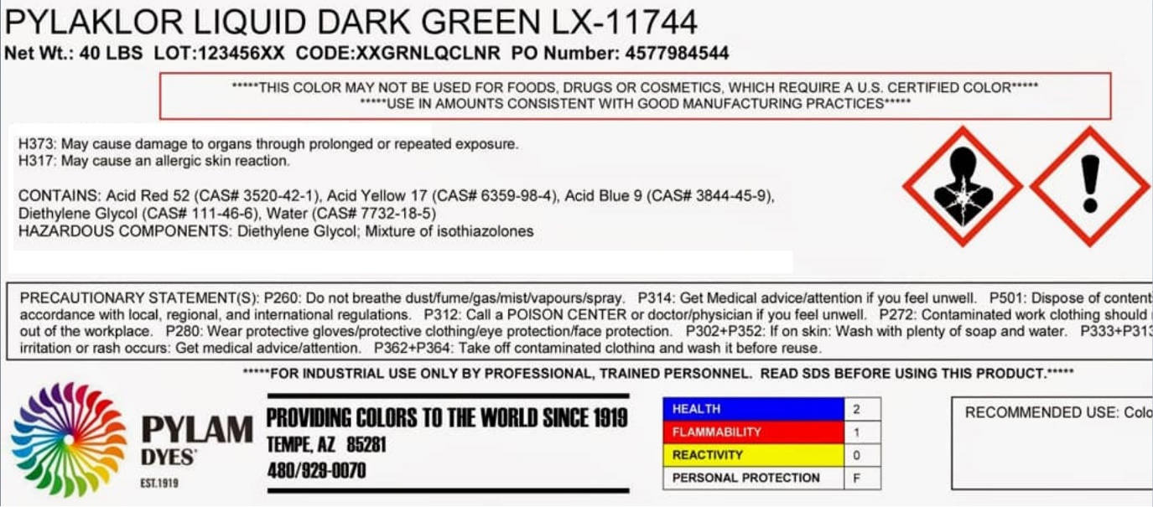﻿  
Figure 6.1 A portion of Safety Data Sheet (SDS) of Diethylene Glycol

**Q6a.**

In order to create a GHS Label for this product, apart from the information available in figure 6.1, state **TWO (2)** other information you need to extract from the SDS.

Two other information are the transport information and regulatory information.

**Marks: 2**

**Q6b.**

What is/are the main purpose of a GHS Label?

A GHS label provides a summary of the chemical’s hazard and warns the users to take precautions if necessary.

**Marks: 2**

**Q6c.**

Kaixin joined a company that handles dangerous goods as a logistics executive. However, she was not allowed to handle dangerous goods (DG) at the warehouse during the first month of work as she has not gone through any training on DG. Suggest **ONE (1)** suitable program that she needs to attend.

One suitable program is the IATA DG awareness and training course for air shipment.

**Marks: 1**

**Q6d.**

Kaixin wants to transport Phosphorous pentasulfide powder from the dangerous goods warehouse to the seaport by truck. Part of the hazards statement states that the powder will release toxic gas when in contact with water. The gas is flammable and may ignite spontaneously. It is also very toxic to aquatic life.  
i) According to UNRTDG, Phosphorous pentasulfide falls under which class of Dangerous Goods?   
ii) Which of the following labels (A, B, C, D) is most suitable to be attached to the truck?  
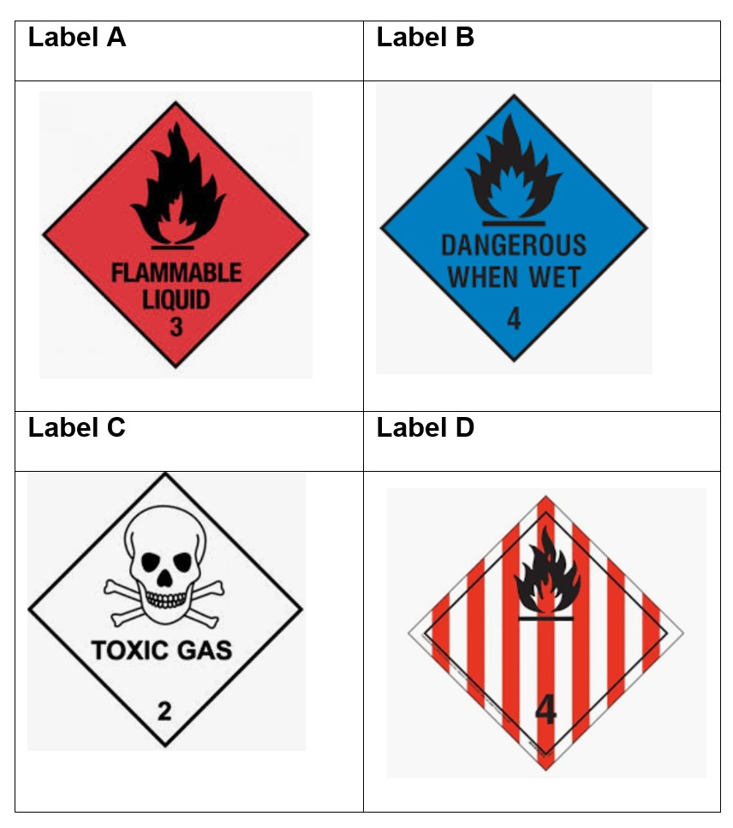﻿  
Figure 6.2 UNRTDG Labels  
  
Fill in the blanks below:

|  |  |
| --- | --- |
| Class of Dangerous goods |  |
| Label attached to the truck |  |

*(Note: If you want to resize the text box, drag the  icon on the lower-right corner.)*