**Section: A (12 MARKS)**

Poster 1 is an advertisement created for the Ministry of the Interior, a ministry responsible for road safety and law enforcement in France.

Refer to Poster 1 and answer all the questions in this section.

**Poster 1**

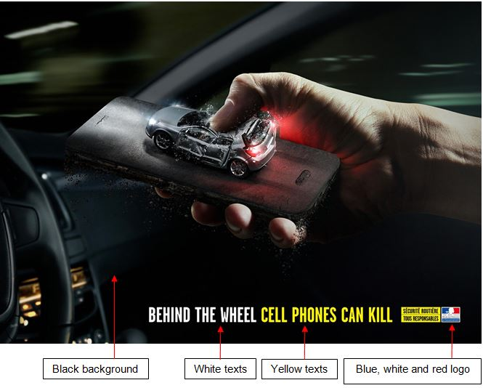

|  |
| --- |
| **The text in Poster 1 reads:**  BEHIND THE WHEEL, CELL PHONES CAN KILL  **The logo at the bottom-right of Poster 1:**  Minister of the Interior, France  *(With words in French: SÉCURITÉ ROUTIÈRE TOUS RESPONSABLES)* |

Image adapted from: http://www.adsoftheworld.com/media/print/french

Top of Form



|  |  |  |
| --- | --- | --- |
| **Q1:** | Based on your understanding of C.A.P.S, which **ONE (1)** of the following **BEST** describes the main target audience of Poster 1? | **Mark (1)** |
|  | Pedestrians | |
|  | Cell phone users | |
|  | Road safety ambassadors | |
|  | Car drivers | |

Bottom of Form

Top of Form



|  |  |  |
| --- | --- | --- |
| **Q2:** | Based on your understanding of C.A.P.S, which **ONE (1)** of the following **BEST** describes the purpose of Poster 1? | **Mark (1)** |
|  | To motivate the audience to reduce speed while driving | |
|  | To persuade the audience not to use the cell phone while driving | |
|  | To stimulate the audience’s discussion about road safety in France | |
|  | To inform the audience about the risks of driving a car | |

Bottom of Form

Top of Form



|  |  |  |
| --- | --- | --- |
| **Q3:** | The Singapore Road Safety Council wishes to adapt a similar theme in Poster 1 for their road safety campaign.  Which **ONE (1)** of the following should they include in their poster? | **Mark (1)** |
|  | A logo of the Ministry of the Interior, France | |
|  | The information about car models in Singapore | |
|  | A slogan that is translated into Malay, Tamil and Mandarin | |
|  | The image of an injured Caucasian man | |

Bottom of Form

Top of Form



|  |  |  |
| --- | --- | --- |
| **Q4:** | The Singapore Road Safety Council has edited the slogan to:  *“Want to come home safe for your loved ones?”*  Identify the type of question used in the edited slogan. | **Mark (1)** |
|  | Clarifying | |
|  | Embarrassing | |
|  | Rhetorical | |
|  | Ambiguous | |

Bottom of Form

Top of Form



|  |  |  |
| --- | --- | --- |
| **Q5:** | Identify **TWO (2)** persuasive appeals found in Poster 1. Provide your explanation for **EACH** of the persuasive appeals identified.  You are required to label each persuasive appeal clearly in your answers. | **Mark (4)** |
|  |  | |
|  | Word Count: 47 | Max Words: Unlimited |

Bottom of Form

Top of Form



|  |  |  |
| --- | --- | --- |
| **Q6:** | Refer to Poster 1 and answer the following questions:  **a)** Describe the use of **Proportion**, citing specific evidence from the poster (1 mark). Analyze how this Principle of Design is used effectively in the poster (1 mark).  **b)** Describe the use of **Colour Contrast**, citing specific evidence from the poster (1 mark). Analyze how this Principle of Design is used effectively in the poster (1 mark).  You are required to label the question and each Principle of Design clearly in your answers. | **Mark (4)** |
|  |  | |
|  | Word Count: 117 | Max Words: Unlimited |

Bottom of Form

**Section: B (8 MARKS)**

Scenario 1 is a conversation between two young working mothers who met after work at NTUC FairPrice.

**SCENARIO 1**

|  |
| --- |
| Carol: Hi Sally, what a coincidence to meet you here. Are you also shopping for milk powder?  Sally: Oh yes. I just rushed off from work to buy some milk powder for my children. It’s been a long day and everyone is waiting for me at home (looks at her watch to check time).  Carol Have you heard of *Premium Formula*? It’s a new milk powder from the U.S, which contains Gain IQ formula. My husband’s company is the sole distributor. Anything from the U.S. must be good! Most importantly, it won’t cost you an arm and a leg!  Sally: *Premium Formula*? Straits Times recently reported that this brand sold milk powder that was tainted with toxic chemicals. Consumers have stopped buying them, right?  Carol: No, the milk powder is really good and authentic. The company sold 200 tins a day and my children have been drinking that milk powder too. They love it!  Sally: Really? Hmm… well … (nods her head and checks her watch again)  Carol: I also heard …  (Sally interrupted Carol before she can continue.)  Sally: Sorry Carol. It’s nice of you to share but I am really tired and I need to run.  Carol: Sure. Just call me if you want to buy. The ball is in your court now. |

Top of Form



|  |  |  |
| --- | --- | --- |
| **Q7:** | Identify **TWO (2)** types of noise present in Scenario 1. For **EACH** type of noise, provide evidence from the scenario to show how it affected the communication process between Sally and Carol.  You are required to indicate the type of noise clearly in your explanation. | **Mark (4)** |
|  |  | |
|  | Word Count: 168 | Max Words: Unlimited |

Bottom of Form

Top of Form



|  |  |  |
| --- | --- | --- |
| **Q8:** | Identify **TWO (2)** ethical issues that are evident in the scenario. For **EACH** ethical issue identified, explain **in your own words** why it is unethical.  You are required to label the ethical issues clearly in your answers. | **Mark (4)** |
|  |  | |
|  | Word Count: 158 | Max Words: Unlimited |

Bottom of Form

**Section: C (8 MARKS)**

Tim, Lisa and Emily are colleagues at Elton International, a real estate firm in Australia. They are preparing for a sales presentation next week. Emily disagreed with Lisa on the timing of the sales launch.

Picture 1 is a scene from the team meeting. Refer to Picture 1 and answer the following questions.

**Picture 1**

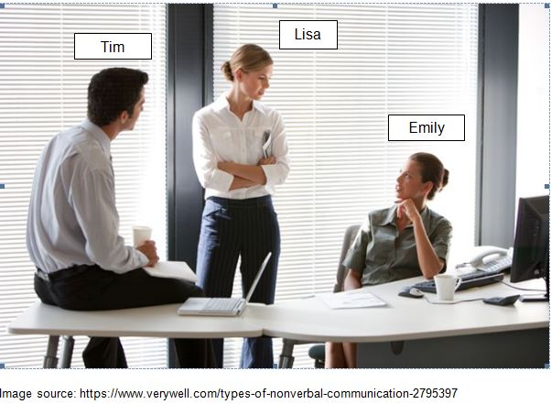

Top of Form



|  |  |  |
| --- | --- | --- |
| **Q9:** | Based on Picture 1, describe **TWO (2)** non-verbal cues exhibited by **LISA**. For **each** non-verbal cue described, interpret the message that is being communicated by **LISA**. | **Mark (4)** |
|  |  | |
|  | Word Count: 49 | Max Words: Unlimited |

Bottom of Form

Top of Form



|  |  |  |
| --- | --- | --- |
| **Q10:** | Which **ONE (1)** of the following non-verbal cues suggests that Tim is involved in the team discussion? | **Mark (1)** |
|  | Tim is facing his teammates, Lisa and Emily | |
|  | Tim is dressed in office attire | |
|  | Tim is holding a cup in his right hand | |
|  | Tim is sitting on the office table | |

Bottom of Form

Top of Form



|  |  |  |
| --- | --- | --- |
| **Q11:** | Which **ONE (1)** of the following describes the physical distance between Tim and Emily? | **Mark (1)** |
|  | Tim and Emily are seated in the corporate zone | |
|  | Tim and Emily are seated in the public zone | |
|  | Tim and Emily are seated in the personal zone | |
|  | Tim and Emily are seated in the intimate zone | |

Bottom of Form

Top of Form



|  |  |  |
| --- | --- | --- |
| **Q12:** | Tim is tasked to give a presentation to the Senior Management next week. He is feeling very anxious. What advice would you give Tim to help him prepare for the presentation? | **Mark (1)** |
|  | Arrive four hours early to set up his equipment to ensure that are no technical failures | |
|  | Be clear about the objectives of the presentation to ensure that the content is relevant to his audience | |
|  | Memorise his presentation word-for-word so that he does not miss out important points | |
|  | Use visual aids including many animated gifs in his presentation to keep his audience engaged | |

Bottom of Form

Top of Form



|  |  |  |
| --- | --- | --- |
| **Q13:** | During Tim’s presentation, one of the Senior Sales Manager asked a difficult question regarding the data he had presented. Unfortunately, Tim did not have the answer to his manager’s question.  Which **ONE (1)** of the following is the **MOST** appropriate course of action for Tim? | **Mark (1)** |
|  | Acknowledge he does not have the answer but promise to get back to the Sales Manager | |
|  | Ask the audience, i.e. the Senior Management if anyone has the data | |
|  | Listen to the entire question and get the Sales Manager to repeat his question | |
|  | Debate with the Senior Sales Manager on the correct answer to the question | |

Bottom of Form

**Section: D (8 MARKS)**

Web-related criminal activity or Cybersecurity threats are on the rise in the USA. There is a lack of skills in the country to address the problem.

Infographic 1 below aims to show the extent of the problem. Refer to Infographic 1 to answer all the questions in this section.

(You may also refer to Appendix A for an enlarged version of the infographic.)

**INFOGRAPHIC 1**

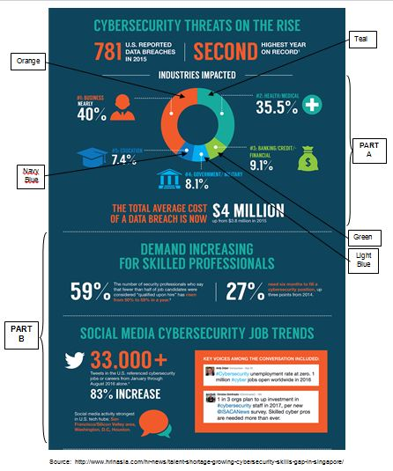

Top of Form



|  |  |  |
| --- | --- | --- |
| **Q14:** | Which **ONE (1)** of the following audience would be least concerned with the information presented in Infographic 1? | **Mark (1)** |
|  | A human resource manager overseeing manpower needs of the company | |
|  | A military officer overseeing IT security for his unit | |
|  | A business owner overseeing budgeting needs of his company | |
|  | A finance manager overseeing insurance needs for customers | |

Bottom of Form

Top of Form



|  |  |  |
| --- | --- | --- |
| **Q15:** | From infographic 1, which **ONE (1)** of the following statement is **false**? | **Mark (1)** |
|  | There were more than 33,000 related tweets on social media about cybersecurity job trends | |
|  | The total average cost of a data breach is $4 million in 2016 | |
|  | 9.1% of companies in the health and medical industries are impacted by cyber security threats | |
|  | Businesses suffered the most impact from cybersecurity threat | |

Bottom of Form

Top of Form



|  |  |  |
| --- | --- | --- |
| **Q16:** | Based on Part A of infographic 1, answer the following questions:  a) Identify the type of data diagram used. (1 mark)  b) What are the **TWO (2)** possible messages the data diagram is trying to convey? (2 marks)  c) Explain how the data diagram was effectively used to convey the message. (1 mark) | **Mark (4)** |
|  |  | |
|  | Word Count: 36 | Max Words: Unlimited |

Bottom of Form

Top of Form



|  |  |  |
| --- | --- | --- |
| **Q17:** | Based on your understanding of media literacy, state **TWO (2)** possible sub-texts of Infographic 1. | **Mark (2)** |
|  |  | |
|  | Word Count: 57 | Max Words: Unlimited |

Bottom of Form

**Section: E (6 MARKS)**

The following passage is a blog post written by Jack, an American who has lived and worked in Japan for the past 27 years. He often compares the cultural differences between Japan and America in his blog posts.

Refer to Passage 1 and answer all the questions in this section.

**Passage 1**

|  |
| --- |
| When I first came to Japan, many aspects of Japan’s culture surprised me. What is considered normal behaviour here in Japan just seems unusual or quirky to Americans. There are many cultural differences between Japan and America, and most of the cultural differences are just different ways of doing things both countries.  In Japan, when riding in car or taxi with superiors, people here will wait until told where to sit. At work, when called to the boss’s office, people in Japan will wait at the door until invited in, and certainly wouldn’t sit down until told.  Once, I gave a light knock on my boss’s door and walked right into his office, fervently conveying to him that I disagreed with his project proposal and suggested he adopt my ideas instead. I was puzzled that he remained quiet but only to find out later that he was shocked and offended, but was too polite to disagree with me. Naturally, the meeting didn’t end on a good note and our project didn’t make any progress.  Dining and drinking with your co-workers is also very common here in Japan, and in fact, can be an unspoken requirement in some companies. Many Japanese feel that after-work parties are an important way to bond with their co-workers and feel a sense of belonging to the company. Co-workers developed closer bonds after casual talks, sharing concerns about their work or about other co-workers.  I would prefer to focus more on my own life outside of work, though on several occasions, I found myself obliged to join my colleagues for a few rounds of drinks after several invitations. |

Adapted from: https://tokyo5.wordpress.com/2012/10/11/culture-differences/ and https://blog.gaijinpot.com/japanese-drinking-culture/

Top of Form



|  |  |  |  |
| --- | --- | --- | --- |
| **Q18:** | The following is an excerpt from Passage 1:   |  | | --- | | *In Japan, when riding in car or taxi with superiors, people here will wait until told where to sit. At work, when called to the boss’s office, people in Japan will wait at the door until invited in, and certainly wouldn’t sit down until told.* |   Which **ONE (1)** of the following cultural dimensions did the excerpt highlight? | **Mark (1)** |
|  | High uncertainty avoidance | |
|  | Low power distance | |
|  | Low uncertainty avoidance | |
|  | High power distance | |

Bottom of Form

Top of Form



|  |  |  |  |
| --- | --- | --- | --- |
| **Q19:** | The following is an excerpt from Passage 1:   |  | | --- | | *Many Japanese feel that after-work parties are an important way to bond with their co-workers and feel a sense of belonging to the company. Co-workers developed closer bonds after casual talks, sharing concerns about their work or about other co-workers.* |   Which **ONE (1)** of the following cultural dimensions did the excerpt highlight? | **Mark (1)** |
|  | Individualism | |
|  | Feminine | |
|  | Collectivism | |
|  | Masculine | |

Bottom of Form

Top of Form



|  |  |  |  |
| --- | --- | --- | --- |
| **Q20:** | The following is an excerpt from Passage 1:   |  | | --- | | *Once, I gave a light knock on my boss’s door and walked right into his office, fervently conveying to him that I disagreed with his project proposal and suggested he adopt my ideas instead. I was puzzled that he remained quiet, but only to find out later that he was shocked and offended, but was too polite to disagree with me. Naturally, the meeting didn’t end on a good note and our project didn’t make any progress.* |   **a)** From the excerpt, identify **ONE (1)** conflict management style that Jack and his boss had **each** adopted that resulted in the conflict. (2 marks)  **b)** Suggest with specific examples **ONE (1)** conflict management strategy that Jack and his boss should **each** adopt to resolve the conflict. (2 marks) | **Mark (4)** |
|  |  | |
|  | Word Count: 123 | Max Words: Unlimited |

Bottom of Form

**Section: F (8 MARKS)**

The following is an excerpt from the Global Humanitarian Assistance Report 2017. The report aims to provide the latest data on poverty, risk and crisis, and examines the resources directed to those experiencing crises.

Refer to Report 1 and answer the following questions.

**Report 1**

|  |
| --- |
| **Title: Global Humanitarian Assistance Report 2017**  In 2016, major conflicts such as in Yemen, Syria, Iraq and South Sudan continued and even escalated, leaving tens of millions of people displaced and in urgent need of humanitarian assistance. Meanwhile the effects of the El Niño and La Niña weather phenomena hit many others. People also continued to suffer due to less high-profile emergencies in countries such as Myanmar, Colombia and Mali.  **Discussion**  Poverty, vulnerability and crisis are clearly interlinked. If a person is extremely poor, they will have fewer resources to deal with risks and shocks and may be hardest hit by crises and most in need of humanitarian assistance. In addition, conflict and disasters deplete people’s assets and livelihoods, driving them into poverty. Conflict, fragility and environmental vulnerability jeopardise achieving the end of poverty and may cause many people to be ‘left behind’.  Consequently, at least 87% of all people living in extreme poverty (equivalent to below $1.9019 per day) were in countries affected by fragility (40%), environmental vulnerability (32%) or both (14%). This same group of countries includes most of those most in need of international humanitarian assistance for crises in 2016 (“States of Fragility: Understanding Violence”, 2016).  **Recommendations**  To best respond to people’s multidimensional needs, data needs to be brought together on the different risks, vulnerabilities and needs they experience, as well as the resources available to them. Joined-up data means gathering together data from different sources in a machine-readable format. For this to be possible, each organisation needs to publish its data to the same technical standard, making sure it is findable, accessible and re-usable (Wilkinson, 2016). Joining up the data is vital for planning, implementing and monitoring a coherent response.  **References**  *States of Fragility: Understanding Violence (2016).* Retrieved from Organisation for Economic Co-operation and Development (OECD)  <http://www.oecd.org/dac/conflict-fragility-resilience/states-of-fragility-2016-9789264267213-en.htm>  Wilkinson M. (2016, June 30). The FAIR Guiding Principles for scientific data management and Stewardship. *Scientific Data, Nature*. doi:10.1038/sdata.2016.18 |

Report adapted from: http://devinit.org/wp-content/uploads/2017/06/GHA-Report-2017-Full-report.pdf

Top of Form



|  |  |  |
| --- | --- | --- |
| **Q21:** | Which of the following countries have seen an escalation of conflicts in the year 2016? | **Mark (1)** |
|  | Yemen, Syria, Iraq and Ghana | |
|  | Yemen, Syria, Iraq and South Sudan | |
|  | Tunisia, Syria, Iraq and South Sudan | |
|  | Myanmar, Syria, Iraq and Ethiopia | |

Bottom of Form

Top of Form



|  |  |  |  |
| --- | --- | --- | --- |
| **Q22:** | With reference to the paragraph provided below, which **ONE (1)** of the following options best matches the meaning of “**jeopardise**” in this context?   |  | | --- | | *“Conflict, fragility and environmental vulnerability* ***jeopardise*** *achieving the end of poverty and may cause many people to be ‘left behind.”* | | **Mark (1)** |
|  | save | |
|  | compromise | |
|  | risk | |
|  | guard against | |

Bottom of Form

Top of Form



|  |  |  |  |
| --- | --- | --- | --- |
| **Q23:** | Identify the text structure of the excerpt below:     |  | | --- | | *“Poverty, vulnerability and crisis are clearly interlinked. If a person is extremely poor, they will have fewer resources to deal with risks and shocks and may be hardest hit by crises and most in need of humanitarian assistance. In addition, conflict and disasters deplete people’s assets and livelihoods, driving them into poverty. Conflict, fragility and environmental vulnerability jeopardise achieving the end of poverty and may cause many people to be ‘left behind’.*  *Consequently, at least 87% of all people living in extreme poverty (equivalent to below $1.9019 per day) were in countries affected by fragility (40%), environmental vulnerability (32%) or both (14%). This same group of countries includes most of those most in need of international humanitarian assistance for crises in 2016 (“States of Fragility: Understanding Violence”, 2016).”* | | **Mark (1)** |
|  | Sequential | |
|  | Compare and Contrast | |
|  | Problem and Solution | |
|  | Cause and Effect | |

Bottom of Form

Top of Form



|  |  |  |  |
| --- | --- | --- | --- |
| **Q24:** | Refer to the **“RECOMMENDATIONS”** section in Report 1. From the following options, identify the **SUPPORTING DETAILS** that supports the topic sentence in this section.   |  | | --- | | i)       Joined-up data means gathering together data from different sources in a machine-readable format.  ii)     For this to be possible, each organisation needs to publish its data to the same technical standard, making sure it is findable, accessible and re-usable.  iii)    Joining up the data is vital for planning, implementing and monitoring a coherent response.  iv)    To best respond to people’s multidimensional needs, data needs to be brought together on the different risks, vulnerabilities and needs they experience, as well as the resources available to them. | | **Mark (1)** |
|  | iii) and iv) | |
|  | i) and ii) | |
|  | ii) and iii) | |
|  | i) and iii) | |

Bottom of Form

Top of Form



|  |  |  |
| --- | --- | --- |
| **Q25:** | Based on your understanding of a report,  **a)** Identify **ONE (1)** error in the format of Report 1. Provide **ONE (1)** suggestion to correct the error. (2 marks)  **b)** Identify **ONE (1)** citation error in the **REFERENCES** section of Report 1. Rewrite the text to correct the identified error. (2 marks) | **Mark (4)** |
|  |  | |
|  | Word Count: 40 | Max Words: Unlimited |

Bottom of Form