- 查看telnet是否安装
rpm -qa | grep telnet
rpm -qa | grep xinetd
- 查找Telnet的安装包
yum list | grep telnet
yum list | grep xinetd
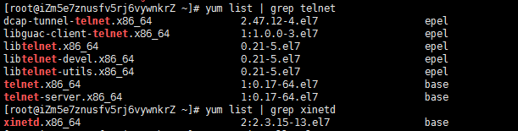

- 安装
yum -y install telnet-server.x86_64
yum -y install telnet.x86_64
yum -y install xinetd.x86_64

- 检测安装结果
rpm -qa | grep telnet
rpm -qa | grep xinetd
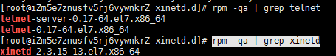
- 设置开机启动
systemctl enable xinetd.service
systemctl enable telnet.socket
- 启动及查看（telnet服务是由xinetd守护，所以要启动telnet服务也需要启动xinetd ）
systemctl start telnet.socket
systemctl start xinetd
ps -ef | grep xinetd
