**Our Partner Organizations**

[](http://www.hiwaay.net/)

[](http://www.earlyworks.com/)

[](http://www.waaytv.com/)

[](http://www.wdrm.com/)

[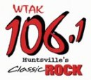](http://www.wtak.com/)

[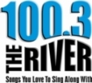](http://www.1003theriver.com/)

[](http://www.huntsvilletimes.com/)