03_joint_model

Randy

1/28/2021

these notes are directly from the textbook:  
“Joint Models for Longitudinal and Time-to-Event Data With Applications in R”  
by Dimitris Rizopoulos  
CRC Press/Taylor & Francis Group/A Chapman & Hall Book

lme_p1 <- lme(log(serBilir) ~ year + drug:year,  
 random = ~ year | id,  
 data = pbc2)  
  
summary(lme_p1)

## Linear mixed-effects model fit by REML  
## Data: pbc2   
## AIC BIC logLik  
## 3082.323 3121.323 -1534.161  
##   
## Random effects:  
## Formula: ~year | id  
## Structure: General positive-definite, Log-Cholesky parametrization  
## StdDev Corr   
## (Intercept) 0.9990381 (Intr)  
## year 0.1722826 0.417   
## Residual 0.3489259   
##   
## Fixed effects: log(serBilir) ~ year + drug:year   
## Value Std.Error DF t-value p-value  
## (Intercept) 0.4956686 0.05807539 1631 8.534915 0.0000  
## year 0.1761726 0.01754759 1631 10.039704 0.0000  
## year:drugD-penicil 0.0027708 0.02411083 1631 0.114920 0.9085  
## Correlation:   
## (Intr) year   
## year 0.177   
## year:drugD-penicil 0.002 -0.705  
##   
## Standardized Within-Group Residuals:  
## Min Q1 Med Q3 Max   
## -4.31683669 -0.49673826 -0.01978638 0.45207679 5.28538333   
##   
## Number of Observations: 1945  
## Number of Groups: 312

# broom.mixed::augment(lme_p1)  
# broom.mixed::tidy(lme_p1)  
# broom.mixed::glance(lme_p1)

mcov_p1 <- getVarCov(lme_p1,  
 individuals = 1:6,  
 ## type: "random effects",  
 ## "conditional"  
 type = "marginal")  
mcov_p1

## id 1   
## Marginal variance covariance matrix  
## 1 2  
## 1 1.1198 1.0358  
## 2 1.0358 1.2035  
## Standard Deviations: 1.0582 1.097   
## id 2   
## Marginal variance covariance matrix  
## 1 2 3 4 5 6 7 8 9  
## 1 1.1198 1.0339 1.0698 1.1490 1.3499 1.4209 1.4925 1.5646 1.6322  
## 2 1.0339 1.1987 1.1204 1.2159 1.4582 1.5438 1.6301 1.7171 1.7986  
## 3 1.0698 1.1204 1.2930 1.2832 1.5671 1.6673 1.7685 1.8704 1.9660  
## 4 1.1490 1.2159 1.2832 1.5530 1.8068 1.9394 2.0732 2.2080 2.3344  
## 5 1.3499 1.4582 1.5671 1.8068 2.5365 2.6295 2.8460 3.0643 3.2689  
## 6 1.4209 1.5438 1.6673 1.9394 2.6295 2.9949 3.1190 3.3667 3.5990  
## 7 1.4925 1.6301 1.7685 2.0732 2.8460 3.1190 3.5159 3.6717 3.9318  
## 8 1.5646 1.7171 1.8704 2.2080 3.0643 3.3667 3.6717 4.1009 4.2674  
## 9 1.6322 1.7986 1.9660 2.3344 3.2689 3.5990 3.9318 4.2674 4.7037  
## Standard Deviations: 1.0582 1.0949 1.1371 1.2462 1.5926 1.7306 1.8751 2.0251 2.1688   
## id 3   
## Marginal variance covariance matrix  
## 1 2 3 4  
## 1 1.1198 1.0327 1.0696 1.1441  
## 2 1.0327 1.1959 1.1185 1.2078  
## 3 1.0696 1.1185 1.2924 1.2759  
## 4 1.1441 1.2078 1.2759 1.5348  
## Standard Deviations: 1.0582 1.0936 1.1368 1.2389   
## id 4   
## Marginal variance covariance matrix  
## 1 2 3 4 5 6 7  
## 1 1.1198 1.0350 1.0712 1.1414 1.2446 1.2855 1.3566  
## 2 1.0350 1.2016 1.1237 1.2088 1.3340 1.3836 1.4699  
## 3 1.0712 1.1237 1.2969 1.2748 1.4215 1.4796 1.5807  
## 4 1.1414 1.2088 1.2748 1.5247 1.5913 1.6659 1.7958  
## 5 1.2446 1.3340 1.4215 1.5913 1.9627 1.9399 2.1121  
## 6 1.2855 1.3836 1.4796 1.6659 1.9399 2.1702 2.2374  
## 7 1.3566 1.4699 1.5807 1.7958 2.1121 2.2374 2.5772  
## Standard Deviations: 1.0582 1.0962 1.1388 1.2348 1.401 1.4732 1.6054   
## id 5   
## Marginal variance covariance matrix  
## 1 2 3 4 5 6  
## 1 1.1198 1.0372 1.0749 1.1492 1.2139 1.2841  
## 2 1.0372 1.2069 1.1314 1.2224 1.3017 1.3876  
## 3 1.0749 1.1314 1.3076 1.2930 1.3863 1.4875  
## 4 1.1492 1.2224 1.2930 1.5537 1.5530 1.6842  
## 5 1.2139 1.3017 1.3863 1.5530 1.8197 1.8554  
## 6 1.2841 1.3876 1.4875 1.6842 1.8554 2.1629  
## Standard Deviations: 1.0582 1.0986 1.1435 1.2465 1.349 1.4707   
## id 6   
## Marginal variance covariance matrix  
## 1 2 3 4 5 6  
## 1 1.1198 1.0724 1.1430 1.2173 1.2914 1.4803  
## 2 1.0724 1.3002 1.2792 1.3853 1.4912 1.7609  
## 3 1.1430 1.2792 1.5304 1.5450 1.6809 2.0274  
## 4 1.2173 1.3853 1.5450 1.8348 1.8807 2.3080  
## 5 1.2914 1.4912 1.6809 1.8807 2.2017 2.5879  
## 6 1.4803 1.7609 2.0274 2.3080 2.5879 3.4230  
## Standard Deviations: 1.0582 1.1403 1.2371 1.3545 1.4838 1.8501

cov2cor(mcov_p1[[1]])

## 1 2  
## 1 1.0000000 0.8922432  
## 2 0.8922432 1.0000000

cov2cor(mcov_p1[[5]])

## 1 2 3 4 5 6  
## 1 1.0000000 0.8921836 0.8883346 0.8712605 0.8503692 0.8250945  
## 2 0.8921836 1.0000000 0.9006202 0.8926836 0.8783299 0.8588684  
## 3 0.8883346 0.9006202 1.0000000 0.9071520 0.8987105 0.8845412  
## 4 0.8712605 0.8926836 0.9071520 1.0000000 0.9235566 0.9187357  
## 5 0.8503692 0.8783299 0.8987105 0.9235566 1.0000000 0.9352176  
## 6 0.8250945 0.8588684 0.8845412 0.9187357 0.9352176 1.0000000

## use expand.grid to set a new design matrix  
## to get the predict value for individual 6  
contrast6 <-  
 expand.grid(  
 id = 6,  
 year = c(0.5, 1.5),  
 drug = c("D-penicil", "placebo"))  
contrast6$pred <-  
 predict(  
 object = lme_p1,  
 newdata = contrast6)  
contrast6

## id year drug pred  
## 1 6 0.5 D-penicil -0.2520967  
## 2 6 1.5 D-penicil -0.2647039  
## 3 6 0.5 placebo -0.2534821  
## 4 6 1.5 placebo -0.2688602

contrast <-  
 expand.grid(  
 year = c(0.5, 1.5),  
 drug = c("D-penicil", "placebo"))  
contrast$pred <-  
 predict(  
 object = lme_p1,  
 newdata = contrast,  
 level = 0)  
contrast

## year drug pred  
## 1 0.5 D-penicil 0.5851403  
## 2 1.5 D-penicil 0.7640837  
## 3 0.5 placebo 0.5837549  
## 4 1.5 placebo 0.7599275

lme_p2 <- lme(log(serBilir) ~ year + drug:year,   
 ## with a diagnoal covariance matrix  
 ## to construct a pdiag class  
 ## a diagnoal positive definite matrix  
 random = list(id = pdDiag(form = ~ year)),  
 data = pbc2)  
summary(lme_p2)

## Linear mixed-effects model fit by REML  
## Data: pbc2   
## AIC BIC logLik  
## 3103.405 3136.834 -1545.702  
##   
## Random effects:  
## Formula: ~year | id  
## Structure: Diagonal  
## (Intercept) year Residual  
## StdDev: 1.022807 0.1730064 0.3477198  
##   
## Fixed effects: log(serBilir) ~ year + drug:year   
## Value Std.Error DF t-value p-value  
## (Intercept) 0.5018477 0.05940260 1631 8.448246 0.0000  
## year 0.1615161 0.01824414 1631 8.853042 0.0000  
## year:drugD-penicil 0.0009133 0.02543324 1631 0.035909 0.9714  
## Correlation:   
## (Intr) year   
## year -0.051   
## year:drugD-penicil 0.003 -0.716  
##   
## Standardized Within-Group Residuals:  
## Min Q1 Med Q3 Max   
## -4.32090846 -0.48702559 -0.02107092 0.44884171 5.35169416   
##   
## Number of Observations: 1945  
## Number of Groups: 312

lme_y1 <- lme(log(serBilir) ~ year,  
 random = list(id = pdDiag(form = ~ year)),  
 data = pbc2)  
summary(lme_y1)

## Linear mixed-effects model fit by REML  
## Data: pbc2   
## AIC BIC logLik  
## 3095.898 3123.758 -1542.949  
##   
## Random effects:  
## Formula: ~year | id  
## Structure: Diagonal  
## (Intercept) year Residual  
## StdDev: 1.022888 0.1723546 0.3477605  
##   
## Fixed effects: log(serBilir) ~ year   
## Value Std.Error DF t-value p-value  
## (Intercept) 0.5019387 0.05940664 1632 8.449202 0  
## year 0.1618612 0.01270475 1632 12.740212 0  
## Correlation:   
## (Intr)  
## year -0.07   
##   
## Standardized Within-Group Residuals:  
## Min Q1 Med Q3 Max   
## -4.31975326 -0.48772130 -0.02165448 0.44883403 5.35048839   
##   
## Number of Observations: 1945  
## Number of Groups: 312

lme_y2 <- lme(log(serBilir) ~ bs(year),   
 random = list(id = pdDiag(form = ~ bs(year))),  
 data = pbc2)  
summary(lme_y2)

## Linear mixed-effects model fit by REML  
## Data: pbc2   
## AIC BIC logLik  
## 2888.831 2938.97 -1435.416  
##   
## Random effects:  
## Formula: ~bs(year) | id  
## Structure: Diagonal  
## (Intercept) bs(year)1 bs(year)2 bs(year)3 Residual  
## StdDev: 1.005864 1.773795 2.148785 1.608119 0.2962375  
##   
## Fixed effects: log(serBilir) ~ bs(year)   
## Value Std.Error DF t-value p-value  
## (Intercept) 0.5211715 0.05863493 1630 8.888414 0  
## bs(year)1 0.6815165 0.13639538 1630 4.996624 0  
## bs(year)2 1.6851088 0.23274184 1630 7.240249 0  
## bs(year)3 1.2867834 0.30293582 1630 4.247710 0  
## Correlation:   
## (Intr) bs(y)1 bs(y)2  
## bs(year)1 -0.101   
## bs(year)2 0.050 -0.334   
## bs(year)3 -0.044 0.226 -0.456  
##   
## Standardized Within-Group Residuals:  
## Min Q1 Med Q3 Max   
## -4.91406447 -0.43002510 0.00535502 0.43838229 4.84009246   
##   
## Number of Observations: 1945  
## Number of Groups: 312

for the joint model, the parameters number, including in the linear predictor and in the model for baseline hazard should be 1/10 and 1/20 of the total number of events in the sample.

the number of spline coefficients m  
the degree of B-spline basis function q  
the number of interior knots n  
m = n + q - 1

increasing the number of knots can increase the flexibility, but keep a balance between bias and variance and avoid overfitting.

after the number of knots decided, the location depends on the percentiles of censor and event times.

lme_y3 <- lme(log(serBilir) ~ bs(year, knots = c(2, 5)),   
 random = list(id = pdDiag(form = ~ bs(year, knots = c(2, 5)))),  
 data = pbc2)  
summary(lme_y3)

## Linear mixed-effects model fit by REML  
## Data: pbc2   
## AIC BIC logLik  
## 2885.038 2957.447 -1429.519  
##   
## Random effects:  
## Formula: ~bs(year, knots = c(2, 5)) | id  
## Structure: Diagonal  
## (Intercept) bs(year, knots = c(2, 5))1 bs(year, knots = c(2, 5))2  
## StdDev: 1.00827 0.4581381 0.8664644  
## bs(year, knots = c(2, 5))3 bs(year, knots = c(2, 5))4  
## StdDev: 1.43594 1.628952  
## bs(year, knots = c(2, 5))5 Residual  
## StdDev: 1.318308 0.26846  
##   
## Fixed effects: log(serBilir) ~ bs(year, knots = c(2, 5))   
## Value Std.Error DF t-value p-value  
## (Intercept) 0.5647052 0.0589869 1628 9.573402 0.0000  
## bs(year, knots = c(2, 5))1 -0.0811263 0.0436029 1628 -1.860572 0.0630  
## bs(year, knots = c(2, 5))2 0.4361126 0.0669364 1628 6.515326 0.0000  
## bs(year, knots = c(2, 5))3 0.8148046 0.1376709 1628 5.918495 0.0000  
## bs(year, knots = c(2, 5))4 1.2468425 0.2166057 1628 5.756279 0.0000  
## bs(year, knots = c(2, 5))5 1.1868444 0.3192865 1628 3.717176 0.0002  
## Correlation:   
## (Intr) b(,k=c(2,5))1 b(,k=c(2,5))2 b(,k=c(2,5))3  
## bs(year, knots = c(2, 5))1 -0.128   
## bs(year, knots = c(2, 5))2 -0.039 -0.122   
## bs(year, knots = c(2, 5))3 -0.039 0.233 -0.249   
## bs(year, knots = c(2, 5))4 -0.009 -0.082 0.191 -0.309   
## bs(year, knots = c(2, 5))5 -0.016 0.089 -0.085 0.177   
## b(,k=c(2,5))4  
## bs(year, knots = c(2, 5))1   
## bs(year, knots = c(2, 5))2   
## bs(year, knots = c(2, 5))3   
## bs(year, knots = c(2, 5))4   
## bs(year, knots = c(2, 5))5 -0.309   
##   
## Standardized Within-Group Residuals:  
## Min Q1 Med Q3 Max   
## -4.585964055 -0.392985786 -0.004107165 0.421633530 4.911305058   
##   
## Number of Observations: 1945  
## Number of Groups: 312

lme_y4 <- lme(log(serBilir) ~ bs(year,   
 ## provide either df or knots  
 # df = length(knots) + degree + 1  
 knots = c(2, 5)),  
 random = list(id = pdDiag(form = ~ year)),  
 data = pbc2)  
  
mcov_y4 <- getVarCov(lme_y4,   
 individuals = 5,   
 type = "marginal")  
mcor_y4 <- cov2cor(mcov_y4[[1]])  
  
summary(lme_y4)

## Linear mixed-effects model fit by REML  
## Data: pbc2   
## AIC BIC logLik  
## 3084.814 3134.944 -1533.407  
##   
## Random effects:  
## Formula: ~year | id  
## Structure: Diagonal  
## (Intercept) year Residual  
## StdDev: 1.012348 0.1818349 0.3433737  
##   
## Fixed effects: log(serBilir) ~ bs(year, knots = c(2, 5))   
## Value Std.Error DF t-value p-value  
## (Intercept) 0.5637991 0.06037573 1628 9.338173 0.0000  
## bs(year, knots = c(2, 5))1 -0.0714169 0.04256212 1628 -1.677945 0.0935  
## bs(year, knots = c(2, 5))2 0.3931256 0.05027977 1628 7.818762 0.0000  
## bs(year, knots = c(2, 5))3 0.9330279 0.12419206 1628 7.512782 0.0000  
## bs(year, knots = c(2, 5))4 2.1919319 0.19305164 1628 11.354122 0.0000  
## bs(year, knots = c(2, 5))5 2.4131185 0.24993352 1628 9.655041 0.0000  
## Correlation:   
## (Intr) b(,k=c(2,5))1 b(,k=c(2,5))2 b(,k=c(2,5))3  
## bs(year, knots = c(2, 5))1 -0.206   
## bs(year, knots = c(2, 5))2 -0.090 -0.035   
## bs(year, knots = c(2, 5))3 -0.063 0.415 0.028   
## bs(year, knots = c(2, 5))4 -0.021 0.027 0.626 0.249   
## bs(year, knots = c(2, 5))5 -0.028 0.203 0.258 0.710   
## b(,k=c(2,5))4  
## bs(year, knots = c(2, 5))1   
## bs(year, knots = c(2, 5))2   
## bs(year, knots = c(2, 5))3   
## bs(year, knots = c(2, 5))4   
## bs(year, knots = c(2, 5))5 0.382   
##   
## Standardized Within-Group Residuals:  
## Min Q1 Med Q3 Max   
## -4.31266856 -0.48092827 -0.02336205 0.44741298 5.30930977   
##   
## Number of Observations: 1945  
## Number of Groups: 312

# broom.mixed::augment(lme_y4)  
# broom.mixed::glance(lme_y4)

td_cox <- coxph(Surv(start, stop, event) ~ drug + CD4,  
 data = aids)  
  
surv1 <- Surv(aids$start, aids$stop, aids$event)  
surv2 <- aids %>%  
 with(Surv(stop, event))  
  
# surv1; surv2  
  
td_cox

## Call:  
## coxph(formula = Surv(start, stop, event) ~ drug + CD4, data = aids)  
##   
## coef exp(coef) se(coef) z p  
## drugddI 0.30948 1.36271 0.14653 2.112 0.0347  
## CD4 -0.19343 0.82412 0.02437 -7.937 2.08e-15  
##   
## Likelihood ratio test=94.62 on 2 df, p=< 2.2e-16  
## n= 1405, number of events= 188

td_cox$coefficients[[2]] %>% exp()

## [1] 0.8241239

## one unit increase of CD4 cell counter   
## will make the risk for death decreased  
## to 82.41% of the chance

aids_id <- aids[!duplicated(aids$patient), ]

we need to elaborate specification of time structures in the time effect for longitudinal submodel. possibly the interactions between the postulated time structure and baseline covariates.

1. consider flexible representations for high order polynomials and splines.
2. incorporate an additional stochastic term

to capture the remaining serial correlation in the observed measurements. for example: Ornstein-Uhlenbeck process, and latent stationary Gaussian process

it is advisable to opt for either 1 or 2; but not necessary for both.

lme_aids <- lme(CD4 ~ obstime + obstime:drug,  
 random = ~ obstime | patient,   
 data = JM::aids)  
  
  
cox_aids <- coxph(Surv(Time, death) ~ drug,  
 data = JM::aids.id,   
 model = TRUE,  
 x = TRUE)

# joint_aids <-   
# JM::jointModel(  
# lmeObject = lme_aids,   
# survObject = cox_aids,  
# ## required in internal computation of mi(t)  
# ## the true value of the time-dependent-varying  
# timeVar = "obstime",  
# ## the type of baseline risk function  
# ## assumed to be piecewise constant  
# method = "piecewise-PH-aGH")  
# save(joint_aids, file = "joint_aids.Rdata")  
  
load("joint_aids.Rdata")  
summary(joint_aids)

##   
## Call:  
## JM::jointModel(lmeObject = lme_aids, survObject = cox_aids, timeVar = "obstime",   
## method = "piecewise-PH-aGH")  
##   
## Data Descriptives:  
## Longitudinal Process Event Process  
## Number of Observations: 1405 Number of Events: 188 (40.3%)  
## Number of Groups: 467  
##   
## Joint Model Summary:  
## Longitudinal Process: Linear mixed-effects model  
## Event Process: Relative risk model with piecewise-constant  
## baseline risk function  
## Parameterization: Time-dependent   
##   
## log.Lik AIC BIC  
## -4328.261 8688.523 8754.864  
##   
## Variance Components:  
## StdDev Corr  
## (Intercept) 4.5839 (Intr)  
## obstime 0.1822 -0.0468  
## Residual 1.7377   
##   
## Coefficients:  
## Longitudinal Process  
## Value Std.Err z-value p-value  
## (Intercept) 7.2203 0.2218 32.5537 <0.0001  
## obstime -0.1917 0.0217 -8.8374 <0.0001  
## obstime:drugddI 0.0116 0.0302 0.3834 0.7014  
##   
## Event Process  
## Value Std.Err z-value p-value  
## drugddI 0.3348 0.1565 2.1397 0.0324  
## Assoct -0.2875 0.0359 -8.0141 <0.0001  
## log(xi.1) -2.5438 0.1913 -13.2953   
## log(xi.2) -2.2722 0.1784 -12.7328   
## log(xi.3) -1.9554 0.2403 -8.1357   
## log(xi.4) -2.5011 0.3412 -7.3297   
## log(xi.5) -2.4152 0.3156 -7.6531   
## log(xi.6) -2.4018 0.4007 -5.9941   
## log(xi.7) -2.4239 0.5301 -4.5725   
##   
## Integration:  
## method: (pseudo) adaptive Gauss-Hermite  
## quadrature points: 5   
##   
## Optimization:  
## Convergence: 0

# str(joint_aids)

the parameter labeled “Assoct” is the alpha; the association between mi(t) and the risk for death.

the xi.. are the epslion parameters for piecewise-constant baseline risk function.

comparison to the cox extended model, we clearly see non-negligible differences.

$$h_{0}(t)=\sum_{q=1}^{Q}{ξ_{q}}I(v_{q−1}<t<v_{q}) (4.3)$$

$$log h_{0}(t)=κ_{0}+\sum_{d=1}^{m}{κ_{d}}B_{d}(t,q) (4.4)$$

$$\left\{\begin{matrix}y_{i}(t)=m_{i}(t)+ϵ_{i}(t) \\ m_{i}(t)=x_{i}^{T}(t)β+z_{i}(t)b_{i} (4.5) \\ b_{i}∼N(0,D) \\ ϵ_{i}∼N(0,σ^{2})\end{matrix}\right.$$

for stochastic process independent of $b_{i}$, $ϵ_{i}$:

$$y_{i}(t)=m_{i}(t)+u_{i}(t)+ϵ_{i}(t) (4.6)$$

currently the package::JM() only works with linear mixed effects submodels with iid error terms and no serial correlation structures as (4.6)

cannot add a correlation structure (correlation argument) or a variance function (weights argument)

regarding to the covariance matrix of the random effects, by default JM::jointModel() assumes it to be unstructured.

it also allows for a diagonal covariance matrix, which can be specified using function pdDiag() in the random argument of lme().

# joint_aids_gh <-  
# JM::jointModel(  
# lmeObject = lme_aids,  
# survObject = cox_aids,  
# ## required in internal computation of mi(t)  
# ## the true value of the time-dependent-varying  
# timeVar = "obstime",  
# ## the type of baseline risk function  
# ## assumed to be piecewise constant  
# method = "piecewise-PH-GH")  
#   
# save(joint_aids_gh, file = "joint_aids_gh_20210207.Rdata")  
  
load("joint_aids_gh_20210207.Rdata")  
summary(joint_aids_gh)

##   
## Call:  
## JM::jointModel(lmeObject = lme_aids, survObject = cox_aids, timeVar = "obstime",   
## method = "piecewise-PH-GH")  
##   
## Data Descriptives:  
## Longitudinal Process Event Process  
## Number of Observations: 1405 Number of Events: 188 (40.3%)  
## Number of Groups: 467  
##   
## Joint Model Summary:  
## Longitudinal Process: Linear mixed-effects model  
## Event Process: Relative risk model with piecewise-constant  
## baseline risk function  
## Parameterization: Time-dependent   
##   
## log.Lik AIC BIC  
## -4340.674 8713.349 8779.69  
##   
## Variance Components:  
## StdDev Corr  
## (Intercept) 4.5286 (Intr)  
## obstime 0.1701 -0.0497  
## Residual 1.8744   
##   
## Coefficients:  
## Longitudinal Process  
## Value Std.Err z-value p-value  
## (Intercept) 7.2066 0.1343 53.6421 <0.0001  
## obstime -0.1902 0.0211 -8.9920 <0.0001  
## obstime:drugddI 0.0189 0.0273 0.6934 0.4880  
##   
## Event Process  
## Value Std.Err z-value p-value  
## drugddI 0.3502 0.1579 2.2182 0.0265  
## Assoct -0.3012 0.0384 -7.8369 <0.0001  
## log(xi.1) -2.4857 0.1967 -12.6393   
## log(xi.2) -2.2040 0.1856 -11.8755   
## log(xi.3) -1.8960 0.2440 -7.7692   
## log(xi.4) -2.4375 0.3441 -7.0842   
## log(xi.5) -2.3594 0.3183 -7.4117   
## log(xi.6) -2.3571 0.4033 -5.8442   
## log(xi.7) -2.3527 0.5352 -4.3956   
##   
## Integration:  
## method: Gauss-Hermite  
## quadrature points: 15   
##   
## Optimization:  
## Convergence: 0

# joint_aids_aft_wb <-  
# JM::jointModel(  
# lmeObject = lme_aids,  
# survObject = cox_aids,  
# ## required in internal computation of mi(t)  
# ## the true value of the time-dependent-varying  
# timeVar = "obstime",  
# ## the type of baseline risk function  
# ## assumed to be piecewise constant  
# method = "weibull-AFT-GH")  
#   
# save(joint_aids_aft_wb, file = "joint_aids_aft_wb_20210207.Rdata")  
  
load("joint_aids_aft_wb_20210207.Rdata")  
summary(joint_aids_aft_wb)

##   
## Call:  
## JM::jointModel(lmeObject = lme_aids, survObject = cox_aids, timeVar = "obstime",   
## method = "weibull-AFT-GH")  
##   
## Data Descriptives:  
## Longitudinal Process Event Process  
## Number of Observations: 1405 Number of Events: 188 (40.3%)  
## Number of Groups: 467  
##   
## Joint Model Summary:  
## Longitudinal Process: Linear mixed-effects model  
## Event Process: Weibull accelerated failure time model  
## Parameterization: Time-dependent   
##   
## log.Lik AIC BIC  
## -4340.161 8702.322 8747.932  
##   
## Variance Components:  
## StdDev Corr  
## (Intercept) 4.5358 (Intr)  
## obstime 0.1673 -0.0664  
## Residual 1.8763   
##   
## Coefficients:  
## Longitudinal Process  
## Value Std.Err z-value p-value  
## (Intercept) 7.1838 0.1345 53.4019 <0.0001  
## obstime -0.1843 0.0210 -8.7738 <0.0001  
## obstime:drugddI 0.0200 0.0272 0.7349 0.4624  
##   
## Event Process  
## Value Std.Err z-value p-value  
## (Intercept) 2.3820 0.1292 18.4338 <0.0001  
## drugddI -0.2780 0.1247 -2.2293 0.0258  
## Assoct 0.2286 0.0367 6.2259 <0.0001  
## log(shape) 0.2354 0.0797 2.9528 0.0031  
##   
## Scale: 1.2654   
##   
## Integration:  
## method: Gauss-Hermite  
## quadrature points: 15   
##   
## Optimization:  
## Convergence: 0

the main estimation methods for joint models is the semiparametric maximum likelihood. this semi-MLE has asymptotic properties under an unspecified baseline risk function.

joint distribution of the observed outcomes $T_{i}, δ_{i}, y_{i}$.

conditional on the random effects which independent of time. random effects acount for both the association between the longitudinal and event outcomes.

$$p(T_{i},δ_{i},y_{i};θ)=p(T_{i},δ_{i}|b_{i}; θ)p(y_{i}|b_{i}; θ) (4.7)$$



$θ=(θ_{t}^{T},θ_{y}^{T},θ_{b}^{T})^{T}$

the censoring mechanism and the visiting process are independent of the true event times and future longitudinal measurements.

for any time point t, we define as observed history all available information for the longitudinal process prior to t.

imply the belief that decisions on whether a subject withdraws from the study or appears at the clinic for a longitudinal measurement depend on the observed past history (longitudinal measurements and baseline covariates), but there is no additional dependence on underlying, latent subject characteristics associated with prognosis.

A setting in which these assumptions are violated is when either of the two processes depends on the random effects.

This is because such a dependence implicitly corresponds to a dependence to future longitudinal measurements.

Evaluating the plausibility of the non-informativeness for the visiting and censoring processes usually requires external information from subject-matter experts, since the observed data do not contain enough information to suggest otherwise

if the score equations corresponding to (4.12) are solved with respect to ??, with p(bi | Ti, ??i, yi; ??) fixed at the ?? value of the previous iteration, then this corresponds to an EM algorithm, whereas if the score equations are solved with respect to ?? considering p(bi | Ti, ??i, yi; ??), also a function of ??, then this corresponds to a maximization of the observed data log-likelihood l(??).

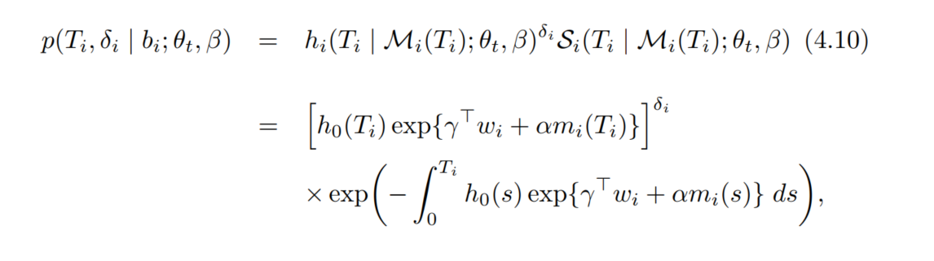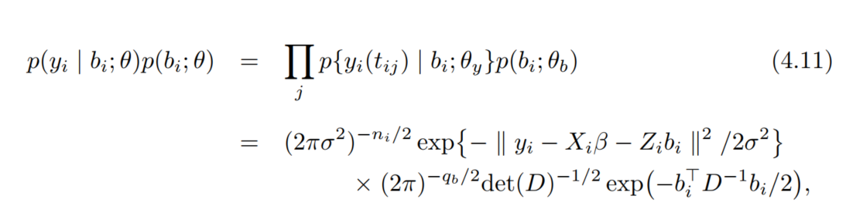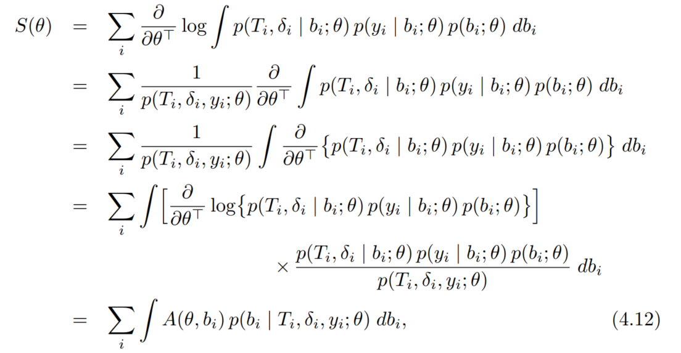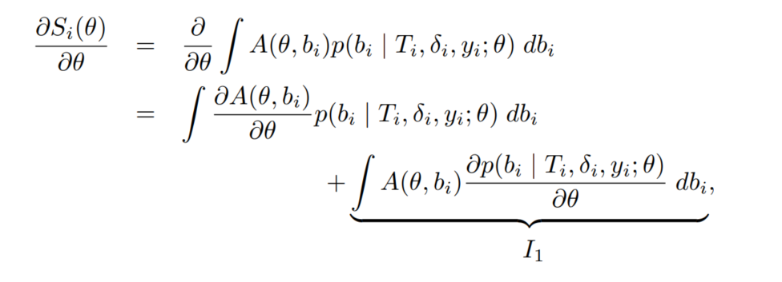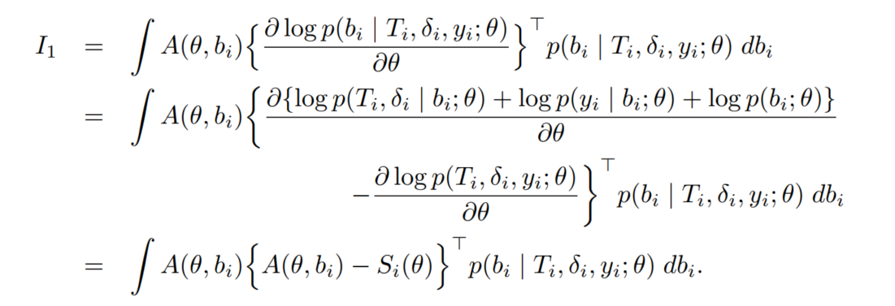

standard errors and inference for the regression coefficients of the (extended) Cox model enjoy nice asymptotic properties similar to those of asymptotic maximum likelihood theory, without having to specify an appropriate baseline risk function

Unfortunately, under the joint modeling framework this nice feature is not carried over

a full likelihood approach must be employed instead.

In order for profile likelihood asymptotic to work, this nonparametric maximum likelihood estimator should not depend on h0(t)

Unfortunately, however, this is not the case under joint models because this estimator has no closed-form solution due to the use of random effects.

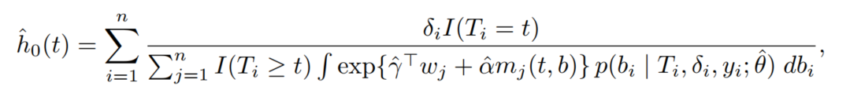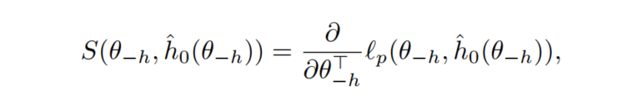

A feasible alternative is to postulate a flexible but parametric model for h0(t). 1. they can be made arbitrarily flexible by increasing the number of internal knots, and thus capture various shapes of h0(t)  
2. under such models, estimation of standard errors directly follows from asymptotic maximum likelihood theory

anova(joint_aids, joint_aids_gh)

## Warning in anova.jointModel(joint_aids, joint_aids_gh): either the two models are not nested or the model represented by 'object2' fell on a local maxima.

##   
## AIC BIC log.Lik LRT df p.value  
## joint_aids 8688.52 8754.86 -4328.26   
## joint_aids_gh 8713.35 8779.69 -4340.67 -24.83 0 1

anova(joint_aids, process = "Longitudinal")

##   
## Marginal Wald Tests Table  
##   
## Longitudinal Process  
## Chisq df Pr(>|Chi|)  
## obstime 126.3887 2 <1e-04  
## drug 0.1470 1 0.7014  
## obstime:drug 0.1470 1 0.7014

anova(joint_aids, process = "Event", L = diag(2))

##   
## Marginal Wald Tests Table  
##   
## User-defined Contrasts Matrix  
## Chisq df Pr(>|Chi|)  
## L 67.3251 2 < 1e-04

anova(joint_aids_aft_wb, process = "Longitudinal")

##   
## Marginal Wald Tests Table  
##   
## Longitudinal Process  
## Chisq df Pr(>|Chi|)  
## obstime 113.6734 2 <1e-04  
## drug 0.5401 1 0.4624  
## obstime:drug 0.5401 1 0.4624

anova(joint_aids_aft_wb, process = "Event", L = diag(3))

##   
## Marginal Wald Tests Table  
##   
## User-defined Contrasts Matrix  
## Chisq df Pr(>|Chi|)  
## L 1751.143 3 < 1e-04

anova(joint_aids_gh, process = "Longitudinal")

##   
## Marginal Wald Tests Table  
##   
## Longitudinal Process  
## Chisq df Pr(>|Chi|)  
## obstime 120.1505 2 <1e-04  
## drug 0.4809 1 0.488  
## obstime:drug 0.4809 1 0.488

anova(joint_aids_gh, process = "Event", L = diag(2))

##   
## Marginal Wald Tests Table  
##   
## User-defined Contrasts Matrix  
## Chisq df Pr(>|Chi|)  
## L 64.3725 2 < 1e-04

pwc <- piecewiseExp.ph(cox_aids)  
pwc$coefficients

## X xi1 xi2 xi3 xi4 xi5 xi6   
## 0.2059221 -3.8393612 -3.4105302 -3.0497646 -3.5896874 -3.4312411 -3.3413437   
## xi7   
## -3.1331363