Title: Bold Arial Black 16

Name: Bold Calibri 14

Date: Bold Calibri 12

# Head1: Bold Calibri 16

## Head2: Bold Calibri 14

### Head3: Bold Calibri 12

* Compact: Calibri 12

First Paragraph: Calibri 12

Body Text: Calibri 12

## source code: Consolas 8  
plot_hist_ag <- aort %>%  
 ggplot(aes(ao_gradient)) +  
 geom_histogram(aes(y = ..density..),  
 fill = "grey70",  
 color = "grey50") +  
 geom_density(alpha = 0.1,   
 size = 1) +  
 theme(legend.position="none") +  
 theme_bw()  
plot_hist_ag

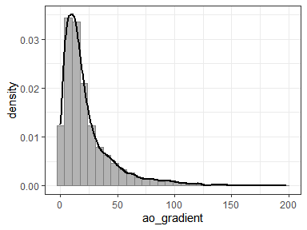

Caption: Bold Italic Cambria 8

| id | tstart | tstop | death | sqrt_aort_grad | oper | sex |
| --- | --- | --- | --- | --- | --- | --- |
| 1 | 0.00 | 0.75 | 0 | 2.1 | SI | Male |
| 1 | 0.75 | 1.86 | 0 | 1.9 | SI | Male |
| 2 | 0.00 | 3.23 | 0 | 2.9 | SI | Male |
| 2 | 10.76 | 11.06 | 0 | 7.6 | SI | Male |
| 2 | 11.06 | 12.00 | 0 | 7.4 | SI | Male |
| 2 | 12.00 | 12.63 | 0 | 9.1 | SI | Male |