Final Model (for publication)

randy

2024-04-11

Table of Contents

Goal of the analysis 2

Fit the joint model 3

Longitudinal model 3

Survival model 4

Joint model 5

Dynamic prediction 8

Individual prediction plots 8

AUC and ROC 27

Start Time 2 28

Start Time 3 33

Start Time 4 38

Start Time 5 43

Start Time 6 48

Start Time 8 53

Brier Score 58

## Goal of the analysis

* ☒ To separate the site and ethnicity as dummy variables
* ☒ Fit the final joint model (without rate) with JMbayes2 based on model selection results
* ☒ Dynamic prediction for the joint model with plots
* ☒ Calculate the AUC and ROC for the joint model for (year)

## Fit the joint model

### Longitudinal model

Summary for the longitudinal model:

| effect | group | term | estimate | std.error | df | statistic | p.value |
| --- | --- | --- | --- | --- | --- | --- | --- |
| fixed | NA | (Intercept) | 7.5166321 | 0.1042432 | 2725 | 72.10669 | 0 |
| fixed | NA | time | -0.5304830 | 0.0116235 | 2725 | -45.63885 | 0 |
| ran_pars | id | sd_(Intercept) | 1.6842278 | NA | NA | NA | NA |
| ran_pars | id | cor_time.(Intercept) | -0.3595600 | NA | NA | NA | NA |
| ran_pars | id | sd_time | 0.1039758 | NA | NA | NA | NA |
| ran_pars | Residual | sd_Observation | 1.2991322 | NA | NA | NA | NA |

Here is the latex code for the longitudinal model:

% latex table generated in R 4.2.2 by xtable 1.8-4 package  
% Wed Apr 10 20:46:26 2024  
\begin{table}[ht]  
\centering  
\begin{tabular}{rlllrrrrr}  
 \hline  
 & effect & group & term & estimate & std.error & df & statistic & p.value \\   
 \hline  
1 & fixed & & (Intercept) & 7.52 & 0.10 & 2725.00 & 72.11 & 0.00 \\   
 2 & fixed & & time & -0.53 & 0.01 & 2725.00 & -45.64 & 0.00 \\   
 3 & ran\_pars & id & sd\_(Intercept) & 1.68 & & & & \\   
 4 & ran\_pars & id & cor\_time.(Intercept) & -0.36 & & & & \\   
 5 & ran\_pars & id & sd\_time & 0.10 & & & & \\   
 6 & ran\_pars & Residual & sd\_Observation & 1.30 & & & & \\   
 \hline  
\end{tabular}  
\caption{Longitudinal model}   
\end{table}

### Survival model

Summary for the survival model:

| term | estimate | std.error | statistic | p.value |
| --- | --- | --- | --- | --- |
| marriedMarried/Partnered | 0.2174655 | 0.0946349 | 2.2979424 | 0.0215651 |
| bc_pillsEver use BC pills | -0.2268031 | 0.0988301 | -2.2948798 | 0.0217400 |
| bmi | -0.0030690 | 0.0067362 | -0.4555921 | 0.6486833 |
| ethnic_black | -0.1763593 | 0.1171415 | -1.5055240 | 0.1321894 |
| ethnic_chine | -0.0461925 | 0.2082844 | -0.2217760 | 0.8244883 |
| ethnic_hispa | -0.2032159 | 0.4114351 | -0.4939197 | 0.6213629 |
| ethnic_japan | -0.1775519 | 0.2024076 | -0.8771994 | 0.3803784 |
| site_c | 0.1102747 | 0.1602660 | 0.6880732 | 0.4914067 |
| site_m | 0.2698247 | 0.1525156 | 1.7691616 | 0.0768669 |
| site_nj | 0.1970137 | 0.3524136 | 0.5590411 | 0.5761337 |
| site_p | 0.5676597 | 0.1606871 | 3.5327014 | 0.0004113 |
| site_ucd | 0.2299409 | 0.1971701 | 1.1662055 | 0.2435314 |
| site_ucla | 0.2625519 | 0.2056597 | 1.2766325 | 0.2017320 |
| smoke_current_smoker | 0.5935254 | 0.1361619 | 4.3589687 | 0.0000131 |
| smoke_past_only | 0.0682581 | 0.1042874 | 0.6545193 | 0.5127773 |

Here is the latex code for the survival model:

% latex table generated in R 4.2.2 by xtable 1.8-4 package  
% Wed Apr 10 20:49:12 2024  
\begin{table}[ht]  
\centering  
\begin{tabular}{rlrrrr}  
 \hline  
 & term & estimate & std.error & statistic & p.value \\   
 \hline  
1 & marriedMarried/Partnered & 0.22 & 0.09 & 2.30 & 0.02 \\   
 2 & bc\_pillsEver use BC pills & -0.23 & 0.10 & -2.29 & 0.02 \\   
 3 & bmi & -0.00 & 0.01 & -0.46 & 0.65 \\   
 4 & ethnic\_black & -0.18 & 0.12 & -1.51 & 0.13 \\   
 5 & ethnic\_chine & -0.05 & 0.21 & -0.22 & 0.82 \\   
 6 & ethnic\_hispa & -0.20 & 0.41 & -0.49 & 0.62 \\   
 7 & ethnic\_japan & -0.18 & 0.20 & -0.88 & 0.38 \\   
 8 & site\_c & 0.11 & 0.16 & 0.69 & 0.49 \\   
 9 & site\_m & 0.27 & 0.15 & 1.77 & 0.08 \\   
 10 & site\_nj & 0.20 & 0.35 & 0.56 & 0.58 \\   
 11 & site\_p & 0.57 & 0.16 & 3.53 & 0.00 \\   
 12 & site\_ucd & 0.23 & 0.20 & 1.17 & 0.24 \\   
 13 & site\_ucla & 0.26 & 0.21 & 1.28 & 0.20 \\   
 14 & smoke\_current\_smoker & 0.59 & 0.14 & 4.36 & 0.00 \\   
 15 & smoke\_past\_only & 0.07 & 0.10 & 0.65 & 0.51 \\   
 \hline  
\end{tabular}  
\caption{Survival model}   
\end{table}

### Joint model

For the lme sub-model:

|  | Mean | StDev | 2.5% | 97.5% | P | Rhat |
| --- | --- | --- | --- | --- | --- | --- |
| (Intercept) | 7.9135455 | 0.1085692 | 7.7084534 | 8.1336243 | 0 | 1.012414 |
| time | -0.5953003 | 0.0125513 | -0.6211691 | -0.5721701 | 0 | 1.015866 |
| sigma | 1.3077694 | 0.0189601 | 1.2711295 | 1.3436842 | 0 | 1.002651 |

% latex table generated in R 4.2.2 by xtable 1.8-4 package  
% Wed Apr 10 21:31:42 2024  
\begin{table}[ht]  
\centering  
\begin{tabular}{rrrrrrr}  
 \hline  
 & Mean & StDev & 2.5\% & 97.5\% & P & Rhat \\   
 \hline  
(Intercept) & 7.91 & 0.11 & 7.71 & 8.13 & 0.00 & 1.01 \\   
 time & -0.60 & 0.01 & -0.62 & -0.57 & 0.00 & 1.02 \\   
 sigma & 1.31 & 0.02 & 1.27 & 1.34 & 0.00 & 1.00 \\   
 \hline  
\end{tabular}  
\caption{Longitudinal model}   
\end{table}

For the surv sub-model:

|  | Mean | StDev | 2.5% | 97.5% | P | Rhat |
| --- | --- | --- | --- | --- | --- | --- |
| marriedMarried/Partnered | 0.1266179 | 0.1490185 | -0.1617231 | 0.4137407 | 0.3875000 | 1.006580 |
| bc_pillsEver use BC pills | -0.0263297 | 0.1322543 | -0.2854227 | 0.2389329 | 0.8211667 | 1.004448 |
| bmi | -0.0482663 | 0.0090790 | -0.0666461 | -0.0309416 | 0.0000000 | 1.016472 |
| ethnic_black | -0.3653539 | 0.1533250 | -0.6638584 | -0.0677044 | 0.0150000 | 1.000042 |
| ethnic_chine | -0.2258512 | 0.2759631 | -0.7497783 | 0.3270956 | 0.4053333 | 1.014657 |
| ethnic_hispa | -0.6071708 | 0.6053575 | -1.7585837 | 0.6166765 | 0.3263333 | 1.051092 |
| ethnic_japan | -0.0380953 | 0.2651336 | -0.5569021 | 0.4735115 | 0.8910000 | 1.008927 |
| site_c | 0.2423351 | 0.2020243 | -0.1562895 | 0.6222388 | 0.2498333 | 1.011504 |
| site_m | 0.3299295 | 0.1904628 | -0.0359440 | 0.7099669 | 0.0785000 | 1.017660 |
| site_nj | 0.6440294 | 0.4900872 | -0.3486416 | 1.5668388 | 0.2110000 | 1.017173 |
| site_p | 0.5092241 | 0.2002082 | 0.1304235 | 0.9174151 | 0.0095000 | 1.020442 |
| site_ucd | 0.1383832 | 0.2553424 | -0.3751667 | 0.6395364 | 0.5673333 | 1.017673 |
| site_ucla | 0.4199383 | 0.2649476 | -0.0869673 | 0.9488132 | 0.1006667 | 1.017816 |
| smoke_current_smoker | 0.1722077 | 0.1751894 | -0.1870096 | 0.5279286 | 0.3048333 | 1.005363 |
| smoke_past_only | -0.0686700 | 0.1346129 | -0.3293920 | 0.1994389 | 0.6005000 | 1.004055 |
| value(lamh) | -1.0086003 | 0.0684292 | -1.1549865 | -0.8799643 | 0.0000000 | 1.059476 |

% latex table generated in R 4.2.2 by xtable 1.8-4 package  
% Wed Apr 10 21:30:38 2024  
\begin{table}[ht]  
\centering  
\begin{tabular}{rrrrrrr}  
 \hline  
 & Mean & StDev & 2.5\% & 97.5\% & P & Rhat \\   
 \hline  
marriedMarried/Partnered & 0.13 & 0.15 & -0.16 & 0.41 & 0.39 & 1.01 \\   
 bc\_pillsEver use BC pills & -0.03 & 0.13 & -0.29 & 0.24 & 0.82 & 1.00 \\   
 bmi & -0.05 & 0.01 & -0.07 & -0.03 & 0.00 & 1.02 \\   
 ethnic\_black & -0.37 & 0.15 & -0.66 & -0.07 & 0.01 & 1.00 \\   
 ethnic\_chine & -0.23 & 0.28 & -0.75 & 0.33 & 0.41 & 1.01 \\   
 ethnic\_hispa & -0.61 & 0.61 & -1.76 & 0.62 & 0.33 & 1.05 \\   
 ethnic\_japan & -0.04 & 0.27 & -0.56 & 0.47 & 0.89 & 1.01 \\   
 site\_c & 0.24 & 0.20 & -0.16 & 0.62 & 0.25 & 1.01 \\   
 site\_m & 0.33 & 0.19 & -0.04 & 0.71 & 0.08 & 1.02 \\   
 site\_nj & 0.64 & 0.49 & -0.35 & 1.57 & 0.21 & 1.02 \\   
 site\_p & 0.51 & 0.20 & 0.13 & 0.92 & 0.01 & 1.02 \\   
 site\_ucd & 0.14 & 0.26 & -0.38 & 0.64 & 0.57 & 1.02 \\   
 site\_ucla & 0.42 & 0.26 & -0.09 & 0.95 & 0.10 & 1.02 \\   
 smoke\_current\_smoker & 0.17 & 0.18 & -0.19 & 0.53 & 0.30 & 1.01 \\   
 smoke\_past\_only & -0.07 & 0.13 & -0.33 & 0.20 & 0.60 & 1.00 \\   
 value(lamh) & -1.01 & 0.07 & -1.15 & -0.88 & 0.00 & 1.06 \\   
 \hline  
\end{tabular}  
\caption{Survival model}   
\end{table}

***Notice: ask EJC for which computer to use for long chain running***

## Dynamic prediction

### Individual prediction plots

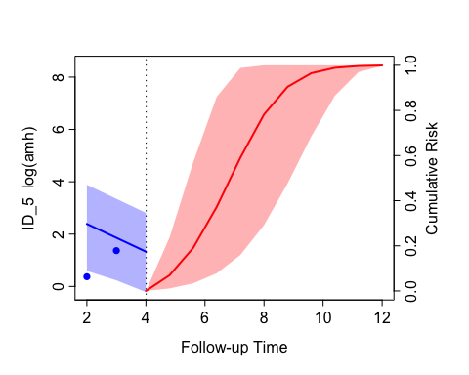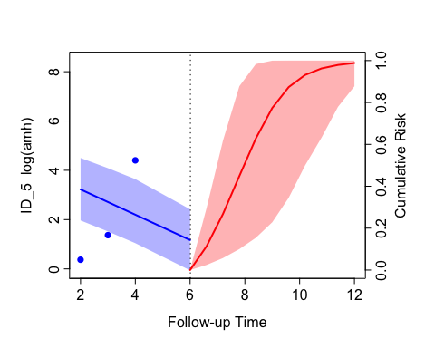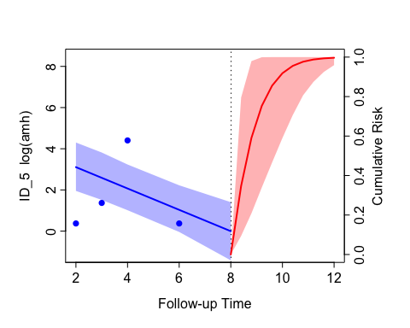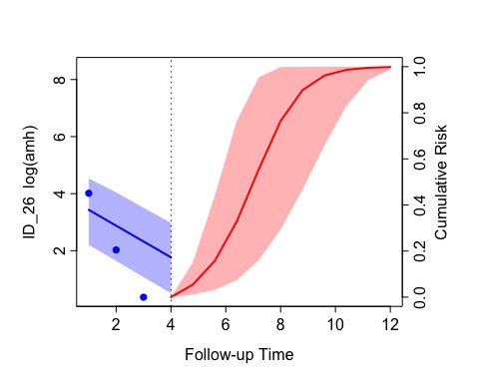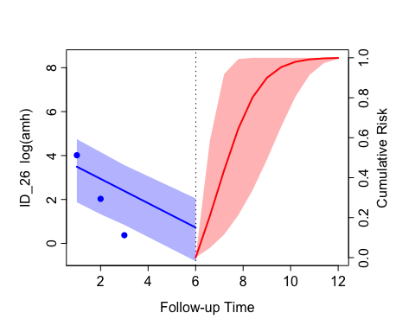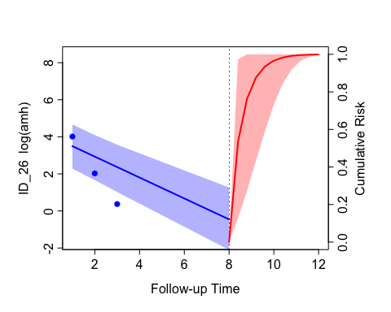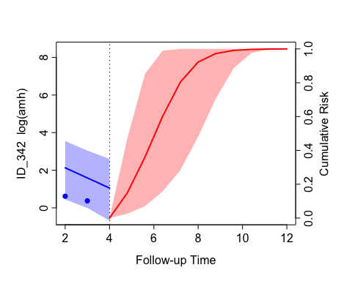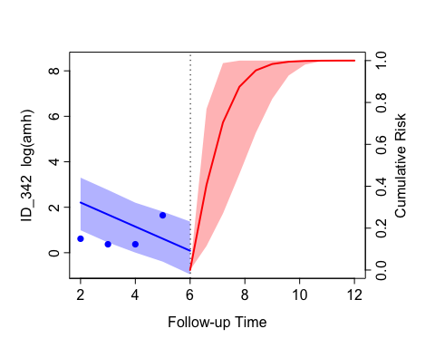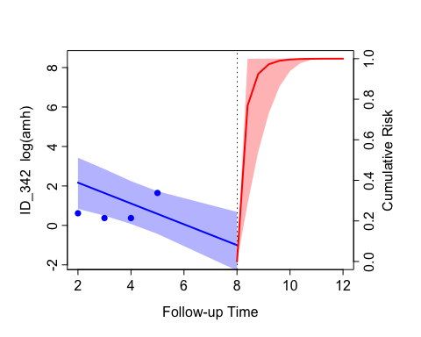

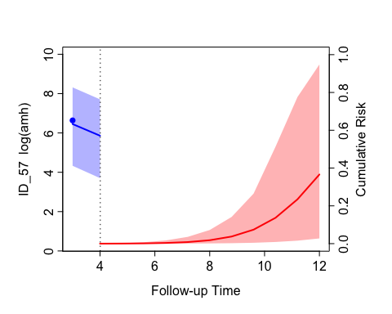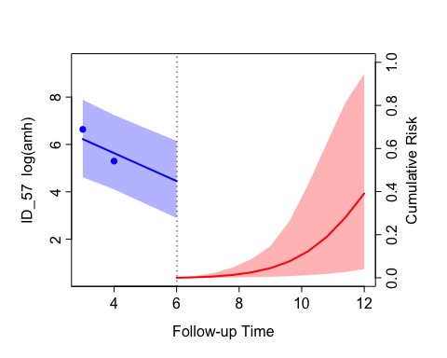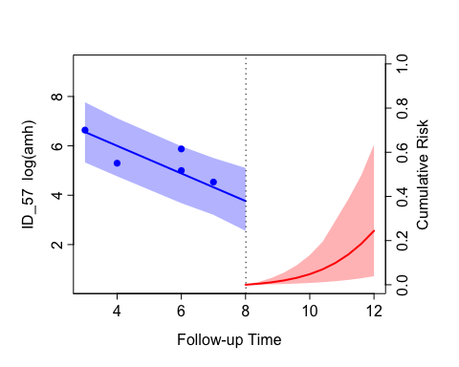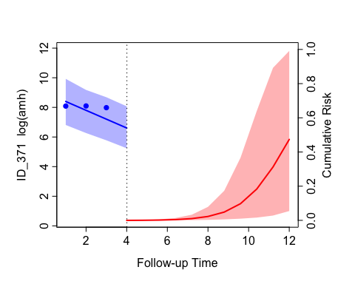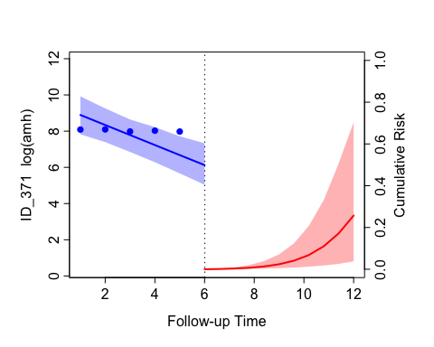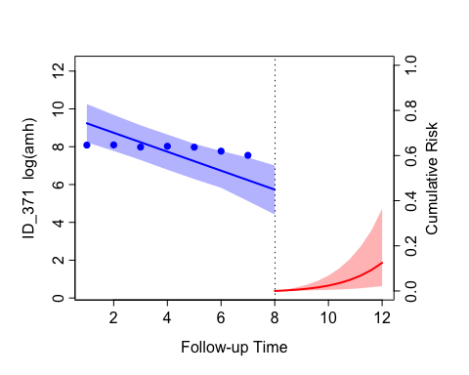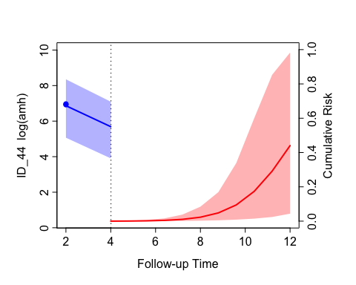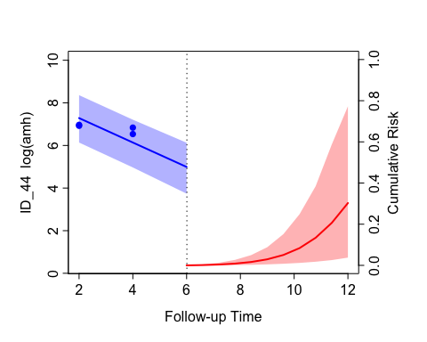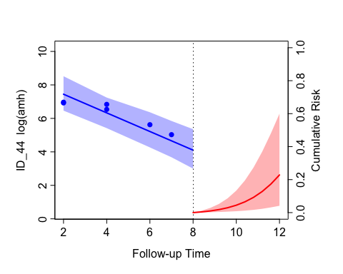

## AUC and ROC

For JMbayes2, the function tvAUC() is used to estimate the time-dependent AUC only for all the subjects (there is no function for individual AUC). Here is an error message for the AUC

Error in tvROC.jm(object, newdata, Tstart, Thoriz, Dt, ...) :   
 it seems that there are no events in the interval [Tstart, Thoriz).

#> Error in tvROC.jm(object, newdata, Tstart, Thoriz, Dt, ...) :   
#> it seems that there are no events in the interval [Tstart, Thoriz).

|  | Dt1 | Dt2 | Dt3 | Dt4 | Dt5 |
| --- | --- | --- | --- | --- | --- |
| Tstart2 | NA | 0.6503 | 0.8988 | 0.8214 | 0.8471 |
| Tstart3 | 0.6741 | 0.9011 | 0.8650 | 0.8105 | 0.8115 |
| Tstart4 | 0.9590 | 0.9172 | 0.8310 | 0.8070 | 0.8070 |
| Tstart5 | 0.8834 | 0.8459 | 0.8244 | 0.8196 | 0.8302 |
| Tstart6 | 0.8256 | 0.8258 | 0.8140 | 0.8278 | 0.8014 |
| Tstart8 | 0.7984 | 0.8063 | 0.7879 | 0.7810 | 0.8306 |

#> % latex table generated in R 4.2.2 by xtable 1.8-4 package  
#> % Thu Apr 11 09:59:35 2024  
#> \begin{table}[ht]  
#> \centering  
#> \begin{tabular}{rrrrrr}  
#> \hline  
#> & Dt1 & Dt2 & Dt3 & Dt4 & Dt5 \\   
#> \hline  
#> Tstart2 & & 0.65 & 0.90 & 0.82 & 0.85 \\   
#> Tstart4 & 0.96 & 0.92 & 0.83 & 0.81 & 0.81 \\   
#> Tstart6 & 0.83 & 0.83 & 0.81 & 0.83 & 0.80 \\   
#> Tstart8 & 0.80 & 0.81 & 0.79 & 0.78 & 0.83 \\   
#> \hline  
#> \end{tabular}  
#> \caption{AUC Table}   
#> \end{table}

The ROC curves for the joint model for by rows,

and by columns are shown below:

### Start Time 2

### Start Time 3

### Start Time 4

### Start Time 5

### Start Time 6

### Start Time 8

## Brier Score

The warning massage for the Brier score is shown below:

Error in br(Thoriz) :   
 it seems that there are no events in the interval [2.000001, 3).  
  
Warning: there are fewer than 5 subjects with an event in the interval [2.000001, 4).

#> Error in br(Thoriz) :   
#> it seems that there are no events in the interval [2.000001, 3).

#> Warning in br(Thoriz): there are fewer than 5 subjects with an event in the interval [2.000001, 4).

#> Warning in br(Thoriz): there are fewer than 5 subjects with an event in the interval [3.000001, 4).

#> Warning in br(Thoriz): there are fewer than 5 subjects with an event in the interval [4.000001, 5).

|  | Dt1 | Dt2 | Dt3 | Dt4 | Dt5 |
| --- | --- | --- | --- | --- | --- |
| Tstart2 | NA | 0.0128 | 0.0349 | 0.0649 | 0.1177 |
| Tstart3 | 0.0084 | 0.0244 | 0.0470 | 0.1146 | 0.1545 |
| Tstart4 | 0.0110 | 0.0261 | 0.0794 | 0.1243 | 0.1764 |
| Tstart5 | 0.0133 | 0.0577 | 0.1089 | 0.1600 | 0.1768 |
| Tstart6 | 0.0433 | 0.0893 | 0.1416 | 0.1700 | 0.1832 |
| Tstart8 | 0.0949 | 0.1589 | 0.1932 | 0.1835 | 0.1219 |

#> % latex table generated in R 4.2.2 by xtable 1.8-4 package  
#> % Thu Apr 11 13:50:22 2024  
#> \begin{table}[ht]  
#> \centering  
#> \begin{tabular}{rrrrrr}  
#> \hline  
#> & Dt1 & Dt2 & Dt3 & Dt4 & Dt5 \\   
#> \hline  
#> Tstart2 & & 0.01 & 0.03 & 0.06 & 0.12 \\   
#> Tstart3 & 0.01 & 0.02 & 0.05 & 0.11 & 0.15 \\   
#> Tstart4 & 0.01 & 0.03 & 0.08 & 0.12 & 0.18 \\   
#> Tstart5 & 0.01 & 0.06 & 0.11 & 0.16 & 0.18 \\   
#> Tstart6 & 0.04 & 0.09 & 0.14 & 0.17 & 0.18 \\   
#> Tstart8 & 0.09 & 0.16 & 0.19 & 0.18 & 0.12 \\   
#> \hline  
#> \end{tabular}  
#> \caption{BS Table}   
#> \end{table}