24_checking

2024-09-26

Table of Contents

## Kaplan-Meire Curve

#> Factor w/ 2 levels "testing","training": 2 2 2 2 2 2 2 2 2 2 ...

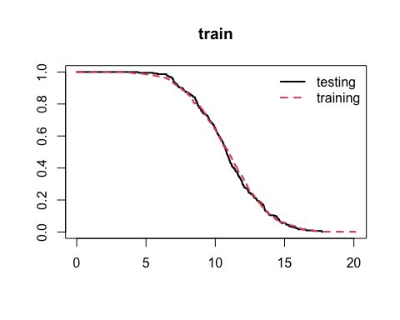

## Longitudinal Spaghetti Plot

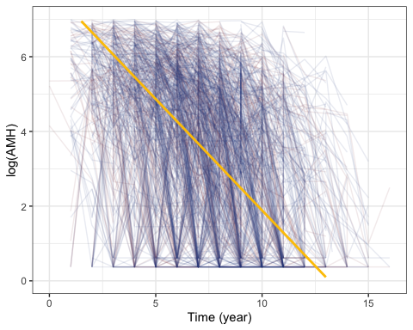

## Age and Other Distribution

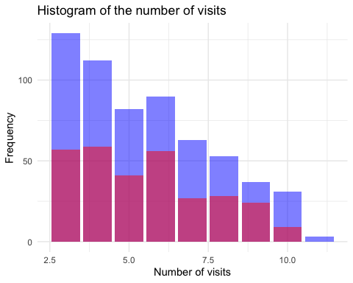

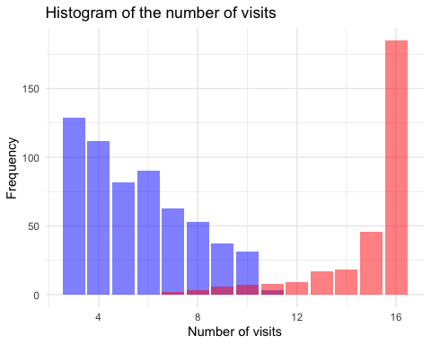

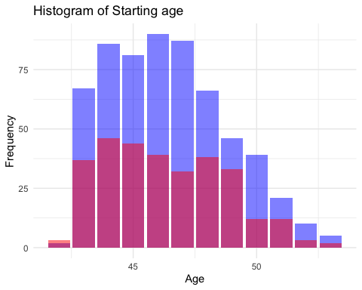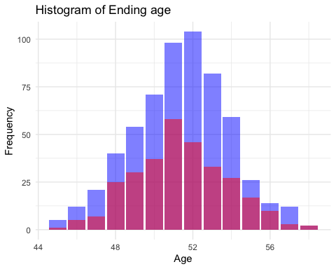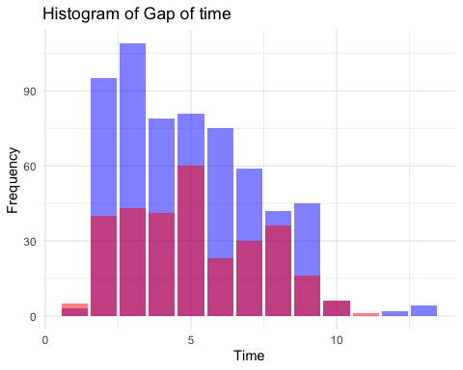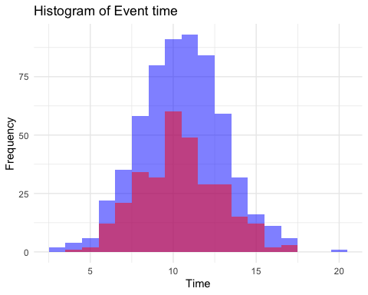

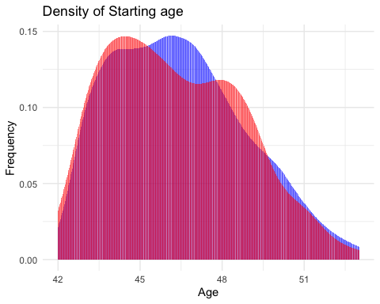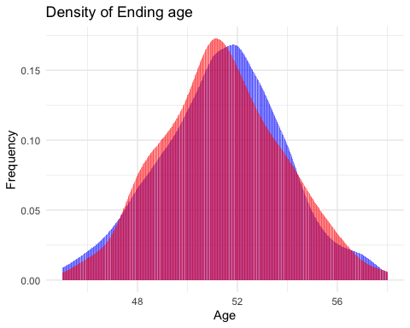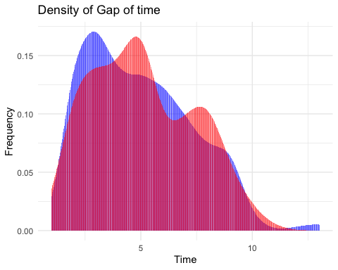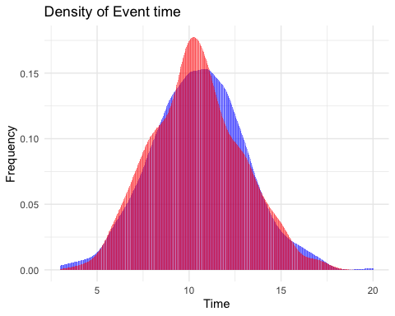

## AUC Rerun

### Training AUC

|  | Dt1 | Dt2 | Dt3 | Dt4 | Dt5 |
| --- | --- | --- | --- | --- | --- |
| Tstart2 | NA | 0.5000 | 0.7209 | 0.7946 | 0.7535 |
| Tstart3 | 0.4979 | 0.6098 | 0.7113 | 0.7636 | 0.7457 |
| Tstart4 | 0.7188 | 0.7814 | 0.7754 | 0.7447 | 0.7398 |
| Tstart5 | 0.7596 | 0.7543 | 0.7580 | 0.7704 | 0.7762 |
| Tstart6 | 0.7960 | 0.7694 | 0.7805 | 0.7964 | 0.7826 |
| Tstart8 | 0.7856 | 0.7964 | 0.7728 | 0.7750 | 0.8165 |

### Testing AUC

|  | Dt1 | Dt2 | Dt3 | Dt4 | Dt5 |
| --- | --- | --- | --- | --- | --- |
| Tstart2_test | NA | NA | 0.4647 | 0.5744 | 0.7929 |
| Tstart3_test | NA | 0.4729 | 0.9199 | 0.7841 | 0.7453 |
| Tstart4_test | 0.9524 | 0.7118 | 0.8710 | 0.7970 | 0.7743 |
| Tstart5_test | 0.9495 | 0.8633 | 0.8424 | 0.8058 | 0.7540 |
| Tstart6_test | 0.8134 | 0.8527 | 0.8118 | 0.7641 | 0.7618 |
| Tstart8_test | 0.7853 | 0.7364 | 0.7576 | 0.7799 | 0.8223 |

## Brier Score Rerun

### Training Brier Score

|  | Dt1 | Dt2 | Dt3 | Dt4 | Dt5 |
| --- | --- | --- | --- | --- | --- |
| Tstart2 | NA | 0.0130 | 0.0346 | 0.0653 | 0.1233 |
| Tstart3 | 0.0089 | 0.0249 | 0.0489 | 0.1176 | 0.1640 |
| Tstart4 | 0.0097 | 0.0232 | 0.0756 | 0.1259 | 0.1794 |
| Tstart5 | 0.0159 | 0.0602 | 0.1143 | 0.1670 | 0.1802 |
| Tstart6 | 0.0455 | 0.0941 | 0.1449 | 0.1679 | 0.1812 |
| Tstart8 | 0.1020 | 0.1550 | 0.1937 | 0.1898 | 0.1371 |

### Testing Brier Score

|  | Dt1 | Dt2 | Dt3 | Dt4 | Dt5 |
| --- | --- | --- | --- | --- | --- |
| Tstart2_test | NA | NA | 0.0126 | 0.0267 | 0.1247 |
| Tstart3_test | NA | 0.0045 | 0.0185 | 0.0751 | 0.1517 |
| Tstart4_test | 0.0054 | 0.0172 | 0.0678 | 0.1322 | 0.1852 |
| Tstart5_test | 0.0089 | 0.0524 | 0.1166 | 0.1741 | 0.2109 |
| Tstart6_test | 0.0436 | 0.0951 | 0.1475 | 0.2006 | 0.1898 |
| Tstart8_test | 0.0992 | 0.1771 | 0.1988 | 0.1804 | 0.1354 |

## Joint model random intercept SD

Hence, we have the final results for the variability of the intercept term.

* The mean value for both intercept : -0.0010564 + 7.8494324 = 7.848376;
* The random effect intercept term based on MCMC is $σ_{β_{0}}$ = 0.5351994;
* The fixed effect intercept term $σ_{b_{0}}$ = 0.0959121;
* We have the pooled $σ_{b0+β0}$ = 0.5437256.
* The 95% CI for the intercept term is (6.7934602, 8.9248646)