02 Dashboard

Randy

9/26/2020

## Boxplots

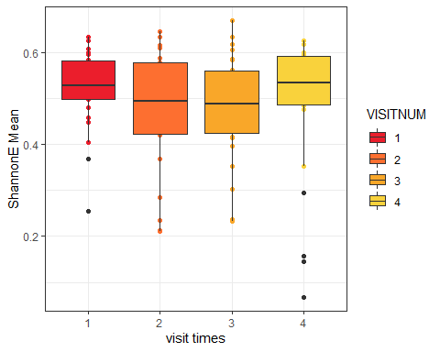

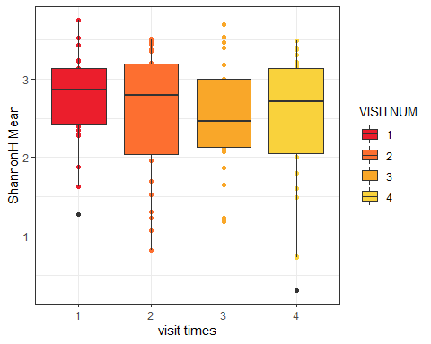

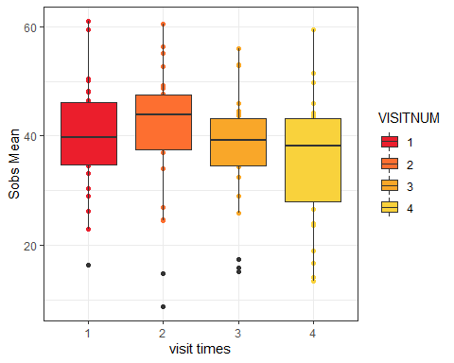

## Relative Abundance

[[1]]

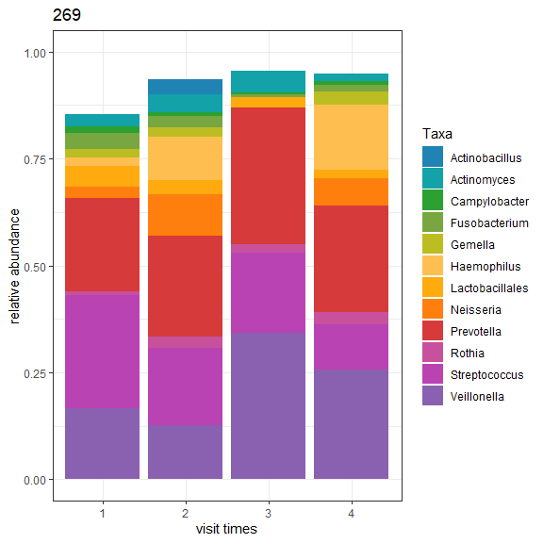

[[2]]

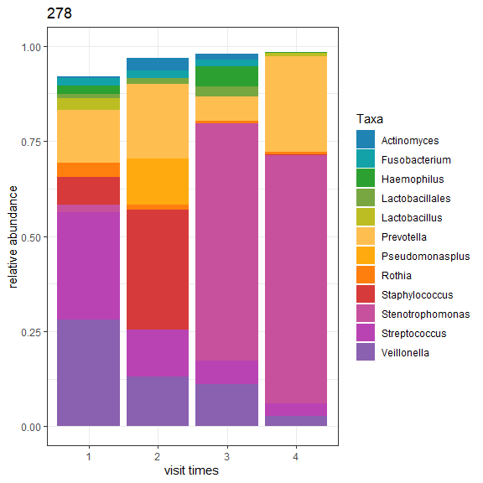

[[3]]

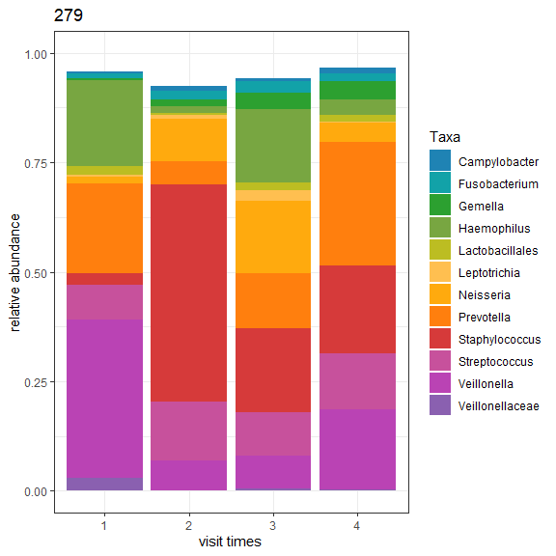

[[4]]

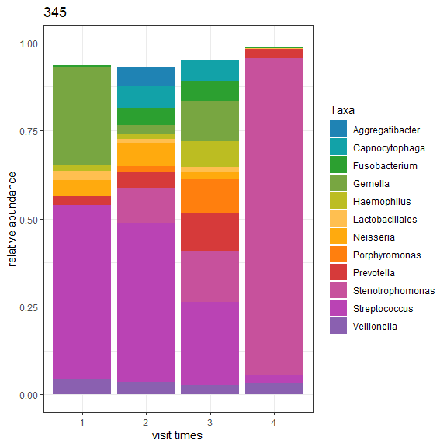

[[5]]

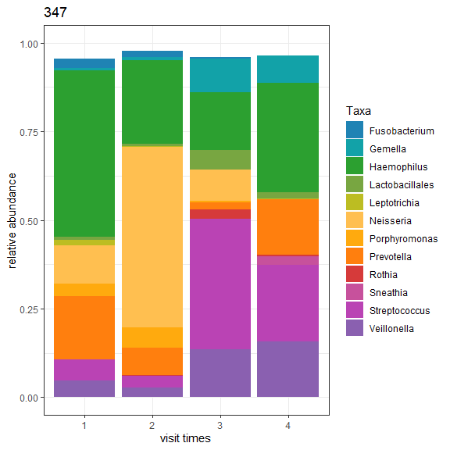

[[6]]

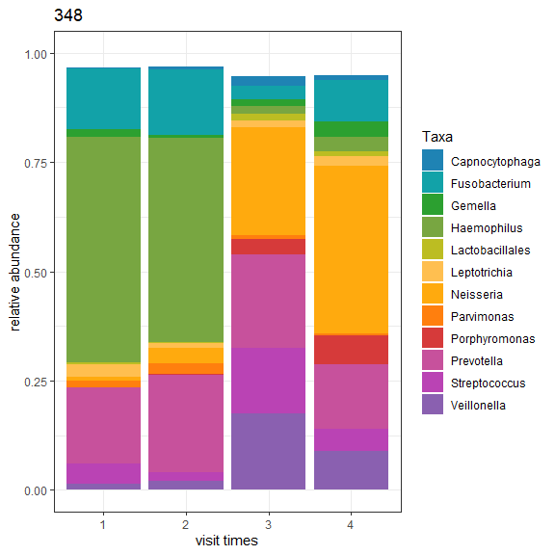

[[7]]

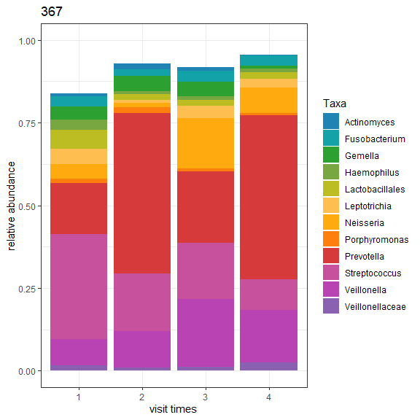

[[8]]

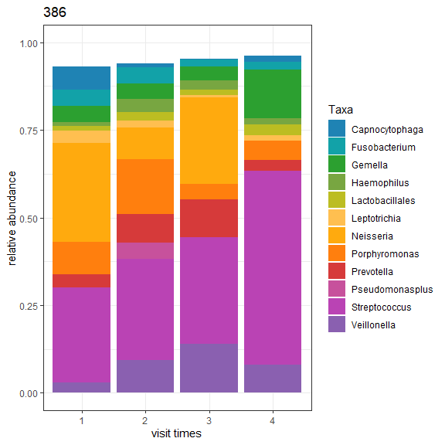

[[9]]

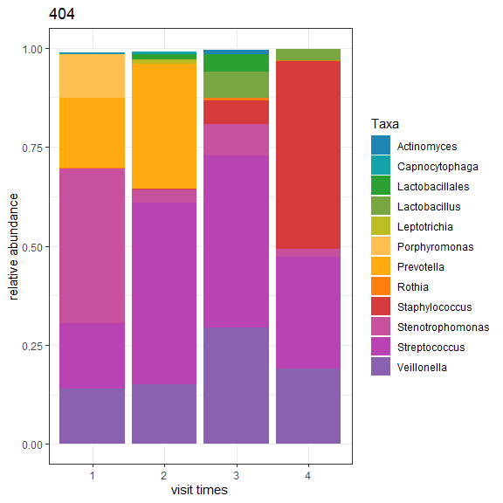

[[10]]

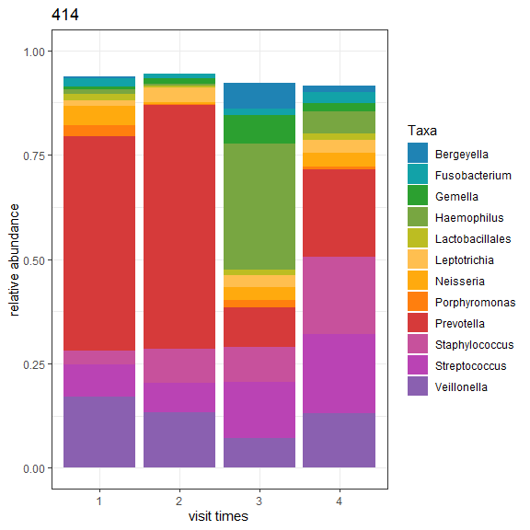

[[11]]

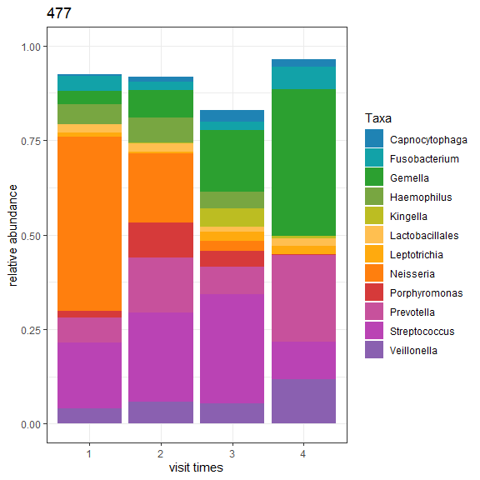

[[12]]

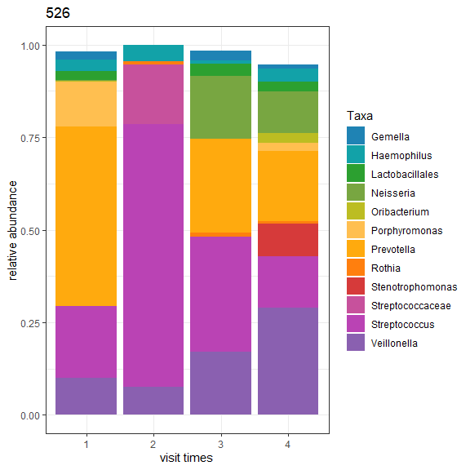

[[13]]

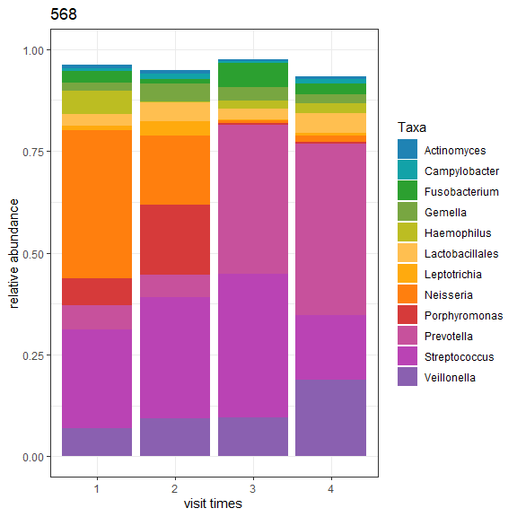

[[14]]

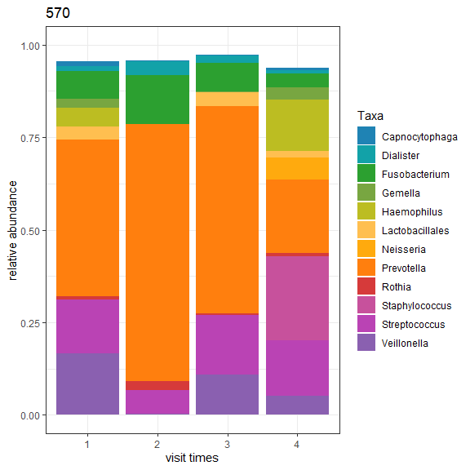

[[15]]

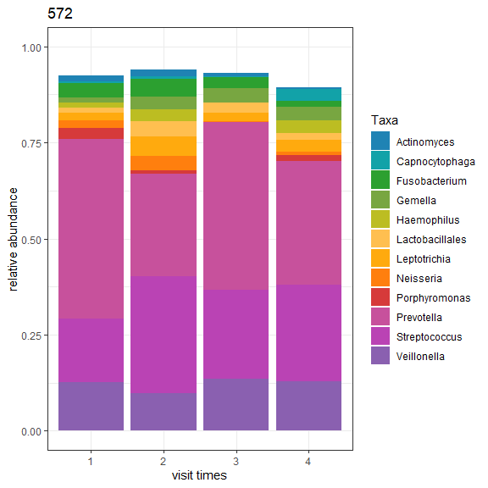

[[16]]

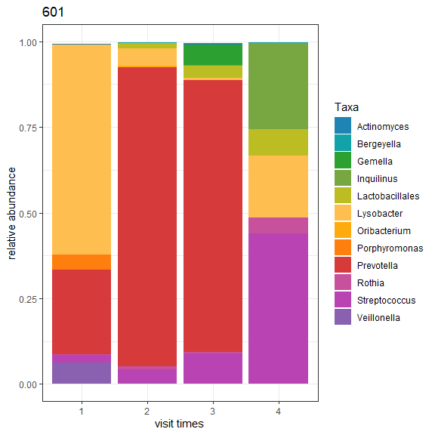

[[17]]

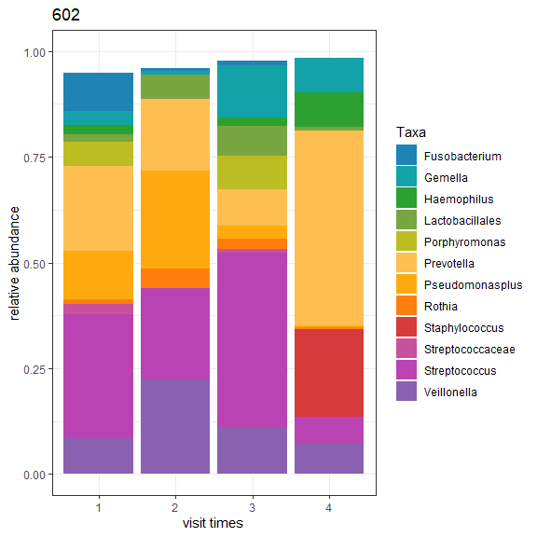

[[18]]

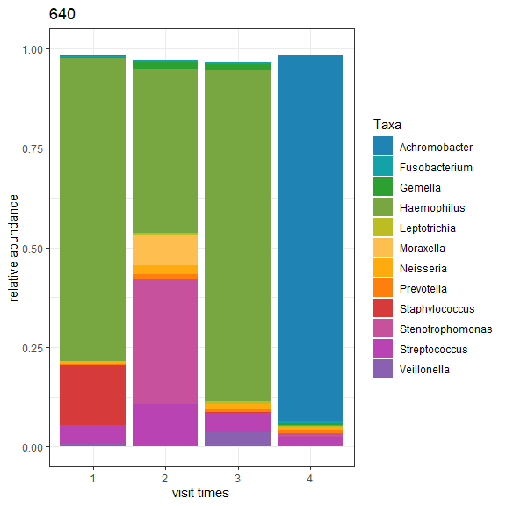

[[19]]

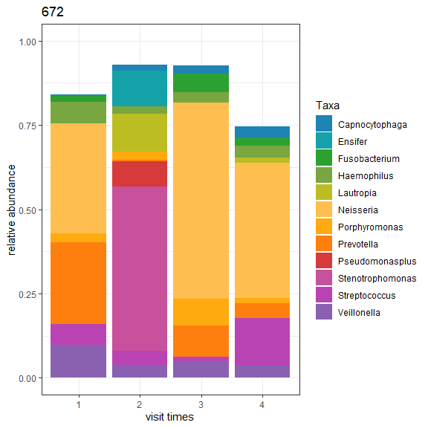

[[20]]

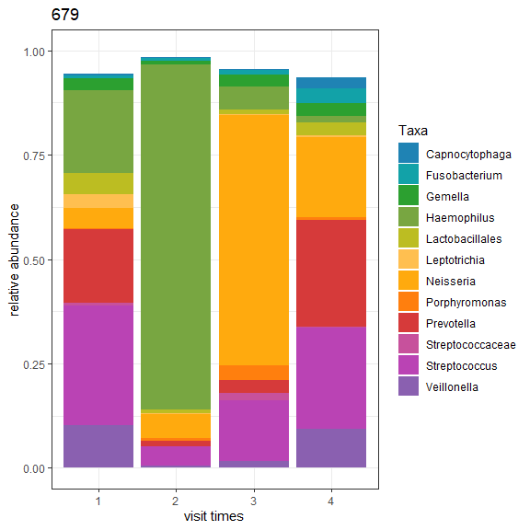

[[21]]

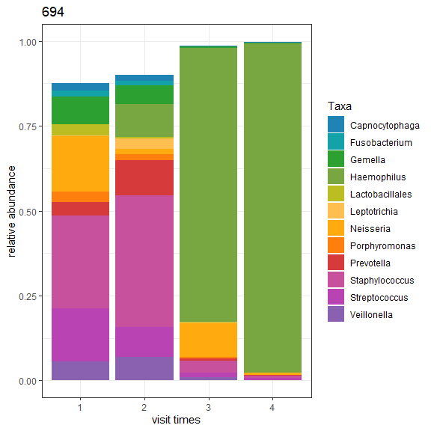

[[22]]

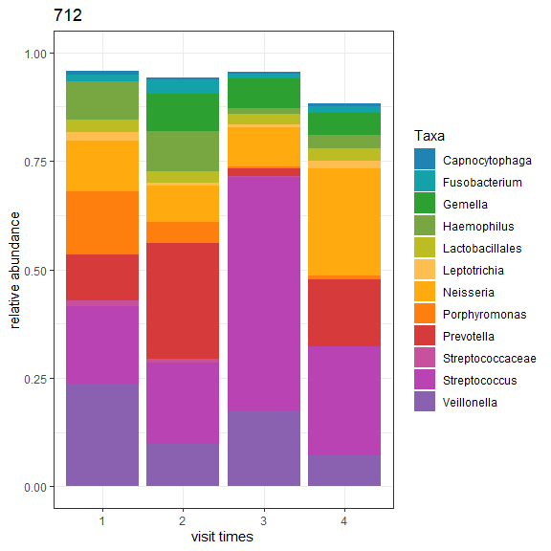

[[23]]

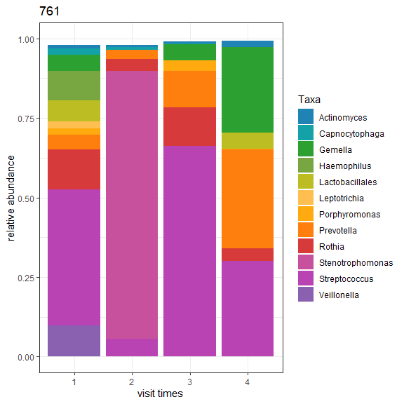

[[24]]

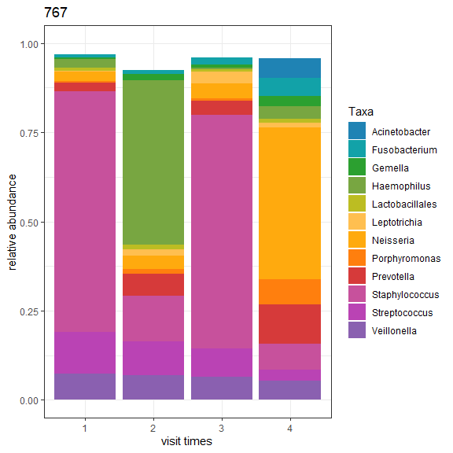

[[25]]

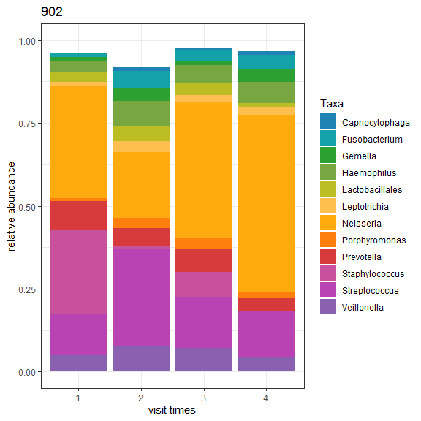

[[26]]

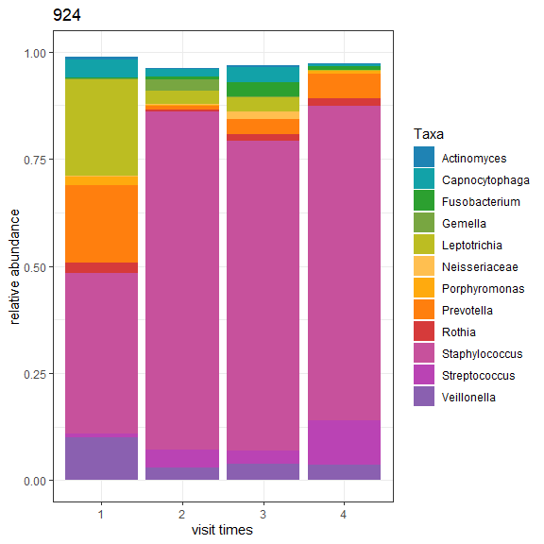

## Alpha Longitudinal

[[1]]

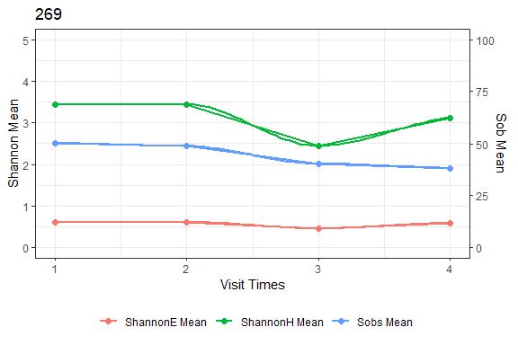

[[2]]

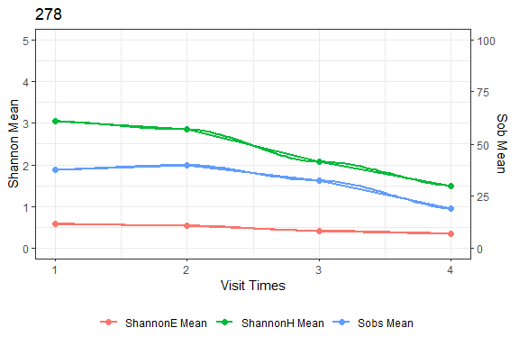

[[3]]

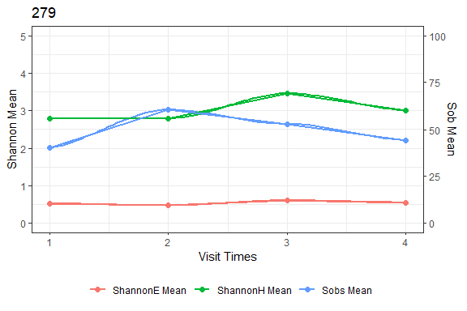

[[4]]

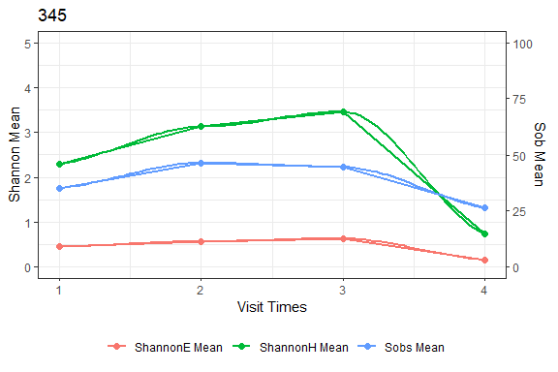

[[5]]

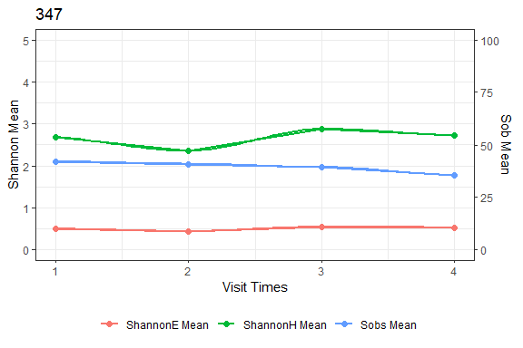

[[6]]

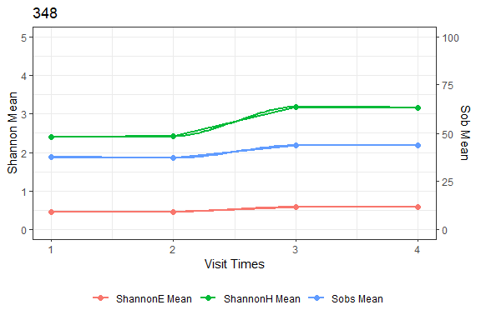

[[7]]

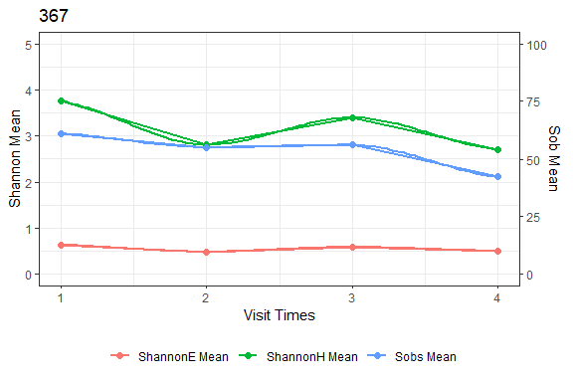

[[8]]

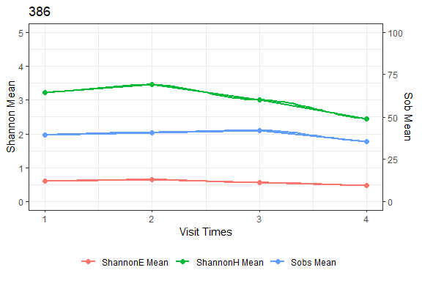

[[9]]

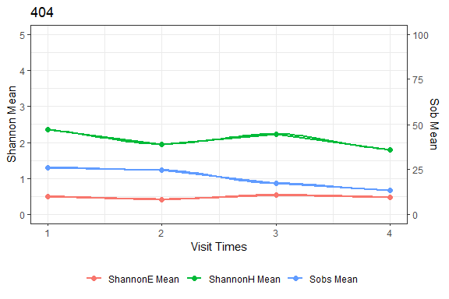

[[10]]

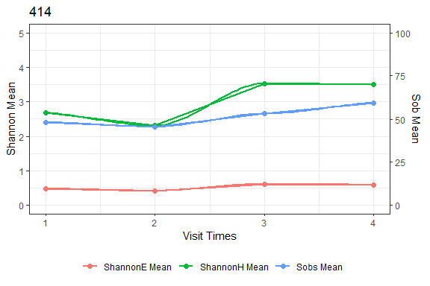

[[11]]

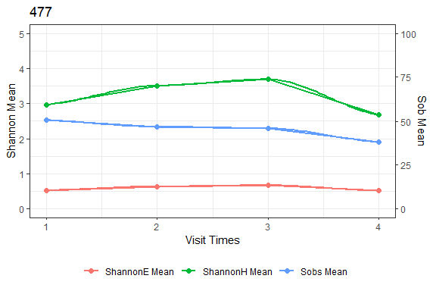

[[12]]

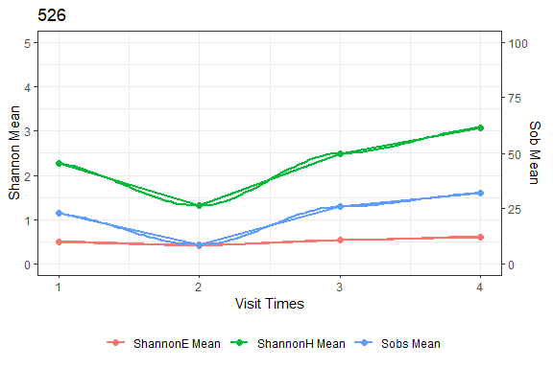

[[13]]

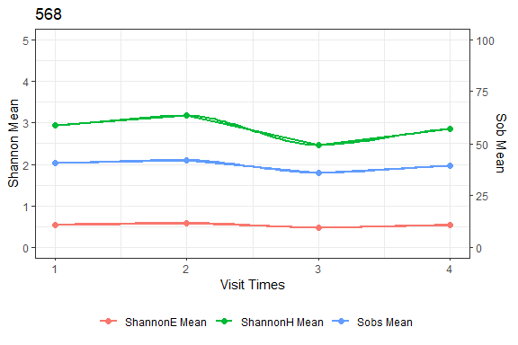

[[14]]

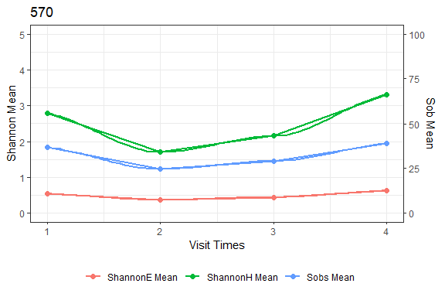

[[15]]

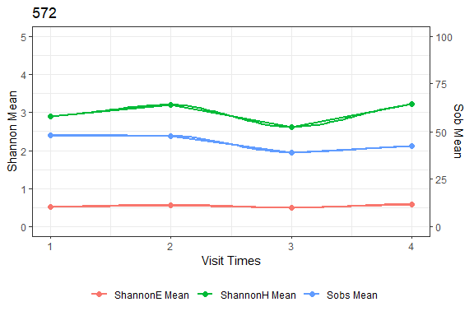

[[16]]

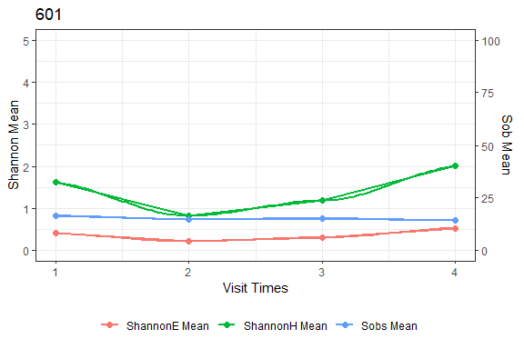

[[17]]

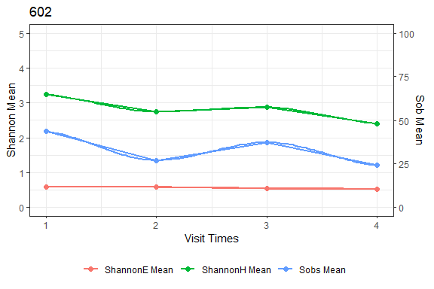

[[18]]

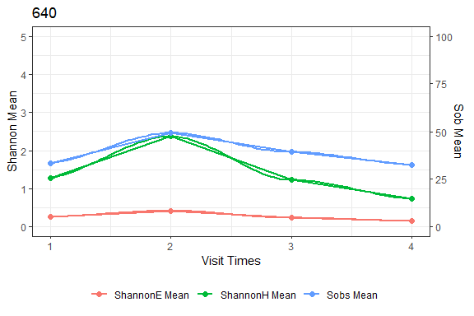

[[19]]

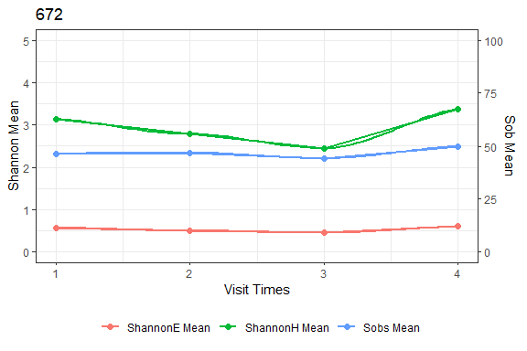

[[20]]

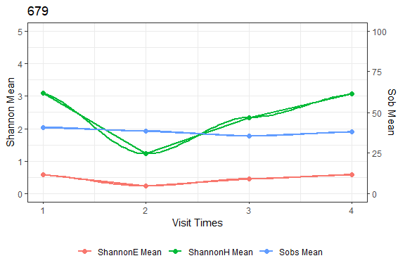

[[21]]

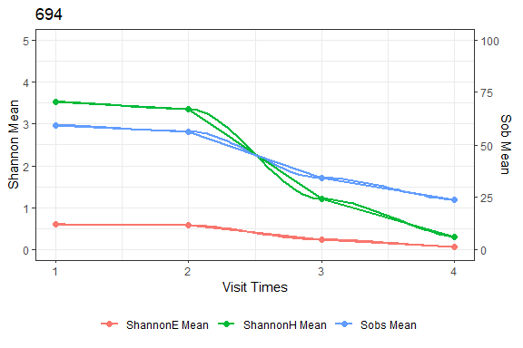

[[22]]

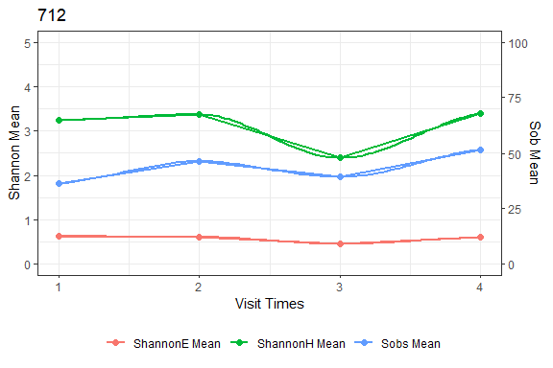

[[23]]

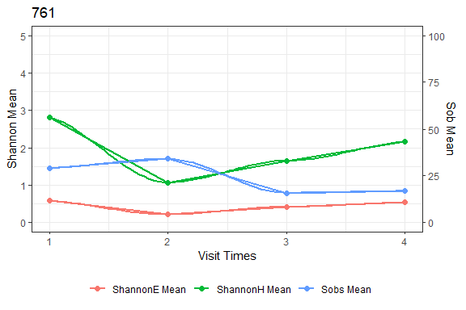

[[24]]

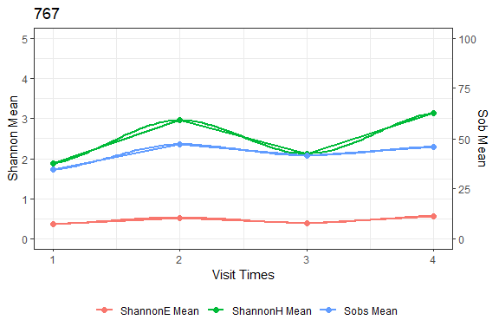

[[25]]

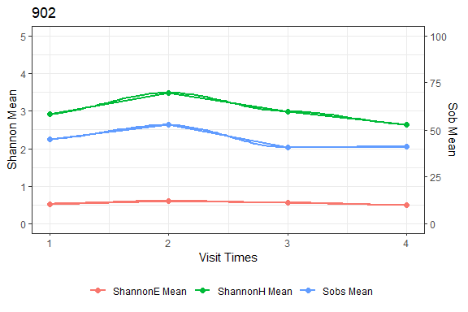

[[26]]

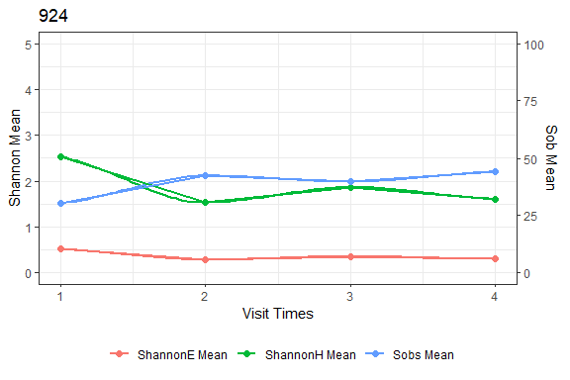

## Lung Activity

| SYSID | Age | Genotype | FVC% (predicted) | FEV% (predicted) | FEV (slope) | FVC (slope) |
| --- | --- | --- | --- | --- | --- | --- |
| 269 | 15.0660 | ΔF508/ΔF508 | 106 | 94.4355 | -2.08980 | -0.82428 |
| 278 | 14.2740 | ΔF508/ΔF508 | 120 | 124.5010 | -2.68016 | -0.32756 |
| 279 | 14.0740 | ΔF508/ΔF508 | 99 | 98.4093 | -3.35807 | -0.12907 |
| 345 | 14.0550 | ΔF508/ΔF508 | 96 | 88.2561 | -1.37694 | 2.61881 |
| 347 | 14.1340 | ΔF508/Other | 111 | 112.3610 | -2.87597 | -0.29116 |
| 348 | 13.0000 | ΔF508/ΔF508 | 100 | 98.8897 | -1.90845 | -1.12542 |
| 367 | 12.0710 | ΔF508/Other | 112 | 100.2400 | -2.21160 | 0.23884 |
| 386 | 14.1780 | ΔF508/ΔF508 | 87 | 97.2014 | -3.50028 | -2.24654 |
| 404 | 13.0160 | ΔF508/ΔF508 | 92 | 93.4613 | -4.03978 | -2.70557 |
| 414 | 12.6900 | ΔF508/ΔF508 | 98 | 94.8078 | -4.46864 | -3.42937 |
| 477 | 11.9840 | ΔF508/Other | 102 | 102.2090 | -2.28639 | 0.54937 |
| 526 | 11.0990 | ΔF508/ΔF508 | 108 | 112.7600 | -2.19565 | -0.91204 |
| 568 | 9.4274 | ΔF508/ΔF508 | 95 | 106.5410 | -0.02011 | 2.05550 |
| 570 | 10.8710 | Other/Other | 118 | 109.8400 | -2.79266 | -0.86832 |
| 572 | 9.9096 | ΔF508/Other | 92 | 95.8448 | -1.90360 | -1.49621 |
| 601 | 8.9534 | ΔF508/ΔF508 | 65 | 61.9186 | -3.13746 | -0.94064 |
| 602 | 13.8470 | Other/Other | 119 | 111.2610 | -2.15447 | 0.76417 |
| 640 | 9.4904 | Other/Other | 114 | 114.2190 | -2.18343 | -0.58599 |
| 672 | 8.0849 | ΔF508/Other | 79 | 64.1099 | -1.47619 | 1.17459 |
| 679 | 7.9945 | Other/Other | 120 | 99.4394 | -0.58584 | 1.58661 |
| 694 | 8.0027 | ΔF508/Other | 93 | 95.4369 | -1.57756 | 0.87164 |
| 712 | 7.1753 | ΔF508/Other | 107 | 88.5267 | -2.31503 | -0.68704 |
| 761 | 8.0630 | ΔF508/ΔF508 | 121 | 112.9560 | 0.56417 | 3.62473 |
| 767 | 6.4603 | ΔF508/Other | 83 | 77.1375 | -2.69773 | -0.41513 |
| 902 | 10.0490 | ΔF508/Other | 112 | 113.6010 | -2.36996 | 0.29967 |
| 924 | 11.9890 | Other/Other | 97 | 100.0890 | -5.37589 | -3.92574 |

## Alpha Facet

