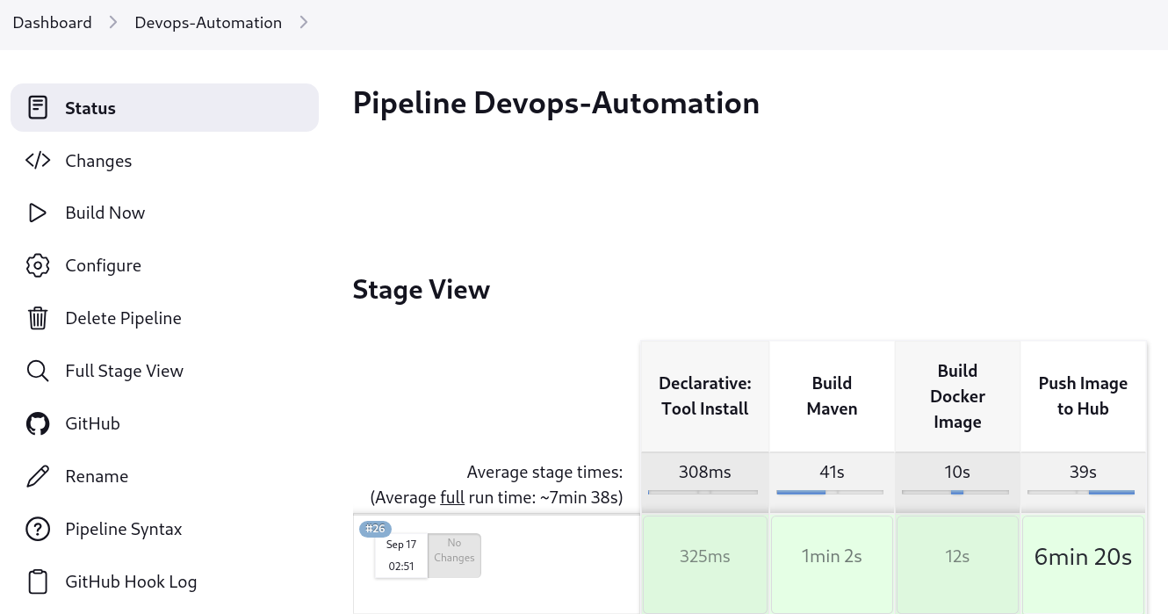

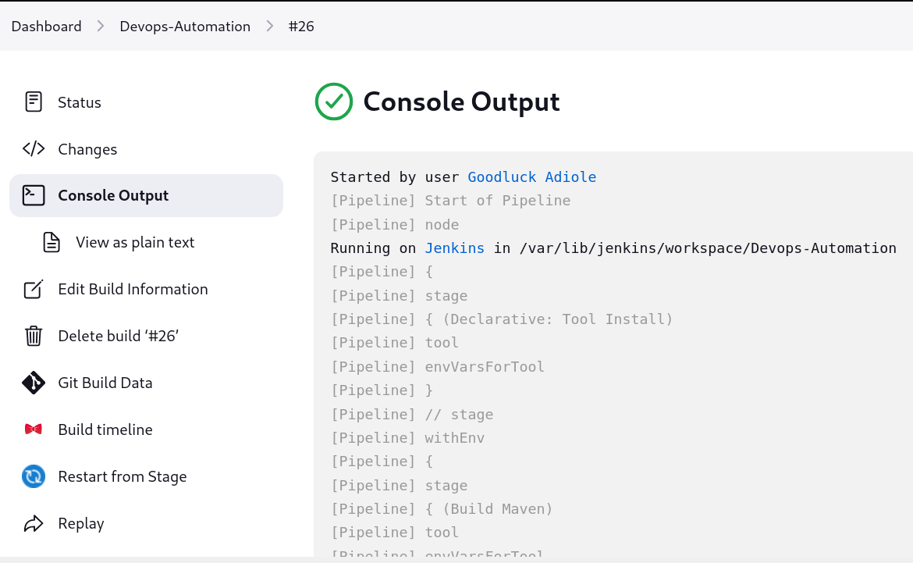

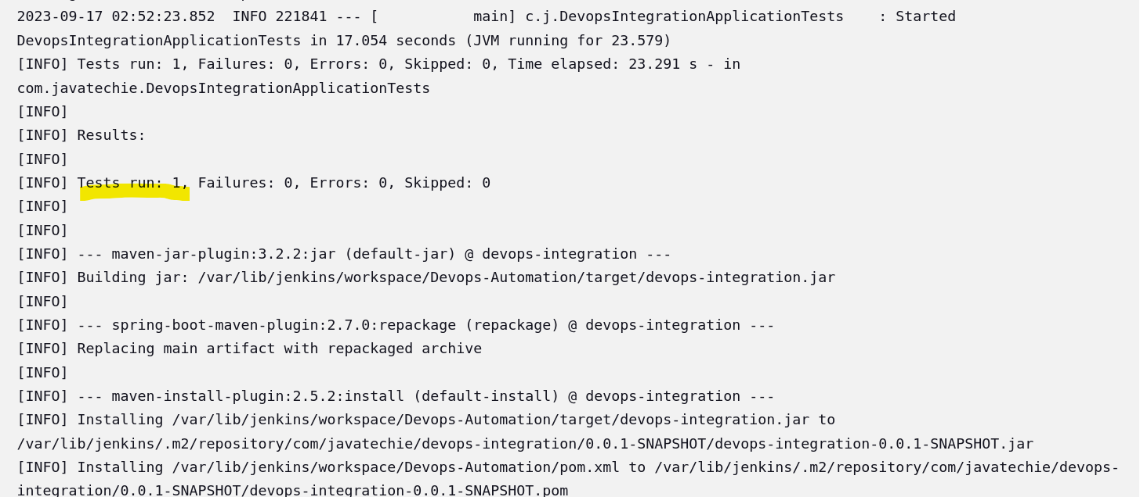

JENKINS URL: <http://localhost:8080/job/Devops-Automation/26/console>

GITHUB URL: