Pair Trade Recommendation

Buy ***L+6.5% Senior Secured TLB* at 47** and ***8% Senior Unsecured Notes* at 45** at a ratio of 1:1. Buying both positions allows one to create a business at 3x FY2019 EBITDA, and it serves as a hedging strategy to maximize the risk-adjusted return.

Capital Structure



*Source: Reorg, company filings, Bloomberg*

Business Description

CEC operates and franchises venues that provide dining (44%) and entertainment (56%) to parents and kids. 

Investment Theses

* In 2019, CEC amended the senior secured loan by **adding a spring maturity clause** that allows the secured loan to mature 91 days before the unsecured (which matures on 2/15/2022), if on such date (11/30/2021) there are more than $50 million of unsecured outstanding. **It’s more likely that the company would find a way to refinance its unsecured bond** because triggering the spring maturity covenant would immediately put the company into a distressed position as the management has to figure out a way to pay off ~$750 million debt. It makes more sense and easier for the company to refinance the unsecured with either sale leaseback financing or with new unsecured notes.
* Of 515 company-operated venues, 506 are leased. The liquidation value of the company’s assets is insufficient to fully recover the 1st lien, albeit higher than the current price. More, **cross holdings and Apollo’s involvement** would discourage 1st lien holders to accelerate. Alternatively, at ~$2 million per venue, the company can use **about 100 venues for a sale leaseback financing to pay off the senior unsecured bond.** This is an attractive proposition for the company as it frees up more cash flow while still being able to operate through leased back venues. I think the company would view this as a favorable option to pay off the 8s.

Considerations

* The new CEO, David McKillips, focuses on international expanding through the franchise model and promotional events/deals. These initiatives, although capex-lite, poses strains on FCF paydown of the secured.
* Apollo, the equity holder and a permitted holder to both tranches, would make this deal hairier. I’m not very sure what Apollo’s playbook look like but given the flat business growth since the LBO, this is perhaps not a performing deal for the sponsor, who might take the “L” or, if it has faith in the new leadership and the expansion strategy, might inject equity cure to alleviate the debt burden.
* Misunderstanding or dismission of certain terms in credit agreements might fundamentally challenge investment theses.

Scenario Analysis



Appendix I: Business Description

The Chuck E Cheese’s concept was created by Nolan Bushnell, founder of Atari Corporation, to expand arcade experience beyond what used to be more adult locations.

1977: 1st location opened in San Jose, CA. Labeled as the first family restaurant to integrate food, animation, and an indoor arcade

1984: as a result of the “video game crash of 1983”, the company filed for bankruptcy to restructure its insurmountable debt obligations

Feb. 2014: Apollo takes the company private for $54 per share. The deal was structured with 1st lien facility consists of a $150 million undrawn revolver and a $760 million TLB, and a senior unsecured bond of $255 million

Oct. 2014: CEC acquired a competitor, Peter Piper Pizza, which adds 32 company owned locations and 155 franchises

2014-2019: the company has been moderately adjusting its store base to 741 system-wide venues

2019: the company tried to go IPO through a merger with Leo Holdings (Apollo owns 55%) but the deal was terminated in the summer. The company refinanced its 1st lien debt with a Spring Maturity added

Today: the RCF is fully drawn; 50% of work force furloughed; expect to close ~80 venues this year; all venues only do delivery and pick-ups

**The company’s revenue segments (2019 total revenue: $912.9 million):**

Company venue sales (97.5% of total revenues)

* Food and beverages (43.9% of company venue sales, ~75% gross margin): the company mainly offers pizza, salad, wings, and other beverages using value-oriented sales approach. During the COVID-19 pandemic, this might be the only segment that supports the company’s top-line income.
* Entertainment and merchandise (56.1% of company venue sales, 92% gross margin): the company has revamped its token system by installing RFID readers that’d allow players to tap the play card to use entertainment equipment. It’s worth noting that the company categorizes game enhancement as a maintenance capex, which in total accounts for 4% of sales.

Franchise fees and royalties (2.5% of total revenues)

* Franchised branches: the company does not disclose the average percentage of gross sales a franchisee must contribute but it takes about $800 thousands to start a franchised branch. It takes about 4 years to recoup the initial investment.

Appendix II: Thesis Analysis – 1st Lien hard to get refinanced due to the straining CF generation

Considering the COVID-19 impact, the credit fundamentals of the business are deteriorating, especially given the CEO’s remark to incur more capital expenditure on remodeling 50 more venues, each would cost ~$500k. That’s **$30 million growth capex to be expended.** After the company has drawn most of its RCF, I estimate the company has cash on hand of $35 million plus the revolver drawn of $105 million. That $140 million would have to support the growth capex and the maintenance capex.

Let’s being rosy here, just assume that the virus is gone by the summer, and kids and parents are happy to celebrate their birthday events or so at CEC. Revenue from food and beverages is intact at 44% of FY2019 sales, and a half haircut is given to the entertainment and merchandise sales, that would leave us $640 million in sales for 2020. The maintenance capex, therefore, would be 4% of that, which is $25.6 million.

With this rosy scenario, the company is left with no cash after mandatory debt services. Further, although the company generates a sizable amount of cash from operations, a good portion of that would go to the maintenance capex to **keep gaming equipment repaired and upgraded to maintain that 56% of sales.**

Overall, the company’s revenue growth is stalling. The recent revenue boost in 2015 is a result of the acquisition of Peter Piper Pizza.

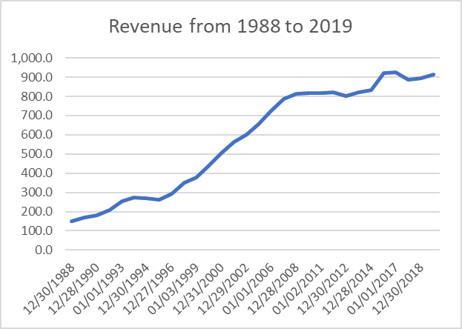The management’s strategy is to continue to introduce promotional deals and trying to win customers though value menu items and through international expansion using the franchise model. Since the franchise revenue is almost *de minimis,* it will take a long time for the international development strategy to effectuate. **By trying to win customers through cheap deals, the growth has to be driven by volume.**

Peter Piper Pizza acquisition effect.

However, the company has failed to do so. In a 2007 earnings call, the management mentioned that the AUV was 1.6 million, and the target is 2.0 million. Since then, the management has stopped disclosing AUV figures until the M&A call in 2019 re the merger with Leo Holdings. The company reported 1.6 million AUV during the call. **That means the volume has been plateaued**, and it shows significant difficulty to drive up that volume, implying flat demands or even a shift in consumers’ preference as streaming services and digital entertainments continue to erode the company’s market share.

People used to give credit to CEC’s superior margins comparing to Dave and Buster’s (PLAY), but the table has turned as CEC trails behind PLAY on every margin metrics. The multiple contraction invites concern over CEC’s future, therefore making it hard to convince lenders to refinance the 1st lien facility. Given the spring maturity clause, the most viable option the management and Apollo have is to enter sale leaseback transactions to prepay the unsecured in full or at most having $50 million outstanding so that the spring maturity won’t be triggered.

It makes more sense to use 100 venues for that purpose because it will substantially ease the debt burden while not being disruptive to the management’s expansion strategy.

Appendix III: Thesis Analysis – Continued

In 2014, the company sold and leased 49 properties back from National Retail Properties, Inc. for $183.7 million, suggesting a proceed of $3.75 million per property. For the sake of being conservative, assume the company can realize $2 million per property through sale leaseback transactions, the senior unsecured can be paid off with 107 properties. Of course, the company might also choose to repurchase a portion of the bond using the revolver or cash on balance sheet as there’s no contractual restriction prevents the company from doing so.

One advantage is that the company has many venues concentrated in areas with “fit” demographic profiles, which include higher median income and higher percentage of juvenile population. That would be a selling point to lessors when engaging in sale leaseback transactions with them.

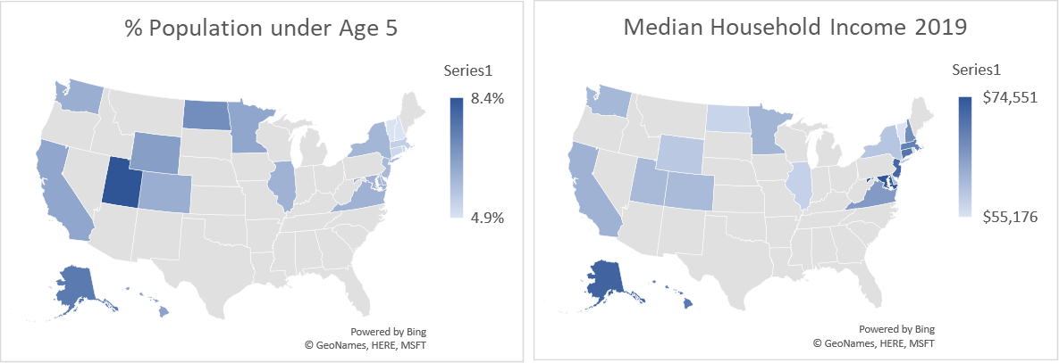

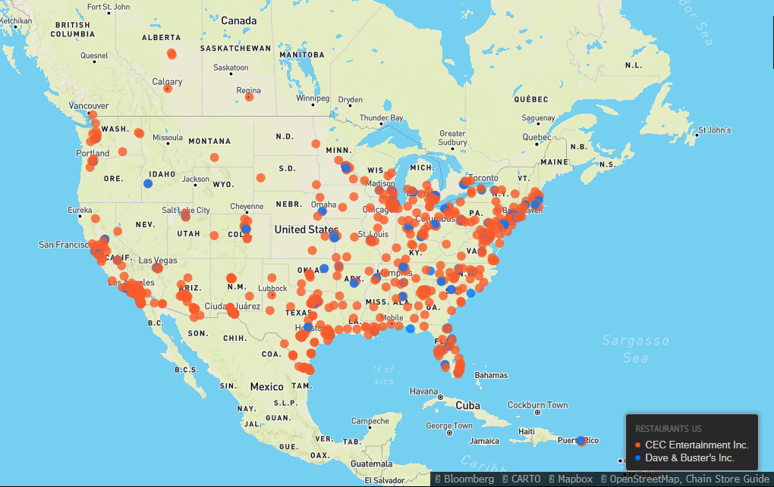

Appendix IV: Holdings and Liquidation Value

There is a low likelihood for the company to be forced into a bankruptcy due to cross holdings.



*Top three cross-holders. Source: companies’ filings*

First lien holders are well secured by the company’s subsidiaries and equity collateral with the HoldCo.

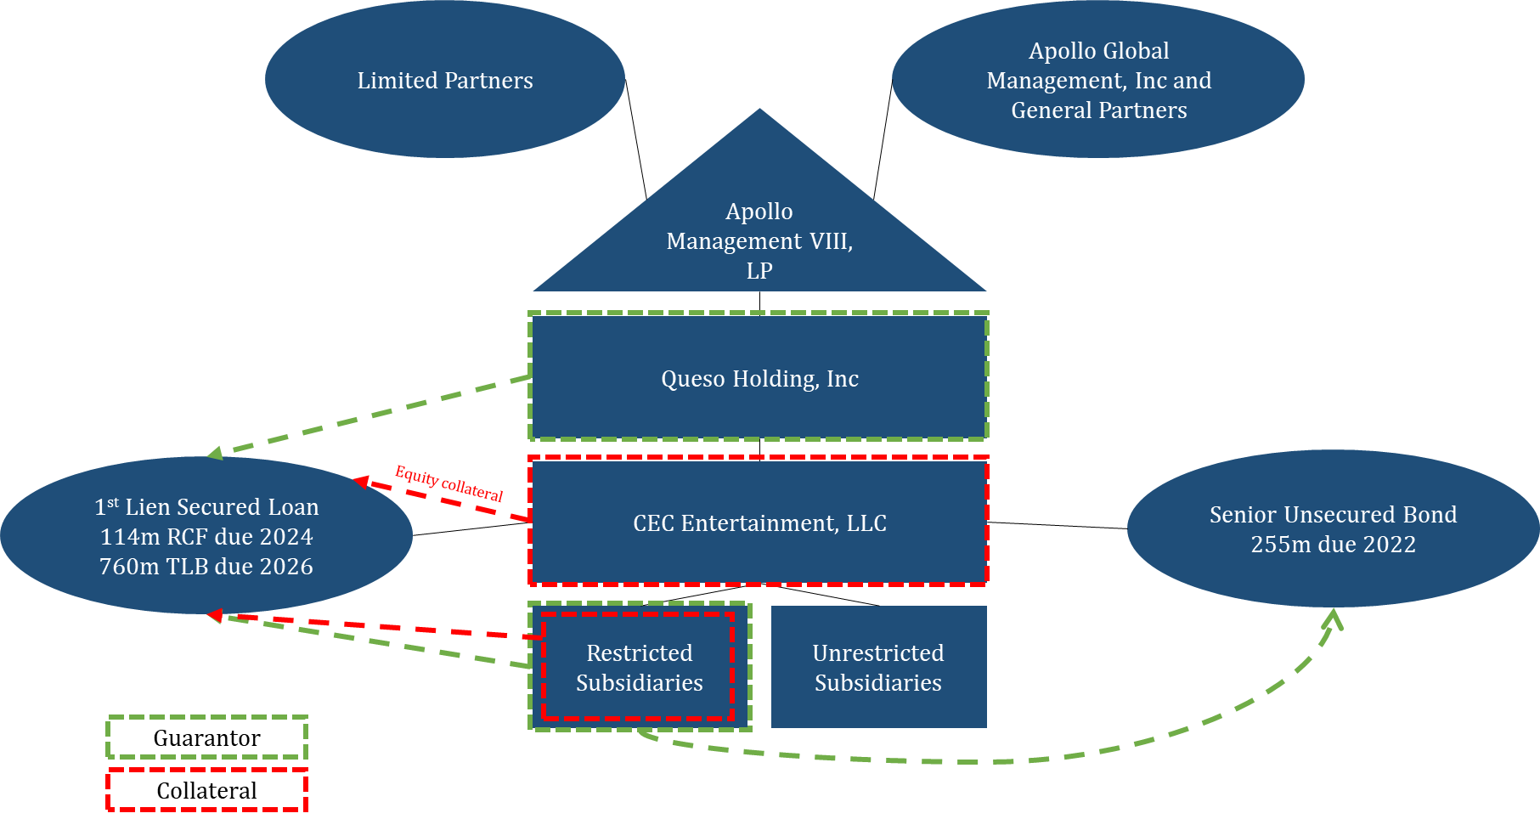 *Source: company filings*

For the bankruptcy scenario, I assume the following. Given no contractual subordination, the adjusted recovery would be 78% for the senior secured while the unsecured would be wiped out. Of course, the actual recovery would be affected by equitization and other trade claims, but this is illustrative enough to show the downside protection of our pair trade.

