ASSIGNMENT:

1. Carefully study the class diagrams below and implement them in JAVA programming language:
2. Customer Bank Account.

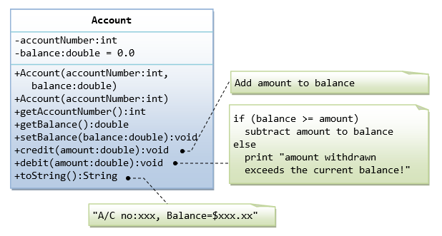

1. Date class.

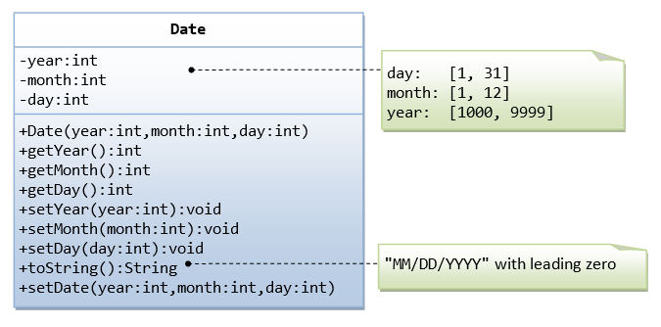

1. Time class.

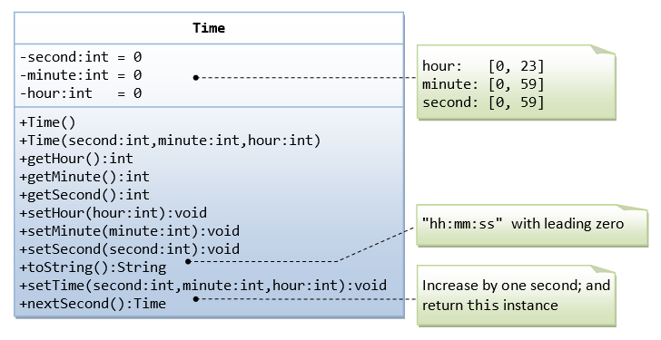

1. Point class

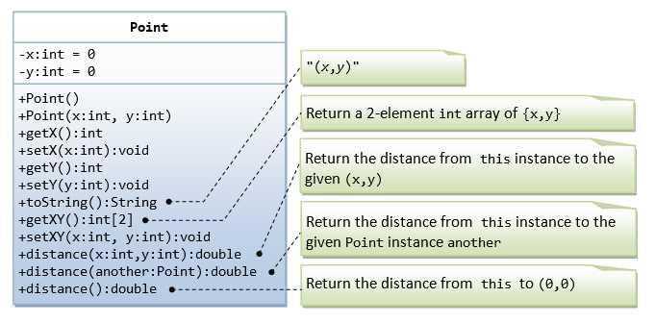

1. Stack is a linear data structure which follows a particular order in which the operations are performed i.e. LIFO. Carefully design a class diagram to represent this data structure and implement it in JAVA programming language.