MARITAL STATUS:

STATE OF ORIGIN:

LOCAL GOVERNMENT AREA:

NATIONALITY:

RELIGION:

EDUCATION BACKGROUND

Obafemi Awolowo University, He-lfe Emmanuel Alayande College, Oyo

Samwagba Comprehensive College, Ore, Ondo State Alafia Nursery and Primary School, Osun State ilASIC QUALIFICATION

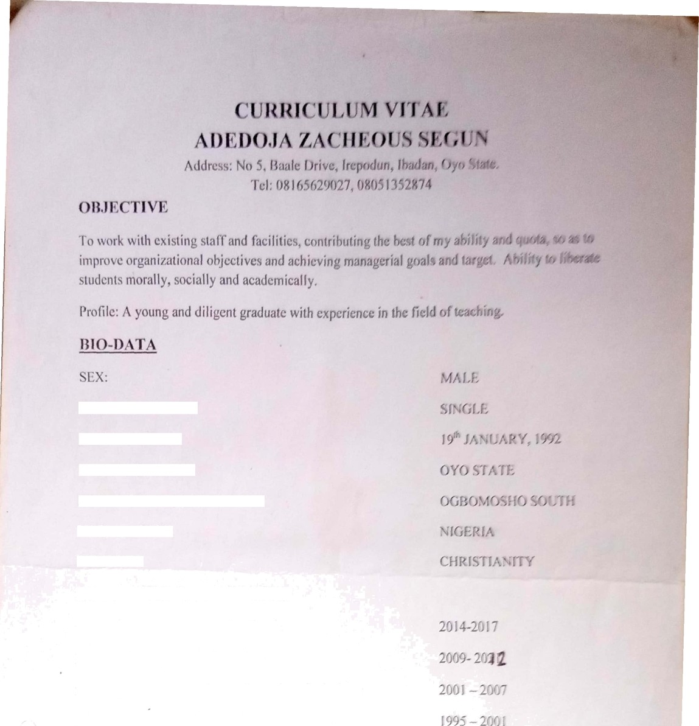

BACHELOR OF ART IN EDUCATION

NJGERIA CERTIFICATE IN EDUCATION NATIONAL EXA MJNA TION COUNCIL PRIMARY SCHOOL LEAV ING CERTIFICATE

2t)17

2fl?

2O0X



Scanned with camscanner

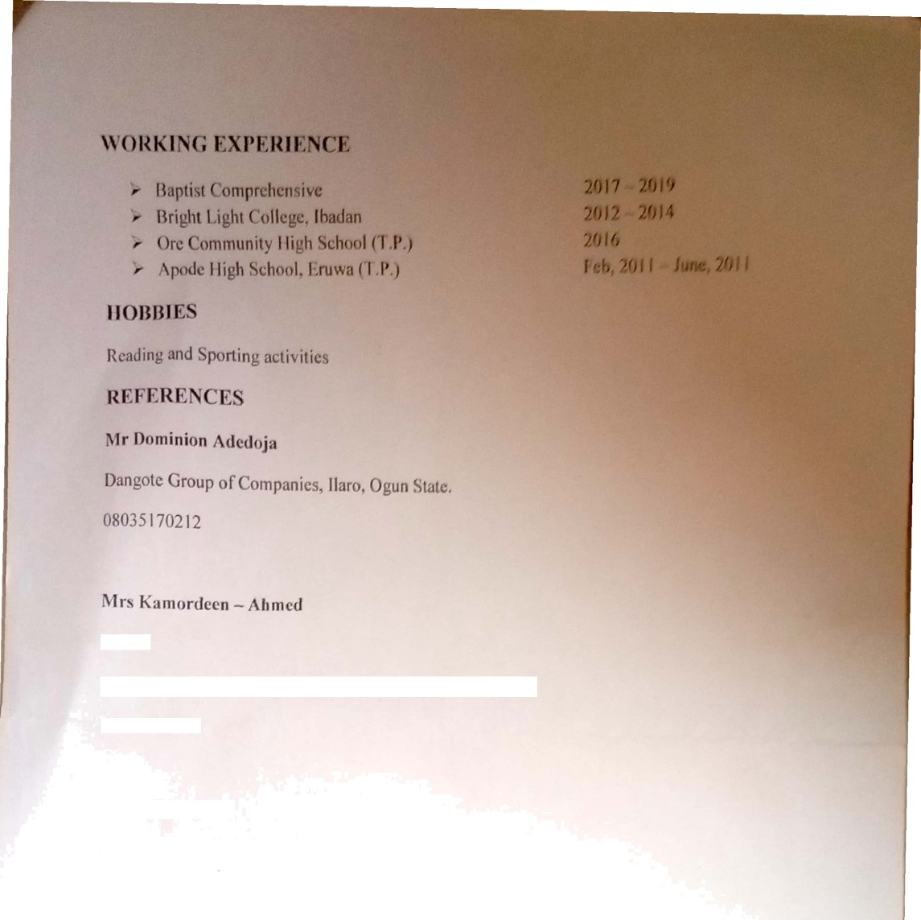

Trader

No 5, Baale Drive, Agbowo Express, Irepodun Street, Jbadan

Mr Ayoola Rasaq

Civil crvants / Lab Scicntist

Opgositc Tose Primary chr›nI, Oyr› tatc

08028876782

Scanned with ¢:nmsnnnn<•r