THE UNIVERSITY OF ZAMBIA
SCHOOL OF NATURAL AND APPLIED SCIENCES
DEPARTMENT OF COMPUTING AND INFORMATICS

FINAL YEAR PROJECT REPORT

ACADEMIC YEAR 2026

SMART BUTCHERY INVENTORY MANAGEMENT SYSTEM (SBIMS)

A Final Year Project Report Submitted to the
Department of Computing and Informatics
in partial fulfilment of the requirements for the award of
[DEGREE PROGRAMME]

By
Josiphiah Simbaya
[COMPUTER NUMBER]

Supervisor: Mr. Alinani Simukanga
Date of Submission: [DATE]

DECLARATION
I declare that this final year project report is my own work and has been prepared in accordance with the academic requirements of the University of Zambia. All sources of information, ideas, data, software, images, and other material that are not my own have been appropriately acknowledged and referenced.
Where this project was undertaken as part of a group, I have clearly identified my individual contributions and have not presented the work of other group members as my own.
Student Name:
________________________________________________________________________________
________________________________________________________________________________
Signature:
________________________________________________________________________________
________________________________________________________________________________
Computer Number:
________________________________________________________________________________
________________________________________________________________________________
Date:
________________________________________________________________________________
________________________________________________________________________________

APPROVAL
This final year project report has been submitted for examination with the approval of the project supervisor.
Supervisor Name:
________________________________________________________________________________
________________________________________________________________________________
Signature:
________________________________________________________________________________
________________________________________________________________________________
Date:
________________________________________________________________________________
________________________________________________________________________________
Departmental/Examiner Approval (if applicable):
________________________________________________________________________________
________________________________________________________________________________

ABSTRACT
Butcheries sell perishable products by weight rather than by unit, and most small butcheries still track stock using notebooks or spreadsheets, or with general-purpose point-of-sale software built for supermarkets. Neither approach copes well with weight-based stock, spoilage, or the different cuts produced from a single meat type, which leads to stock discrepancies, untracked wastage, and poor restocking decisions.
This project presents the Smart Butchery Inventory Management System (SBIMS), a weight-based inventory and point-of-sale platform for a single butchery outlet. SBIMS consists of an Android cashier application and a web management dashboard, both calling a shared Node.js/Express REST API backed by a MySQL database. The Android app lets a cashier build a multi-item cart by weight, complete a sale, and print a receipt, with barcode scanning available for fast product lookup; stock is deducted automatically, inside a database transaction that locks the affected product rows so that two simultaneous sales cannot oversell the same cut. The web dashboard mirrors the same workflows for management: it shows stock per category, today's sales and low-stock alerts, records deliveries, and routes wastage reports through a manager approval step before stock is written down. Both clients authenticate against the same JSON Web Token API, with roles separating cashier and manager actions.
The system was built iteratively by a two-person team: a Node.js/Express/MySQL backend (Goodson Mwenso Jr.) and the Android app, web dashboard and project documentation (Josiphiah Simbaya, the author of this report). At the time of writing, the core transactional flows -- authentication, weight-based sales with row-level locking, stock deliveries, a wastage approval workflow, and reporting -- are implemented and exercised through the Android app and web dashboard against a live backend. The report documents the system's requirements, architecture, database design, implementation and testing approach, and evaluates it against the objectives set out in the original proposal.
Keywords: weight-based inventory; perishable goods; Android point-of-sale; REST API; MySQL transactions

ACKNOWLEDGEMENTS
I would like to thank my supervisor, Mr. Alinani Simukanga, for his guidance and feedback throughout the design and development of this project. I am grateful to the Department of Computing and Informatics at the University of Zambia for the training that made this project possible. I also thank my project partner, Goodson Mwenso Jr., for building and maintaining the backend API and database that both client applications rely on, and for his collaboration throughout the project. Finally, I thank my family and friends for their support and patience during the course of this project.

TABLE OF CONTENTS
(Right-click this field in Word and choose “Update Field”, or press Ctrl+A then F9, to generate the table of contents.)

LIST OF FIGURES
Figure 1: SBIMS system architecture
Figure 2: Entity-relationship diagram of the SBIMS database
Figure 3: System sequence diagram -- Log In (UC1)
Figure 4: System sequence diagram -- Record Sale, batch/cart (UC2)
Figure 5: System sequence diagram -- Add Stock / Record Delivery (UC3)
Figure 6: System sequence diagram -- Record and Approve Wastage (UC5 / UC6)
Figure 7: System sequence diagram -- Generate Reports (UC7)

LIST OF TABLES
Table 1: Abbreviations and acronyms used in this report
Table 2: SBIMS compared with manual records and generic point-of-sale systems
Table 3: Project stakeholders and their interests
Table 4: Functional requirements -- authentication and access
Table 5: Functional requirements -- products, categories and prices
Table 6: Functional requirements -- stock
Table 7: Functional requirements -- sales
Table 8: Functional requirements -- wastage
Table 9: Functional requirements -- reports and dashboard
Table 10: Functional requirements -- users
Table 11: Non-functional requirements
Table 12: Actors and their responsibilities
Table 13: Use case summary
Table 14: Brief use cases
Table 15: Architecture tiers and responsibilities
Table 16: Indicative REST API
Table 17: Key architectural decisions
Table 18: Data dictionary
Table 19: Android app screens
Table 20: Web dashboard pages
Table 21: Development environment per component
Table 22: Implementation challenges and how they were addressed
Table 23: Automated test areas
Table 24: Manual test cases
Table 25: Achievement of project objectives

LIST OF ABBREVIATIONS AND ACRONYMS
Abbreviation | Meaning
API | Application Programming Interface
CRUD | Create, Read, Update, Delete
ERD | Entity-Relationship Diagram
FR | Functional Requirement
GUI | Graphical User Interface
HTTP / HTTPS | HyperText Transfer Protocol (Secure)
JSON | JavaScript Object Notation
JWT | JSON Web Token
KG | Kilogram
MySQL | My Structured Query Language (a relational database system)
NFR | Non-Functional Requirement
POS | Point of Sale
REST | Representational State Transfer
SBIMS | Smart Butchery Inventory Management System
SQL | Structured Query Language
SSD | System Sequence Diagram
UC | Use Case
UI | User Interface
UML | Unified Modeling Language
UNZA | University of Zambia
Table 1: Abbreviations and acronyms used in this report

IMPORTANT NOTE ON GROUP PROJECTS
Where a project is undertaken by a group, each student should prepare an individual final report rather than submitting an identical group report. The report may describe the shared project context, requirements, architecture, and overall system, but sufficient emphasis must be placed on the student's own contribution. The student's individual contribution should be evident throughout the relevant chapters and must be formally documented in Appendix A: Individual Contribution Statement.
- State the overall group project and explain how the individual work fits within it.
- Clearly identify the student's own responsibilities and deliverables.
- Focus detailed analysis, design, implementation, experiments, testing, and/or evaluation on the student's contribution.
- Acknowledge the work completed by other group members where it is discussed.
- Include an Individual Contribution Statement in the appendices and, where useful, a contribution summary in the methodology or implementation chapter.
- Do not claim another group member's work, results, code, data collection, or design decisions as your own.
Assessment emphasis: The final report is an individual academic submission. Examiners should be able to identify the student's own work from the relevant chapters, not only from this appendix.

CHAPTER 1: INTRODUCTION

1.1 Background and Context
Inventory management is central to the efficiency and profitability of any retail business, and butcheries face a version of the problem that general retail software is not built for. Meat is sold by weight rather than by unit, is highly perishable, and is broken down into multiple cuts from a single meat type (for example beef into ribs, steak and mince), each priced and tracked separately. In many small and medium-scale butcheries, particularly in developing economies such as Zambia, stock is still tracked manually in notebooks or spreadsheets, or with general-purpose point-of-sale systems designed for supermarkets that assume items are counted rather than weighed.
Manual and unit-based systems are prone to human error, provide no real-time visibility of stock movement, and give business owners little accountability over staff handling of stock. With mobile and web technologies now widely available, there is an opportunity to replace these manual processes with a system purpose-built for a butchery's workflow: weight-based stock, a fast till for cashiers, and a live view of stock, sales and wastage for management.

1.2 Problem Statement
Traditional butchery operations face several related problems: difficulty tracking meat by weight (kilograms) rather than by unit count; losses from spoilage and poor stock rotation that go unrecorded; no real-time visibility of daily sales and stock movement for the owner or manager; errors introduced by manually recording stock in and stock out; and no systematic way to track the different cuts produced from each meat type. Together these result in financial loss, operational inefficiency, and a lack of accountability between staff and management.

1.3 Project Aim
The aim of this project is to design and develop a Smart Butchery Inventory Management System (SBIMS) that enables real-time, weight-based tracking, recording and management of stock in a single butchery outlet, through an integrated Android cashier application and a web-based management dashboard.

1.4 Project Objectives
The specific objectives of the project are to:
- Develop an Android application that lets cashiers record stock transactions by weight (kilograms), including a multi-item cart, checkout, and printable receipts.
- Design a web-based dashboard that mirrors the Android app's core workflows for desktop/counter use, so management can monitor stock levels, sales and wastage in real time.
- Implement a centralised MySQL database and REST API that keeps the Android app and web dashboard synchronised against one source of truth.
- Incorporate barcode scanning on both the Android app and the web dashboard, using each device's own camera, for fast and error-free product selection at the point of sale.
- Provide reporting features that give management insight into sales trends, stock usage, wastage and estimated profit.
- Improve data accuracy and reduce stock discrepancies through atomic, validated stock transactions rather than manual recording.

1.5 Research Questions (where applicable)
This is a software development project rather than an empirical research study, so it is not organised around research questions in the usual sense. The project is instead driven by the objectives in Section 1.4 and evaluated against them in Chapter 6.

1.6 Scope of the Project
In scope
- An Android application for stock input: weight-based sales through a shopping-cart-style checkout, printable receipts, and recording deliveries (stock in).
- A web dashboard mirroring the Android app's core workflows, for monitoring stock, sales and wastage, and for management-only actions.
- Weight-based inventory tracking, with stock held in kilograms per product.
- User authentication and role-based access (manager / cashier).
- Stock categorisation by meat type and cut (e.g. beef, chicken, pork; ribs, steak, mince).
- Barcode scanning for product lookup using each device's own camera (Android, via CameraX and ML Kit; the web dashboard, via the browser camera), rather than dedicated handheld scanner hardware.
- Low-stock alerts surfaced to management on the dashboard.
- Reporting and analytics: sales, stock usage, wastage and profit estimation.
- A shared Node.js/Express REST API and MySQL database design and implementation.
Out of scope
- Integration with external payment systems (e.g. mobile money, card POS terminals) -- a sale's total is recorded, not the payment method.
- Advanced AI-based demand forecasting.
- Multi-branch / multi-outlet butchery management.
- Hardware integration with digital weighing scales (a future enhancement; weight is entered by the operator after reading a physical scale).
- Expiry-date tracking with automated alerts.
- Enterprise-scale cloud deployment (a single-instance deployment, currently on Railway, is sufficient for one outlet).

1.7 Significance of the Project
For the butchery owner or manager, SBIMS gives an accurate, real-time view of stock and takings, a record of wastage that would otherwise go unmeasured, and reports to support restocking and pricing decisions. For the cashier or attendant, it replaces manual price calculation and stock books with a quick weight-and-cut entry that updates stock immediately. More broadly, the project demonstrates that a weight-based, perishable-goods inventory problem -- under-served by both manual record keeping and generic unit-based POS software -- can be addressed with an ordinary three-tier web/mobile architecture, without specialised hardware, which makes the approach realistic for small butcheries with limited budgets.

1.8 Limitations
The system is designed for a single butchery outlet with one backend instance; it does not synchronise stock across multiple branches. Weighing is performed on an ordinary scale and the reading is typed in by the operator -- there is no integration with a connected digital scale in this iteration. The Android app shows a clear error if a request fails while the network is down, but does not yet queue and resynchronise a sale automatically once connectivity returns; this is identified as a stretch goal rather than a guarantee (see Section 8.6). Development also took place under a fixed academic timeline with a two-person team covering three deliverables (backend, Android app, web dashboard), which constrained how much of the non-core scope -- described in Section 1.6 -- could be attempted.

1.9 Organisation of the Report
Chapter 2 reviews literature on inventory management and perishable-goods tracking and positions SBIMS relative to existing systems. Chapter 3 describes the development methodology, tools, and ethical and legal considerations. Chapter 4 presents the system analysis and design: requirements, use cases, architecture and database design. Chapter 5 describes the implementation. Chapter 6 presents the testing approach and results and evaluates the project against its objectives. Chapter 7 discusses the findings, and Chapter 8 concludes the report with recommendations and future work.

CHAPTER 2: LITERATURE REVIEW

2.1 Introduction
This chapter reviews literature on inventory management, perishable-goods handling, and enterprise mobile/web systems that is relevant to SBIMS, and reviews existing point-of-sale and inventory systems used in Zambian retail and butchery settings. It closes by identifying the gap SBIMS addresses.

2.2 Key Concepts and Theories
Effective inventory management is essential for supply chain efficiency and for minimising operational costs; traditional, non-digital methods often fail to give real-time insight into stock, which leads to inefficiency (Chopra and Meindl, 2016). Perishable inventory introduces an additional dimension beyond ordinary stock control: Nahmias and Olsen (2015) note that improper handling and tracking of perishable goods can cause significant losses, and argue for systems that incorporate time-sensitive tracking and accurate measurement units -- directly relevant to a butchery, where stock is both perishable and weight-based rather than unit-based.
On the systems side, Laudon and Laudon (2020) describe how modern enterprise systems integrate mobile applications with a centralised database to give real-time data access and support decision-making, which is the architectural pattern SBIMS follows (Android app and web dashboard over one REST API and database). Kumar and Suresh (2018) show that digital inventory systems reduce human error and improve operational efficiency through automation and data validation, which motivates SBIMS's approach of validating and committing every stock change (delivery, sale, wastage) as a single atomic database transaction rather than relying on manual reconciliation. Sommerville (2016) provides the software engineering foundation applied in the project's requirements analysis, architecture and testing approach (Chapters 3, 4 and 6).

2.3 Existing Systems / Related Work
Most small and medium butcheries observed informally during the requirements stage of this project -- including independent butcheries and the butchery sections of larger retailers such as Shoprite -- rely on manual record keeping in notebooks or spreadsheets, with no automated stock deduction on a sale. Where digital point-of-sale systems are used, such as NPOS (NetOne Point of Sale) or general supermarket POS software, stock is modelled as discrete, unit-counted items: a POS terminal decrements “a unit” rather than “2.3 kg of a cut”, and the software has no concept of a cut's low-stock threshold in kilograms, a cost-per-kilogram for profit estimation, or a wastage/spoilage workflow.
Firebase and RESTful APIs are now standard tools for synchronising data between mobile and web clients, which makes an integrated mobile/web system like SBIMS straightforward to build technically; what is missing from the generalised solutions on the market is a data model and workflow tailored to weight-based, perishable, cut-based stock.

2.4 Comparative Analysis
The table below compares SBIMS against the two categories of existing system identified above, against the criteria that matter for a butchery.
Criterion | Manual records (notebook / spreadsheet) | Generic unit-based POS (e.g. supermarket POS, NPOS) | SBIMS
Stock unit | Ad hoc, operator-defined | Discrete units / items | Kilograms per cut
Real-time stock visibility | None | Yes, for counted items | Yes, for weight-based stock
Spoilage / wastage tracking | Rarely recorded | Not modelled | Dedicated workflow with manager approval
Meat-cut categorisation | Informal | Not modelled | Meat type -> cut, each separately priced and tracked
Concurrent-sale safety | Not applicable | Depends on vendor | Row-level DB locking prevents overselling
Deployment cost for a small outlet | Lowest (paper only) | Licence / hardware cost | Open-source stack; optional hardware
Table 2: SBIMS compared with manual records and generic point-of-sale systems

2.5 Research / Knowledge Gap
The literature and the systems reviewed above point to the same gap: general-purpose inventory and POS software is built around counted, non-perishable units, and the academic literature on perishable-inventory management (e.g. Nahmias and Olsen, 2015) is written at a level of generality that does not translate into a concrete system design for a small butchery. No system identified during this review combines weight-based tracking, perishability (spoilage/wastage), cut-level categorisation, and real-time stock updates across a mobile and web client in one data model. SBIMS is positioned to fill that gap at the scale of a single butchery outlet.

2.6 Conceptual or Theoretical Framework (where applicable)
This project is a software system build rather than a study grounded in a single theoretical framework. The closest conceptual framework is the inventory-control model of stock as a running balance adjusted by discrete, typed movements (deliveries in; sales and wastage out), drawn from standard inventory management theory (Chopra and Meindl, 2016). SBIMS implements this directly: each product's stock_kg is a stored running total, and every delivery, sale and approved wastage record is the typed movement that adjusts it inside one database transaction (see Section 4.7).

2.7 Chapter Summary
The literature confirms that real-time, validated digital inventory tracking reduces error and loss compared with manual methods, and that perishable goods need time-sensitive, correctly-unitised tracking that general inventory theory does not fully specify. The systems reviewed show that existing digital options in the local market are unit-based and do not serve a weight-based, perishable, multi-cut business such as a butchery. SBIMS is designed to close that gap, and Chapters 4 and 5 show how its requirements, data model and transactions were built around weight rather than unit count.

CHAPTER 3: METHODOLOGY

3.1 Introduction
This chapter describes how the project was carried out: the development approach, how requirements were gathered, the overall workflow, the tools and technologies used, the ethical and legal considerations that applied, and how the finished system was evaluated.

3.2 Research / Development Approach
The project used an Agile development approach, chosen for its support for iterative delivery, continuous testing, and incorporating feedback as the backend API, Android app and web dashboard were built in parallel by a two-person team. Development proceeded in roughly two-week iterations, with each iteration adding a vertical slice of functionality (for example, “record a sale end to end”) rather than finishing one layer of the system before starting the next. This reduced the risk of the backend API and the two client applications drifting apart, since each iteration forced them to be integrated and exercised together.

3.3 Requirements / Data Collection
Requirements were gathered from three sources: the problem as experienced by small butcheries (informed by informal observation of local butchery and retail operations, described in Section 2.3); the academic and industry literature on inventory and perishable-goods management (Chapter 2); and iterative discussion with the project supervisor, Mr. Alinani Simukanga, during proposal review and subsequent supervision meetings. These were consolidated into the functional and non-functional requirements in Sections 4.3 and 4.4, and into the use cases in Section 4.5. No human-subject data collection (surveys, interviews, or similar instruments) was used; Appendix E records this explicitly.

3.4 System Architecture / Research Workflow
SBIMS follows a client-server architecture: the Android app and the web dashboard are both thin clients that call one Node.js/Express REST API over HTTPS and JSON, and the API is the only component that talks to the MySQL database. The development workflow followed the sequence: requirement analysis, system design (use cases, database schema), backend API development, frontend development (Android and web, built in parallel once the API contract was stable), integration and testing, then deployment and evaluation. The full architecture diagram and its rationale are presented in Section 4.6.

3.5 Tools and Technologies
The system was built with the following tools and technologies.
Programming languages
- Java -- Android application development.
- JavaScript / Node.js -- backend REST API development.
- HTML, CSS and vanilla JavaScript -- web dashboard frontend.
Frameworks and libraries
- Android Studio, with CameraX and ML Kit Barcode Scanning for in-app barcode scanning.
- Retrofit -- typed HTTP client used by the Android app to call the REST API.
- Node.js with Express -- backend REST API framework.
- jsonwebtoken and bcrypt -- authentication (JWT issuing/verification) and password hashing.
- mysql2 -- MySQL driver and query layer, used with connection-pooled transactions.
Database
- MySQL 8 -- relational database for all structured data.
Development environment and supporting tools
- Visual Studio Code and Android Studio.
- Git and GitHub for version control, issue tracking and pull requests.
- Postman for manual API testing.
- Railway for hosting the deployed backend and MySQL database.
Note on backend technology: the original proposal anticipated a Spring Boot (Java) backend, for language consistency with the Android client. During early implementation the team adopted Node.js with Express instead, to keep the backend lightweight, speed up iteration within the compressed development timeline, and because both team members had faster working familiarity with it. The REST API contract, database design and system responsibilities described elsewhere in this report are unaffected by that change.

3.6 Ethical and Legal Considerations
Data privacy
- User login credentials are never stored in the clear: passwords are hashed with bcrypt before being written to the database.
- Access to management-only data and actions (pricing, wastage approval, reports, user management) is restricted by role.
User consent and data collection
- Every user must authenticate with an authorised account before using either client.
- Data collection is limited to what the system needs to operate (stock, sales and wastage records, and the user accounts that create them); no customer personal data is collected.
Security
- Authentication and authorisation are enforced on every protected API endpoint (see Section 4.4, NFR1).
- A deactivated account's token is rejected on its very next request, rather than remaining valid until it expires (Section 5.4).
Intellectual property
- SBIMS is original work produced by the project team.
- Third-party libraries and frameworks used (Express, Retrofit, jsonwebtoken, bcrypt, CameraX/ML Kit, and others listed in Section 3.5) are open-source and used under their respective licences; none of them are redistributed as part of this report.

3.7 Evaluation Method
The system was evaluated in three ways, presented in full in Chapter 6. First, automated and manual test cases were written against the backend API and exercised through the Android app and web dashboard, covering the stock-affecting operations (sale, delivery, wastage) and their edge cases (insufficient stock, concurrent sales, invalid input). Second, the finished system was evaluated objective-by-objective against the six objectives in Section 1.4, to state plainly which were met and which were only partially met. Third, qualitative evaluation was carried out through supervisor review and an end-to-end demonstration run-through of the core scenario (log in, sell by weight, confirm stock and dashboard reconcile, record and approve wastage).

3.8 Chapter Summary
The project was built using an Agile, iterative approach over a two-person team, with requirements drawn from the proposal, informal field observation, and supervisor feedback. A conventional three-tier architecture -- two REST clients over one Node.js/Express API and one MySQL database -- kept the Android app and web dashboard consistent with each other. The next chapter sets out the resulting requirements, use cases, architecture and data design in detail.

CHAPTER 4: SYSTEM ANALYSIS AND DESIGN

4.1 Introduction
This chapter sets out the requirements, use cases, architecture and data design that the implementation in Chapter 5 is built from.

4.2 Stakeholder and User Analysis
Stakeholder | Interest
Butchery owner / manager | Accurate stock and takings, reduced spoilage loss, reports to support decisions, control over staff access
Cashier / shop attendant | A fast way to record a sale by weight and to add a delivery
Customer | Being charged correctly for the weight bought
Supervisor / assessor | A worked example of analysis, design and implementation, including a mobile client
Table 3: Project stakeholders and their interests

4.3 Functional Requirements
Authentication and access
ID | Requirement
FR1 | A user must log in with a username and password before any other screen.
FR2 | Passwords are stored only as bcrypt hashes.
FR3 | Each user has a role: cashier or manager (admin).
FR4 | The Android client authenticates with a JWT token returned at login and sent on every subsequent request.
FR5 | Product/price management, wastage approval, reports and user management are manager-only actions.
Table 4: Functional requirements -- authentication and access
Products, categories and prices
ID | Requirement
FR6 | A manager can add a product category (meat type), e.g. beef, chicken, pork.
FR7 | A manager can add a product (cut) under a category with a price per kilogram and a low-stock threshold in kilograms.
FR8 | A manager can change a product's price per kilogram and low-stock threshold.
FR9 | A manager can retire a product (mark it inactive) without deleting its sale/stock history.
Table 5: Functional requirements -- products, categories and prices
Stock (weight-based)
ID | Requirement
FR10 | Every product has a current available stock in kilograms (stock_kg).
FR11 | A user can record a delivery (stock in) for a product: a weight in kilograms, with the date and the user who recorded it; this increases the product's stock_kg.
FR12 | Every delivery is written to the stock_batches table, giving an audit trail of stock received.
FR13 | A user can view current stock per product, grouped by category.
Table 6: Functional requirements -- stock
Sales (by weight)
ID | Requirement
FR14 | A cashier selects a product and enters the weight sold in kilograms; the system computes the line amount as weight x price per kilogram.
FR15 | A sale may contain one or more lines (a cart).
FR16 | On completing a sale, the system records each line and deducts the sold weight from the product's stock_kg inside one database transaction.
FR17 | The system rejects a sale line whose weight exceeds the product's current stock_kg; nothing is saved for a rejected line or, for a batch sale, for the whole cart.
FR18 | A cashier can view today's sales total (kilograms sold and revenue).
Table 7: Functional requirements -- sales
Wastage / spoilage
ID | Requirement
FR19 | A user can report wastage for a product: a weight in kilograms, a reason (spoilage, expiry, trim, other) and an optional note.
FR20 | A wastage report starts in a PENDING state and does not change stock until a manager approves it.
FR21 | A manager can approve or reject a PENDING wastage report; approval deducts the weight from stock_kg, rejection records a rejection reason and leaves stock unchanged.
Table 8: Functional requirements -- wastage
Reports and dashboard
ID | Requirement
FR22 | The dashboard shows stock per category, today's sales (kilograms and revenue) and products at or below their low-stock threshold.
FR23 | The system produces a sales report (kilograms sold and revenue, per product) over a chosen date range.
FR24 | The system produces a profit-estimation report (revenue minus cost of goods sold, using each product's recorded cost per kilogram) over a chosen date range.
FR25 | The system produces a stock-usage / wastage report over a chosen date range.
Table 9: Functional requirements -- reports and dashboard
Users
ID | Requirement
FR26 | A manager can create, list and deactivate user accounts and set each account's role.
Table 10: Functional requirements -- users

4.4 Non-Functional Requirements
ID | Requirement
NFR1 Security | Token-based API authentication; role-gated sensitive actions; passwords hashed; a deactivated account's token is rejected on its next request.
NFR2 Data integrity | Weights and money are stored as fixed-point DECIMAL columns, never floating point; every sale, delivery and wastage approval is one atomic transaction; concurrent sales on one product are serialised with row-level locking so stock cannot go negative.
NFR3 Auditability | Every stock-changing action (delivery, sale, wastage) is recorded with the user who performed it and a timestamp.
NFR4 Availability / offline tolerance | The Android app shows a clear error and keeps the entered data on screen if the network drops mid-request; automatic retry-and-resync is a stretch goal (Section 8.6), not a guarantee.
NFR5 Usability | The sell screen needs only a product choice and a weight; a new cashier needs only a short walkthrough (Appendix B).
NFR6 Portability | The backend runs on any machine with Node.js and MySQL installed; backend/.env.example documents the required local configuration.
NFR7 Performance | A sale, delivery or stock query completes in about one second under single-outlet transaction volumes.
Table 11: Non-functional requirements

4.5 Use Cases / User Stories
Table 7 lists the actors and the system-raised condition; Table 8 summarises all nine use cases; the five highest-priority use cases are then fully dressed.
Actor | Client | Responsibilities
Cashier / Attendant | Android app | Log in; record a weight-based sale; add a stock delivery; view stock; view today's sales; report wastage.
Manager / Admin | Web dashboard | All cashier actions, plus product/price management, wastage approval, reports and user management.
System (rule-triggered) | -- | Flags a product as low-stock when stock_kg falls to or below its threshold.
Table 12: Actors and their responsibilities
ID | Use case | Priority | Client(s)
UC1 | Log In | High | Android + Web
UC2 | Record Sale (by weight, auto stock deduction) | High | Android
UC3 | Add Stock / Record Delivery | High | Android + Web
UC4 | View Available Stock | High | Android + Web
UC5 | Record Wastage / Spoilage | Medium | Android + Web
UC6 | Approve or Reject Wastage | Medium | Web
UC7 | Generate Reports | Medium | Web
UC8 | Manage Users | Medium | Web
UC9 | Low-Stock Alert | Low | Web (system-raised)
Table 13: Use case summary
UC1 -- Log In
Primary actor: Cashier (Android) or Manager (Web). Precondition: the user has an active account. Postcondition: the client holds a JWT token carrying the user's role. Trigger: the user opens the app or a protected page.
- 1. The client shows the login screen.
- 2. The user enters a username and password.
- 3. The system finds an active account and verifies the password against its bcrypt hash.
- 4. The system returns a JWT token carrying the user's role.
- 5. The client shows the home screen for that role.
Extension 3a: an unknown user, inactive account, or wrong password returns a 401 authentication error and no token is issued.
UC2 -- Record Sale (by weight)
Primary actor: Cashier (Android). Precondition: the cashier is logged in. Postcondition: a sale line is stored per cart item and each product's stock_kg is reduced, all in one transaction. Trigger: a customer buys meat at the counter.
- 1. The cashier opens New Sale; the app lists products with price per kilogram and available stock (or scans a barcode to add a product directly).
- 2. The cashier selects a product and enters the weight sold, e.g. 2.5 kg; the app shows the line amount (weight x price per kilogram) and adds it to the cart.
- 3. The cashier repeats step 2 for further products as needed.
- 4. The cashier selects Checkout / Complete Sale.
- 5. For each cart line, locked in a consistent product order to avoid deadlocks between concurrent checkouts, the system checks that the line's weight does not exceed that product's current stock_kg.
- 6. In one transaction, the system deducts each line's weight from the matching product's stock_kg and inserts a sales row per line.
- 7. The system returns the saved lines and the grand total; the app shows a confirmation and can print a receipt.
Extensions: 5a) a line's weight exceeds that product's current stock -- the whole sale is rejected with an “not enough stock” error and nothing is saved; 5b) a cart with no items, or a zero/negative weight, is rejected; 6a) the transaction fails for any other reason -- full rollback, no sale and no stock change.
UC3 -- Add Stock / Record Delivery
Primary actor: Cashier or Manager. Precondition: the user is logged in and the product exists. Postcondition: the product's stock_kg is increased and a stock_batches row is recorded. Trigger: a fresh delivery of meat arrives.
- 1. The user opens Add Stock and selects a product.
- 2. The user enters the delivered weight in kilograms.
- 3. The user submits.
- 4. In one transaction, the system records a stock_batches row and adds the weight to the product's stock_kg.
- 5. The system confirms the new stock_kg.
Extension 2a: a weight of zero or less is rejected and nothing is saved.
UC5 -- Record Wastage / Spoilage
Primary actor: Cashier or Manager (reporting); Manager (approving). Precondition: the user is logged in and the product exists. Postcondition: a wastage row is created as PENDING; stock only changes once a manager approves it. Trigger: meat is found spoiled, expired, or trimmed off.
- 1. The user opens Record Wastage, selects a product, and enters the wasted weight, a reason (spoilage, expiry, trim, other), and an optional note.
- 2. The system stores the report with status PENDING; stock is not yet affected.
- 3. A manager reviews the pending report and approves or rejects it.
- 4. On approval, in one transaction, the system deducts the weight from the product's stock_kg and marks the report APPROVED.
- 5. On rejection, the system records a rejection reason and marks the report REJECTED; stock is unchanged.
This two-step report-then-approve flow means meat cannot be written off as wasted without a second person confirming it, which was a deliberate design decision (Section 5.4).
UC7 -- Generate Reports
Primary actor: Manager (Web). Precondition: the manager is logged in. Postcondition: none (read-only). Trigger: management wants to review performance.
- 1. The manager opens Reports and chooses a report type and a date range.
- 2. Sales report: kilograms sold and revenue per product and in total over the range.
- 3. Profit-estimation report: revenue minus cost of goods sold, using each product's recorded cost per kilogram.
- 4. Stock-usage report: deliveries in, sales out, wastage out and net change per product over the range.
Extension 1a: a “from” date after the “to” date returns a validation message and no data.
Brief use cases
ID | Use case | Summary
UC4 | View Available Stock | Any logged-in user lists products with current stock_kg, grouped by category.
UC6 | Approve or Reject Wastage | A manager reviews a PENDING wastage report and approves (stock reduced) or rejects it (stock unchanged, reason recorded).
UC8 | Manage Users | A manager creates, lists and deactivates user accounts and sets each account's role.
UC9 | Low-Stock Alert | The dashboard lists every product whose stock_kg is at or below its low_stock_threshold_kg.
Table 14: Brief use cases

4.6 System / Solution Architecture
SBIMS uses a three-tier architecture: a presentation tier (the Android app and the web dashboard), an application/domain tier (Express route handlers containing the business logic), and a data tier (MySQL, reached through the mysql2 query layer). A JWT authentication middleware sits across the application tier and guards every protected route.
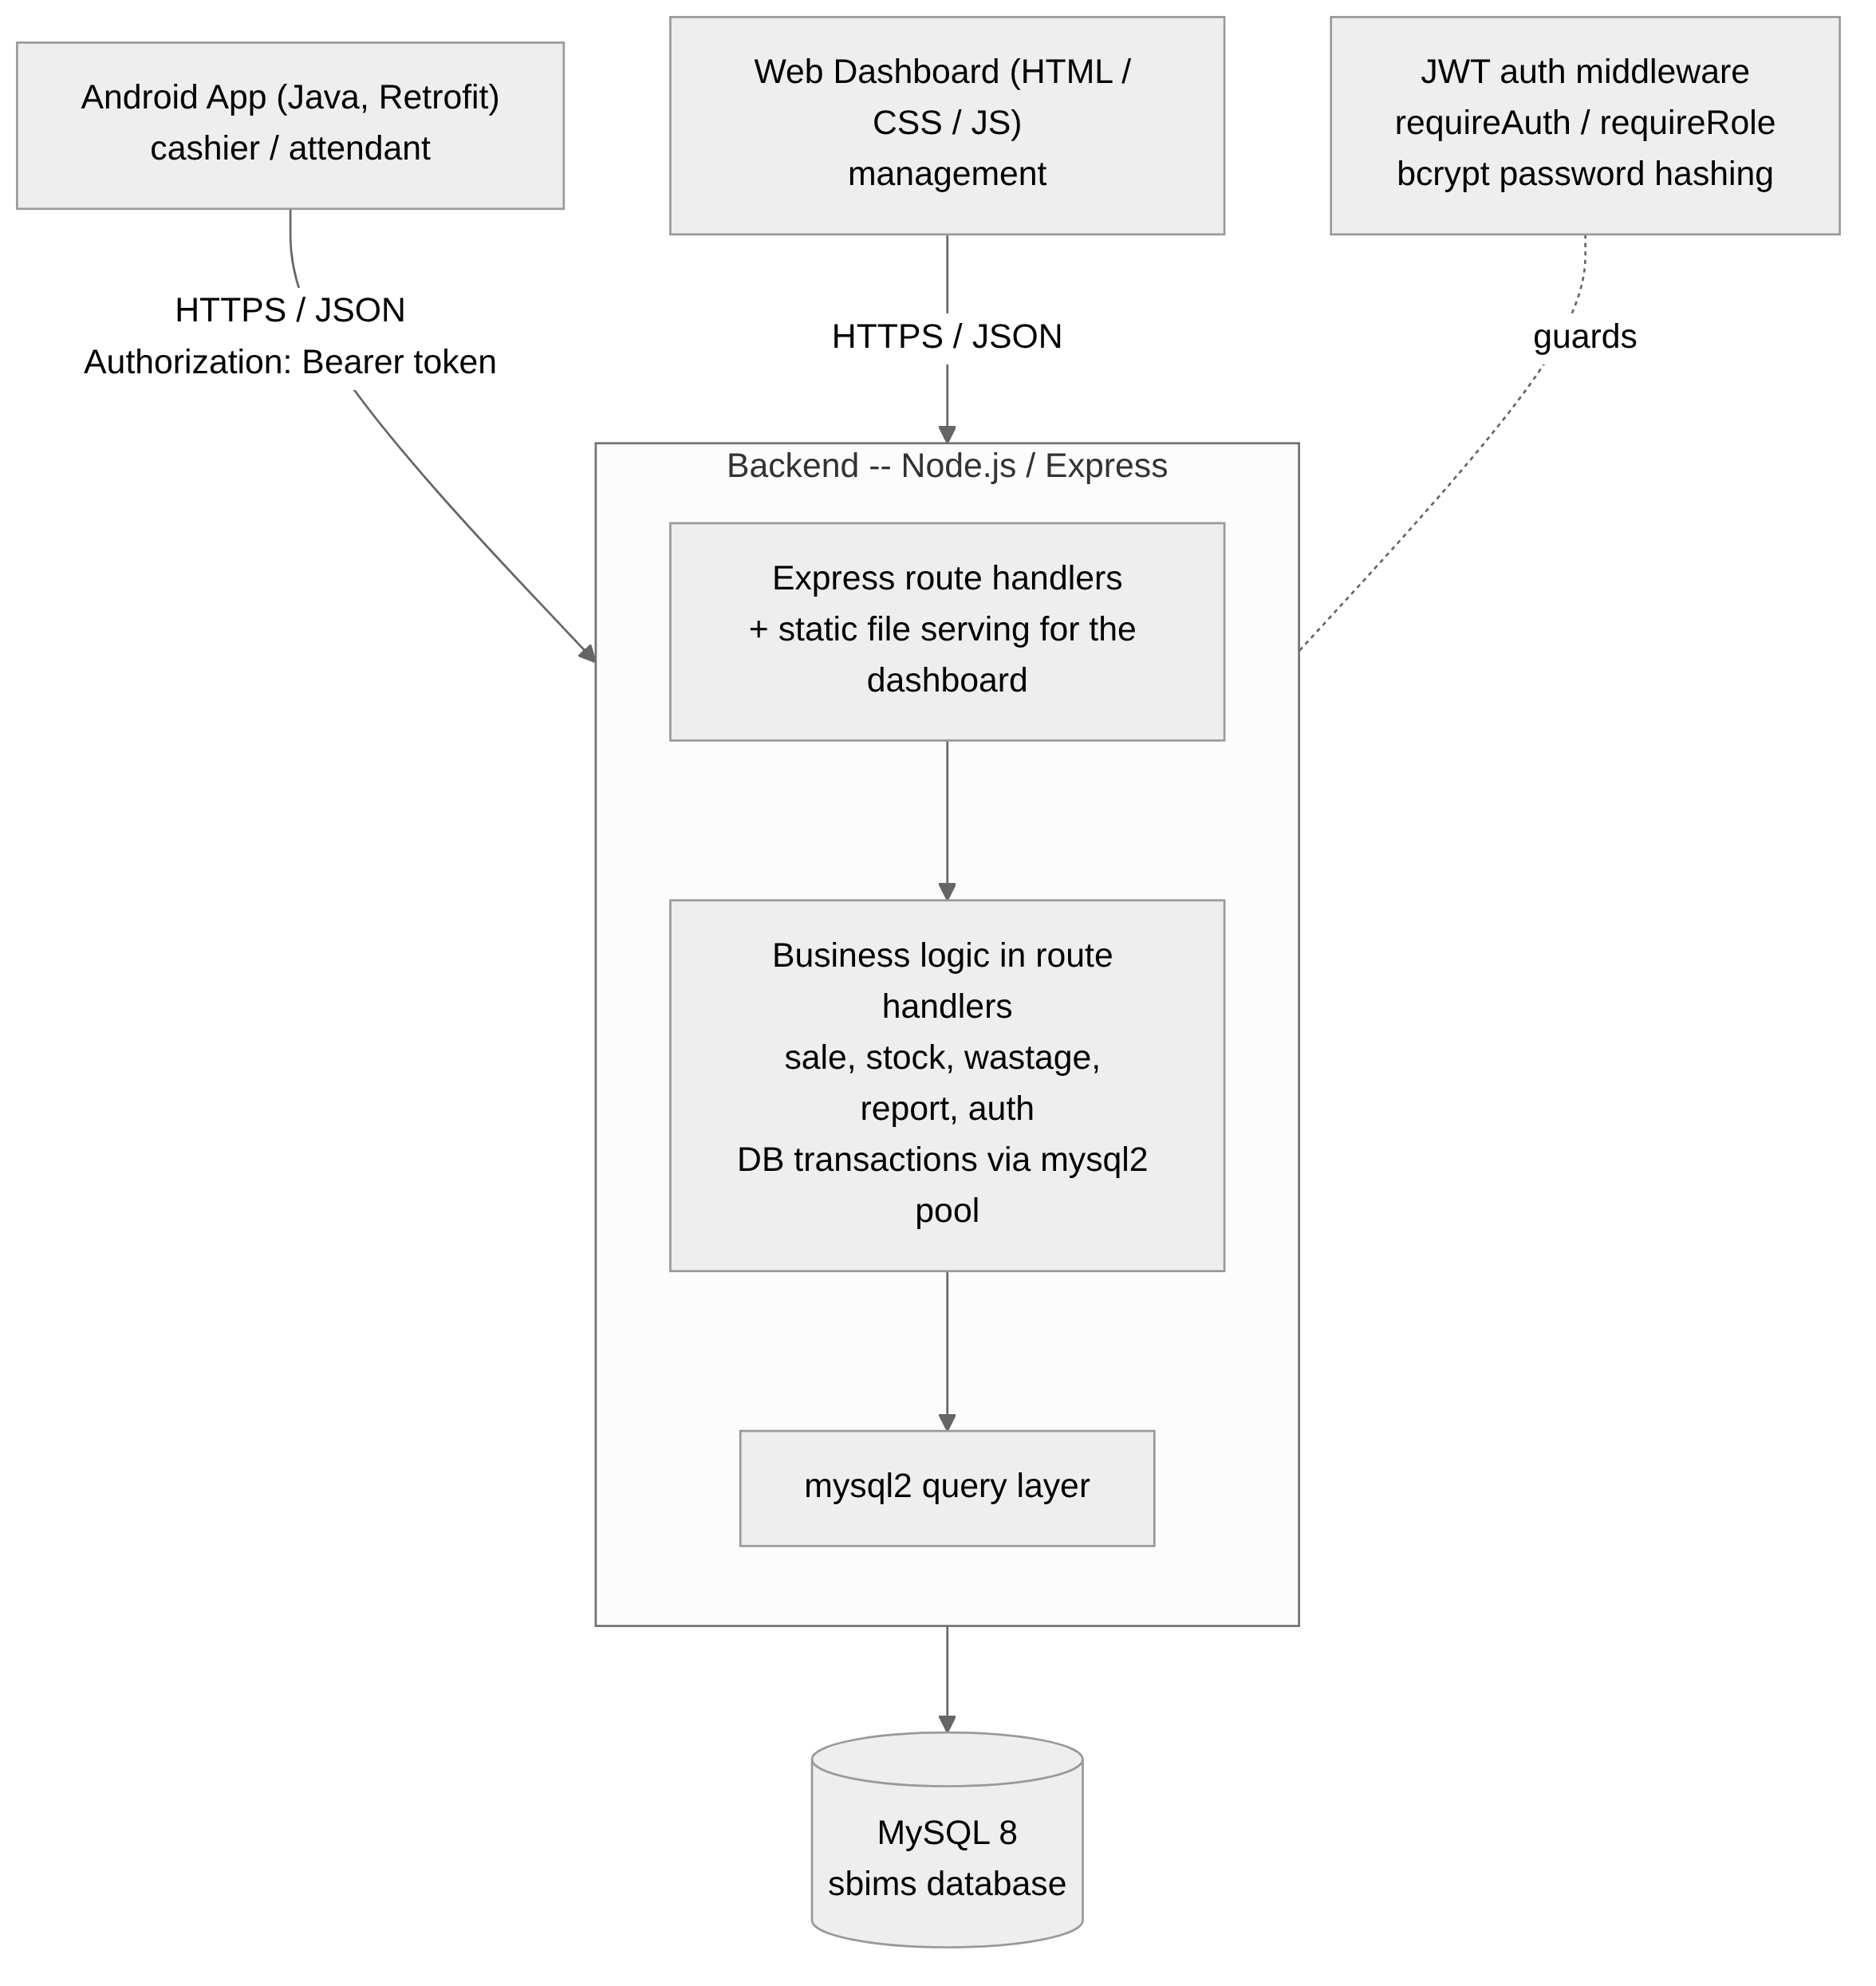
Figure 1: SBIMS system architecture
Tier | Contains | Responsibility
Presentation | Android app; web dashboard | Capture input, call the backend, display results. No business rules.
Application / domain | Express route handlers | Weight-based stock deduction, sale totalling, wastage approval, report queries, validation, transactions.
Data access | mysql2 query layer | Persistence and queries only.
Database | MySQL | The tables described in Section 4.7.
Cross-cutting | JWT auth middleware (jsonwebtoken + bcrypt) | Token authentication, role rules, password hashing.
Table 15: Architecture tiers and responsibilities
The Android app talks to the backend over HTTPS/JSON, logging in at POST /api/login and sending the returned token as an Authorization: Bearer header on every subsequent call. The web dashboard is a standalone HTML/CSS/JS application calling the same /api/** endpoints -- there is no server-side templating, since the backend is Node rather than a server-rendering framework. The indicative REST API is summarised below.
Method & path | Purpose | Role
POST /api/login | Obtain a JWT token | any
GET /api/categories, GET /api/products | List categories / products with price and stock_kg | any
POST /api/products, PUT /api/products/:id | Add / edit a product (price, threshold) | manager
GET /api/stock | Available stock per product, grouped by category | any
POST /api/stock | Record a delivery (stock in) | any
POST /api/sales, POST /api/sales/batch | Record a sale (single line / cart) -- deducts stock | cashier
GET /api/sales/today | Today's kilograms sold and revenue | any
POST /api/wastage | Report spoilage / wastage (PENDING) | any
PUT /api/wastage/:id/approve, /reject | Approve or reject a pending wastage report | manager
GET /api/reports/sales, /profit, /stock-usage | Sales / profit / stock-usage reports | manager
GET/POST /api/users | List / create users | manager
Table 16: Indicative REST API
Decision | Rationale
One Node.js/Express backend serving both clients | Android needs JSON; the dashboard is plain HTML/CSS/JS calling the same endpoints -- no second server, no second language.
Stock held as products.stock_kg, plus an append-only stock_batches table for deliveries | Fast reads and simple threshold checks, with an audit trail of deliveries.
One atomic transaction per stock-changing action | A sale, delivery or wastage approval never half-applies.
Row lock (SELECT ... FOR UPDATE) plus a conditional UPDATE (stock_kg >= ?) during a sale | Stock cannot go negative or be oversold under concurrent requests (see Section 4.9).
DECIMAL columns for weight and money | No floating-point drift on kilograms x price.
Wastage reports require manager approval before stock changes | Meat cannot be written off as spoiled without a second person confirming it.
JWT for API authentication, bcrypt for passwords | Standard, stateless auth suited to a mobile client; passwords are never stored in the clear.
Table 17: Key architectural decisions
The backend is deployed as a single Node.js process connecting directly to a managed MySQL instance, currently hosted on Railway so that the Android app and web dashboard can point at a real server instead of localhost during development and demonstration.

4.7 Database / Data Design (where applicable)
The database is a single MySQL schema (sbims) of six tables: users, categories, products, stock_batches, sales and wastage. An earlier design pass sketched a more elaborate model (separate meat_type, cut, sale_line and stock_movement tables); during implementation this was deliberately simplified to the schema below, and this report has been reconciled to describe the schema that was actually built and is used throughout Chapters 4 to 6.
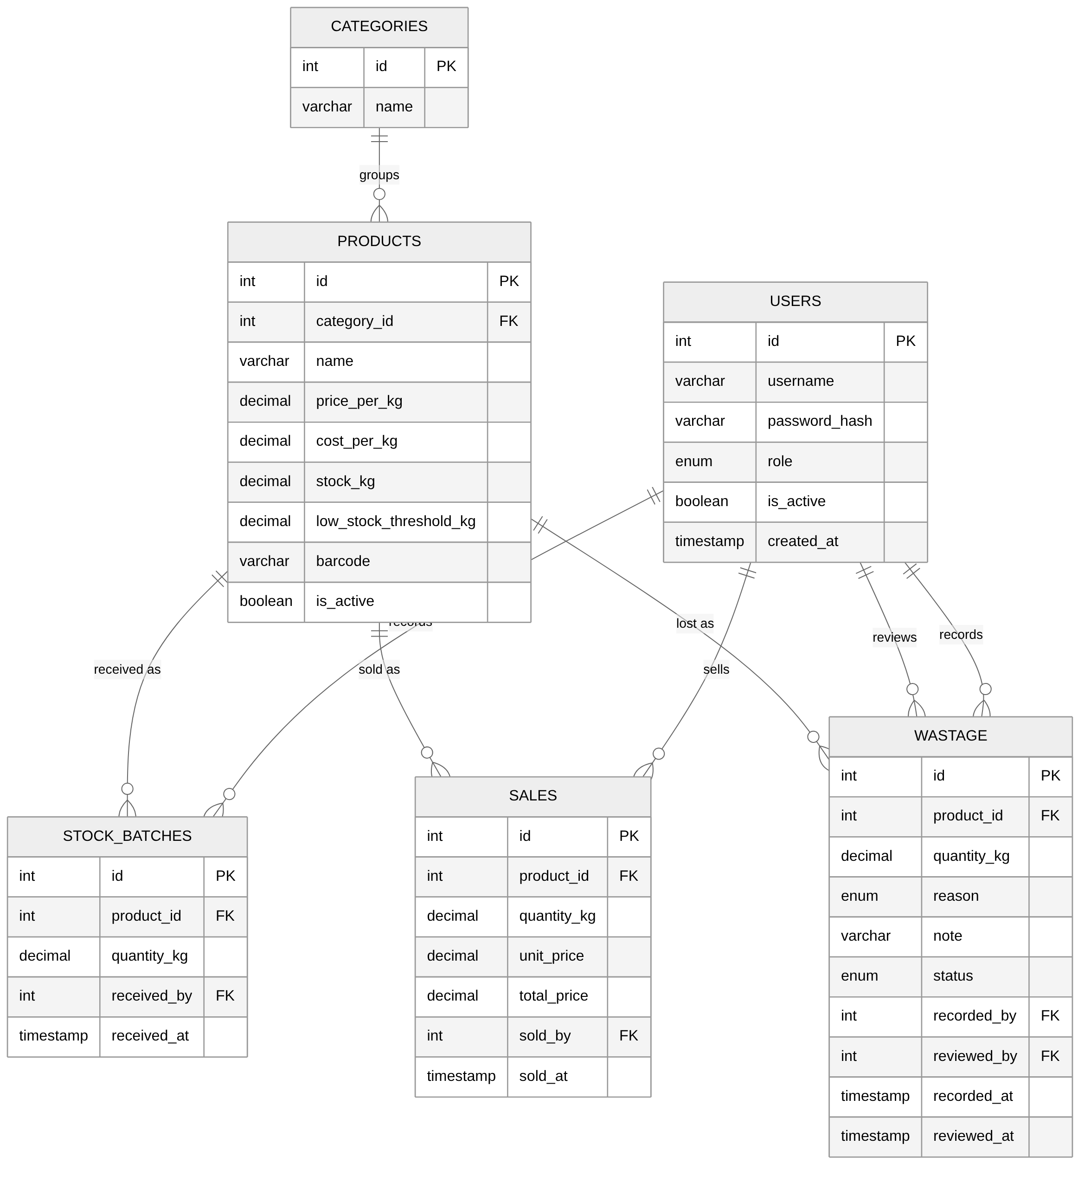
Figure 2: Entity-relationship diagram of the SBIMS database
Data dictionary
Table | Purpose | Key columns
users | Login accounts | username (unique), password_hash, role (admin/cashier), is_active
categories | Meat types, e.g. beef, chicken, pork | name (unique)
products | A cut priced per kilogram | category_id (FK), name, price_per_kg, cost_per_kg, stock_kg, low_stock_threshold_kg, barcode, is_active
stock_batches | Stock-in (delivery) events | product_id (FK), quantity_kg, received_by (FK user), received_at
sales | One sold line (a batch sale inserts one row per cart line) | product_id (FK), quantity_kg, unit_price, total_price, sold_by (FK user), sold_at
wastage | Spoilage / wastage reports | product_id (FK), quantity_kg, reason (enum), note, status (PENDING / APPROVED / REJECTED), recorded_by (FK user), reviewed_by (FK user), rejection_reason
Table 18: Data dictionary
Design points
- Weight is DECIMAL(10,3) and money is DECIMAL(10,2) throughout -- never floating point -- so kilograms x price-per-kilogram calculations do not drift.
- products.stock_kg is a stored running total rather than always being recomputed from history, so a stock check during a sale is a single indexed read; stock_batches, sales and wastage together give the audit trail behind that total.
- sales.unit_price and sales.total_price are captured at the time of sale (a snapshot), so a later price change does not alter the amount recorded for a past sale.
- Foreign keys reference users.id from stock_batches, sales and wastage (recorded_by / reviewed_by), so every stock-affecting action can be traced to the user who performed it.
- wastage.status enforces the report-then-approve workflow at the data level: a row starts PENDING and only an explicit approval transitions it to APPROVED and reduces stock_kg.
Normalisation
Starting from an unnormalised “delivery note / sales sheet” record with a repeating group of product lines: first normal form is reached by splitting the repeating line group into its own row per line (stock_batches / sales / wastage, one row per movement); second normal form is reached by pulling product attributes (name, price, threshold) out into their own products table, removing the partial dependency of those attributes on a composite key; third normal form is reached by pulling category out into its own categories table and user details out into users, removing the transitive dependency of a category's name, or a user's role, on a product or movement row. The two deliberate exceptions to strict normalisation -- products.stock_kg as a derivable running total, and the unit_price/total_price snapshot on each sales row -- are kept because they are read far more often than they are written, and because a sale's recorded amount must not change retroactively when a price changes.

4.8 Interface / Interaction Design (where applicable)
Both clients are organised around the same set of workflows, so that a manager who learns the web dashboard already recognises the Android app's cashier screens, and vice versa.
Android app screens (cashier / attendant)
Screen | Purpose
Login | Authenticate and route to the home screen for the user's role.
Dashboard | Entry point: today's sales, quick links to Sell, Add Stock, Stock and Wastage.
Sale entry (cart) | Build a multi-line sale by product and weight; shows a running total; checkout.
Barcode scanner | Camera-based lookup (CameraX / ML Kit) that adds a product to the cart by its barcode.
Receipt | Printable confirmation of a completed sale.
Add stock | Record a delivery for a product.
Stock list | Current stock_kg per product.
Wastage | Report spoiled or wasted stock.
Table 19: Android app screens
Web dashboard pages (management)
Page | Purpose
Login | Authenticate as a manager (or cashier, for the shared actions).
Dashboard | Stock by category, today's sales, low-stock alerts.
Products | Add/edit products, prices and low-stock thresholds.
Stock | Record deliveries; view current stock.
Sale | Record a sale from the web, mirroring the Android cart flow.
Wastage | Report wastage.
Wastage review | Manager approval queue for PENDING wastage reports.
Reports | Sales, profit-estimation and stock-usage reports over a date range.
Users | Create, list and deactivate user accounts.
Table 20: Web dashboard pages
[STUDENT TO ADD: a screenshot of each screen/page listed above, taken from a running instance of the app and the dashboard, inserted under its row or alongside this section. The web-dashboard HTML/CSS and the Android layouts already exist in the repository (web-dashboard/*.html and android-app/app/src/main/res/layout/*.xml); this report cannot capture screenshots itself since that needs the system to be run.]

4.9 Algorithms / Models / Technical Design
Weight-based stock deduction (single sale line)
A sale is not simply “check stock, then deduct it”, because two cashiers could pass the check at the same instant. SBIMS instead combines a row lock with a conditional update inside one transaction: the product row is selected with FOR UPDATE, which blocks a second transaction from reading it until the first commits or rolls back; the deduction itself is an UPDATE ... WHERE id = ? AND stock_kg >= ? statement, so the row only changes if enough stock is still present at the moment of the write; if the statement affects zero rows, the transaction is rolled back and the API returns 409 Not enough stock. This makes the check-then-deduct step atomic without needing a separate application-level lock.
Multi-line (cart) sale and deadlock avoidance
A cart can contain several products, each needing its own row lock. If two concurrent checkouts contain the same two products in opposite order, naively locking them in cart order can deadlock (each transaction waits for a row the other is holding). SBIMS avoids this by sorting each cart's lines by product_id before locking them, so every transaction acquires locks in the same global order regardless of how the cashier added items to the cart; the response is then reassembled in the cart's original order before being returned, so the receipt still matches what the cashier entered.
Authentication and session validity
Rather than trusting a JWT's contents for the duration of its lifetime, the auth middleware re-reads the user's row from the database on every request after verifying the token's signature, and rejects the request if the account has since been deactivated. This means deactivating an account takes effect on that user's very next request, not whenever their token happens to expire.
Wastage approval as a state machine
A wastage report moves through three states: PENDING (reported, stock unaffected) to APPROVED (stock deducted, in the same transaction as the status change) or REJECTED (stock unaffected, a rejection_reason is stored). Only a manager can move a report out of PENDING, which is the control that stops stock being written off as spoiled on a single person's say-so.

4.10 Chapter Summary
This chapter translated the problem in Chapter 1 into twenty-six functional requirements, seven non-functional requirements, nine use cases, a three-tier architecture, and a six-table database design built around a weight-based, transactionally-safe stock model. Chapter 5 describes how this design was implemented.

CHAPTER 5: IMPLEMENTATION / DEVELOPMENT

5.1 Introduction
This chapter describes how the design in Chapter 4 was implemented: the development environment, the components that make up each of the three deliverables (backend, Android app, web dashboard), the implementation details behind the transactional stock logic, how the components were integrated, the challenges encountered, and the author's individual contribution to the group project.

5.2 Development Environment
Component | Environment
Backend | Node.js, Express, mysql2, jsonwebtoken, bcrypt; developed in Visual Studio Code; MySQL 8 locally and on Railway for the deployed instance.
Android app | Java, Android Studio, Gradle 8.7, Retrofit for HTTP, CameraX/ML Kit for barcode scanning; built against the deployed backend's base URL.
Web dashboard | Standalone HTML/CSS/JavaScript, no build step; served statically and calling the same REST API as the Android app.
Version control | Git, hosted on GitHub, with feature branches per area (e.g. josiphiah/android-app, josiphiah/user-management, josiphiah/wastage-approval) merged into main.
API testing | Postman, used to exercise and validate endpoints independently of either client.
Table 21: Development environment per component

5.3 System Components / Modules
Backend (backend/src/)
The backend is organised as Express route modules, one per resource, mounted under /api in app.js: authRoutes, productRoutes, saleRoutes, stockRoutes, wastageRoutes, reportRoutes and userRoutes. A single requireAuth / requireRole middleware pair (middleware/auth.js) guards every protected route, and a shared mysql2 connection pool (config/db.js) is used for both plain queries and the transactions described in Section 4.9.
Android app (android-app/app/src/main/java/com/sbims/pos/)
The Android app is split into three packages: model (plain request/response classes such as Product, SaleRequest, SaleBatchRequest, SaleBatchResponse, WastageRequest and WastageResponse, matching the REST API's JSON shapes), network (ApiClient, ApiService, AuthInterceptor and SessionManager, which configure Retrofit and attach the stored JWT to every request), and ui (one Activity per screen -- LoginActivity, DashboardActivity, SaleEntryActivity, BarcodeScannerActivity, ReceiptActivity, AddStockActivity, StockListActivity and WastageActivity -- plus supporting adapters for the cart, the product picker, the stock list and the receipt).
Web dashboard (web-dashboard/)
The web dashboard is a static HTML/CSS/JS application: one HTML page per workflow (login.html, dashboard.html, products.html, stock.html, sale.html, wastage.html, wastage-review.html, reports.html, users.html, add-stock.html) and one JavaScript module per page under web-dashboard/js/, plus a shared api.js that wraps fetch() calls to the backend and attaches the stored token, mirroring the role the network package plays on Android.

5.4 Key Implementation Details
The transactional stock-deduction algorithm, the deadlock-avoidance ordering used for multi-line sales, the re-checked authentication middleware, and the wastage approval state machine are described in Section 4.9 as design, and were implemented directly in saleRoutes.js, wastageRoutes.js and middleware/auth.js respectively. Two further implementation details are worth noting here. First, every stock-affecting endpoint uses the mysql2 pool's connection.beginTransaction / commit / rollback explicitly, with a try/catch/finally that always releases the connection back to the pool, so a thrown error cannot leak a held connection. Second, validation is deliberately done at the top of each route handler before any database work begins (for example, rejecting a missing product_id or a non-positive quantity_kg immediately), so an invalid request never opens a transaction at all.

5.5 Integration
The Android app and the web dashboard integrate with the backend purely through the REST API described in Section 4.6 -- neither client talks to MySQL directly. The Android app's AuthInterceptor attaches the stored JWT as an Authorization: Bearer header to every outgoing Retrofit call; the web dashboard's api.js does the equivalent for fetch() calls. Because both clients were built against the same documented endpoints (and the same Postman collection used to validate them independently), changes to the API contract could be caught before they reached either client. The backend also serves the web dashboard's static files directly (via Express static file serving), so the dashboard and the API are deployed together as one Node.js process, currently hosted on Railway with a managed MySQL database.

5.6 Challenges and Solutions
Challenge | Solution
Incorrect stock after a sale or a crash mid-request | Every sale, delivery and wastage approval is wrapped in a single database transaction that commits or rolls back as a whole (Section 4.9).
Stock oversold by concurrent sales on the same product | SELECT ... FOR UPDATE row locking combined with a conditional UPDATE ... WHERE stock_kg >= ? (Section 4.9).
Lock-order deadlocks on multi-item cart sales | Cart lines are sorted and locked by product_id in a fixed order before any update is issued (Section 4.9).
One person (the author) responsible for two client deliverables -- the web dashboard and the Android app | The web dashboard was built first against the backend API, which then doubled as a working reference and a way to validate the API contract before the Android app reused the same endpoints.
Original Spring Boot backend plan slowed early progress | The team switched the backend to Node.js/Express during early implementation, since both members had faster working familiarity with it, without changing the agreed REST contract or database design.
Planned database design (docs/database-design.md) drifted from the schema actually implemented | This report's Section 4.7 was written directly from the committed schema (backend/database/schema.sql) rather than the earlier planned tables, so the documentation and the implementation now agree.
Meat being written off as “spoiled” without a second check | Wastage reports are PENDING until a manager approves them; stock is only reduced on approval (Section 4.9).
Deployment auto-redeploy not firing reliably after the repository was renamed | Noted in backend/README.md as an open item -- Railway's GitHub connection needs re-authorising after the rename; in the meantime, a redeploy is triggered manually after merging to main.
Table 22: Implementation challenges and how they were addressed

5.7 Individual Contribution (group projects)
This project was carried out by a two-person team. Goodson Mwenso Jr. was responsible for the backend: the Express REST API, the MySQL schema, authentication, and the business logic behind sales, stock, wastage and reports. As the author of this report, my own responsibility and the work described in detail in this chapter and the next was:
- The Android cashier application in full: the model, network and ui packages listed in Section 5.3, covering login, the cart-based sale flow, barcode scanning, receipts, add-stock, stock viewing and wastage reporting.
- The web management dashboard in full: all nine HTML pages and their JavaScript modules listed in Section 5.3, including the shared api.js integration layer.
- Integrating both clients against Goodson's backend API, including raising and working through API-contract issues (for example GitHub issue #24, reconciling the database design documentation with the schema actually implemented).
- Overall project coordination and the project's documentation set, including this report.
Backend code (backend/src/, backend/database/) was written by Goodson and is described in this report only as the system the author's two clients integrate against, consistent with the guidance on individual final reports for group projects given at the start of this document.

5.8 Chapter Summary
The backend, Android app and web dashboard were implemented as three separate codebases integrated purely through a documented REST API, with the transactional, concurrency-safe stock logic concentrated in the backend's route handlers. The author built both client applications and the project's documentation; the backend was built by the author's project partner. Chapter 6 presents how this implementation was tested and evaluates it against the project's objectives.

CHAPTER 6: TESTING, RESULTS AND EVALUATION

6.1 Introduction
This chapter describes how SBIMS was tested, the test cases defined for its core transactional flows, and an evaluation of the finished system against the objectives set out in Section 1.4.

6.2 Testing Strategy
Testing was planned at three levels.
- Automated tests against the Express app -- the stock and money logic: a sale deducts the correct weight, insufficient stock is rejected, concurrent sales on one product cannot oversell it, stock batches and approved wastage adjust stock_kg correctly, report totals reconcile, and authentication/role rules are enforced.
- API tests (a Postman collection kept in the repository) covering every /api/** endpoint: the happy path, a validation failure, an unauthorised request, and a request made with the wrong role.
- Manual, end-to-end tests through the Android app and the web dashboard, used for the demonstration run-through of the full scenario: add stock, sell by weight, confirm the stock and dashboard reconcile, record and approve wastage.

6.3 Test Cases and Results
Automated test areas
Area | Cases
Sale | Line amount = weight x price per kg; multi-line total; stock reduced by exactly the sold weight; a zero or missing weight is rejected.
Insufficient stock | A line above the product's stock_kg rejects the whole sale; nothing is saved.
Concurrency | Two simultaneous sales that together exceed stock -- exactly one succeeds.
Delivery | stock_kg increases by the delivered weight; a weight of zero or less is rejected.
Wastage | A PENDING report does not change stock_kg; an APPROVED report reduces it; a REJECTED report does not.
Reports | Sales report kg/revenue per product over a range; profit = revenue minus cost of goods; an invalid date range is rejected.
Auth | Login returns a token; a protected endpoint returns 401 without one; a manager-only endpoint returns 403 for a cashier.
Snapshot | A price change after a sale does not alter the unit_price/total_price already recorded on that sale.
Table 23: Automated test areas
Manual test cases
ID | Scenario | Steps | Expected outcome | Result
MT1 | Android login | Open the app; log in with a valid cashier account. | The cashier home screen is shown.
MT2 | Sell 2.5 kg beef ribs | Start a new sale; select beef ribs; enter 2.5 kg; complete the sale. | Line amount = 2.5 x price per kg; stock_kg drops by 2.5; a confirmation is shown.
MT3 | Oversell a product | Start a sale for more kilograms than the product's current stock_kg. | The sale is rejected; stock_kg is unchanged.
MT4 | Add a 10 kg delivery | Open Add Stock; select a product; enter 10 kg; submit. | stock_kg rises by 10.
MT5 | Report and approve 1 kg spoilage | Report 1 kg wastage for a product; as a manager, approve the report. | stock_kg drops by 1 only after approval; the record shows in the wastage report.
MT6 | Dashboard reconciles | After MT2, MT4 and MT5, open the web dashboard. | Stock and today's sales shown on the dashboard match the actions above.
MT7 | Low-stock alert | Reduce a product's stock_kg below its low_stock_threshold_kg. | The product appears in the dashboard's low-stock alerts.
MT8 | Cashier blocked from reports | Log in as a cashier; call a /api/reports/** endpoint. | The request is rejected with 403.
MT9 | Barcode lookup | From the Android cart, scan a product's barcode. | The matching product is added to the cart without a manual search.
Table 24: Manual test cases
[STUDENT TO COMPLETE: run MT1-MT9 (and the automated/API tests above) against the deployed system, and fill in the Result column with Pass/Fail plus any screenshot or log evidence. This report can define what should be tested and the expected outcome from the implemented logic, but an actual pass/fail result has to come from running the system.]

6.4 Experimental Results / Performance Results (where applicable)
[STUDENT TO COMPLETE: NFR7 (Section 4.4) targets roughly one second for a sale, delivery or stock query under single-outlet volumes. Record actual response times for a few representative requests against the deployed Railway backend (for example with Postman's response-time display, or simple timing around a few /api/sales and /api/stock calls) and report them here against that target.]

6.5 User Evaluation (where applicable)
[STUDENT TO COMPLETE: this section is for feedback from someone outside the project team actually using the system -- for example a short walkthrough with the supervisor or a butchery contact used during the field observation in Section 2.3 -- on how usable the sell screen and the dashboard are in practice. No such evaluation has been recorded yet, so this section is intentionally left for you to complete rather than invented here.]

6.6 Analysis of Results
The system's core correctness properties follow directly from its design rather than from chance: stock cannot go negative because every deduction is a conditional UPDATE guarded by a row lock (Section 4.9), a sale's recorded amount cannot drift after a price change because it is snapshotted at sale time (Section 4.7), and stock cannot be written off as wasted without a second person's approval because of the PENDING/APPROVED/REJECTED state machine (Section 4.9). The manual test cases in Section 6.3 are designed to exercise exactly these properties end to end through both clients, rather than only at the API level.
[STUDENT TO COMPLETE: once the Section 6.3 results are recorded, summarise here what they show -- in particular, whether any test exposed a gap between the design in Chapter 4 and the implemented behaviour, and how it was or will be resolved.]

6.7 Objective-by-Objective Evaluation
The six objectives set out in Section 1.4 are evaluated below against the implementation described in Chapter 5. This reflects what is present in the codebase at the time of writing; Sections 6.3-6.5 record the evidence from actually running the system.
Objective | Status
1. Android app for weight-based sales, cart and receipts | Implemented: SaleEntryActivity builds a multi-line cart by weight, CartAdapter/ReceiptLineAdapter support it, and ReceiptActivity produces a printable confirmation.
2. Web dashboard mirroring the Android app for management | Implemented: all nine dashboard pages listed in Section 5.3 cover the same workflows as the Android app, plus the manager-only wastage-review and users pages.
3. Centralised database synchronising both clients | Implemented: both clients call the same REST API over the schema in Section 4.7; there is no client-local data store to fall out of sync.
4. Barcode scanning on both clients | Implemented on Android (BarcodeScannerActivity, CameraX/ML Kit) and exposed through products.barcode in the schema; the web dashboard's camera-based scanning should be confirmed against the current web-dashboard/js code as part of Section 6.3.
5. Reporting on sales, stock usage and inventory performance | Implemented: reportRoutes.js and the dashboard's reports.html/reports.js cover sales, profit-estimation and stock-usage reports over a date range.
6. Improved data accuracy via automated, validated tracking | Implemented: every stock-affecting action is validated before any database write and committed as a single transaction (Section 4.9), replacing manual recording with an atomic, auditable one.
Table 25: Achievement of project objectives

6.8 Individual Results (group projects)
[STUDENT TO COMPLETE: once Section 6.3 is run, summarise the results attributable specifically to your own work -- the Android app and the web dashboard -- separately from the backend logic your project partner is responsible for, consistent with Section 5.7.]

6.9 Chapter Summary
A three-level testing strategy was defined, covering automated backend logic, the API contract, and manual end-to-end scenarios through both clients. Five of the six project objectives are fully implemented in code at the time of writing, with the web dashboard's barcode scanning flagged for confirmation. The remaining gap in this chapter is execution evidence -- recorded pass/fail results, performance figures, and user feedback -- which is marked throughout Section 6.3 to 6.5 for completion once the system is run through its test cases.

CHAPTER 7: DISCUSSION

7.1 Introduction
This chapter interprets the findings of Chapters 5 and 6, relates SBIMS back to the existing systems and literature reviewed in Chapter 2, states its contributions, and discusses its limitations.

7.2 Interpretation of Findings
The problem stated in Section 1.2 was that butcheries cannot track weight-based, perishable, multi-cut stock accurately with manual methods or generic unit-based POS software. The design and implementation in Chapters 4 and 5 address this directly rather than approximately: stock is modelled in kilograms rather than units throughout the schema and both clients; every stock-affecting action is an atomic, row-locked transaction rather than a manually reconciled entry; and wastage requires a second person's approval before it reduces stock, which manual notebooks have no equivalent control for. Five of the six project objectives are implemented in code (Section 6.7); the sixth (web-dashboard barcode scanning) needs confirmation once Section 6.3's manual tests are run.

7.3 Comparison with Existing Work
The comparative analysis in Section 2.4 showed that neither manual record keeping nor generic unit-based POS software models a butchery's actual unit of stock -- weight -- or its two main sources of loss -- spoilage and oversold stock under concurrent sales. SBIMS's row-locked, weight-based transactions (Section 4.9) and its report-then-approve wastage workflow (Section 4.9) are direct responses to those two gaps, and go beyond what Laudon and Laudon (2020) describe at the level of “enterprise systems integrate mobile applications with a centralised database” by specifying exactly how that integration is made safe under concurrent use for this domain.

7.4 Contributions of the Project
The project's main practical contribution is a working reference design for a weight-based inventory system aimed at a single small butchery outlet: a data model (Section 4.7), a concurrency-safe transaction pattern for weight-based stock (Section 4.9), and two client applications built against the same API contract, which together demonstrate that this problem can be solved with an ordinary, low-cost technology stack rather than specialised retail hardware. For the author specifically, the Android cashier application and the web management dashboard (Section 5.7) are the individual technical contribution evaluated in this report.

7.5 Limitations and Implications
The limitations noted in Section 1.8 shape how the results in Chapter 6 should be read. The system has not yet been load-tested under realistic concurrent volumes beyond the two-transaction scenario the design targets (Section 4.9), so NFR7's performance target is stated but not yet measured (Section 6.4). The Android app's handling of a dropped connection mid-sale is a visible error rather than an automatic retry, so a cashier on an unreliable connection must manually resubmit a failed sale; this is acceptable for the single-outlet scope in Section 1.6 but would need revisiting before a multi-branch deployment. Finally, because this report's execution evidence (Sections 6.3 to 6.5) is marked for completion rather than filled in from an actual test run, the conclusions in Section 7.2 should be read as holding at the design and code level, to be confirmed once those sections are completed.

7.6 Chapter Summary
SBIMS's weight-based data model and transactional stock logic directly answer the gap identified in the literature and in existing systems (Chapter 2), and the implementation matches the design in five of six project objectives. The main open item is execution evidence rather than a design gap, which Chapter 8 reflects in its recommendations and future work.

CHAPTER 8: CONCLUSION AND RECOMMENDATIONS

8.1 Introduction
This final chapter summarises the project, states its conclusions, reviews achievement of its objectives, and sets out recommendations and future work.

8.2 Summary of the Project
SBIMS was built to solve a specific, under-served problem: small butcheries sell perishable stock by weight and in multiple cuts per meat type, a combination that neither manual record keeping nor generic unit-based POS software handles well (Chapters 1 and 2). The project designed and implemented a three-tier system -- an Android cashier app, a web management dashboard, and a shared Node.js/Express/MySQL backend -- built around a weight-based stock model with transactional, concurrency-safe stock updates and a manager-approved wastage workflow (Chapters 4 and 5). The author was individually responsible for both client applications and the project's documentation, working against a backend built by the project partner.

8.3 Conclusions
The project shows that a weight-based, perishable-goods inventory problem can be addressed with an ordinary three-tier web/mobile architecture and an open-source technology stack, without requiring specialised retail hardware. The central technical finding is that correctness under concurrent use -- stock never going negative, a sale's recorded amount never drifting after a later price change, wastage never being applied without approval -- can be guaranteed by database-level transaction design (row locking, conditional updates, snapshotted values, and an explicit approval state machine) rather than by application-level checks alone.

8.4 Achievement of Objectives
Section 6.7 evaluates each of the six objectives from Section 1.4 individually against the implementation. In summary, five objectives are fully implemented at the time of writing (the Android cashier app, the mirrored web dashboard, the centralised database/API, reporting, and automated/validated stock tracking); the sixth (barcode scanning on both clients) is implemented on Android and needs confirmation on the web dashboard as part of completing Section 6.3.

8.5 Recommendations
- Complete the execution evidence flagged throughout Chapter 6 -- run the manual and automated test cases, record pass/fail results, and capture the screenshots flagged in Section 4.8 -- before this report is finalised for submission.
- Re-authorise Railway's GitHub connection (noted in backend/README.md) so that merges to main redeploy the backend automatically again.
- Confirm and, if needed, finish the web dashboard's barcode scanning against the browser camera, to close out objective 4 in Section 6.7.
- Agree and record the individual contribution percentages in Appendix A with the project partner before submission.

8.6 Future Work
The following were identified as out of scope for this iteration (Section 1.6) and are natural next steps:
- Automatic retry-and-resync for a sale when the Android app's network connection drops mid-request, rather than requiring the cashier to resubmit manually.
- Integration with a connected digital weighing scale, so a weight is read directly rather than typed in.
- Expiry-date tracking with automated alerts, in addition to the existing spoilage/wastage workflow.
- Multi-branch butchery management, synchronising stock across more than one outlet.
- Integration with external payment systems (mobile money or card POS), beyond recording a sale's total.

REFERENCES
Chopra, S. and Meindl, P., 2016. Supply Chain Management: Strategy, Planning, and Operation. 6th ed. Pearson.
Kumar, S. and Suresh, N., 2018. Operations Management. New Age International Publishers.
Laudon, K.C. and Laudon, J.P., 2020. Management Information Systems: Managing the Digital Firm. 16th ed. Pearson.
Nahmias, S. and Olsen, T.L., 2015. Production and Operations Analysis. 7th ed. Waveland Press.
Sommerville, I., 2016. Software Engineering. 10th ed. Pearson.
[STUDENT TO REVIEW: these five references are the ones carried over from the original project proposal. Chapter 2's literature review was written from them plus informal field observation (Section 2.3); if your supervisor expects a wider academic literature search for the final report, add further sources here and extend Section 2.2-2.5 accordingly.]

APPENDICES

APPENDIX A: INDIVIDUAL CONTRIBUTION STATEMENT (GROUP PROJECTS)
Purpose of this Statement
This statement is required for students who completed their final year project as part of a group. Although the project may have been conceived, developed, and evaluated collaboratively, each student is expected to demonstrate their own understanding and contribution through an individual final report. The statement should be consistent with the content presented in the main report. Students should not claim the work of another group member as their own.
Project and Group Information
Project Title: Smart Butchery Inventory Management System (SBIMS) Student Name: Josiphiah Simbaya Computer Number: [Computer Number] Supervisor: Mr. Alinani Simukanga Group Size: 2 Group Members: Josiphiah Simbaya [Computer Number]; Goodson Mwenso Jr. [Computer Number]
Overall Group Project
The group built the Smart Butchery Inventory Management System (SBIMS): a weight-based inventory and point-of-sale platform for a single butchery outlet, consisting of an Android cashier application and a web management dashboard over a shared Node.js/Express REST API and MySQL database. The common problem was that butcheries sell perishable stock by weight and by cut, which neither manual record keeping nor generic unit-based point-of-sale software tracks accurately (see Chapter 1 of the main report).
Individual Role and Responsibilities
My role was client-side development and project documentation: building both the Android cashier application and the web management dashboard against the REST API, integrating them with my project partner's backend, and coordinating and writing the project's documentation set, including this report. My project partner, Goodson Mwenso Jr., was responsible for the backend: the REST API, the MySQL schema, authentication, and the business logic behind sales, stock, wastage and reports.
Detailed Individual Contribution
I contributed to requirements analysis and use-case definition for the client-facing workflows (Section 4.5 of the main report); designed and implemented the Android application in full -- login, the cart-based sale flow, barcode scanning, receipts, add-stock, stock viewing and wastage reporting (Section 5.3); designed and implemented the web management dashboard in full, including the manager-only wastage-review and user-management pages (Section 5.3); integrated both clients against the backend API, including raising and resolving API-contract issues such as GitHub issue #24 (reconciling the database design documentation with the implemented schema); and authored the project's documentation set, including the requirements, design, testing and evaluation material consolidated into this report.
Individual Deliverables
List the specific outputs or deliverables produced primarily by the student:
1. Android cashier application — login, cart-based weight sale, barcode scanning, receipts, add-stock, stock view and wastage reporting (android-app/).
2. Web management dashboard — all nine pages listed in Section 5.3, including wastage review and user management (web-dashboard/).
3. Project documentation set — requirements, architecture, database design, use cases, test plan and this final report (docs/, and this document).
4. API integration and contract fixes across both clients and the backend (e.g. GitHub issue #24).
Contribution to the Main System or Research Output
The entire presentation tier of SBIMS -- the Android application and the web dashboard -- was developed by me. The application/domain and data tiers (the Express API, business logic and MySQL schema, Section 4.6) were developed by Goodson Mwenso Jr. The REST API contract between the tiers (Section 4.6) was agreed jointly and adjusted collaboratively as both clients were integrated against it.
Individual Implementation and Technical Work
On Android: the model, network and ui packages described in Section 5.3, including the Retrofit-based network layer (ApiClient, ApiService, AuthInterceptor, SessionManager) and the CameraX/ML Kit barcode-scanning integration. On the web dashboard: all nine pages and their JavaScript modules, including the shared api.js integration layer that mirrors the Android network package's role. Across both clients: handling the API's transactional responses correctly, in particular surfacing the 409 “not enough stock” and 403 role-rejection responses to the user rather than treating them as generic errors.
Individual Testing and Evaluation Contribution
I defined the manual end-to-end test cases (MT1-MT9, Section 6.3) that exercise the system through both clients rather than only at the API level, and I am responsible for executing them and recording results as part of finishing Chapter 6. I also debugged client-side integration issues surfaced while connecting the Android app and web dashboard to the backend API during development.
Collaboration with Other Group Members
Both client applications I built depend entirely on the REST API designed and implemented by Goodson Mwenso Jr.; neither the Android app nor the web dashboard stores or computes business data locally. The web dashboard was deliberately built first against the backend, which both validated the API contract early and gave a working reference the Android app could then reuse the same endpoints against (Section 5.6). Where the schema or an endpoint needed to change to support a client workflow, this was agreed and implemented jointly.
Contribution Summary
Distinguish between:
(1) work primarily completed by the student;
(2) work completed jointly with other group members; and
(3) work primarily completed by other group members but used or incorporated into the student's work.
(1) Primarily mine: the Android application, the web dashboard, and the project documentation set, including this report. (2) Joint: the REST API contract (endpoint shapes and status codes) and the overall requirements and use cases in Chapter 4. (3) Primarily my partner's, used in my work: the backend API, business logic and MySQL schema that both clients call.
Estimated Contribution
Provide an approximate indication of the student's contribution across the major project activities. The percentages are intended to indicate the nature and distribution of the student's work and are not necessarily expected to total 100% across rows.
Problem Analysis: [Individual %] / [Collaborative %]
Literature Review: [Individual %] / [Collaborative %]
Requirements Analysis: [Individual %] / [Collaborative %]
System/Research Design: [Individual %] / [Collaborative %]
Implementation/Development: [Individual %] / [Collaborative %]
Testing and Evaluation: [Individual %] / [Collaborative %]
Documentation: [Individual %] / [Collaborative %]
Other: [Individual %] / [Collaborative %]
Statement of Authorship and Contribution
I confirm that the contribution described in this statement accurately represents the work that I personally undertook as part of the group project. I have identified collaborative work and have not knowingly claimed the work of another group member as my own.
Student Name: ______________________________________
Computer Number: ____________________________________
Signature: ___________________________________________
Date: _______________________________________________
Supervisor Verification
I confirm that, to the best of my knowledge, the contribution described above is consistent with the student's participation in the group project.
Supervisor Name: ____________________________________
Signature: ___________________________________________
Date: _______________________________________________

APPENDIX B: USER MANUAL / INSTALLATION GUIDE
B.1 Backend installation
- cd backend && npm install
- cp .env.example .env, then fill in local MySQL credentials and a JWT secret.
- mysql -u root -p < database/schema.sql, to create the sbims database and its tables.
- npm run dev to start the API. It listens on http://localhost:3000 by default; GET /api/health confirms it is running.
A deployed instance also runs on Railway (Node.js app + MySQL), so the Android app and web dashboard can point at a real server instead of localhost for a demonstration. Seeded accounts for testing are admin/admin123 and cashier/cashier123 -- these should be changed before any real submission or demonstration where security matters.
B.2 Web dashboard
The dashboard is served statically by the backend (Express static file serving) once the backend is running, or can be opened directly from web-dashboard/index.html for local development against the same API.
B.3 Android app
Open android-app/ in Android Studio, let Gradle sync, and run the app on a device or emulator with camera access (needed for barcode scanning). The app's base API URL is configured in the network package (ApiClient) and should point at the backend instance you are running against.
B.4 Using the Android app (cashier / attendant)
- Logging in: open the app, enter your username and password, tap Log in.
- Recording a sale: tap New Sale; choose a cut (or scan its barcode); type the weight sold in kilograms, e.g. 2.5; the line amount (weight x price per kg) appears; add more cuts if needed; tap Complete sale. Stock is reduced automatically and a confirmation shows the total kilograms and amount.
- Adding stock (a delivery): tap Add Stock, choose the cut, enter the delivered weight in kilograms, tap Save. The cut's available weight increases.
- Viewing stock: tap Stock to see available kilograms per cut.
- Today's sales: tap Today to see total kilograms sold and revenue for the day.
- Reporting wastage: tap Wastage, choose the cut, enter the wasted weight and a reason, submit. Stock is not affected until a manager approves the report.
B.5 Using the web dashboard (management)
- Logging in: open the dashboard URL and sign in with a manager account.
- Dashboard: shows stock per meat type, today's sales (kilograms and revenue), and any low-stock cuts.
- Meat cuts and prices: add a meat type; add a cut with its price per kilogram and low-stock threshold; edit a price; retire a cut.
- Stock: record deliveries and view current stock.
- Wastage review: approve or reject pending wastage reports.
- Reports: choose a date range and view the sales, profit-estimation and stock-usage reports.
- Users: create cashier or manager accounts and deactivate ones no longer used.
B.6 Troubleshooting
- 401 / login rejected: confirm the account is active and the username/password are correct; a deactivated account is rejected immediately, even with a previously-valid token.
- “Not enough stock” on a sale: another sale may have just reduced the product's stock below the requested weight; refresh the product list and retry with the current stock_kg.
- Dashboard figures look out of date: confirm the dashboard is pointed at the same backend URL the Android app is using.
[STUDENT TO ADD: a screenshot under each numbered step above, taken from a running instance, as flagged in Section 4.8.]

APPENDIX C: ADDITIONAL SYSTEM DESIGNS / DIAGRAMS
The system architecture (Figure 1) and the database entity-relationship diagram (Figure 2) appear in Chapter 4. The system sequence diagrams below show the message flow for the five highest-priority use cases from Section 4.5.
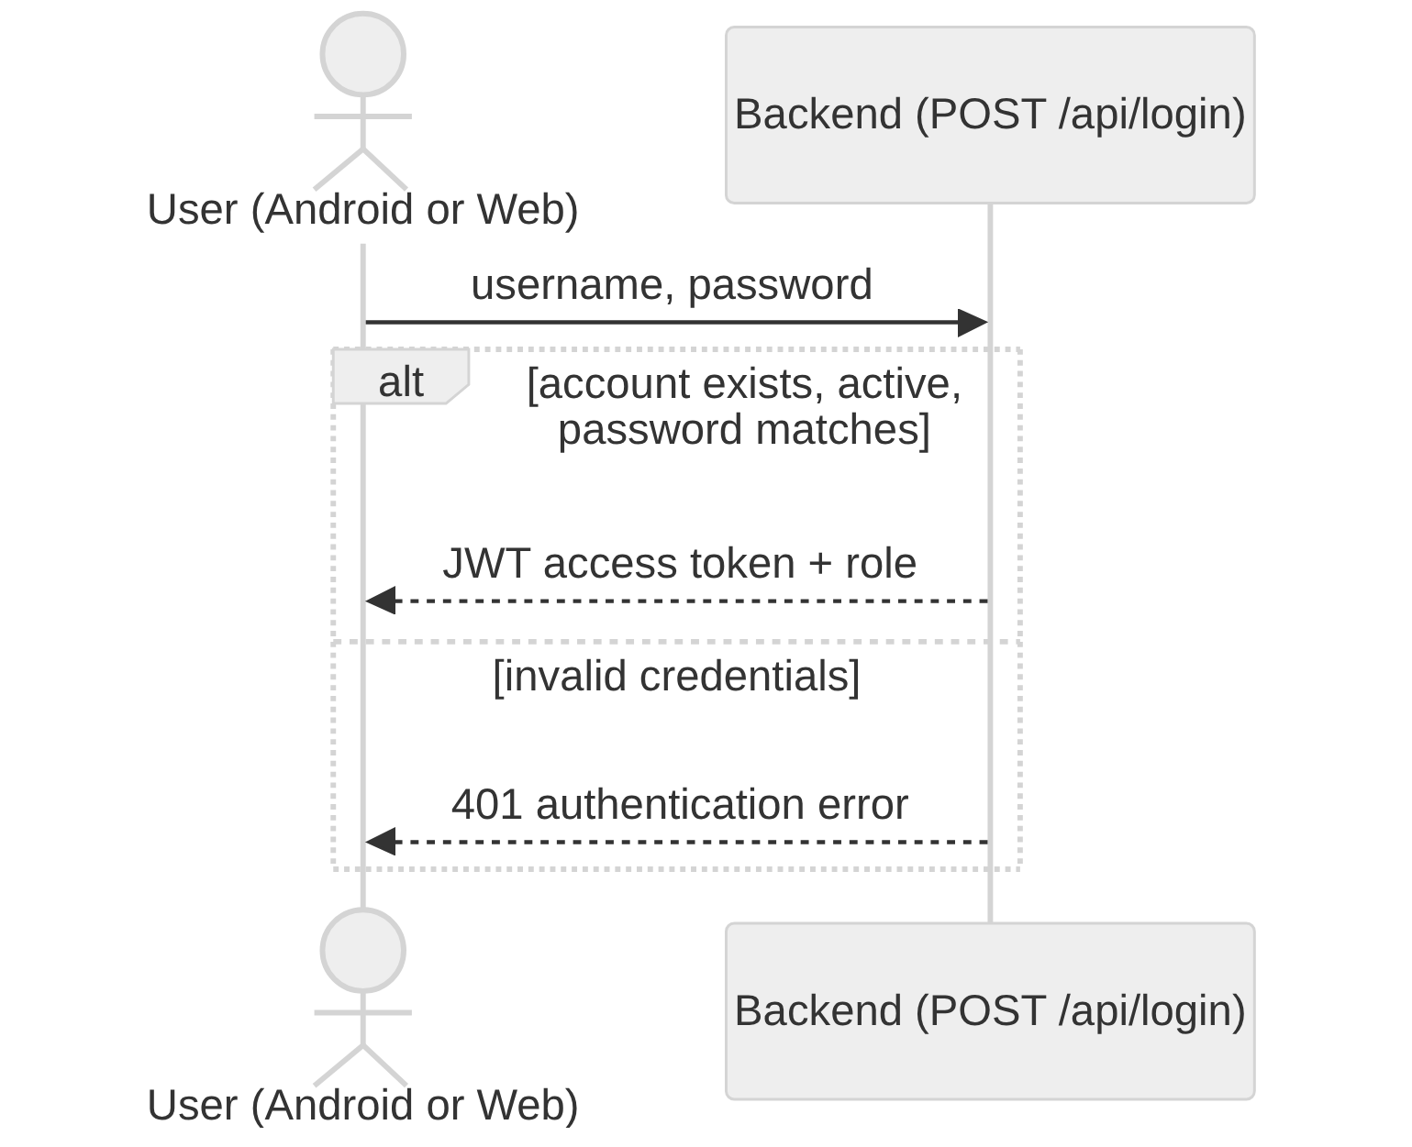
Figure 3: System sequence diagram -- Log In (UC1)
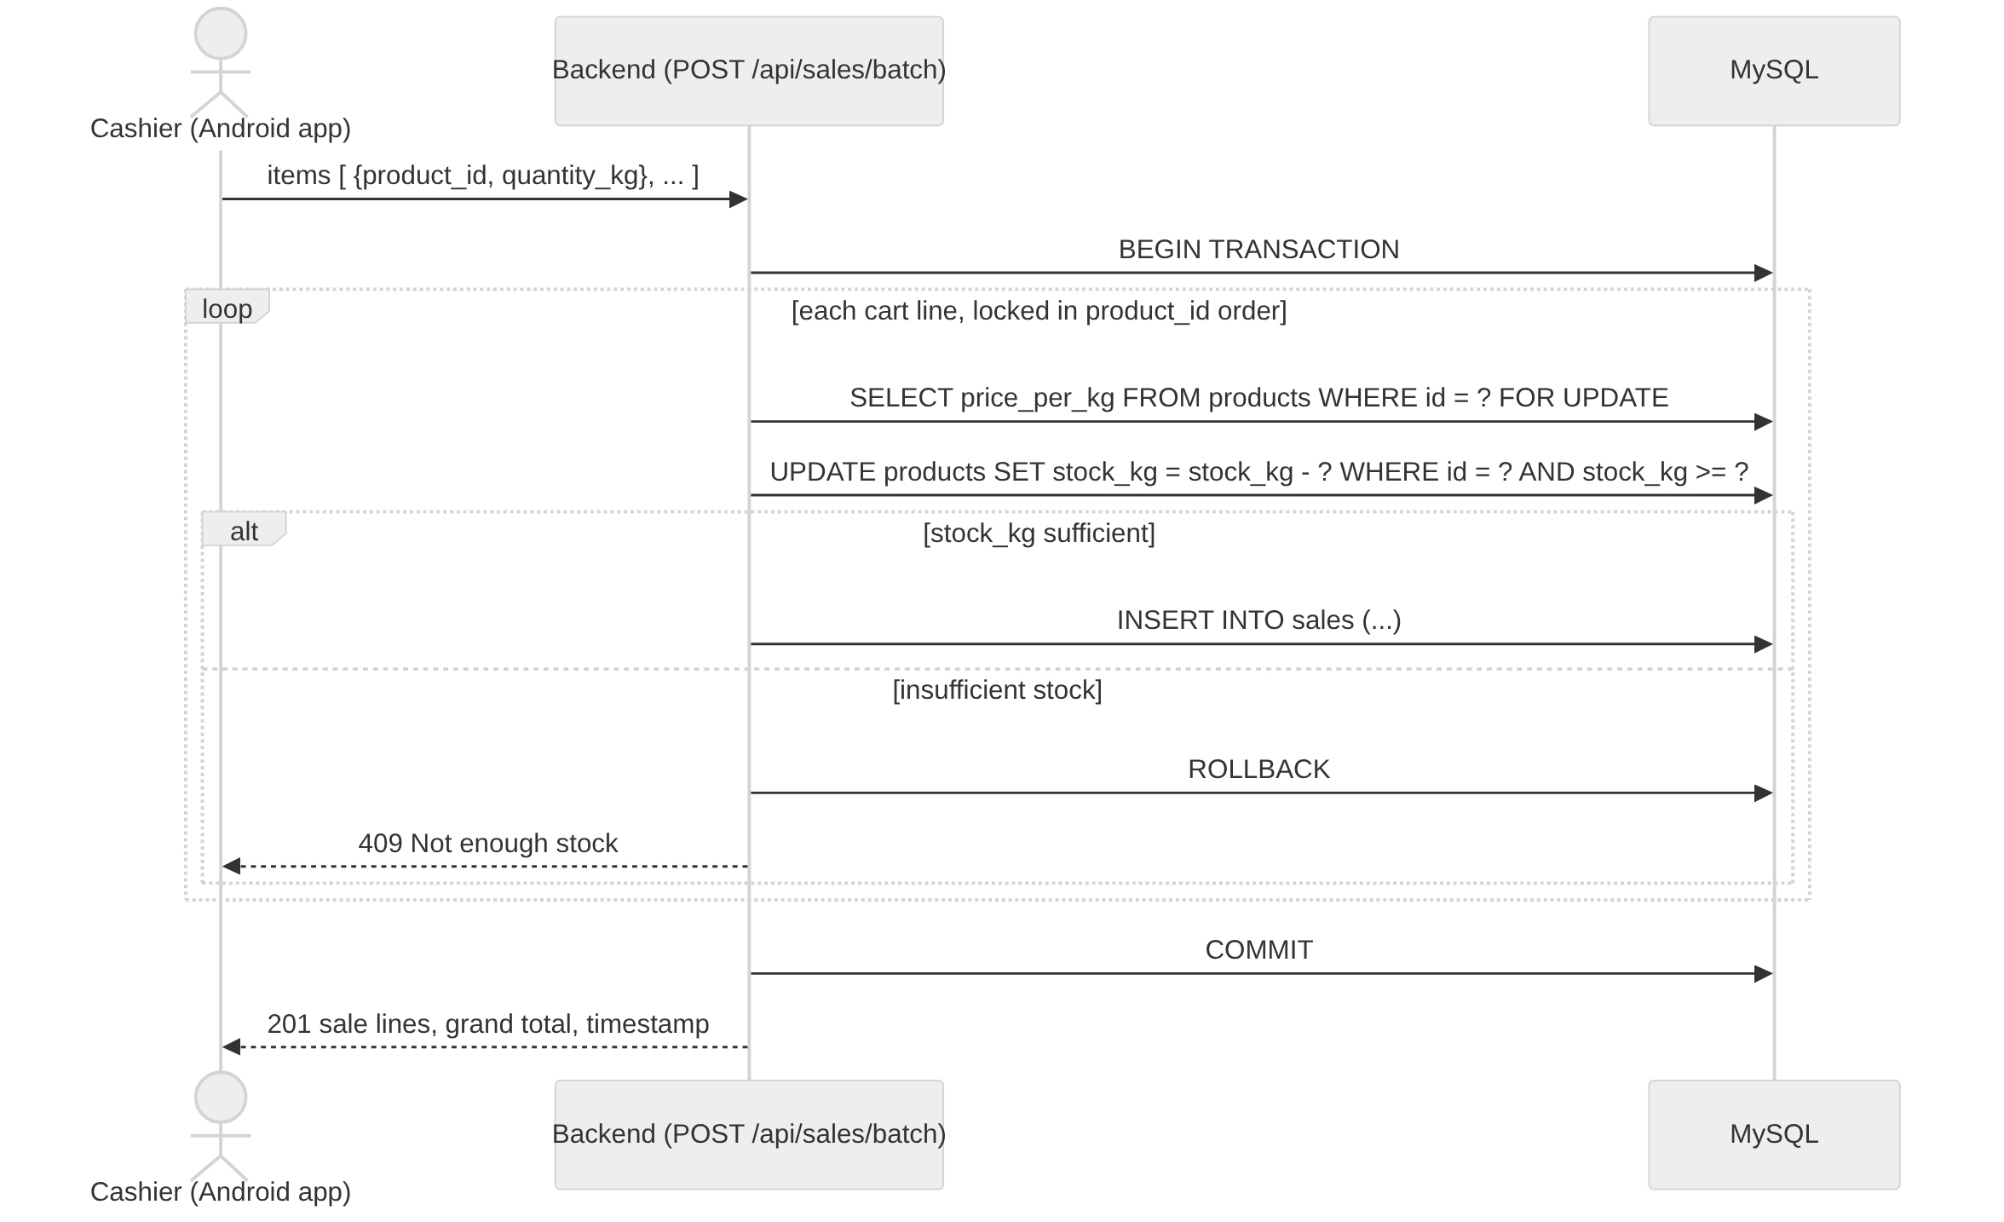
Figure 4: System sequence diagram -- Record Sale, batch/cart (UC2)
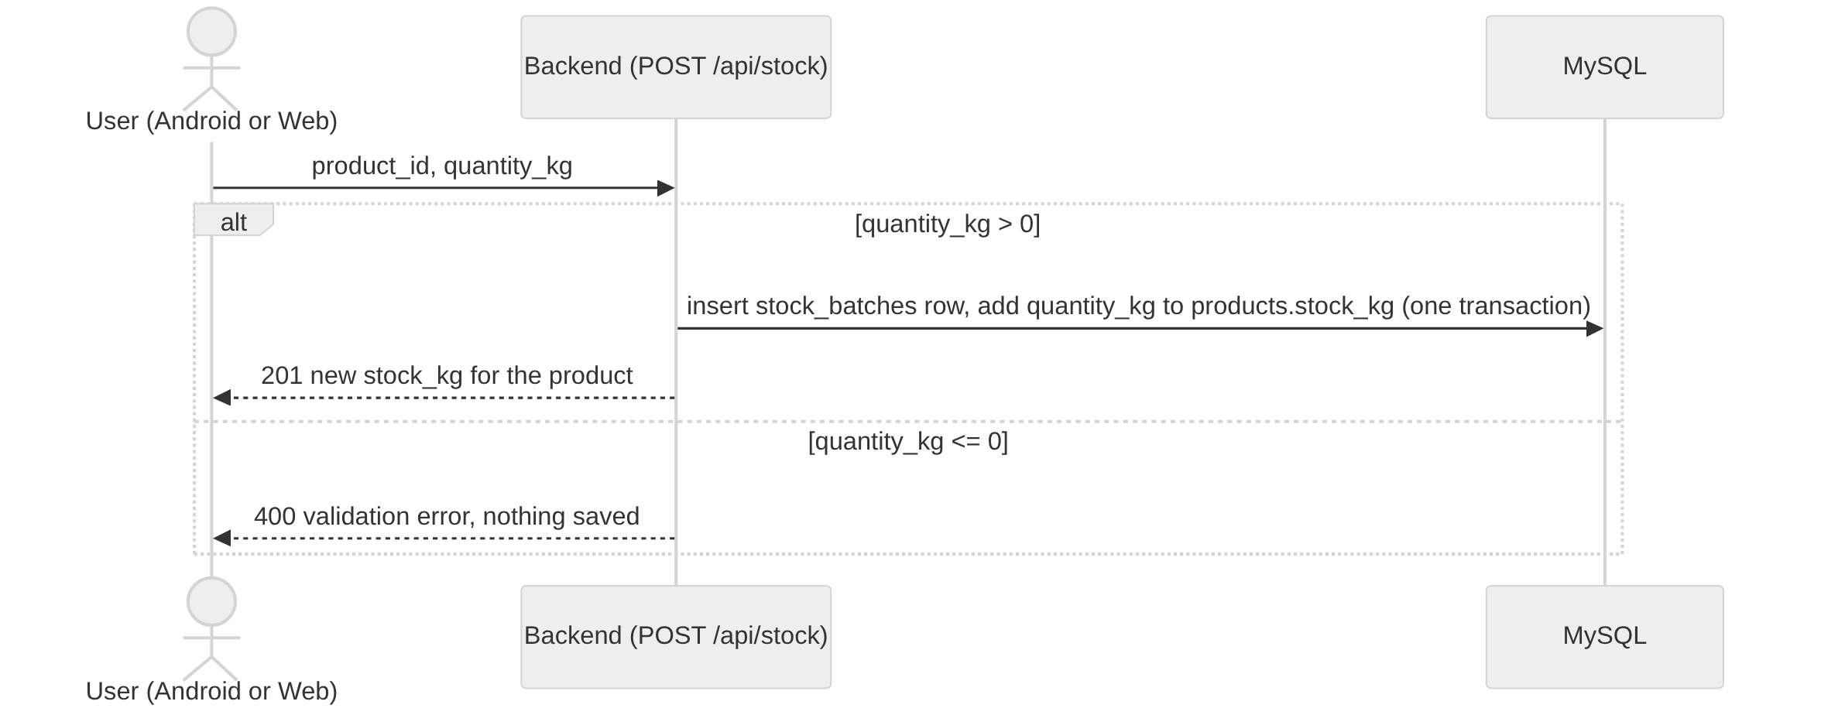
Figure 5: System sequence diagram -- Add Stock / Record Delivery (UC3)
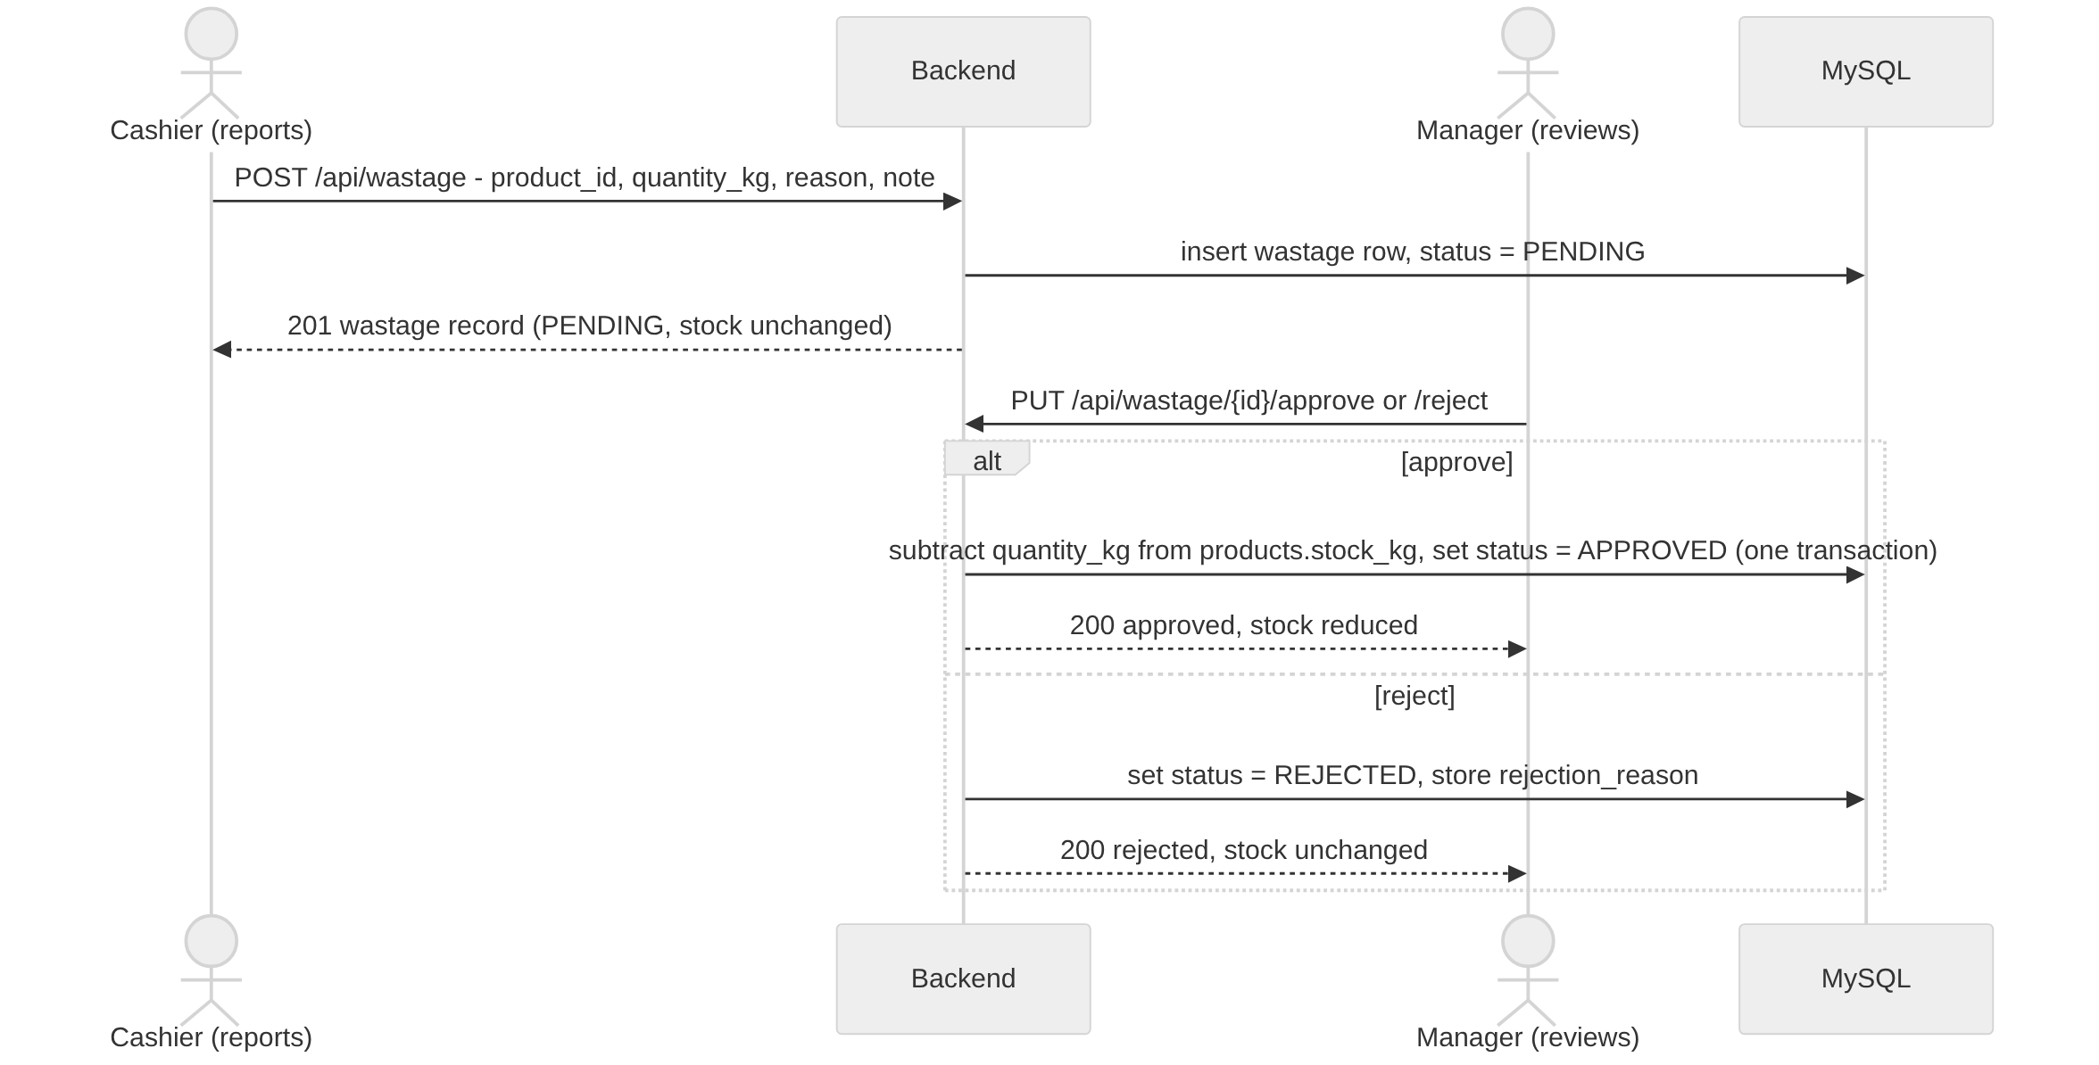
Figure 6: System sequence diagram -- Record and Approve Wastage (UC5 / UC6)
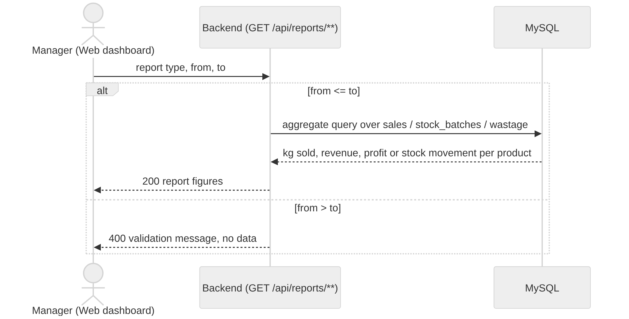
Figure 7: System sequence diagram -- Generate Reports (UC7)

APPENDIX D: ADDITIONAL TEST CASES AND RESULTS
The core manual test cases (MT1-MT9) and the automated test areas are listed in Section 6.3. A Postman collection covering every /api/** endpoint (happy path, validation failure, unauthorised request, wrong role) is kept in the project repository for API-level regression testing ahead of each demonstration.
[STUDENT TO ADD: exported Postman run results or screenshots, and any automated test output (e.g. from `npm test` once the automated suite in Section 6.2 is written), once Section 6.3 has been executed.]

APPENDIX E: DATA COLLECTION INSTRUMENTS
Not applicable. This project did not use questionnaires, interviews, or other formal data collection instruments; requirements were drawn from informal field observation, literature, and supervisor discussion, as described in Section 3.3.

APPENDIX F: ADDITIONAL CODE / CONFIGURATION
F.1 Database schema (backend/database/schema.sql)
CREATE DATABASE IF NOT EXISTS sbims;
USE sbims;

CREATE TABLE users (
id INT AUTO_INCREMENT PRIMARY KEY,
username VARCHAR(50) NOT NULL UNIQUE,
password_hash VARCHAR(255) NOT NULL,
role ENUM('admin', 'cashier') NOT NULL,
is_active BOOLEAN NOT NULL DEFAULT TRUE,
created_at TIMESTAMP DEFAULT CURRENT_TIMESTAMP
);

CREATE TABLE categories (
id INT AUTO_INCREMENT PRIMARY KEY,
name VARCHAR(50) NOT NULL UNIQUE
);

CREATE TABLE products (
id INT AUTO_INCREMENT PRIMARY KEY,
category_id INT NOT NULL,
name VARCHAR(100) NOT NULL,
price_per_kg DECIMAL(10, 2) NOT NULL,
cost_per_kg DECIMAL(10, 2) NULL,
stock_kg DECIMAL(10, 3) NOT NULL DEFAULT 0,
low_stock_threshold_kg DECIMAL(10, 3) NOT NULL DEFAULT 5,
barcode VARCHAR(50) UNIQUE NULL,
is_active BOOLEAN NOT NULL DEFAULT TRUE,
created_at TIMESTAMP DEFAULT CURRENT_TIMESTAMP,
FOREIGN KEY (category_id) REFERENCES categories(id)
);

CREATE TABLE stock_batches (
id INT AUTO_INCREMENT PRIMARY KEY,
product_id INT NOT NULL,
quantity_kg DECIMAL(10, 3) NOT NULL,
received_by INT NOT NULL,
received_at TIMESTAMP DEFAULT CURRENT_TIMESTAMP,
FOREIGN KEY (product_id) REFERENCES products(id),
FOREIGN KEY (received_by) REFERENCES users(id)
);

CREATE TABLE sales (
id INT AUTO_INCREMENT PRIMARY KEY,
product_id INT NOT NULL,
quantity_kg DECIMAL(10, 3) NOT NULL,
unit_price DECIMAL(10, 2) NOT NULL,
total_price DECIMAL(10, 2) NOT NULL,
sold_by INT NOT NULL,
sold_at TIMESTAMP DEFAULT CURRENT_TIMESTAMP,
FOREIGN KEY (product_id) REFERENCES products(id),
FOREIGN KEY (sold_by) REFERENCES users(id)
);

CREATE TABLE wastage (
id INT AUTO_INCREMENT PRIMARY KEY,
product_id INT NOT NULL,
quantity_kg DECIMAL(10, 3) NOT NULL,
reason ENUM('SPOILAGE', 'EXPIRY', 'TRIM', 'OTHER') NOT NULL DEFAULT 'OTHER',
note VARCHAR(255),
status ENUM('PENDING', 'APPROVED', 'REJECTED') NOT NULL DEFAULT 'PENDING',
recorded_by INT NOT NULL,
recorded_at TIMESTAMP DEFAULT CURRENT_TIMESTAMP,
reviewed_by INT NULL,
reviewed_at TIMESTAMP NULL,
rejection_reason VARCHAR(255) NULL,
FOREIGN KEY (product_id) REFERENCES products(id),
FOREIGN KEY (recorded_by) REFERENCES users(id),
FOREIGN KEY (reviewed_by) REFERENCES users(id)
);
F.2 Weight-based stock deduction with deadlock-safe locking (backend/src/routes/saleRoutes.js, abridged)
// backend/src/routes/saleRoutes.js (batch/cart checkout, abridged)
// Lock rows in a consistent order (by product_id) across all requests to
// avoid deadlocks between two concurrent checkouts that share products.
const ordered = items.map((item, index) => ({ ...item, _index: index }));
ordered.sort((a, b) => a.product_id - b.product_id);

await connection.beginTransaction();
for (const { product_id, quantity_kg, _index } of ordered) {
const [products] = await connection.query(
'SELECT name, price_per_kg FROM products WHERE id = ? FOR UPDATE',
[product_id]
);
const [updateResult] = await connection.query(
'UPDATE products SET stock_kg = stock_kg - ? WHERE id = ? AND stock_kg >= ?',
[quantity_kg, product_id, quantity_kg]
);
if (updateResult.affectedRows === 0) {
await connection.rollback();
return res.status(409).json({ error: 'Not enough stock', product_id });
}
// ...insert the sales row for this line...
}
await connection.commit();

APPENDIX G: OTHER SUPPORTING MATERIAL
The full source code, commit history and issue tracker for SBIMS are kept in the project's GitHub repository, Smart-Butchery-Inventory-Management-System, under GitHub Classroom for this course. The original project proposal (docs/Project-Proposal.pdf and docs/SBIMS Final Year Project Proposal.docx) and the working design notes this report was consolidated from (docs/*.md) are kept in the repository's docs/ folder.

FINAL REPORT SUBMISSION CHECKLIST
☐ Title page completed with project title, student details, supervisor, programme, and submission date.
☐ Declaration completed and signed.
☐ Supervisor approval completed where required.
☐ Abstract accurately reflects the completed project and major findings.
☐ Acknowledgements completed where appropriate.
☐ Table of contents, list of figures, list of tables, and abbreviations are updated.
☐ All chapters describe completed work rather than proposed work.
☐ Every project objective is addressed and evaluated.
☐ Figures and tables are numbered, titled, referenced in the text, and discussed.
☐ All external sources are cited in the text and listed in References.
☐ Group-project students clearly identify and document their own contribution.
☐ Ethical, legal, privacy, security, and intellectual-property issues are addressed where applicable.
☐ Testing/evaluation evidence is included and results are interpreted.
☐ Appendices contain supporting rather than essential arguments.
☐ Formatting, spelling, numbering, page numbers, cross-references, and citations have been checked.

