Project Report

**Project Name**: ShopBridge

**Project** **Type**: Inventory system

**Fron-End technology used**: Angular

**Frontend functionality**

1. Items add, update and delete feature added
2. Reactive forms are used for better resulting of forms.
3. Storing items data in browser’s local storage.
4. User can add multiple items at the same time by clicking on “Add more items+”.
5. Listing of inventory items are done on cards and flipping of card feature added to view more details and delete item.
6. Implemented PWA service worker.

**Styling**

1. For theme I have used bootstrap.
2. Sass styles have been used for more effective styling.

**Validations**

1. Added required validations for name, category, description and price.
2. Maximum length validation added for name and description.
3. Cross-site scription(xss) validations added for each form controls to avoid any security breach while saving data.
4. Custom directive added for validation errors.

**Test** **coverage**

1. 60% code coverage done.

**Deployment:**

Auto-deployment enabled in Heroku as merging to master will deploy the code via cicd to heroku.

Website url: <https://systeminventory1.herokuapp.com/>

Github repository url: <https://github.com/Goodvaibs/InventorySystem>

**Screenshots of the website:**

Item Listing:

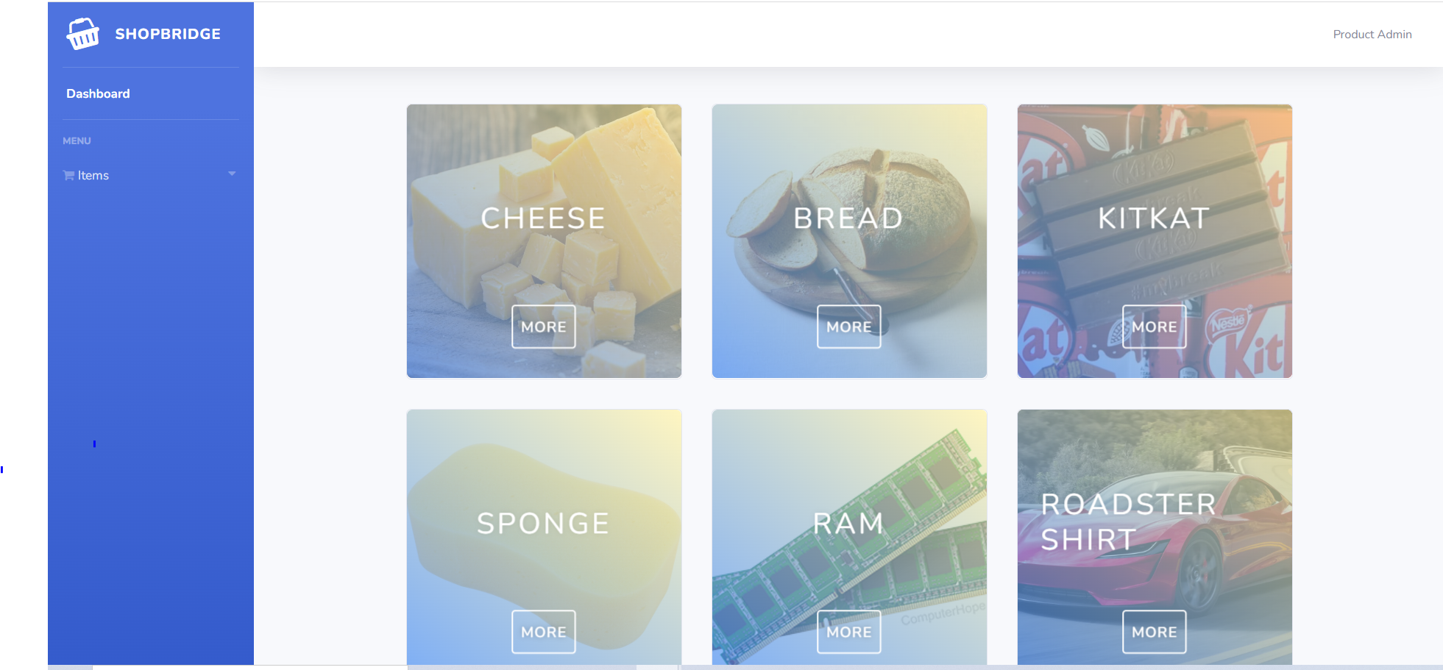

Add Item:

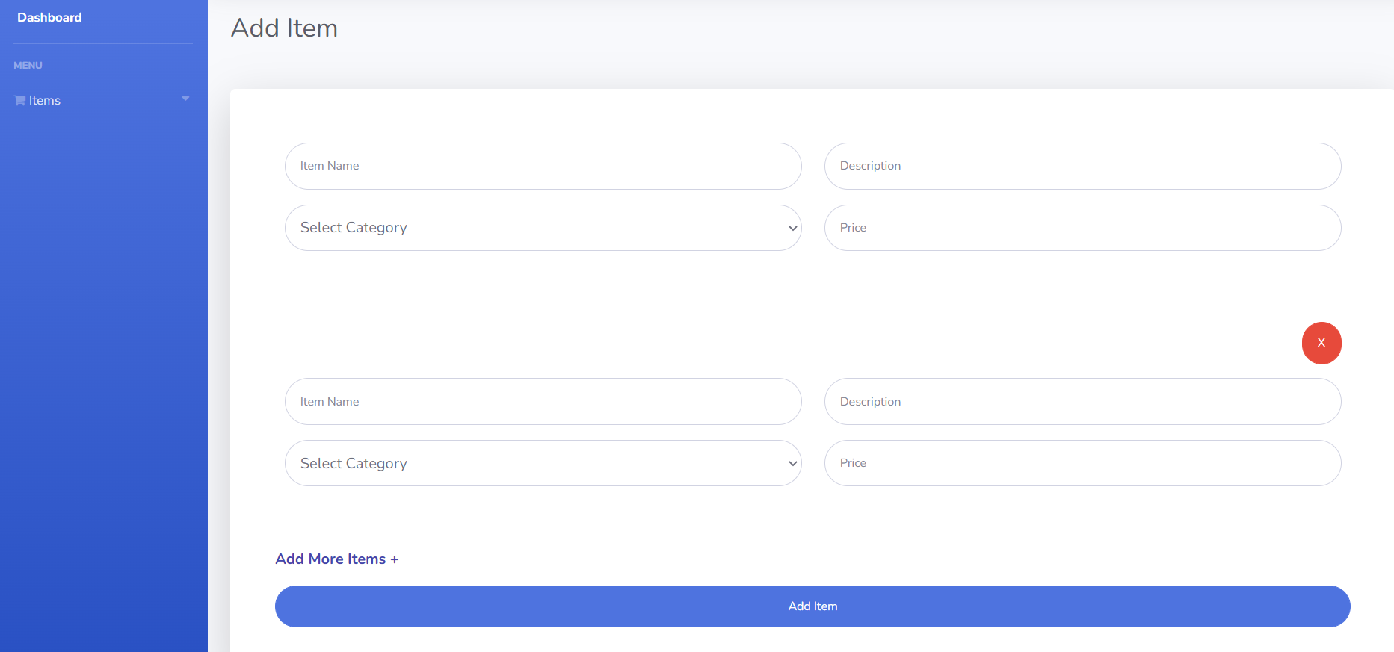

Edit Item:

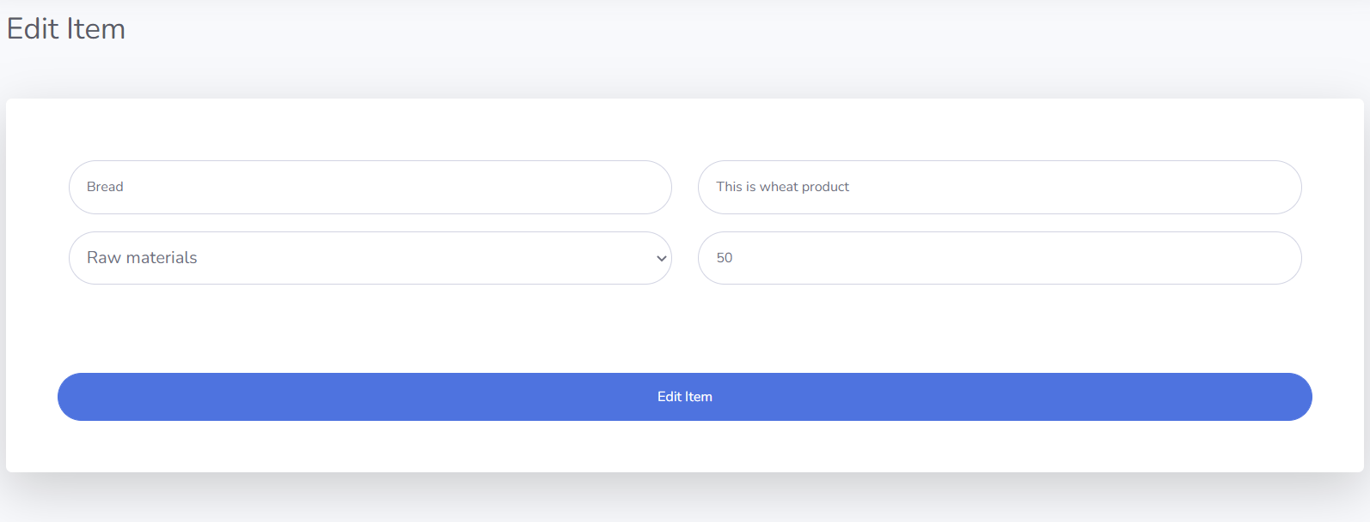

Delete Item:

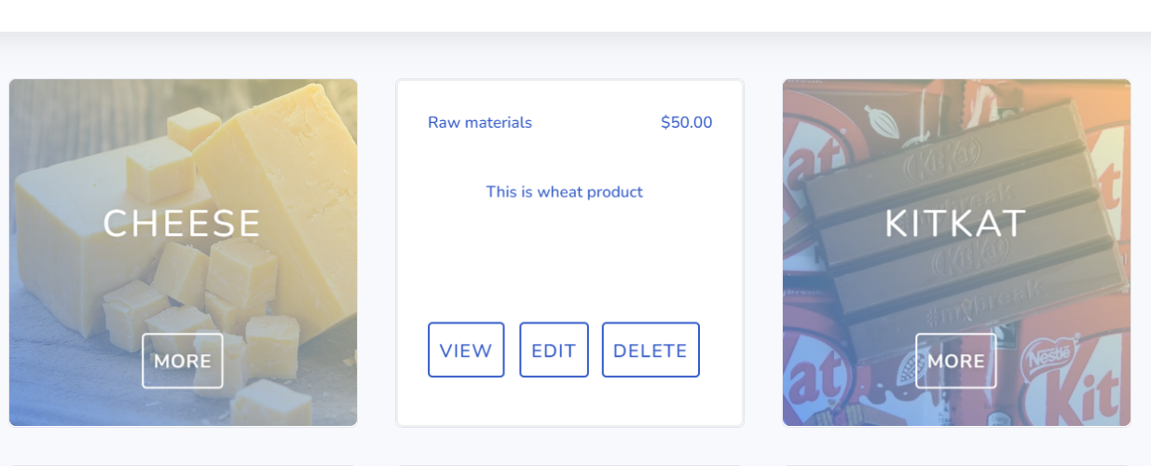

View Item:

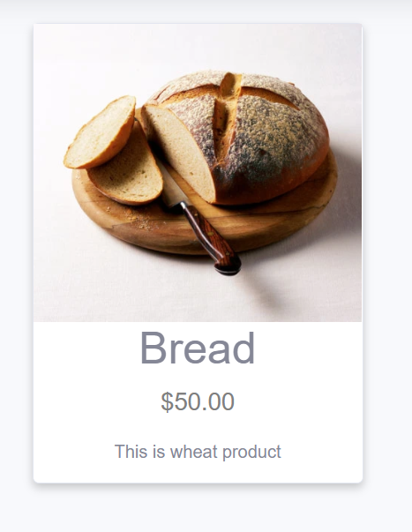

**Time spent on modules:**

1. Project setup and structure: 4h
2. Add item module: 8h
3. Listing module: 8h (card design and view card functionality)
4. Report and documentation: 1h