Go to: <http://dialer.ebrokercenter.com>

Login as Administrator. Put your extension in. Password is 463221

Click on **Campaigns** on the left. Then **Real-Time Campaigns Summary** on top right.

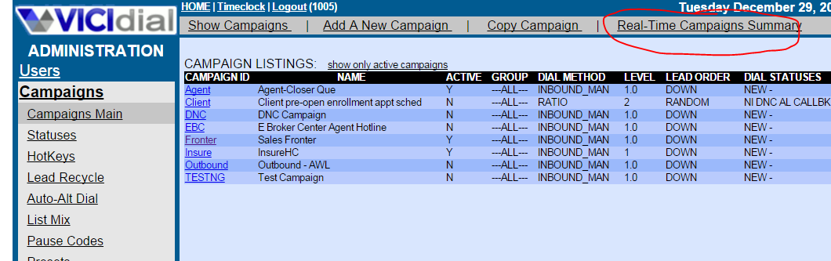

Click on **Fronter**

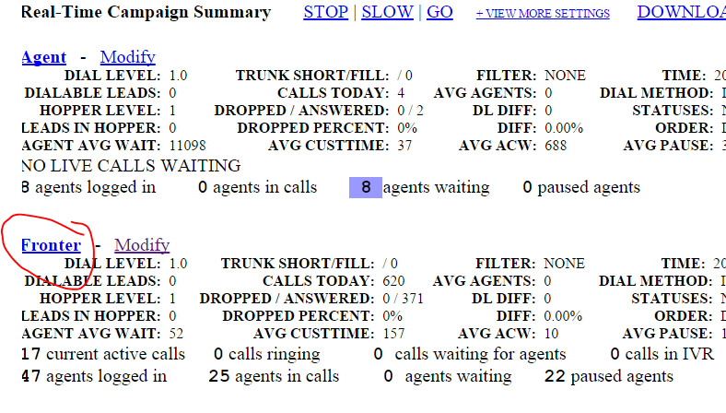

Click on **Choose Report Display Options**

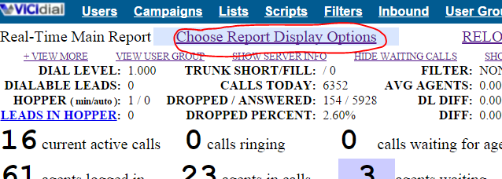

Choose **MONITOR** from the **Monitor dropdown box**. Make sure the Phone says **1082a**. Click **Submit.**

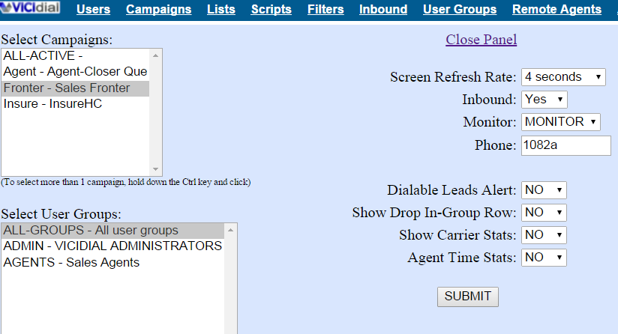

Then click Listen to whatever call you want to listen to.