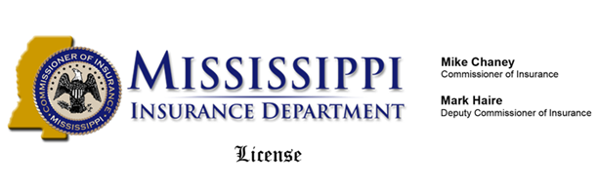

**Insurance Producer**

* Accident and Health

**MATTHEW OGOEGBUNAM BOSAH**

16067 CIRCLE DIAMOND RD

SLYMAR, CA 91342

**is authorized to transact business as described above**

License No: 10408216 Issue Date: 10-28-2015 Expiration Date: 11-30-2016

Generated by Sircon 119833797

|  |  |
| --- | --- |
| State TitleWallet State Seal  THIS IS TO CERTIFY THAT  MATTHEW OGOEGBUNAM BOSAH  16067 CIRCLE DIAMOND RD, SLYMAR, CA 91342  LICENSE NUMBER: 10408216 | IS HEREBY AUTHORIZED TO TRANSACT BUSINESS IN ACCORDANCE TO THE LICENSE DESCRIPTION SHOWN BELOW:  **Insurance Producer**   * Accident and Health   Issue Date: 10-28-2015  Expiration Date: 11-30-2016  Generated by Sircon 119833797 |